**Georgia Department of Behavioral Health and Developmental Disabilities**

**Helpful Websites:**

**IDD Connects Online Application Link for individuals/families to access the IDD-Connects portal**

[**https://georgiacollaborative.com/individuals-families/iddconnects**](https://georgiacollaborative.com/individuals-families/iddconnects)

**Page will appear as image below. Indicates documents required with I/DD Application. Click on Log in** 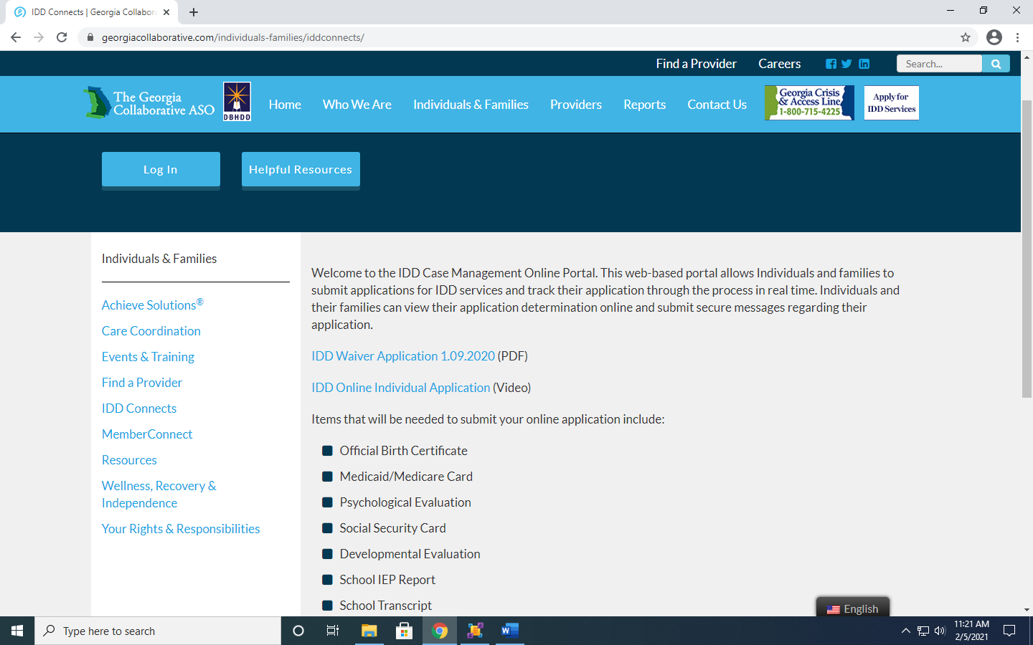

**When Log in button is clicked, next page will appear as image below. Click on New User and follow prompts.**

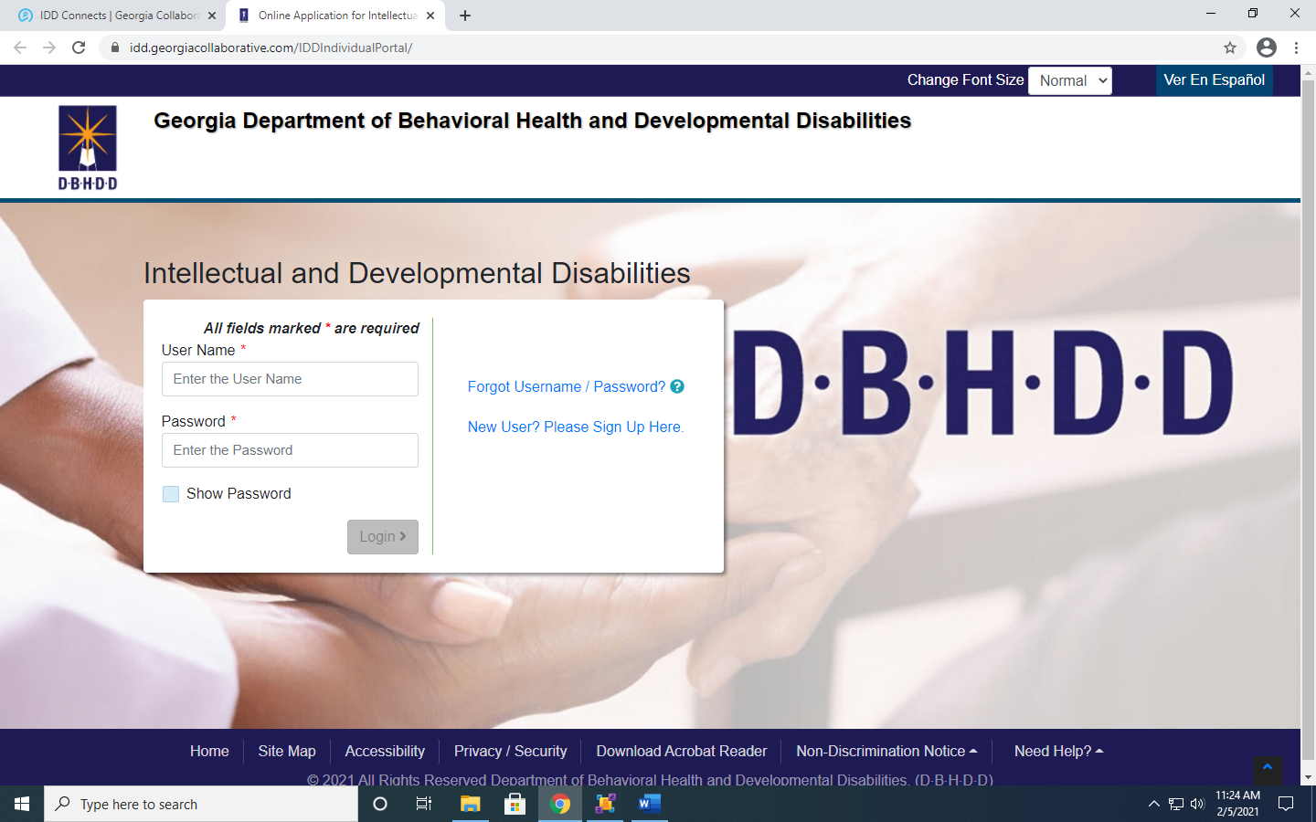

**Georgia Department of Behavioral Health and Developmental Disabilities**

**Helpful Websites:**

***GA Vocational Rehabilitation Agency (VR) information can be found on the DBHDD website:*** [**https://dbhdd.georgia.gov/supported-employment-2**](https://dbhdd.georgia.gov/supported-employment-2)

At the bottom of the page is a PDF document/brochure “DBHDD Guide to Supported Employment” which provides more explanation**.**

**Access Medicaid Waiver Program Manuals GA Medicaid Management Information System (GAMMIS):**

[**https://www.mmis.georgia.gov/portal/PubAccess.Provider%20Information/Provider%20Manuals/tabId/44/Default.aspx**](https://www.mmis.georgia.gov/portal/PubAccess.Provider%20Information/Provider%20Manuals/tabId/44/Default.aspx)

**DBHDD Family Support Services and Policy:**

[**https://dbhdd.georgia.gov/be-compassionate/home-services/family-support-services**](https://dbhdd.georgia.gov/be-compassionate/home-services/family-support-services)

**Parent to Parent of Georgia**

[**info@p2pga.org**](mailto:info@p2pga.org)

**Resources for youth under 21 years old**

**Georgia Pediatric Program for Children (GAPP)**

[**https://healthforcega.com/georgia-pediatric-program-children/**](https://healthforcega.com/georgia-pediatric-program-children/)

**GA Autism State Benefit Plan/ Adaptive Behavior Services (ABS)**

[**https://medicaid.georgia.gov/programs/all-programs/autism-spectrum-disorder**](https://medicaid.georgia.gov/programs/all-programs/autism-spectrum-disorder)