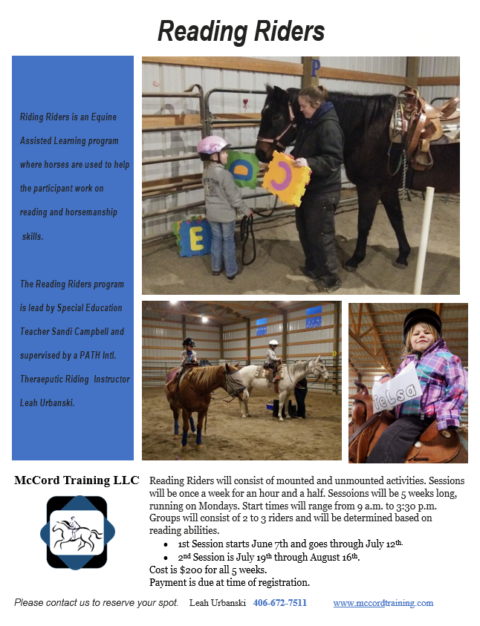

**Reading Riders Syllabus**

Lessons consist of both dismounted and mounted activities.

Books and additional materials will be based upon reading level and age appropriate activities.

Student riders will learn about horses and riding and relate it to reading activities.

Activities will include matching games, letter/word/sentence searches in the arena, trail/obstacle activities to build letter/word/sentence skills, scavenger hunts, pin the word part on the horse/tack, etc.

Approximate groupings: Student riders can be moved up or down at the discretion of the instructor.

Each lesson will start with reading a story, then the student will tack up their horse and engage in reading/riding activities that are age appropriate.

* Reading Level 1(ages 3-5)(weekly lesson/1 hour)Pre-emergent readers; learning letters. Student riders will use a letter wand to find and match letters .Alphabet matching games to learn things about horses.

* Reading Level 2(ages 5-7)(weekly lesson/1 hour) Emergent readers; knows letters and working  on sight words. Student riders will match sight words using word wands. Use words to make sentences. Learn the parts of the horse and tack.

* Reading Level 3 (1st/2nd grade) (weekly lesson/ 1 ½ hour)  Beginning readers, sentences or short passages, struggling with decoding or recognizing sight words, fluency issues. Student riders will read short passages and engage in scavenger hunts for comprehension. Match definitions to words related to horse knowledge.

* Reading Level 4* (3rd/4th/5th  grade) (weekly lesson/ 1 ½ hour)intermediate readers,  short to medium passages; limited decoding, comprehension, and/or fluency.

Student riders will engage in activities that match their reading needs.

Activities will include horse knowledge for both riding and reading.

*Upper ages can be expanded beyond suggested limits.

Reading Riders Schedule

1st Session – Starts June 7th and goes through July 12th.

-Small group of 2 or 3 riders that meet once a week on Mondays for an hour and a

                 half.

-Start times

O Reading Level 1 – 9 a.m.

O Reading Level 2 – 11 a.m.

O Reading Level 3 – 1:30 p.m.

O Reading Level 4 – 3:30 p.m.

- No Lessons June 21st.

- Cost $200 per rider. Payment due at time of registration.

2nd Session – Starts July 19th and goes through August 16th.

-Small group of 2 or 3 riders that meet once a week on Mondays for an hour and a

     half.

-Start times

O Reading Level 1 – 9 a.m.

O Reading Level 2 – 11 a.m.

O Reading Level 3 – 1:30 p.m.

O Reading Level 4 – 3:30 p.m.

-Cost $200 per rider.

-Payment due at time of registration.