

**9464 Tipperarie Trl**

**Molt, MT 59057**

**406-672-7511**

**mccordtraining@yahoo.com**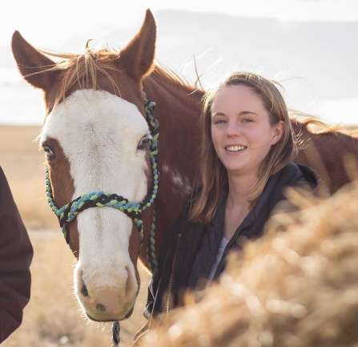

Welcome to McCord Training!

McCord Training LLC is owned and operated by Leah McCord Urbanski. She has been a certified therapeutic horseback riding instructor for 7 years, and has multiple equine degrees from Rocky Mountain College. She is first aide and CPR certified. Her goal is to create a premier riding lesson program in which every person is welcome.

Here at McCord Training LLC, we specialize in horseback riding lessons, and therapeutic riding lessons.

According to the PATH Intl. “**Therapeutic riding** is an **equine-assisted** activity for the purpose of contributing positively to the cognitive, physical, emotional and social well-being of individuals with special needs.” Individuals who participate in horseback riding benefit in many different ways including strength, balance, flexibility, coordination, self-assurance, and more.

In a typical hour lesson, the participant learns proper horse care, and proper horse handling. This includes how to groom the horse, lead, tack up, mount, ride, dismount, and untack. Our goal is to set the rider up to be independent and prepare them for if they ever want to have their own horse one day.

To become enrolled in our program, please fill out the enclosed paperwork and get ahold of Leah. She can be reached by calling or messaging her at 406-672-7511, e-mailing [mccordtraining@yahoo.com](mailto:mccordtraining@yahoo.com), or thorough our Facebook page. You can also see what riding lesson openings we have or activities are going on by going on our website or on our Facebook page.

Thank you! We are looking forward to hear from you.

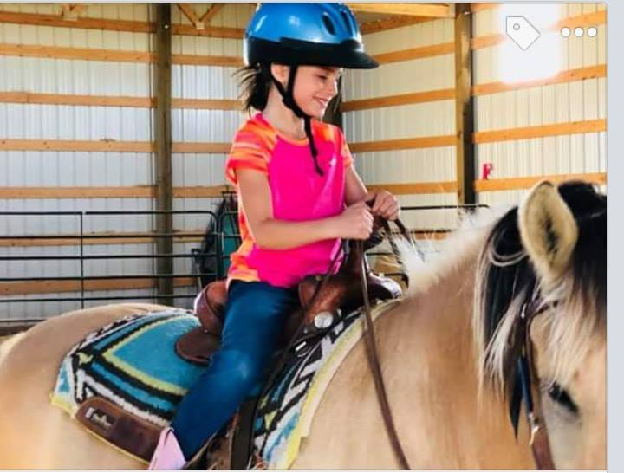



Rider Paperwork

Riders Name: _______________________________________ Age:_______

Address:___________________________________________________

City:___________________________ State:___________ Zip:_______

E-mail:___________________________Phone #:____________________

Lesson Frequency:__________________ Desired Start Date:________________

Safety Concerns Regarding Rider: _____________________________________

____________________________________________________________

Liability Release

I, _________________________, (Client or Authorized Parent/Guardian if Client is a Minor ) acknowledge and accept that horseback riding and activities related thereto, involve the risk of personal injury. By my signature I hereby waive all rights, if any, claims, causes of action and lawsuits against McCord Training LLC, the McCord’s, the Urbanski’s, their family, heirs, executors, legal representatives, administrators, successors, assigns, guests, employees, or agents affiliated with any of them in any manner for any injury, liability or damages which may occur while riding any horse, whether leased or owned by me or by any other person, or for any injury or damages which may occur while participating in any activity related to horseback riding. I agree to indemnify, defend and hold harmless McCord Training or any person or entity whose land a horseback ride crosses, for any accident, injury, or loss that might occur, and free such persons from all liability for such injury or loss. I understand that horseback riding always involves danger and I ride at my own risk.

I understand that horseback riding involves being in remote areas for extended periods of time, far from communications, transportation, and medical facilities; that these areas have many natural and man-made hazards which horseback riders cannot anticipate, identify, modify, or eliminate; that horses can be excitable, difficult to control, and unpredictable; and that accidents can happen to anyone at any time. I further understand that horseback riding involves such things as crossing creeks, riding over uneven terrain, and being in strange places under adverse weather conditions which could result in injury to myself and the horse I am riding.

I agree to take full responsibility for myself and the animal I am riding. I am aware that wearing a certified safety helmet is a good preventive measure against head injury, and further understand that helmets are not provided to riders by McCord Training. My signature below constitutes acceptance of the above terms and conditions. I have read and fully understand this liability release.

Signature:_____________________________________________________

Signature of Client or Authorized Parent/Guardian if Client is a Minor

Printed Name: ____________________________ Date: ______________

**\**

Emergency Medical Info.

Client Name: __________________________________________________

**In Case of an Emergency Contact:**

* Name:___________________________________________________

Relationship:__________________Phone#:____________________

* Name:__________________________________________________

Relationship:____________________Phone#:__________________

**Known Medical Problems and Medications:**

*This information is included to provide information to emergency personnel of medical problems and medications in an emergency situation.*

Are you currently taking any medication?_______________________

If yes, what kinds and how much?______________________

_______________________________________________________

Do you have any known Allergies?_________________________

If yes, what are they? **__________________________________**

Photo Release

Please check one of the following Options:

____ I hereby consent to and authorize the use and reproduction by McCord Training LLC of any and all photographs, digital reproductions, and any other audio/visual material taken of me/my son/my daughter/my ward for promotional material, whether electronic, print, digital or electronic publishing via the Internet, education activities, exhibits or for any other use for the benefit of McCord Training for an unlimited period of time and without monetary compensation or other remuneration.

____ I do not consent to and authorize the use of any and all photographs and any other audio/visual materials taken of me for promotional material, education activities, exhibits, or for any other use for the benefit of the program.

____________________________________________________________Signature of Client or Authorized Parent/Guardian if Client is a Minor

Printed Name:_________________________________Date:____________



Barn Rules

1. Barn hours are 8 A.M. to 8 P.M. Lesson clients visit by appointment only.
2. Speed Limit is 5 MPH when entering and exiting the property.
3. No driving past the barn unless authorized. Parking is to the north of the barn.
4. No Outside Dogs Allowed. Exceptions are certified companion or working therapy support animals, proof of certification/training must be provided and on file.
5. No Smoking.
6. No drugs, alcohol, or weapons.
7. No one is allowed in the pastures without instructor’s approval.
8. Do not feed the horses unless it’s your own or under instructor’s supervision.
9. Everyone MUST sign all required paperwork. This includes a liability release and emergency medical release in order to participate in ANY horse-related activity.

1. Parents must provide supervision for their children when they are not involved in a lesson.
2. No running or screaming. Be aware that horses can be easily scared.
3. We are not responsible for loss, theft, or damage of trailers, vehicles, or personal items on the property.
4. No climbing on arena rails, pasture gates, or hay bales.
5. Lessons take precedent. Boarders must relinquish use of indoor or outdoor arenas when lessons are/about to take place. In addition, boarders and their horses must keep their distance from those coming out for lessons.
6. Do not tie horses to round-pen, fence post, etc. Only tie horses to the hitching post or tie rings in arena.
7. All accidents must be reported.



Program Policies

1. An instructor must be present before a lesson can start which includes approaching any horses tied up.

1. For the safety of the horse, lessons are not given when the temperature is under 32 degrees Fahrenheit.
2. Riders (who are using a McCord Training horse) must wear an ASTMI certified riding helmet when mounted. McCord Training does have helmets available for use.
3. To ensure the safety of horse and rider, there is a rider weight limit of 200 lbs.
4. Riders must be at least 4 years old and up to ride.
5. Riders must be able to physically get on a horse from the mounting block. This requires the rider to be able to stretch/lift their foot up approximately 2 feet and swing their other leg over the back of the horse.
6. Riders with special needs may need to undergo an evaluation to ensure that we can safely accommodate them and in some cases McCord Training will request a doctor to sign off that horseback riding is a safe activity for that individual.
7. All riders MUST wear closed toed shoes while being around and riding the horses. Boots with a heel and long pants preferred. NO SANDALS.
8. Late arrivals- We will wait 20 minutes past the start of your scheduled class time. After 20 minutes, horses will be put away and will no longer be available.
9. Please contact McCord Training as soon as possible if you are unable to make it to your scheduled lesson time.
10. McCord Training reserves the right to cancel any classes due to weather or an emergency related situation.



Scheduling Policies

1. Lessons are scheduled one month at a time.
   1. The Monthly schedule is available on the 15th of each month for the following month both on our Facebook page https://www.facebook.com/McCordTrainingLLC/ and on our website [www.mccordtraining.com](http://www.mccordtraining.com).
2. Lessons must be prepaid.
   1. Lessons must be paid for by the 28th to be on the schedule for the following month.
      1. If payment isn’t received by the 28th then the time slot becomes open to another rider.
3. Most lessons are weekly and semi- weekly.
   1. There will only be a few openings for those clients who want irregular lessons.
      1. Those riders who schedule weekly and semi-weekly lessons take precedent over those irregular lessons.
4. To get on the schedule call/text Leah at 406-672-7511. You can also e-mail [mccordtraining@yahoo.com](mailto:mccordtraining@yahoo.com) or message us on Facebook <https://www.facebook.com/McCordTrainingLLC/>.



Billing Policies

1. Prices
   1. Private lessons- $40 per lesson.
   2. Group lessons - $30 per rider per lesson.
      1. Whether a lesson is private or group, a lesson generally takes an hour to an hour and a half.
2. Lessons must be prepaid for the following month by the 28th.
   1. McCord Training accepts cash, checks, or paypal- [mccordtraining@yahoo.com](mailto:mccordtraining@yahoo.com)
   2. Statements or invoices won’t be e-mailed out unless requested by a client.
   3. If lessons are not prepaid for the following month by the 28th then the time slot becomes available for someone else.
3. Rider Cancellations - McCord Training does not issue credits for participants who have prepaid/reserved a lesson time and are absent due to sickness, vacation, etc.
4. Late Arrivals- Riders arriving 20 minutes or more late will be treated the same as a rider cancellation- no credits issued and no lesson.
5. No Shows- Clients who do not show up for their lesson will not receive credit.
6. Credit will be given for any cancellations made by McCord Training due to weather or emergency related cancellations.



I ,____________________, have read, understood, and will adhere to the barn rules, program, scheduling and billing policies.

____________________________________________________________Signature of Client or Authorized Parent/Guardian if Client is a Minor

Printed Name:_________________________________Date:____________