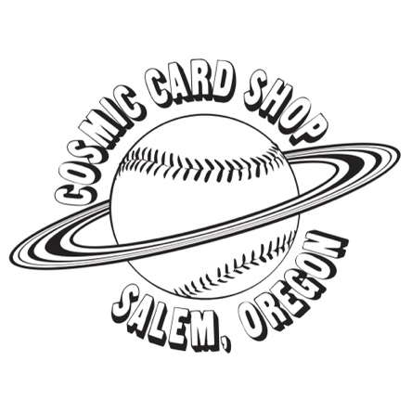
SALEM TRADING CARD EXPO
Saturday June 20th, 2026
Sponsored by Cosmic Card Shop
431 Ferry St SE
Salem, OR 97301

Mission: The Salem Trading Card Expo is designed to be a fun, family friendly event where our community can come together in a safe, inclusive environment to share in the hobby we all love.
Event Hours: Saturday June 20th,2026 10am-4pm
Decorating: Professional Signage and banners are allowed but participants are responsible for set up and break down and hanging equipment must be temporary.
Application Deadline: Booth spaces are being offered on a first come first serve basis and will fill up quickly. Get your application in early to ensure a booth space. No booth will be held until payment in full is received with the application. All applications must be submitted with payment in full no later than June 1st, 2026. Late Applications are subject to approval, based on availability, and will require an additional fee. ($150 per table.)

Primary Vendor
Name: ___________________________________________________________

Business Name: ____________________________________________________

Phone: ______________________________ Email: _____________________________________

Type of items sold: ______________________________________________________

Additional Vendor
Name: ___________________________________________________________

Business Name: ____________________________________________________

Phone: _______________________________Email: _____________________________________
Access badges are required for all vendors, including any additional staff working the booth. Two vendor maximum permitted at each booth. If you plan to utilize a secondary individual to help work your booth, please include their information above.
Table(s) Rental: _______ 6ft table (enter quantity) $100.00 for 1 / $180.00 for 2
Extra Chair Rental: _______ Folding chair (enter quantity) $5 each (optional)

Full balance due with application

Total Balance: $________________________________________________________

Send invoice to email: __________________________________________________

Booth Fees:
6’ Table x1 $100
6’ Table x2 $180
Extra Chair x1 $5

Rental Includes one chair. Additional chair rentals can be purchased for $5. (Two chair limit per table.)

Cancellation Policy:
All rentals are final and non-refundable under any circumstances, including but not limited to illness, weather, travel changes, or personal commitments. We encourage you to carefully consider your availability before reserving a booth. No exceptions will be made to this policy.

Event Rules and guidelines

WEAPONS OF ANY KIND ARE STRICTLY PROHIBITED.

Access badges are required for all vendors, including any additional staff working the booth. Two vendor maximum permitted at each booth.

Please supervise your children at all times.

With such a wide variety of vendors, please be mindful and respectful of others. Do not block the front half of your booth, so your neighbor is not as visible. Respect the space of other vendors and leave space beside your table to allow for vendors to move around easily.

If you are having an issue, please notify a member of the Cosmic Card Shop staff ASAP.

The use of a personal video recording device is highly encouraged for security and promotional purposes.

Vendors can begin setup as early as 8am and must have their booth fully broken down by 6pm.

Exhibitor’s Financial/ Legal Responsibility:

Exhibitor is financially responsible for any damage caused to booths, decorations, property or any injuries/damages to third persons or the property during event that is caused by or originates in exhibitor’s booth or through exhibitor’s action. Third persons include, but are not limited to, guests, invitees, visitors, other exhibitors, event staff, and any other persons in attendance at the Trading Card Expo. Exhibitor shall protect Cosmic Card Shop and its affiliates from all such claims, Defend Cosmic Card Shop and its affiliates from such claims, and hold Cosmic Card Shop and its affiliates harmless from all such claims and the expenses thereof including the cost of any attorney fees incurred in defending such claims, and shall pay all such claims for which any legal liability is established.

I have read and understand the terms and conditions as outlined in this application and agree with them. I further agree that I will not hold Cosmic Card Shop, it’s owners, staff, or the event venue responsible for any damage that may occur during my participation in this event. Cosmic Card Shop also has the right to terminate this contract at any time for any reason if the exhibitor has misrepresented themselves.

All participants must sign and date below to bind this contract

Signature: _____________________________________________Date: _____________________
By signing this paper, you have read and agreed to the terms on all pages.

Signature: _____________________________________________ Date: _____________________
By signing this paper, you have read and agreed to the terms on all pages.

Email or drop off applications to Cosmic Card Shop

431 Ferry St SE
Salem, OR 97301
cosmiccards444@gmail.com

