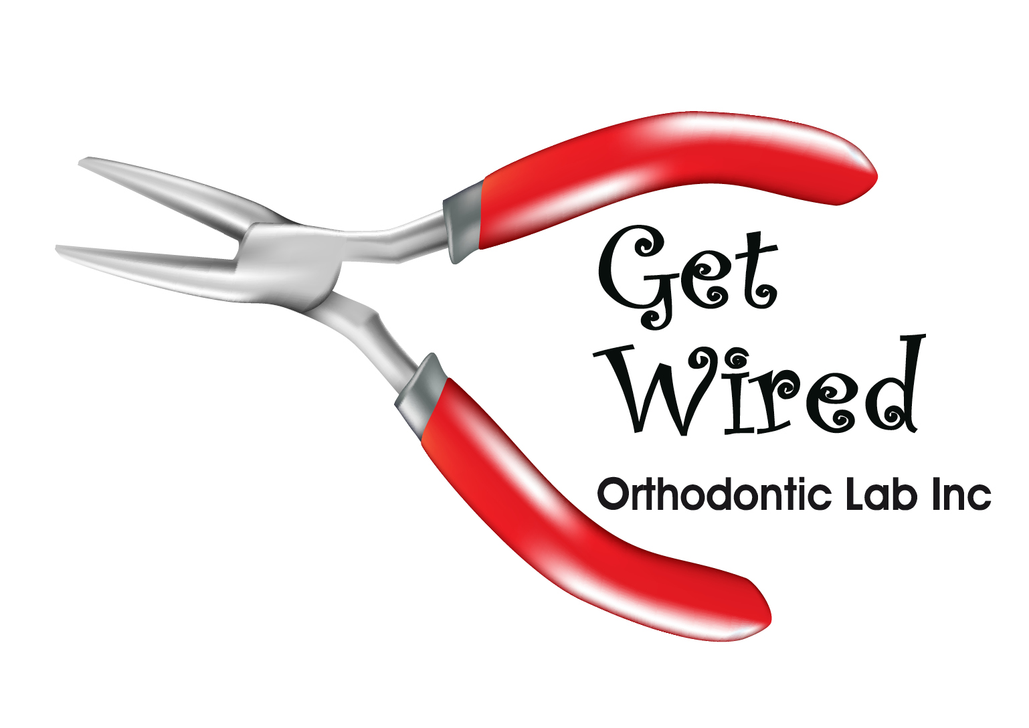

BASIC FEE GUIDE- Jan. 2024

Removable Appliances:

Maxillary Hawley $179.07

Maxillary wraparound Hawley $191.88

Essix retainer $107.52

Anterior/Posterior crossbite appl $236.63

Mandibular spring aligner $230.24

Thermaflex splint (3D printed or manual) $214.67

3D printed Hard Splint $229.11

Dual Layer Splint $235.53

Fixed Appliances:

Loop spacer (unilateral) $101.59

Nance $144.69

Lower Holding Arch $120.00

Upper Holding Arch $125.00

Quad Helix $184.90

HYRAX (rapid palatal expander) $204.65 Crib $204.65

Mand Lingual 3-3 wire (straight) $ 96.38

Mand Lingual 3-3 braided wire $114.44

Max Ling. 2-2 wire (straight) $ 84.33

Max Ling. 2-2 braided wire $ 95.00

Printed Resin Models:

Mx or Md model (ortho trimmed) $44.00

Mx or Md model with appliance $22.00

More Custom Orthodontic appliances available not listed above…additional charges for impression pour up ($21.86), band fit & supply ($27.32/band), and added wire work. Courier fees are added for out of town offices. Rush cases with < 24 hr turnaround time incur an $80 rush fee...< 6 hrs a $100 rush fee.

**Get Wired Orthodontic Lab Inc.**

4212-97 Street Edmonton, AB T6E 5Z9 ph (780) 966-WIRE