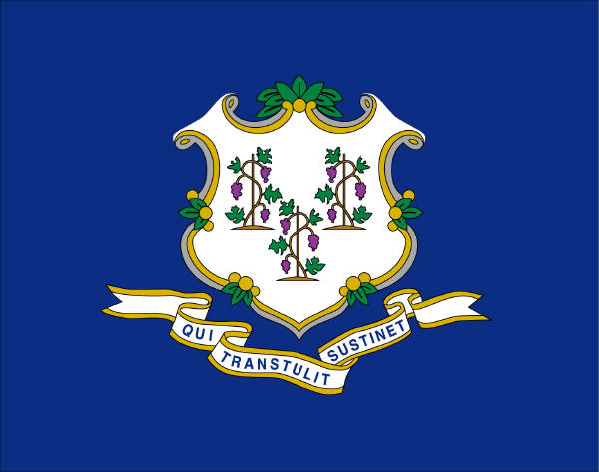
CTAMSS
Connecticut Association Medical Staff Services
2025 Membership Registration

Membership: New [ ] [ ] CPCS [ ] CPMSM other Degree/Certifications:_____________________

_________________________________________________ __________________________ ______________________________ _________________
Last Name First Name MI
________________________________________________________________________________________________________________________________
Home Address
__________________________ ________ _________ ____________ _________________
City State Zip
___________________________________________ _____________________ __________________________________ _________________________
Title Office Tel # Office Fax #
_____________________________________________________________________ __________________________________________________
Employer email address
___________________________________________________________ _________________________________________ _________ ______________
Contact Address City State Zip

Authorization to publish Contact Information & email address on CTAMSS website: [ ] Yes [ ] No

Type of Healthcare Facility: [ ] Hospital [ ] Health Center [ ] Managed Care Organization [ ] CVO
[ ] Other_______________________________________________________

Type of accreditation: [ ] The Joint Commission [ ] HFAP [ ] CMS
[ ] Other: ___________________________________________________________________________

Who do you report to: (CEO, COO, CMO, COS, RM, other): ____________________________________ # of Providers: _________

Credentialing software: _________________________________________________________________

Would your organization be interested in hosting one of the quarterly meetings? [ ] Yes [ ] No

Are you currently a member of NAMSS (National Association Medical Staff Services)? [ ] Yes [ ] No
If No, visit NAMSS website for information and benefits www.namss.org

List your main areas of interest (Medical Staff Management, Credentialing, Privileges, Risk Management, etc):
________________________________________________________________________________________________________________________________

______________________________________________________________ _____________________________
Signature Date

Send Membership Registration to:
Sarah Cappellina, CPCS
cappellina@uchc.edu

For more information or questions, contact:
Sarah Cappellina, CTAMSS Membership Chair,
Medical Staff Services
UConn Health
P-860-679-7606
F-860-679-1992

