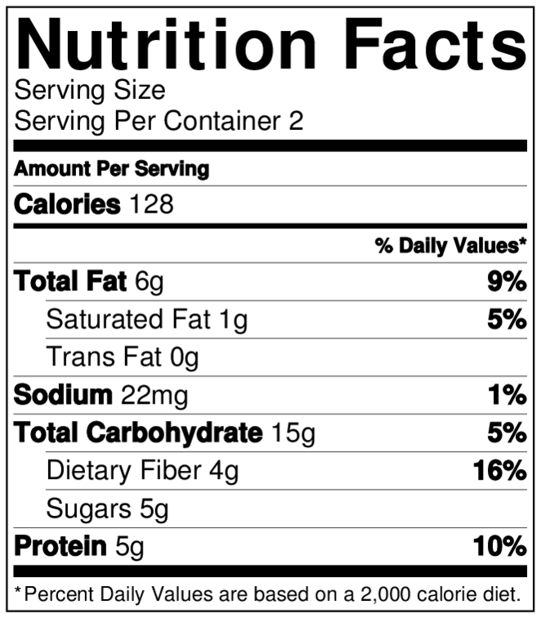  Target Blood glucose Ranges: 80-130 mg/dl before Meals.  2 hours Post meal < less than 180 mg/dl.  BG < less 70 mg/dl Hypoglycemia! Eat a snack! 15 gram Carbs. 15/15 rule.  Carb counting is great for Pre-Diabetes and Weight management!  2  Ioi  Note: Diets are individualized per Activity, weight and energy needs.  For weight loss, start with the lower daily Carbohydrate amounts. |  | General Guidelines for Consistent Carbohydrate Meal Plan. (Macronutrient meal plan) Goal is to Eat consistent Carbohydrate amounts daily. Healthy Choice Carbs and limit starchy/grains serving to 20-30 gram/carbs or less per meal.  Include Protein choice with each meal. Meat/ lean options.  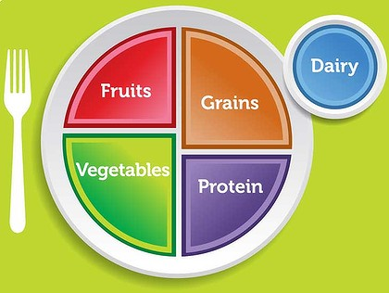  Meal plan plate Choices    (Snack recommendation is 15-20 Carb grams)  This meal plan guideline is FREE download on home page   Scan this QR Code to HOMEPAGE for FREE Meal plan guide. Download Copy and Share! | Your PLAN  Count the Carbohydrates  1 Carb choice/  exchange =  15 grams of Carbs 1 Apple = 15 grams. | Carbohydrates. Total carbohydrates per day. 150-180 grams divided into meals and snacks.  Men 60-70 grams/ Carbs per meal  + Snack. Inactive or wt. loss needs start with 45-60 gram/carbs per meal.  Women 45-60 grams per meal + snacks  Inactive or wt. loss needs. 30-45 grams per meal or 20-30g net Carbs  50 grams or less of carbs per day may cause Ketoacidosis. 35 grams of net carbs is considered Keto diet.  Always follow your medical management team recommendations.  General calorie Counts for 1200-1500-1800-2000-2200 depending on activity & weight needs.  Start by Counting the Carbohydrates  and Choose food lower in calories  Nutritional Fact label Video provides Saturated Fat recommendations for weight and improving cholesterol levels.  Go to Diabeteslearnhealthy.com for more downloads.  Free education Videos UTUBE Channel Lorie RN BSN CDE for free Videos!  SCAN QR for YouTube Channel Videos
Meal planning |  |  | Exchange | Carbohydrates | Calories/other
1-2 Eggs | 4 oz. | Scrambled Eggs - protein = 2 grams | 1 Pro | 0.4-5 g yolk | 63 cal
Breakfast
Lunch |  |  |  | Count your Carbs!

