This product is an aftermarket (off road) performance enhancer. Ultimate Performance has no control over the installation and/or use of the products we manufacturer or sell. The purchaser assumes ALL responsibility for the safety, proper installation, performance and applicability of these products. Ultimate Performance will not be held liable for personal, property, legal or financial damages or claims stemming from the use or misuse of any of our products. If you have any questions or concerns about the installation, function, performance or proper use of these products please call us before proceeding with the installation.

Installation Tips for 2017+ Ford Fusion Sport/Lincoln MKZ Front Mount Intercooler

- Before starting your install be sure to jack the vehicle up to a sufficient height that you can safely work under. Chock your rear wheels and use good quality jack stands to secure the vehicle at a workable height. NEVER work under your car unless it is properly secured in this manner.

- Remove both lower engine protectant shields. The larger one has 22 bolts (either 10mm or 7mm). The smaller one has 11 bolts. (10mm)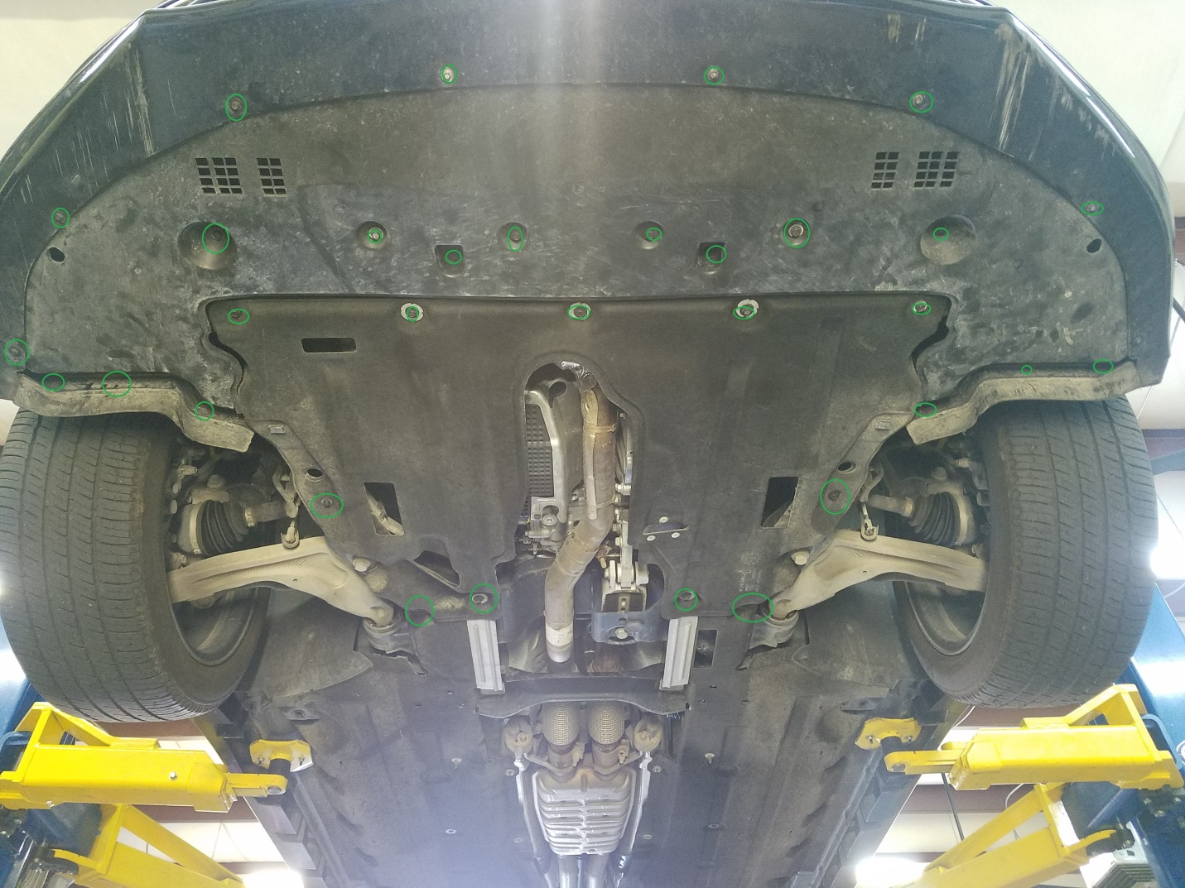

- Use a lifting device such as a floor jack to support the lower radiator support. Remove the 4 bolts holding the radiator support to the frame. (13mm) Slowly lower the jack and the radiator and intercooler will drop down into a workable position. (3 to 4 inches and the radiator will stop because it is still supported by the hoses and frame.)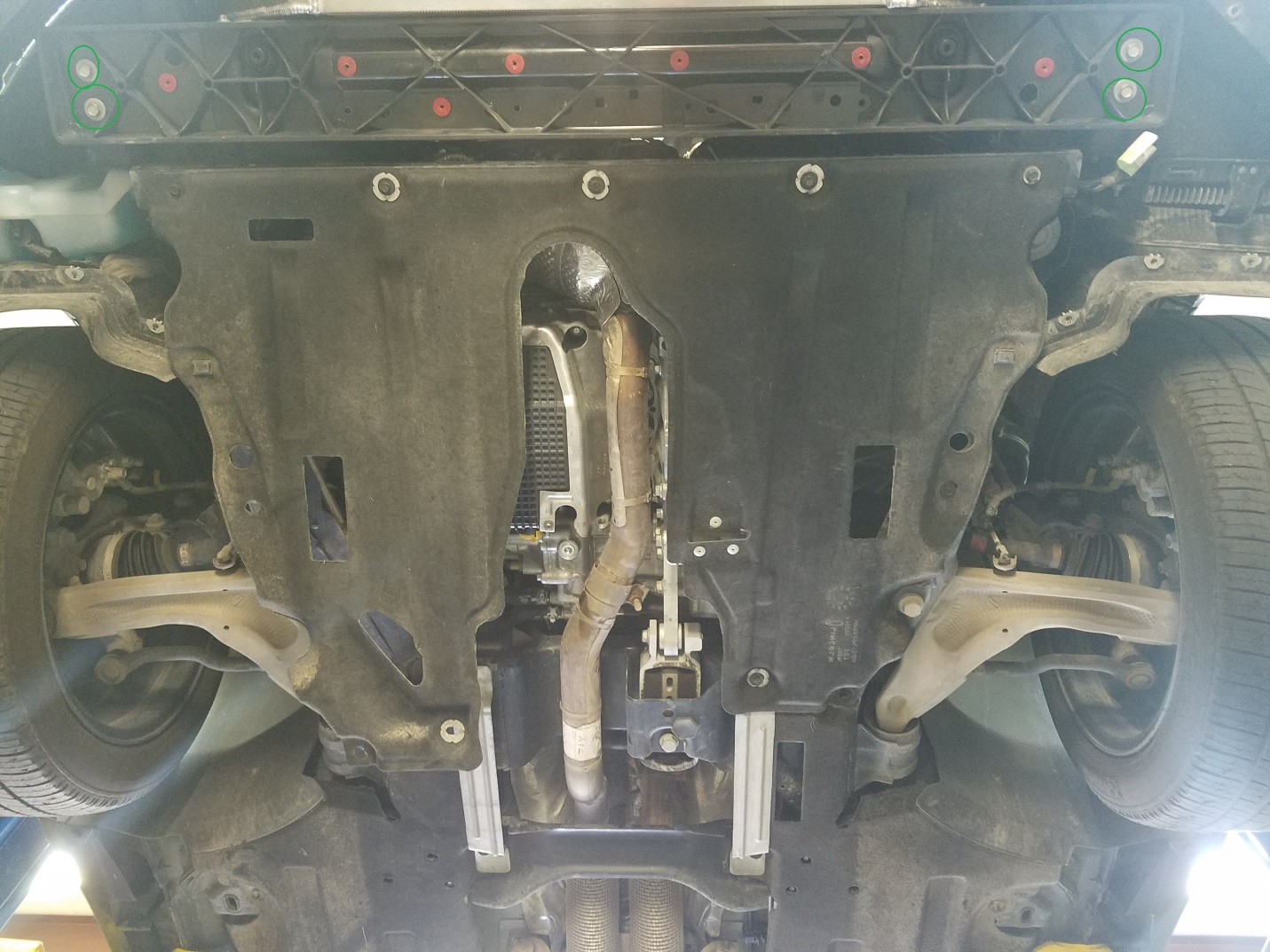
- You will now have better access to the charge hoses (from turbos) and feed hose to the intake manifold. Loosen all three clamps (7mm head on hose clamps)

- Disconnect the IAT/Map sensor harness located on the passenger’s side of the intercooler.
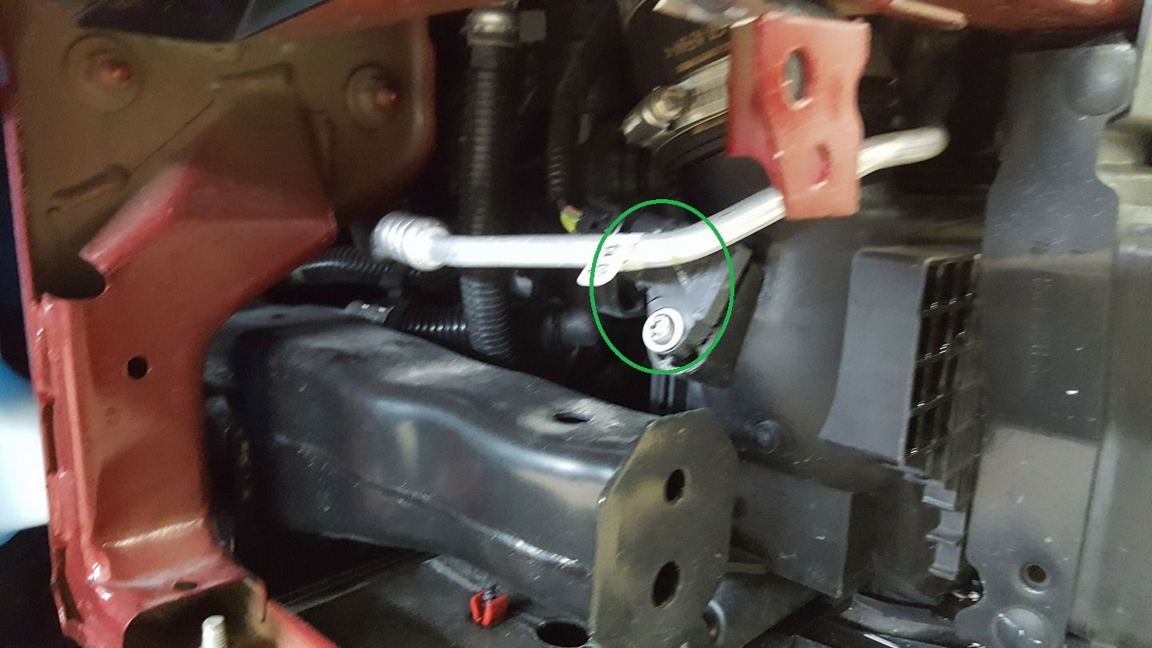

- From the driver’s side reach up with an 8mm ratchet wrench and remove the upper intercooler mounting bolt. Then remove the two lower intercooler mounting bolts.
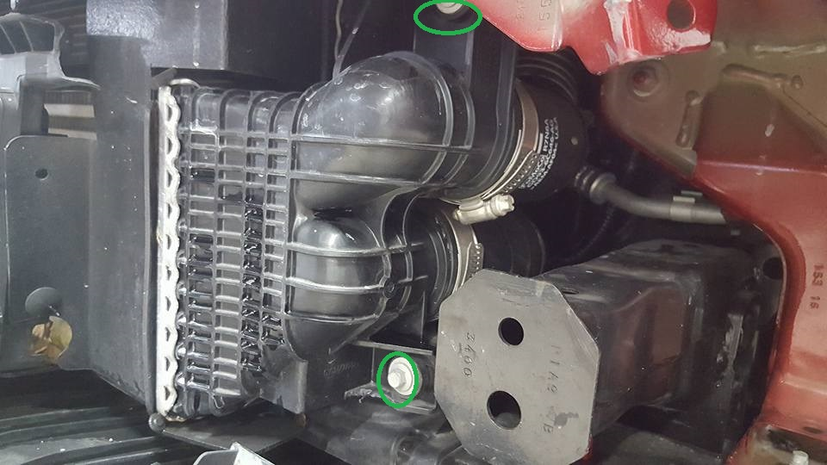

- There is a plastic tube extending from the radiator on the passenger side that functions as a final support for the intercooler. There is a plastic “hook” on the top of the intercooler that clips onto the plastic tube that extends from the radiator. CAREFULLY reach up from the bottom with a flat head screwdriver, position the screwdriver between the hook and the tube and rotate the screwdriver until it pops the hook loose. The intercooler will now be free.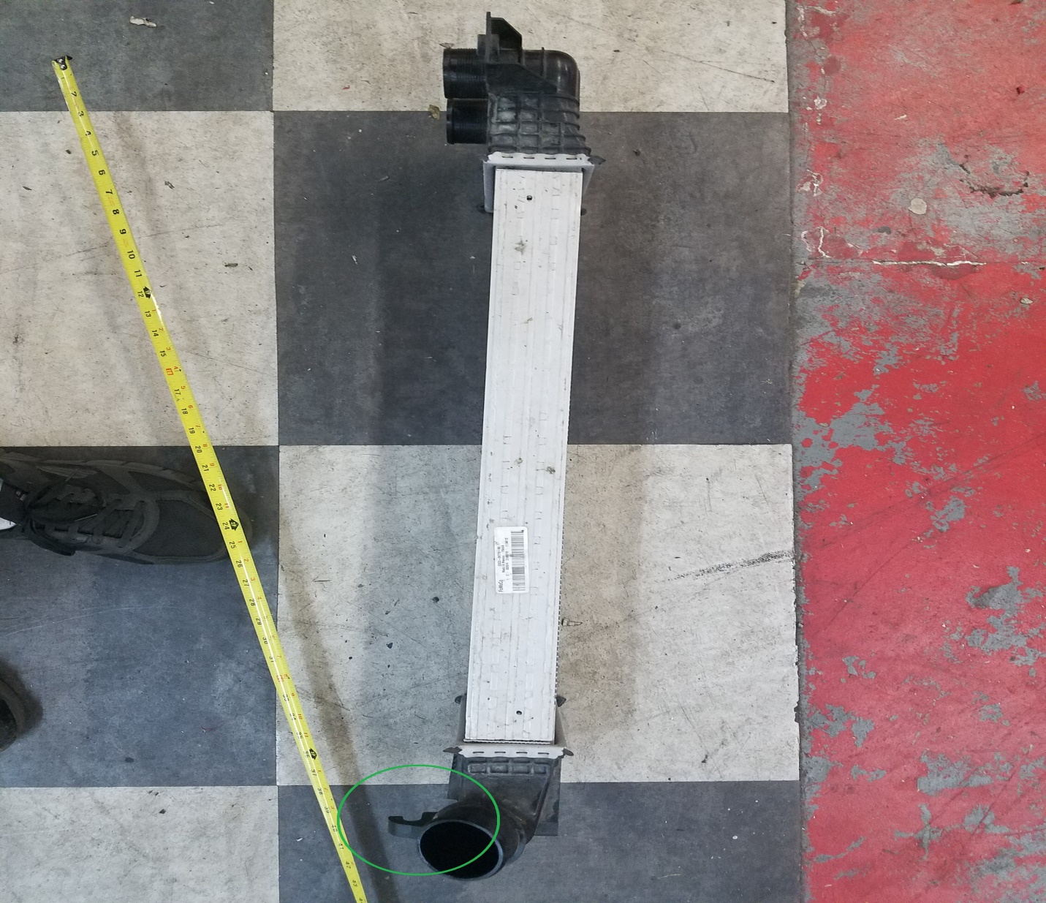

- Remove the MAP/IAT2 sensor from the stock intercooler (the bolt should be a T30 torx).
Put a drop or two of oil on the oring and pop it into the new cooler. Put a dab of silicone sealant on the bolt and carefully snug it down till it seems tight.

- Before installing the new IC, remove the 2 hose clamps from the hot side rubber inlet tubes. The clamps have a “grip/aligator clip” that holds them onto the rubber so they stay in a certain orientation and don’t fall off the hose. Once you have removed the clamps from the hose, either bend the grip clip up out of the way or gently bend it back and forth until it breaks off. Once you complete this on both clamps put them loosely back onto to the hoses and locate the clamps so they are easily accessible to tighten in the later steps.
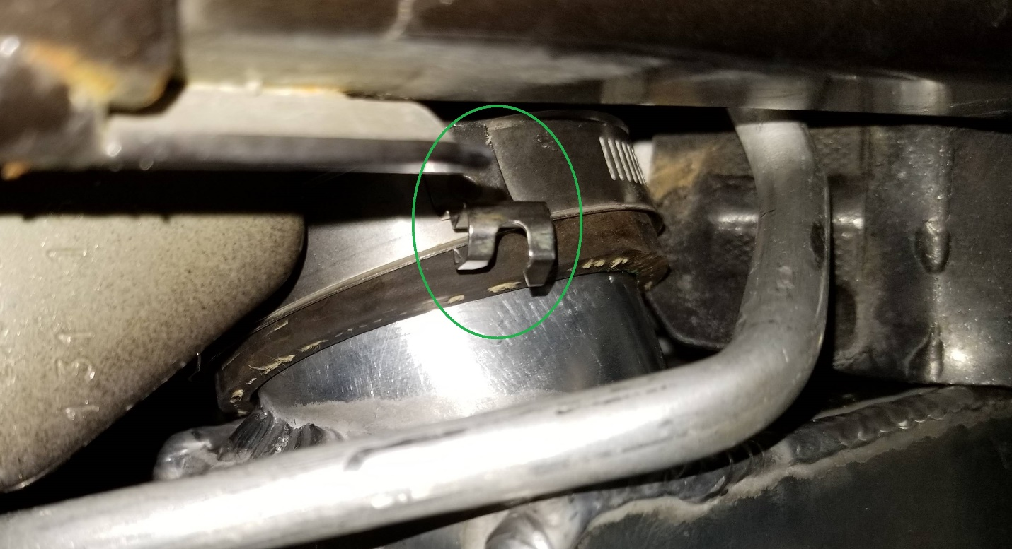

- Push the new cooler up into the proper space and loosely place the intake hoses onto the nipples on the cooler. Make sure the hose is bottomed out as far as it can go onto the nipple. Loosely install the Intercooler mounting bolts to hold it in place and then locate the clamps very close to the edge of the rubber so there is only 1/8” of rubber sticking out past the clamp. Tighten the hose clamps and push cooler into final resting place. Place and tighten the final hose (outlet to intake manifold).
- Now you can begin to reinstall the radiator support bracket and bolts, put a bit of oil or soap on the rubber grommets that hold the radiator in place to the lower rad support to aid them into popping back into their holes . Using reverse order, put everything back where it was!
- Reconnect the electrical harness to the MAP/IAT2 sensor.
- Make sure every hoseclamp and bolt or fitting are tight and secure.
- Because the new IC is bigger it hangs down about ½” lower than before, this is ok. The lower plastic covers will have to bend around it a little bit.
- Have fun with your new , better performing car!

