2013-2019 Ford Explorer Sport 3.5 TT intercooler instructions

- Disconnect battery
- Remove front Fascia/bumper cover, set aside.
- Remove both headlights, set aside.
- Remove horn mounting bracket and disconnect electrical harness, set horn assembly aside.
- Using a cutting tool like an oscillating tool/ cut off wheel/or sawzall begin cutting the composite radiator support. This can be done on the vehicle, removing is not required and is very labor intensive. Using the picture as a starting point carefully begin cutting the composite, it is soft and wont take much effort. Be careful not to cut into the radiator or ac condenser.
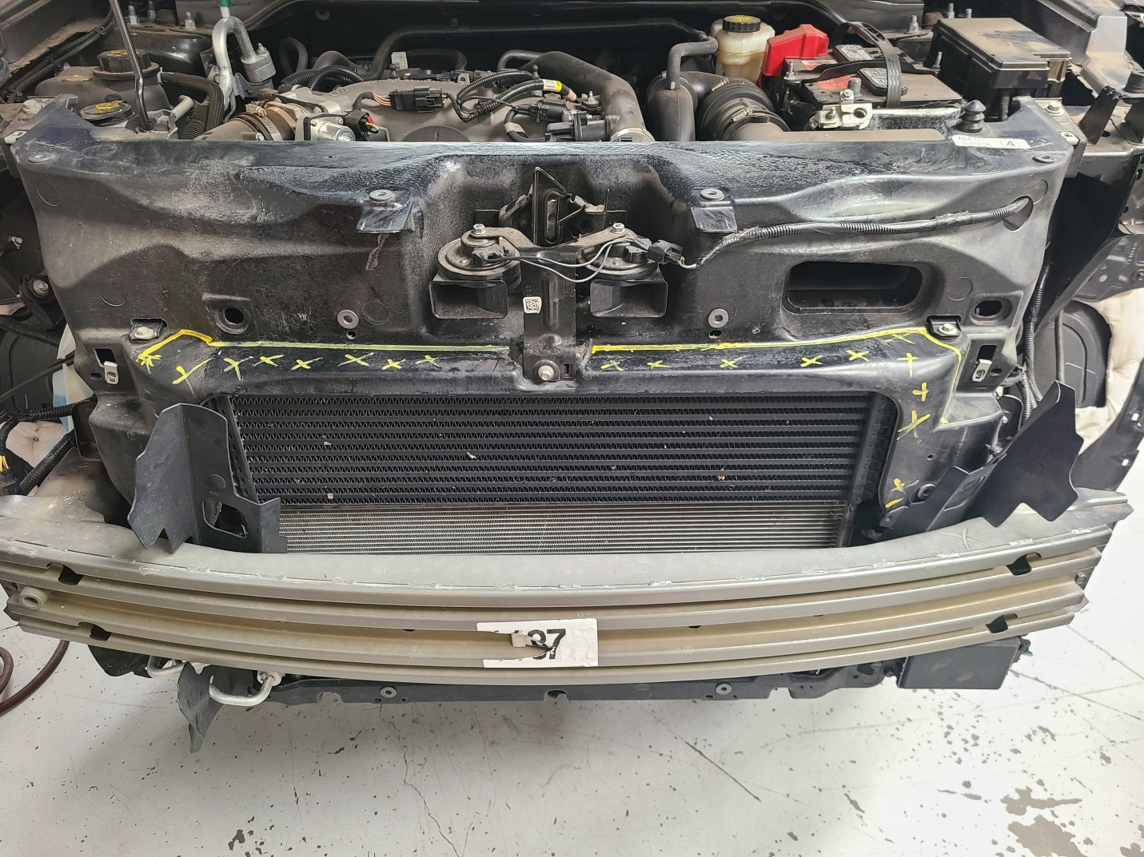

- Continue cutting until you can access the intercooler bolts and remove the stock intercooler. It should look like this: 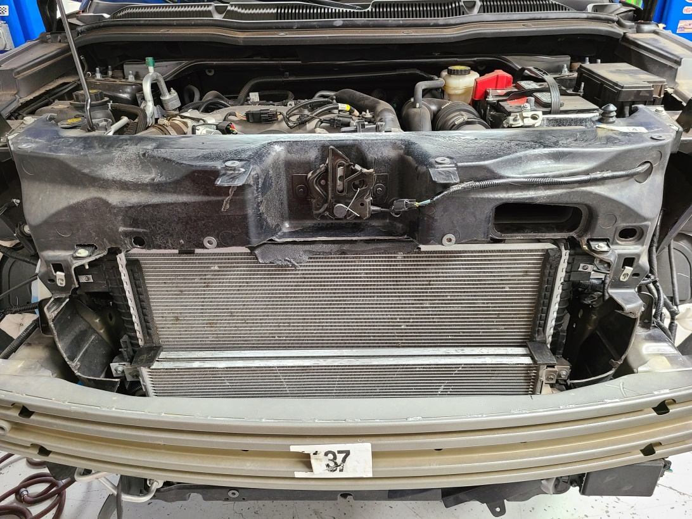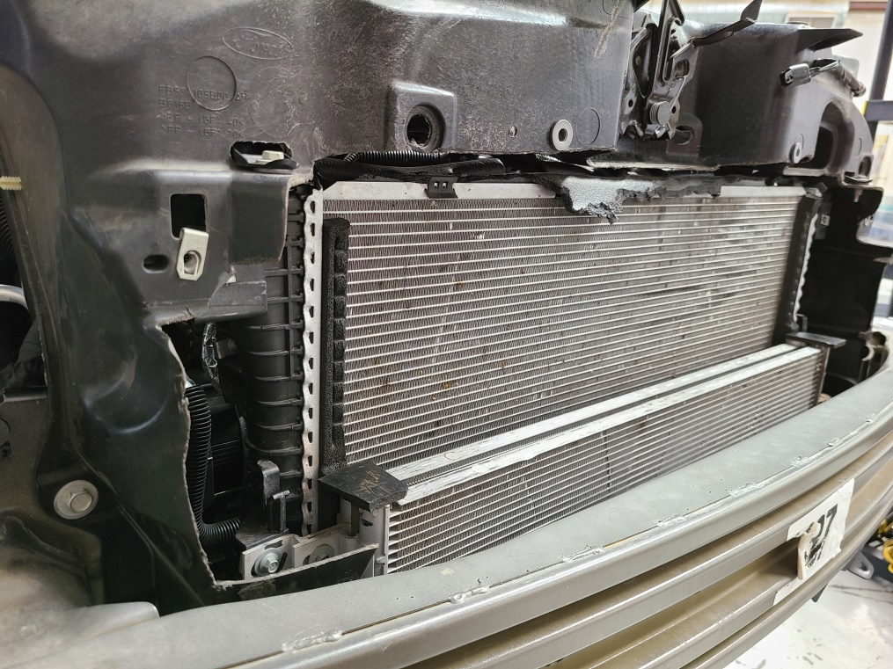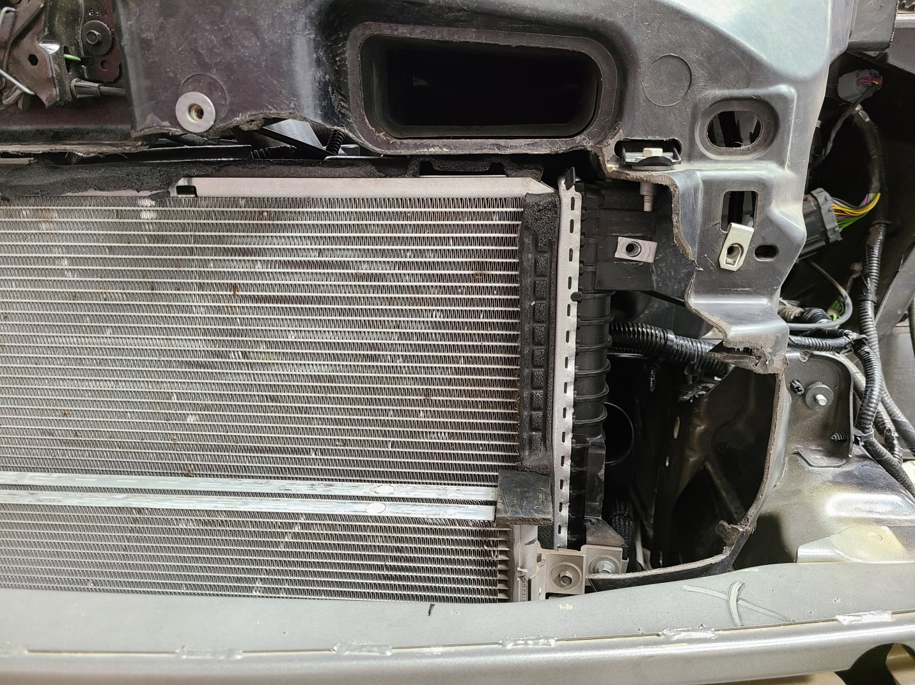
- Once you have cut enough out, loosen the hose clamps and mounting bolts on the intercooler and remove it.

- Grab the horn assembly and cut off the bottom of the bracket just above the bend. Drill a ¼” hole in the lower right corner. See picture: 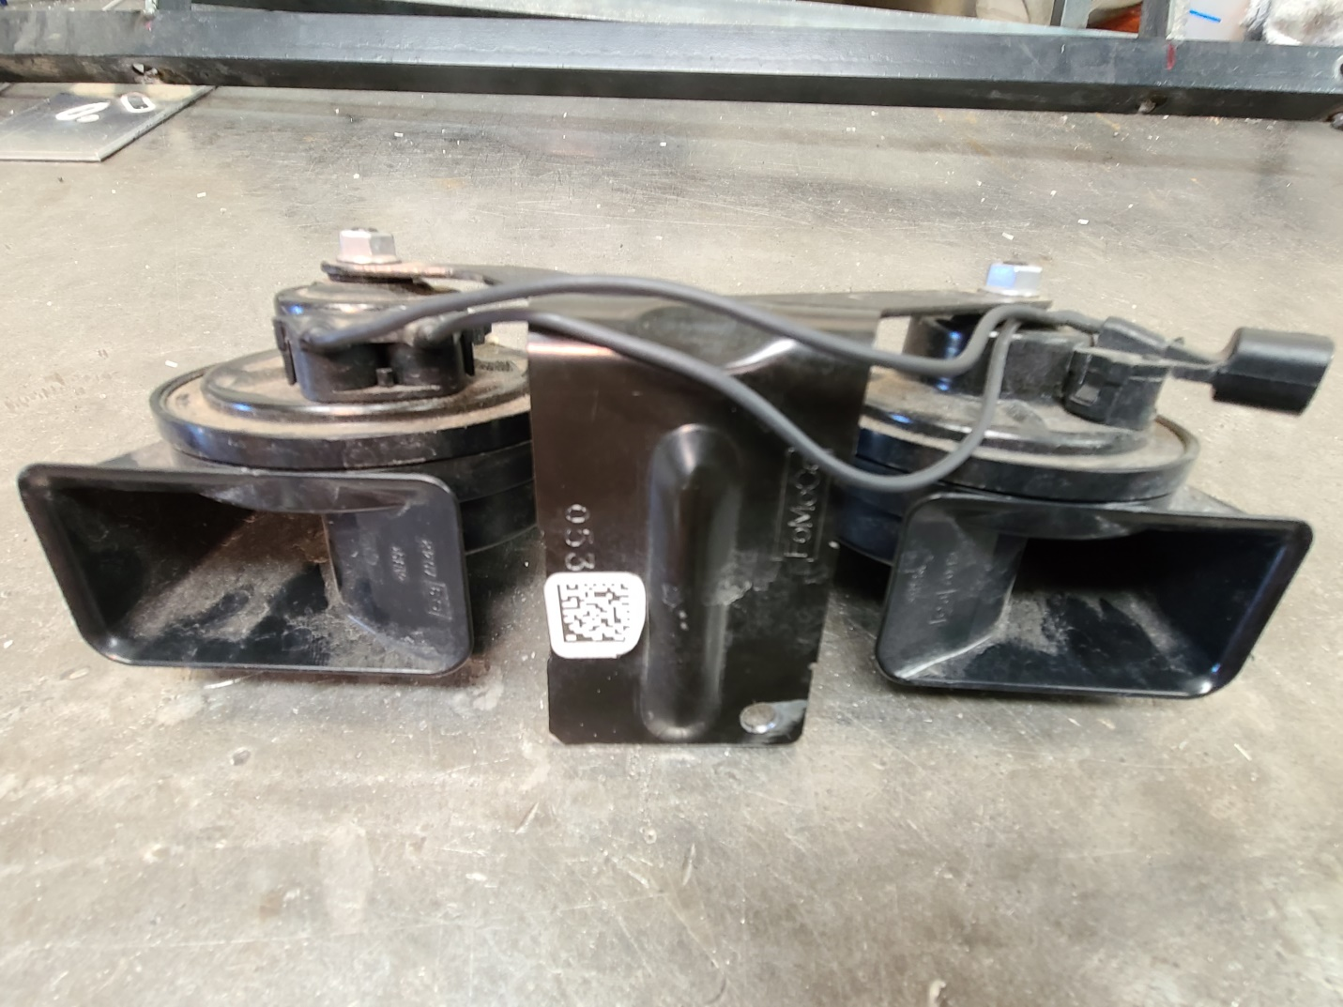
- Remove the stock rubber coupling on the driver side charge pipe. Remove both stock clamps and break off the vampire teeth that hold the clamp on the rubber. Install the new supplied longer coupling onto the tube with the clamps.
- Glue supplied rubber pieces on top of ac condenser corners: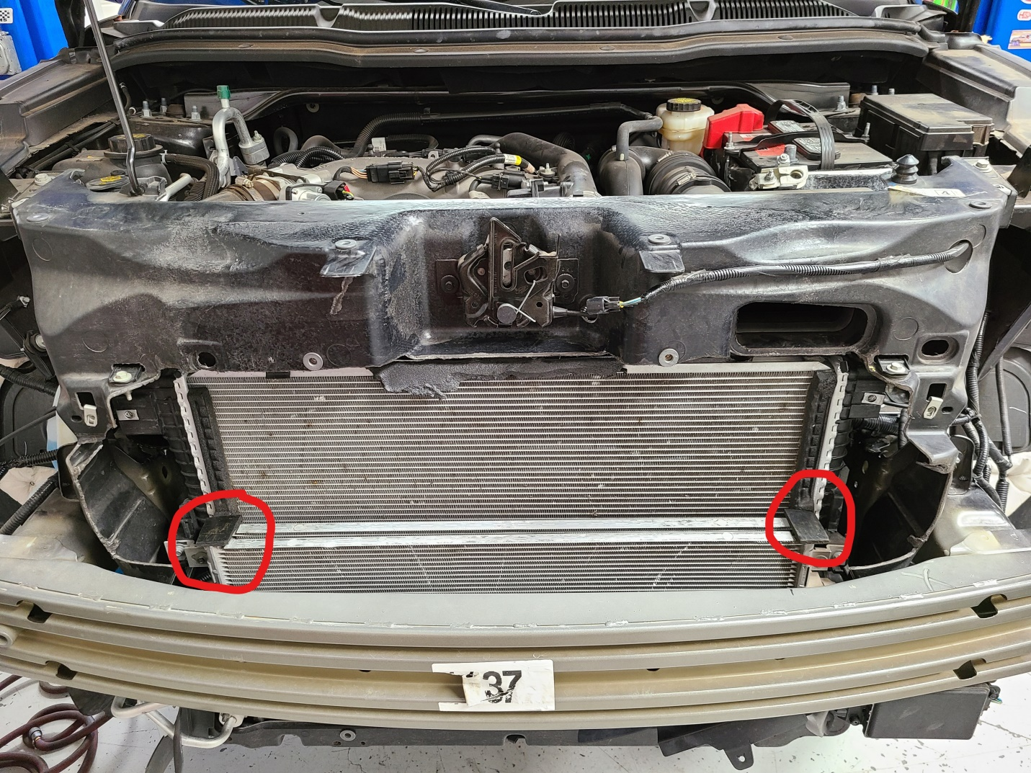

- Install the new intercooler reusing the factory bolts and fasten it down. Reinstall the rubber couplers and tighten the hose clamps.
- Install the modified horn and bracket assembly using the supplied bolt and nut. Reconnect electrical connector.
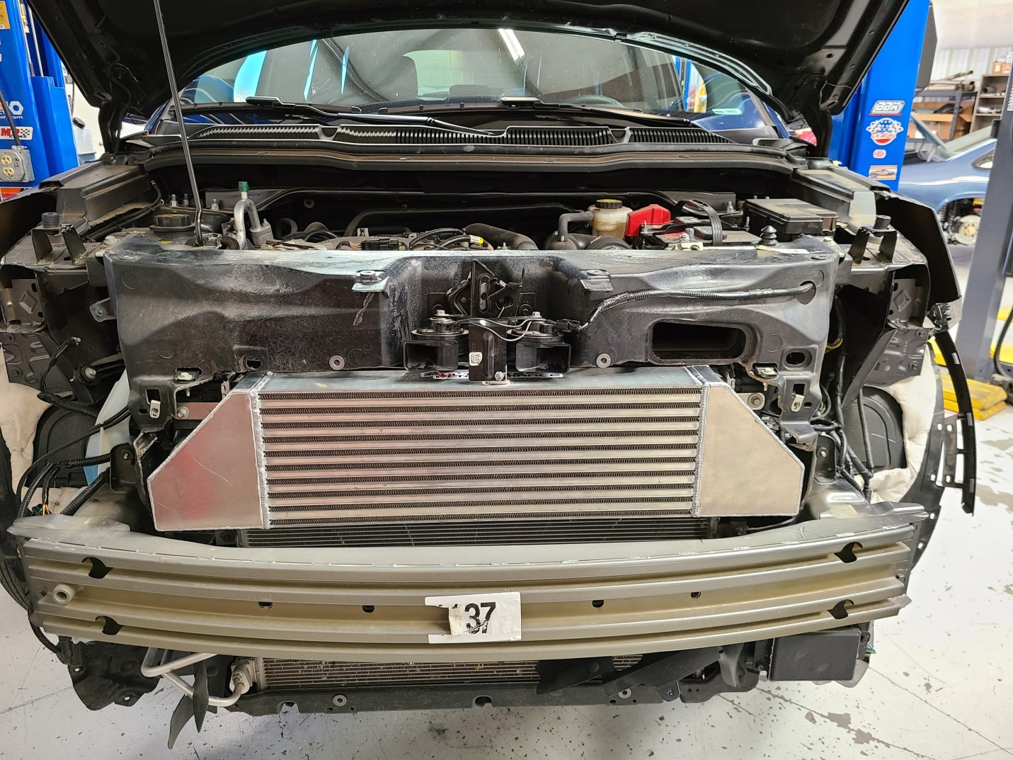
- Reinstall bumper cover and headlights.
- You are done. Enjoy your new found power!

