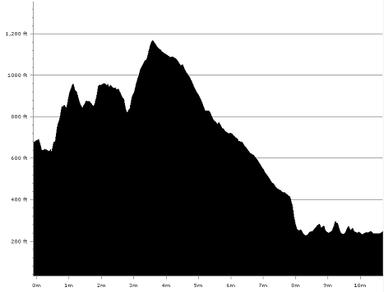

For the start of the leg there is plenty of street parking and a number of smaller car parks only a couple of minutes walk from the start, down the hill from the start near Wells House - the old Ilkley College (where the Ilkley Fell race and Badger Stone relay start). Please do not drive up the road to the start as this is quite narrow and will only lead to congestion.

For the finish parking and showering facilities are available at the Bradford and Bingley Rugby club on Wagon Lane in Bingley (turn off the main A650 by Beckfoot Grammar school signposted Gilstead/Ilkley). Refreshments will be available here, this is also where the prize presentation will take place and where the last leg runners can collect their teams commemorative T-shirts.

To get to the start, walk up the road from the old Ilkley college until you come to a road on the left, walk up this road for a short distance until you see a path on your right with a small stone footbridge.
The handover will be on this track just before the stone footbridge.

From the start go over the stone footbridge and cross the road. The path then turns left and follows the side of the road for a short distance before branching off to the right. Continue to follow this path across the moor until you reach a track coming up from the road. Turn right and follow this track up to White Wells.

From behind White Wells take the footpath up the hill. Follow the path until you reach a distinct fork, where you take the left turn into a rocky valley. At the far end of the valley the path forks again. Here turn left and continue down to the stream (Backstone Beck). Cross over the stream and continue forward, ignoring the path on your right, to a large opening in the ground at the Cow and Calf Rocks. Turn right here and follow the path which runs parallel with the road on your left, slowly climbing up to the ridge.

After a short distance you will reach a wall. Continue straight forward following the ridge. At the end of the wall go straight down the hill and across the stream. Go up the other side, continuing on until a well used path crosses from left to right. Here turn right up the hill passing the dam on your left until you reach a group of large stones. Once here turn left over open moorland until you reach the ruins of Horncliffe Well.

From Horncliffe Well go through the stile, turn left and follow the path down the hill and over another stile to Otley Road. At the road turn right and then left down the road in front of Weecher Reservoir.

From Weecher Reservoir go down the metalled lane with the reservoir on your right and ignore the track that goes off to the left. Continue on the lane until you reach the T-junction at Birch Close Farm. Turn right and continue along the track with the farm on your left, passing through a farm gate onto a grassy lane. This soon becomes a horse training track. Continue along the track, with the wall on your right, and as the fence curves round to the left go straight forward and over the stile next to a gate. Here turn right keeping close to the wall until you reach another stile/gate.
Follow the grassy path with a ditch on your left, until you reach a fence in front of you constructed on the remains of an old wall. Here the track turns sharply right to a stile immediately before Golcar Farm.

Follow the bridleway to the road. Cross the road and follow the footpath sign to “The Glen”, passing to the right of the farm buildings. Continue on this path with the stream on your right until you reach open moorland (Shipley Glen). Continue parallel with the road for about three quarters of a mile until you reach Bracken Hall on the left. Continue past Bracken Hall to the Old Glen House Pub. Take the walled track down the right hand side of the pub and at the junction turn left down to Coach Road

Turn right along the road and over the bridge then left down the track until you reach the weir. Follow the track passing to the left of the boathouse. Continue on the riverbank until you reach the canal.

At the canal turn right and cross over the bridge (206). Turn down behind the houses and follow the path round and back onto the canal aqueduct. At the far end of the aqueduct take the path on the right into Hirst Wood. Follow the path up the hill to the fork, where you turn right and down the hill to the river. Go under the railway bridge. You will pass a small entrance to Nab Wood Cemetery on your left.

Continue following the river, eventually reaching a high-walled pathway. Ignore the path to the left and go straight forward until you reach a gate. Continue forward and across the field to a stile. Carry on past the rugby fields following the river, still on your right, until you reach Cottingley Road Bridge. Turn right and follow the footpath to the second road on the right. Turn right on Wagon Lane for approx 200 metres to the finish in the grounds of the Bradford & Bingley Rugby Club.

