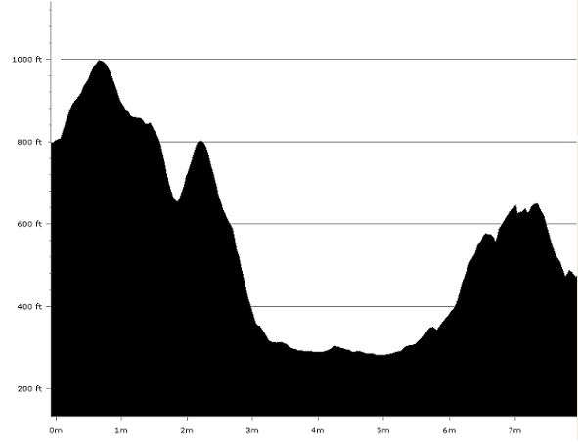
Parking is available in Laycock village (On race day the residents of Laycock village will be providing tea/coffee/cakes/etc in the village hall please bring some money and support their efforts, toilets will be available in the village hall), please park considerately and do not block any drives or farm entrances. again particularly on the narrow sections and round the S-bends by the primary school as the service bus needs to get through here – cars causing an obstruction for the bus may be towed away by the police.

For the end of the leg parking is available on the side roads off the main A6034 Silsden – Addingham road but please do not block any drives, etc The area around Silsden Park is only a couple of minutes from the end of the leg. There is also a pay-and-display car park (free on Sundays) and toilets at the bottom of the main road in Silsden village about 5 mins. walk from the end of Leg 3.

Leg 3 starts at Laycock Village Hall. From the start turn right after a few metres up a narrow lane (Chapel Drive). At the top you will reach the double walled lane. Turn right along the walled lane, at the end of this lane go through the gate and bear left up the hill and through the stile in the far corner of the wall. Go over several more stiles until you reach a stile in the fence by the cluster of buildings. Go over the stile and across the yard, over another stile and into a field. Cross the field to a stone stile which leads onto the road. Turn right along the road to a stile in the wall on the left.

Once through this stile head diagonally right for the stile in the far corner of the field. Go through 2 stiles in quick succession and then head for the top right hand corner of the next field. Once through the next stile head for another stile which is clearly visible in the middle of the wall ahead of you. From this stile head down the middle of the field for the green public footpath sign which is just visible in the distance. Go over the stile onto the road (1M) and continue forward down the road for approximately a mile, turning left again up Intake Lane (2M).

Go over the top of Intake lane and turn right through a gate and continue down the hill following the bridleway as it bears left to a gate in the wall across the path. Go through the gate and down past the top of a disused quarry to where the path forks. Take the right hand path down to a flagged lane (3M). Follow this to the post office at the main road at Eastburn.

Turn left towards the pelican crossing and cross the road when safe to do so. After the pelican crossing turn right down Green Lane, go to the bottom and turn right again along a walled track towards the hospital. Continue on this track to the second gateway. Do not go through this gateway but turn left and follow the path with the fence on your right. At the end of the fence head diagonally right to a gate in the fence. Go through the gate and continue diagonally left across the field until you reach the stile at the edge of the housing estate.

Cross over the railway line, taking extreme care PLEASE DO NOT TAKE ANY RISKS.

Head diagonally right across the field to the gate/gap in the wall by the power line pole go through the gap (or over the stile next to the gate). Continue across the field (4M) into the far left corner where the fence meets the wall (Ignore the public footpath sign on your left halfway down the fence). Go over the stile and almost immediately cross another stile on your left and up the banking to the main A629.

Here the race route will deviate from the official Millennium Way route description. Turn right at the top of the embankment and run along the grass verge to cross the busy dual-carriageway at the marked crossing point on the roundabout. Please take care as this is a very busy road and traffic will be travelling at speed.

Having crossed the dual-carriageway bear round to the left on the Silsden road and continue forward until you reach Silsden Bridge. Cross Silsden road on the brow of the bridge where you will have a good view of traffic coming in both directions and where the footpath starts on the opposite side of the road.

Cross over the road, and then go through a gap stile in the wall on the right. Continue forward over a small stone bridge and then over the field and over the embankment. Cross the stream in front of you using the footbridge.

Go straight across the next field and follow the track round to the right keeping close to the fence on the left. At the end of the field cross a
small ditch and continue through an aluminium gate. (5M) Now head diagonally right towards the power line pole, to a stile in the wall. Through the stile bear left following the wall to a stream, then follow the stream to a crossing point and head across the field to the wall corner.

Follow the fence and wall across several fields to a gate by a small pond.. Continue through two small fields with stiles, after the 2nd stile turn left up the gravel path until you reach the road.
Turn left along the road, when you reach a sharp left hand bend, go through the stile on the right bear left across the field heading for the telegraph poles to the canal. At the canal turn right and follow the towpath to the swing bridge (193). Cross over the bridge and head up the lane and through Howden Park Farm to the road (6M).

At the road turn left over the bridge and follow the footpath sign on the right. Head for the first telegraph pole and then bear left to a stile towards the top of the wall. Go over the stile in the wall and head for another stile by the end of the wall in front. Turn left to another stile and out onto the lane.

Turn right up the lane to the gates of Tomling Cote. Here turn left through a small gate and cross the golf course following the stream firstly on your right then switching to your left. By the 12th tee there is a gate hidden in the wall, cross the field to the road.at Brunthwaite. Turn right up the hill until you reach a bend in the road. Turn left on the footpath in front of High Brunthwaite Farm and round to the side of the farm buildings. Take the path on the left through a gate and head across the field, head slightly down to the left to a stile at the start of a small wood (7M).

Turn right following the wall past an old aqueduct. Continue down across a small gorge using the footbridge. Turn left and up the hill to the wall. With the wall on your right go through the wood for some distance until you reach a stone marker set in the wall straight in front of you marked (BCWW 1858). Here go through the gap, bear left, and continue on just before Swartha House go over the stile on your right and across the field until you reach the road.

Turn right up the road until you reach a stile on the left. Take this path past Raikes House Farm (DO NOT GO INTO THE GROUNDS OF THE HOUSE) bear slightly left past a small dry-stone sheep fold and follow the track down between some gorse bushes with the wall on your right, which becomes a walled track. Continue down this track until it turns to the left.
Here go over the stile in front of you (ignore the gate to the right) and continue down through the fields following the line of the trees to the stile before the allotments. Here the path you want is tucked away in the right hand corner and is not the obvious opening straight in front of you. Follow the path round the allotments until you reach the main road on the edge of Silsden Village.

Here the track emerges onto the busy main road with no footpath on the right hand side. Turn right up the road keeping to the right hand side until it is safe to cross. You have a stretch of about 100 yds where you need to get across the road. Cross the road with care. Once across the road, take the stile in the wall on the left after the row of houses. Cross the field to the finish at the far side of the field.

