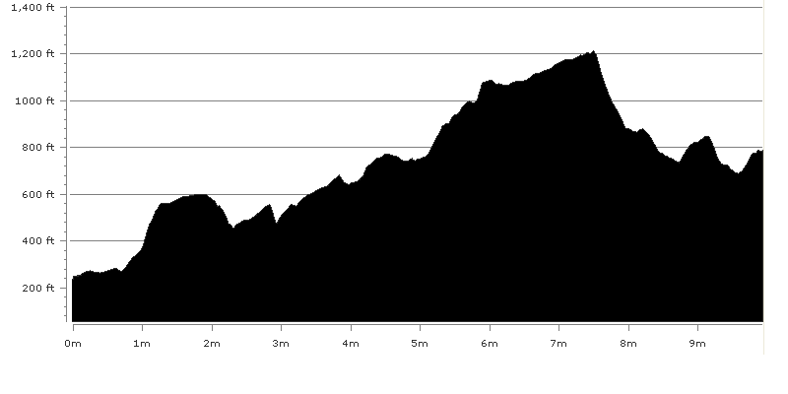

First leg runners must collect their numbers and hand in their team declaration forms at Bradford and Bingley Rugby club on Wagon Lane, Bingley. (If approaching Bingley from Bradford on the A650 turn right after Cottingley Bridge by Beckfoot Grammar school (signposted Gilstead/Eldwick).

The Race starts on Beckfoot Lane. From the registration at Bradford &
Bingley Rugby club walk down Wagon Lane to the main A650. Take care
crossing the A650. Walk over the river bridge and turn right on Beckfoot
Lane. The start is a short distance on Beckfoot Lane. PLEASE DO NOT
PARK ON BECKFOOT LANE. There is plenty of parking at the Bradford & Bingley Rugby club which is only 5 minutes walk from the start.

For the end of Leg 1, parking is available in the main car park of Penistone Hill Country Park, Moorside Lane, Haworth. From the Haworth to Hebden Bridge Road (A6033), as it passes through Oxenhope take the road on your right after the Bay Horse pub to Shaw. Follow this road round and at the top of the hill on the right is Penistone Hill Country Park.

If approaching from Haworth, head out of Haworth towards Stanbury and take Cemetery Road to Moorside Lane. Turn left at Moorside Lane and the entrance to Penistone Hill is on your lefFrom the start, follow Beckfoot Lane passing the entrance to Shipley Golf Club. Continue to the end of this lane to a small hamlet, Beckfoot. Go through the gap to the right of the buildings and cross over the beck using the pack horse bridge (you may cross the ford if you wish).

At the far side of the bridge, go through a stile on your right, turning immediately left following the wall to a second stile. Go through the stile and along the lane until you reach another small hamlet. Before the houses turn left down the steps and cross the bridge over Harden Beck. Follow the white stones over the Golf Course for some way (keep a watch out for golf balls) to a wooden stile. Go over the stile off the golf course, bear left and pick up path round the edge of a ditch and then bear half right up to a gap in the top wall of the field and into Ruin Bank Woods.

Follow this rough path up through the woods until you reach a second stretch where the track flattens out. At the end of the flat stretch there is a small path on the left. Follow this path up and through a stile in the wall.
Cross the field to the next stile. Continue diagonally left across the next field to a stile in the far left corner. Follow the walled path and go through the stile at the end, keeping the wall on your right until you reach the road.

Turn left along the road and almost immediately go through a stile on your right. Follow the wall on your right through several fields, finally reaching a wooded hillside. Here turn right and follow the well defined path that keeps closest to the wall until you reach a rough sandy road. Turn left down the road and almost immediately take the faint path on your left down the hill to a stile in a wall on your left. Do not go back onto the road, but go through the stile and continue across the field to a stream. Go over the stream, up the field and over the stile to the main road opposite the garden centre.

At this point the route emerges onto a potentially busy main road with no footpath. Turn left and please stick to the left hand side, close to the wall, until it is safe to cross, you have approx. 50m stretch in which to cross.

Having crossed the road continue up the road until you pass the houses on the right, Cherry Tree Row. Go through the stile on your right and follow the path with the wall on your right until you reach Crag Wood. Continue through the wood on the footpath with the wall now on your left ignoring the first path to the left and proceed straight forward under the pylon. Where the paths fork after the pylon, take the path to the left up to a stile and go over the stile into the field with the wall now on your right. Halfway along this field turn right over the stile and back into the wood. Take the steep winding path down the hill.

At the bottom of this hill just before the caravan site turn left and follow the stream. Carry on up the path passing the waterfalls on your right, climb up the rocks by the metal railings and continue ahead until you reach Hallas Bridge. Do not cross this bridge but turn left and immediate right up some steps, follow the path past the old mill to the road above it. Turn right down to the footpath on the left. Continue straight on going through several stiles, before dropping down the hill. Now cross another stile and carry on through the field to the road.

Again this path emerges onto a busy road with no footpath, please take care crossing the road. Cross the road and take the second footpath on the left just before the bridge.
Go through the stile and follow the path by the side of the stream up to a walled track just before Hewenden Viaduct.

Do not follow this track, but cross over the stile turn left and go under the viaduct, turn immediately left and follow the line of the viaduct then climb upwards and bear right. Where the paths become indistinct bear right towards the Gorse bushes with the broken wall on your right heading for the house in the distance with reservoir below to your right. Continue past Glen House, down the driveway through the gate. Follow the lane under the old Railway Bridge and down to the road. Cross the road and follow the footpath through the field with the wall on your left.

Go over the stile to Holling Park House. At the house turn right along the track and continue down past the row of cottages on your left and turn right over the bridge. Go over the stile at the end of the bridge and climb up the hill immediately in front of you then follow the wall on your right to another stile. Once over this stile continue straight on over the disused railway. Follow the path round to the left, then to a stile on your right in front of an allotment.

Go over the stile and up the walled path. At the end of this path go up the steps and follow the track, bear slightly left between the bungalow on your left and houses on your right Turn right onto Foster Park Road and follow it round to the left until you reach the main road where you turn right.

Cross over the busy main road, (take care crossing the road as this is a nasty blind bend for drivers) and take the footpath on the left, Edge Bottom. Follow the footpath on the left to the top of the hill. At the top of the hill it can be a little confusing (Do not go through the gate but climb over the ladder stile to the left). Go diagonally over the field following a feint depression, with the wind turbines straight ahead in the distance, to the far corner. Go through the gate and turn left down a walled track. At the bottom turn right along Pit Lane.

At the end of Pit Lane go through a turnstile into a field. Take the footpath over to the left wall and at the end of this field go through another turnstile into the road. Turn right up the road to a lane on the left. Turn left along the lane to a stile and a gate. Continue straight on. Go through the next gate and continue forward, turning right at the corner of the field to a gate. Go through the gate and carry on following the path to the next gate. Carry straight on up the lane to the junction of the tarmac lanes and turn right. Follow the edge of the reservoir embankment passing through a gate. Follow the track until you reach a sign post on your right.

From here turn right and follow the sunken track down to the wall. Continue to follow the wall until you reach the conduit. Cross over the conduit using the ladder stile and continue down the fields heading for the small wood to a stone bridge. Cross over the bridge, turn right and cross the field until you reach a wooden footbridge at the end of Leeming Reservoir.

Cross this bridge turn right and follow the wall up the hill. The reservoir is on your right. Continue following the wall going through a number of stiles until you reach a track with a gate across. Go through the gate and follow the track down to the reservoir banking. Do not cross the banking but go down the grassy track past the side of the house. Continue down to the bridge. Follow the road climbing to Back Leeming.

After the top of the road watch out for the first turning on your left down the steps and across the mill yard to a gap stile. Follow the narrow path with the wall on your left, over the bridge and continue along a double walled path, through the gap stile and straight forward to the road.

Turn left up Hill House Lane past Meadow Bank to the next stile in the wall on your right. Go through this stile and up the flagged path in the field to the main road (A6033). Turn right down this road to St Mary’s Church, taking care crossing the road. Turn left just before the church and follow the lane to the stile on the right. Go through this stile and follow the flagged path to the next stile and straight on through Westcroft Head Farm. Turn left at Olde Croft and follow the path round to Moor Edge.

From the track take the path on the right down past the house and down the path to the lane. Cross this lane and take the stile immediately in front of you. Continue down two fields to a stile about 10 yards from the left corner and emerge onto the road.

Here turn left, taking care crossing the road, continue on to the old mill on the right. Turn down by the side of the mill and follow the path with the wall on your right until you reach the stream. Here turn right through a stile/gate following the stream until you reach a footbridge. Cross the bridge and go through several fields.
In the last field before the house, follow the wall on your left past a gateway to a stile. Go through this stile and turn right to the stile in front of the house (Mould Greave).

Go past the front of the house on the flagged path, turning left and then right between the buildings onto a farm track. Cross over the track and through the field following the wall on your right until you reach the lane. Here turn left up to the old chapel.

Turn left along Marsh Lane and take the first path off to the right.
Here the race route will divert from the official route, instead of turning right down the side of the mill continue straight ahead on the road, round the bend and up the hill (past the farm) to reach Marsh Lane on your right. Turn right on Marsh Lane continue on Marsh Lane until you reach a footpath on your left to Marsh Common. Turn left and follow this path up several fields to South View Farm. Continue up the lane to the road at Lily Hall Farm. Turn right and after approximately 50 yds turn left between the houses. Follow the track bearing half left up to the end of the leg just before the main car park of Penistone Hill.

