FORT PIERCE FARMERS MARKET

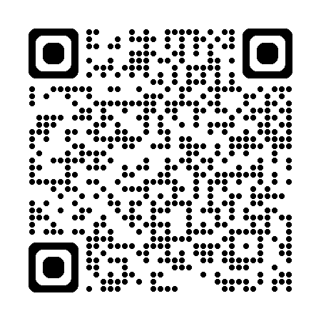

Fortpiercefarmersmarket.com