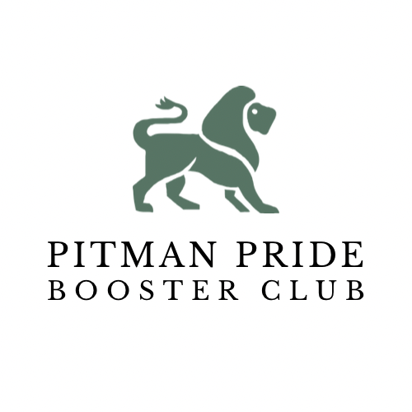

**Agenda 02/21/23, 5:30 PM, Pitman Library**

1. **Call to Order**
2. **11/16/22 Minutes Review**
3. **Director of Athletics Report**
4. **Treasurer Report**
   1. Accounts Summary Review
   2. Accounts Pending (Tennis)
5. **Coaches/ Reps Report**
   1. Schedule, Fundraisers, Events, etc
6. **PPBC Committees**
   1. Sober Grad Nite Committee
      1. Report
   2. Pitman Development Foundation
      1. Report
   3. Fundraising
      1. Annual Dinner 4/22/23 at Turlock Pentecost
         1. Committee Member Sign Ups
         2. Team Baskets & Table Decor
         3. Sales Tickets - $65/pp or $500 Table of 8
      2. Golf Tourney (Memorial weekend 2024) Location, Cost
      3. $10 Dean Pizza Cards - $8 profit (throughout year)
   4. Purchasing
      1. Student Athlete Recovery Ice Machine Quotes
      2. PPBC Shirt & Hoodie Online Store - Impact Prints
   5. Membership
      1. Membership Forms
   6. Marketing
      1. Facebook & Instagram Posts
      2. Website Updates
   7. Adjourn

| **Account Summary as of 2/20/23** | | | |
| --- | --- | --- | --- |
| Booster Main | $4053.61 | Sober Grad | $9917.18 |
| Football | $19453.870 | Wrestling | $23693.96 |
| Track | $232.00 | Cheerleading | $8222.19 |
| Cross Country | $3179.28.00 | Softball | $2,202.00 |
| Boys Soccer | -$1588.96 | Tennis | 0 |

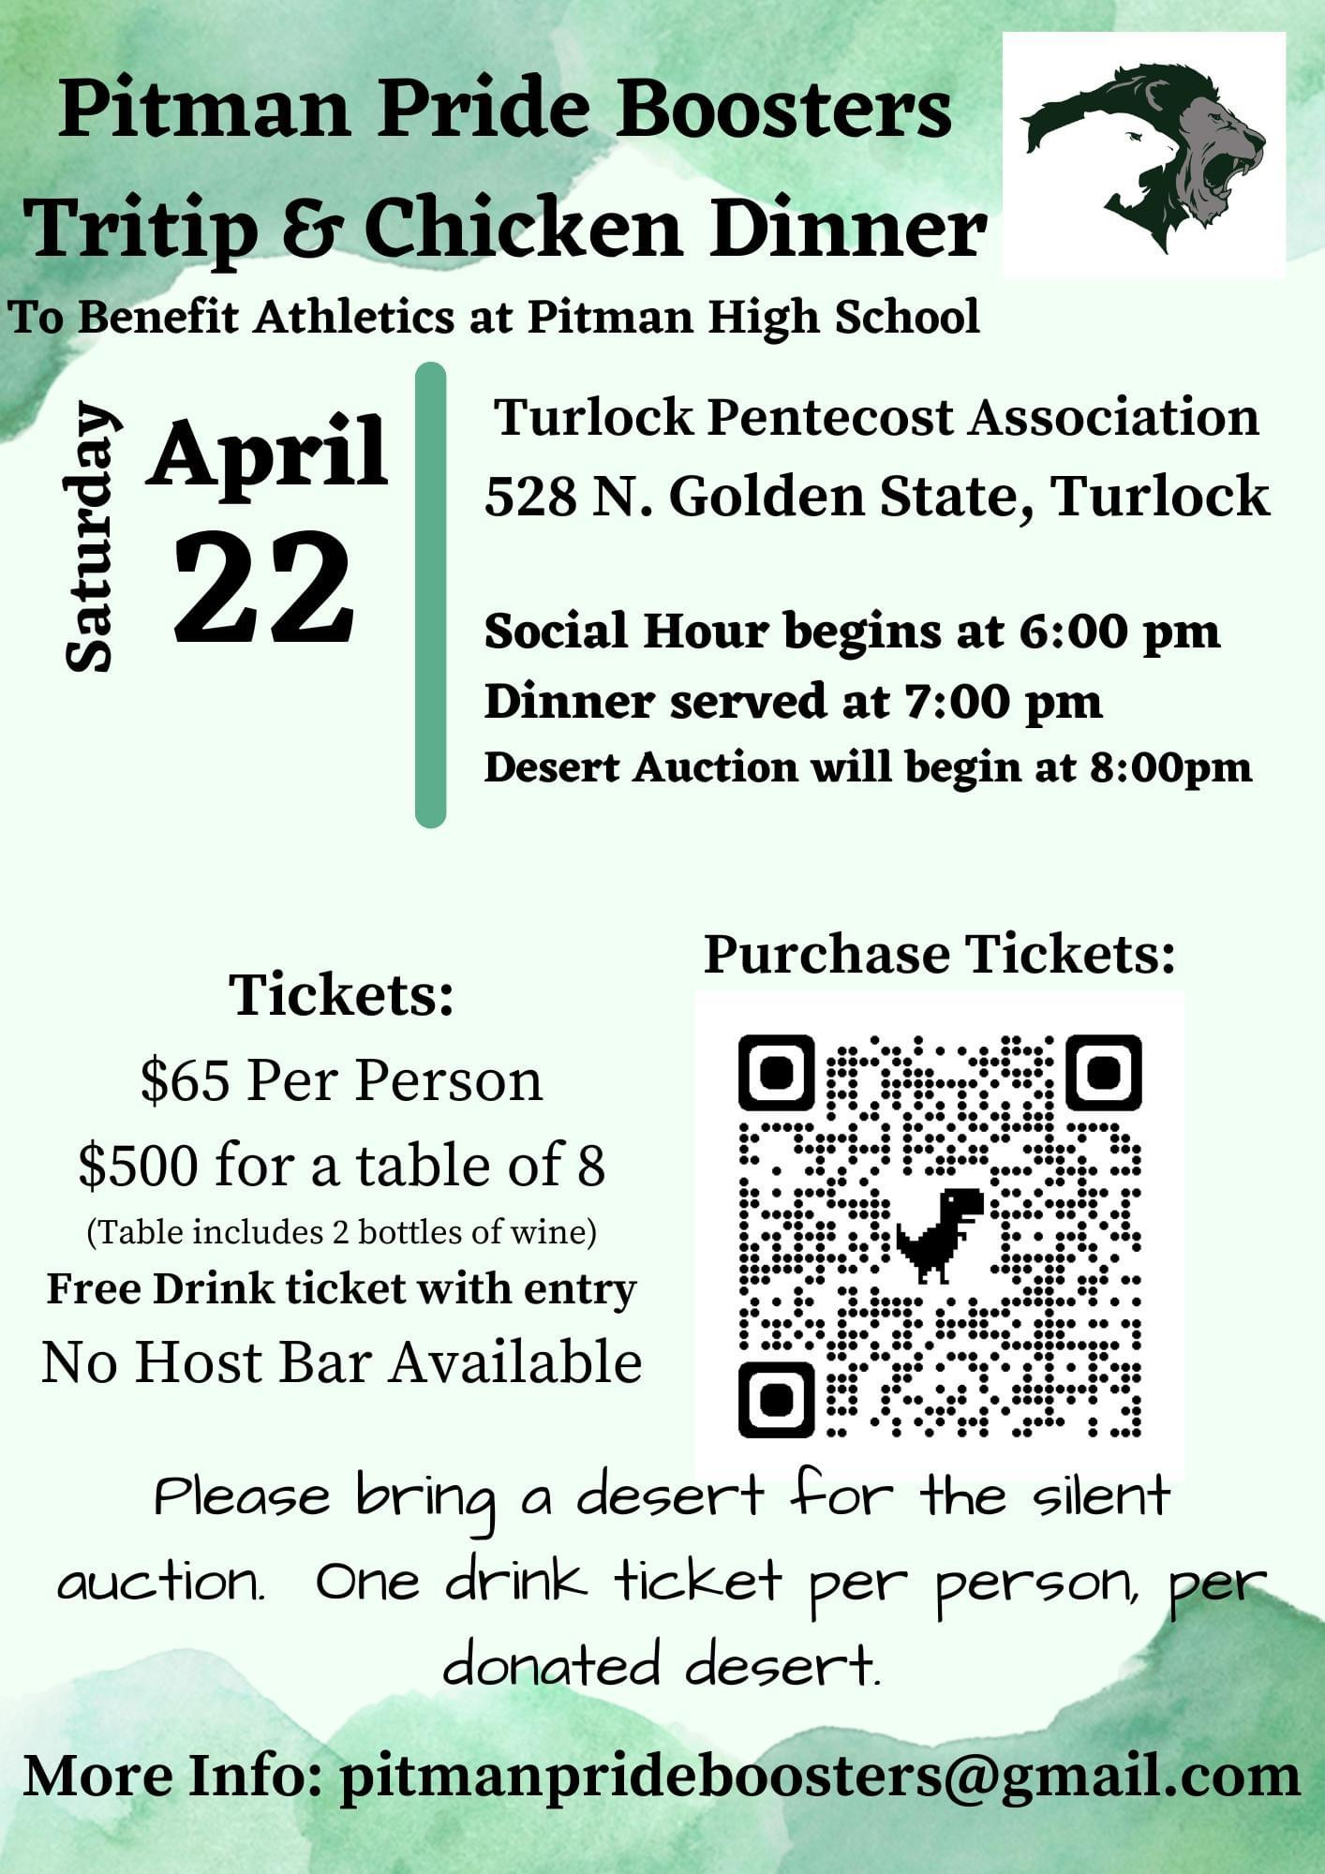

*Our objective is to support all academic, athletics and activity programs at Pitman so that every student athlete will have the opportunity to receive the benefits of quality sport programs and have the opportunity to achieve their maximum potential.*

**Pitman Pride Booster Club**

Meeting Notes - 11/16/22

1. Call to Order - 5:35 P.M.
2. 10/19/22 Minutes Review - Approved
3. Director of Athletics Report
4. All winter sports have begun - boys and girls basketball, soccer, wrestling
5. Girls volleyball team and cross country team were very successful!
6. Before each sports season, there will be a meeting for all the sports occurring during that season. Athletes and parents will be required to attend the meeting before attending the team's parent meeting.
7. Treasurer Report
8. Open Accounts Summary as of 11/13/22

* Booster Main - $4912.00
* Track - $352.00
* Cross Country - $8515.00
* Sober Grad - $4030.00
* Wrestling - $2,000.00
* Cheerleading - $9058.00
* Softball - $2202.00
* Football - $20,099.00

1. Accounts Pending as of 11/16/22 - tennis, boys soccer
2. Procedures and forms

* All checks need to be written out to Pitman Pride Boosters
* QR Code
* All deposits need to accompany a deposit slip

1. Coaches / Reps Report
2. Cross Country - “Mom Squad” put together a wonderful awards banquet!
3. Sober Grad - The goal is to raise $12,000. Team is currently working on logistics for selling tickets and collecting money - November - December 16th $35, January - March $45, after March 1st $55. There is an opportunity for community members to sponsor students. The next big fundraiser is at Applebee’s for a Christmas Breakfast on Saturday December 3.
4. Wrestling - Currently in the middle of a fundraiser for a Disney trip - tickets are $10.00. Each team member needs to sell a book of 10 tickets. The money raised will go towards uniforms. Everyone is to make an effort to post and repost on social media.
5. Cheer - Most of the fundraising is complete. An online See’s candy fundraiser will be happening soon. Tryouts for the 2023-2024 school year will be in April.
6. Softball - Softball starts with a meeting in January to check on the number of students signed up - to begin fundraising for player packs. Each home game will have a small concession stand - to continue with parent help.
7. Football - Awards banquet was great! The freshman awards banquet will be November 29. Fundraisers that are planned for next season will be fireworks tickets, callathon, and cards.
8. Tennis - Girls tennis made it to the playoffs. The Mod Pizza fundraiser did very well - still waiting for the check. Boys tennis will begin soon.
9. Girls Basketball - Sprintathon will be a huge fundraiser for the team. The parent meeting will be before the first game.
10. PPBC Committees
11. Sober Grad - The goal is to raise $12,000. Team is currently working on logistics for selling tickets and collecting money - November - December 16th $35, January - March $45, After March 1st $55. There is an opportunity for the community to sponsor students. The next big fundraiser is at Applebee’s for a Christmas Breakfast on Saturday December 3.
12. Fundraising

* Tito’s dinner pick up at truck - December - day will be decided this week
* Eat Out - Panda - January / Chipotle - March - Encourage teams to have team dinner there to publicize the fundraiser!
* Valentine Breakfast - 2/11/23 - Loza - pickup breakfast
* Annual Dinner - 4/22/23 - The location will be The Turlock Ballroom. The menu will be tri tip or chicken. The tickets will be around $65 and come with a drink ticket. Every sport will buy a table and decorate it.
* Golf Tourney - Memorial weekend 2024 - Date, Location, Cost - TBD - Mr. Curtiss has phone calls out and is waiting for info.
* Cornhole Tourney - Fall 2023 - date, location, cost - TBD
* $10 Dean Pizza Cards - $8 profit - to be sold throughout the year - We will make an effort to put info out on social media.

1. Purchasing

* Student Athlete Recovery Ice Machine Quotes - Have found a machine within budget to meet our needs. It is a returned item, but has the same warrantee. We are waiting to decide on other storage locations to decide on placement for the ice bath. Mr. Curtiss to inquire about water line installation.
* PPBC Shirt & Hoodie Design & Quote - Impact Prints has the design. We will put shirts and hoodies online for sale.

1. Membership

* Membership Forms - Boosters to attend parent meetings.
* Distribute Lawn Signs

1. Marketing

* Facebook and Instagram Posts - Repost and tag us
* Website Updates

1. Light at PHS Track

* Lighting Install Date - Rescheduled for Spring 2023 - The district has provided 2 temporary lights, but more are needed for safety. On social media, comment, share and repost to get the word out.

1. Adjourn - 6:40 P.M.