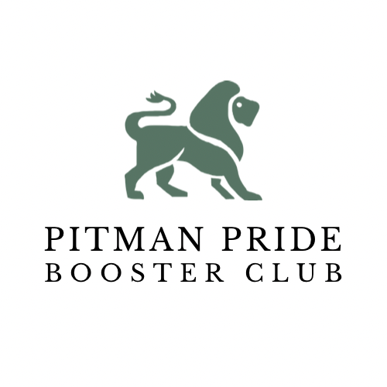

**Agenda 03/16/23, 5:30 PM, Pitman Library**

1. **Call to Order**
2. **2-21-23 Minutes Review**
3. **Director of Athletics Report**
4. **Treasurer Report**
   1. Accounts Summary Review
   2. Team Affiliation Fee
5. **Coaches/ Reps Report**
   1. Schedule, Fundraisers, Events, etc
6. **PPBC Committees**
   1. Sober Grad Nite Committee
      1. Report
   2. Pitman Development Foundation
      1. Report
   3. Fundraising
      1. Annual Dinner 4/22/23 at Turlock Pentecost
         1. Sales Tickets - $50/pp or $400 Table of 8
         2. Team Baskets & Table Decor
      2. Harvest Bowl Tacos & Beer Dinner
         1. Harvest Bowl Pancake Breakfast (Players & Alumni)
      3. Golf Tourney (Memorial weekend 2024) Location, Cost
      4. $10 Dean Pizza Cards - $8 profit (throughout year)
   4. Purchasing
      1. Student Athlete Recovery Ice Machine Quotes
      2. PPBC Shirt, Hoodie & Hats - Impact Prints
   5. Membership
      1. Freshman Orientation
   6. Outreach
      1. Remind
      2. Social Media
      3. Website Updates
   7. Adjourn

| **Account Summary as of 3/16/23** | | | |
| --- | --- | --- | --- |
| Booster Main | $6509.62 | Sober Grad | $10064.38 |
| Football | $19453.870 | Wrestling | $26003.96 |
| Track & Field | $9559.36 | Cheerleading | $8222.19 |
| Cross Country | $3179.28.00 | Softball | $2,202.00 |
| Boys Soccer | -$10.66 | Girls Basketball | $6782.97 |

*Accounts Pending (Girls/Boys Tennis, Boys Basketball)

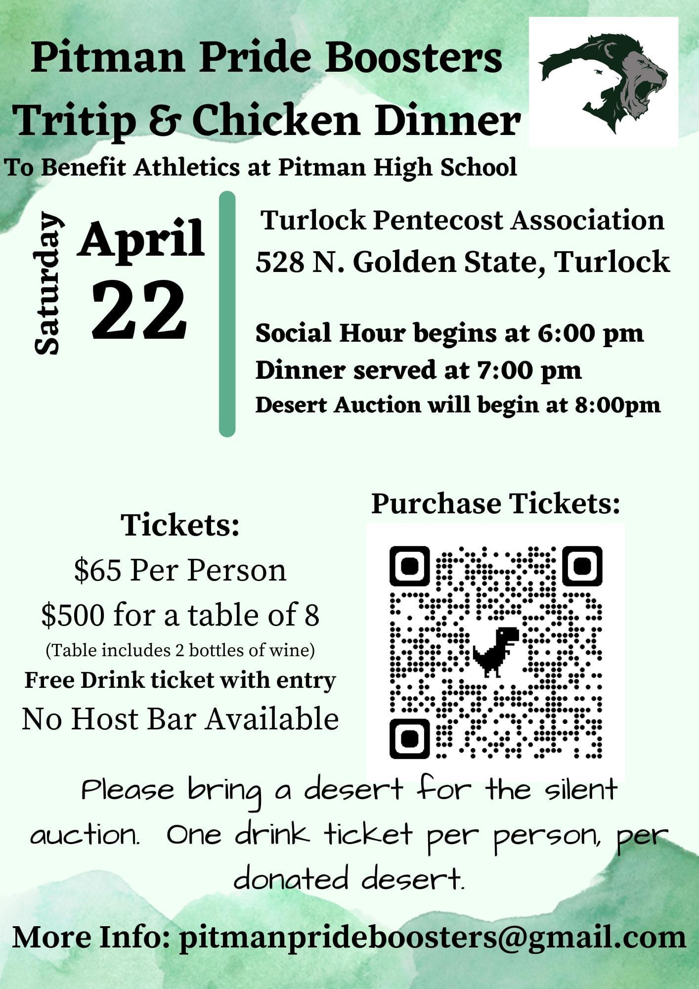

*Our objective is to support all academic, athletics and activity programs at Pitman so that every student athlete will have the opportunity to receive the benefits of quality sport programs and have the opportunity to achieve their maximum potential.*

**Pitman Pride Booster Club**

Meeting Notes - 2/21/23

1. Call to Order - 5:39
2. 11/16/22 Minutes Review
3. Director of Athletics Report
4. Winter sports are done
5. Wrestlers are going to state championships
6. Spring sports are beginning - boys volleyball - new sport
7. For next year, a universal parent meeting
8. Sports paperwork / physical paperwork completed online
9. Treasurer Report
10. Open Accounts Summary as of 2/20/23

* Booster Main - $4053.61
* Track & Field - $232.00
* Cross Country - $3179.28
* Sober Grad - $9917.18
* Wrestling - $23,693.96
* Cheerleading - $8222.19
* Softball - $2202.00
* Boys Soccer - -$1588.96
* Football - $19,453.87
* Tennis - 0

1. Accounts Pending- tennis
2. Coaches / Rep. Reports
3. Cheer - Awards banquet potluck - 2/28/23
4. Softball - Finishing tryouts
5. Football - The schedule for varsity and junior varsity are complete and the freshman schedule is almost complete. Fundraisers that are planned are Dean’s Pizza cards for April, fireworks tickets for May and June, Hourathon for the end of June, and Gold Cards for early August. The Intrasquad scrimmage is planned for August 5. Boosters are going to bring in Kona Ice. Football will sell tickets for a BBQ. Hoping for the lights to be complete over summer so that football can have a midnight workout to celebrate.
6. Track - The schedule is set, but may be added to later on. There are great coaches for each event. Pitman is hosting this week in Hughson and for the CCAL 1 at Turlock. Blast fundraiser has gone well. The next fundraiser will be FastTrack.
7. Cross Country - A thank you video was sent out. All teams finished first in the league.
8. PPBC Committees
9. Sober Grad Nite - looking for gift card donations
10. Pitman Development Foundation - PDF goal is to bring more Alumni in. June 24 there will be a poker party at the home of the Staack Family. There will be a bus trip to a casino on September 9. The Hall of Fame dinner is planned for October where past athletes will be honored.
11. Fundraising

* The Annual Dinner will be April 22 at Turlock Ballroom. Each sports team will decorate a table and donate a gift basket to auction off. The tickets are for sale on Eventbrite with the hopes of selling 300 tickets ($65 each / table of 8 $500). Those attending are encouraged to bring a dessert for a dessert auction. A drink ticket will be given for each dessert donated. We will continue to promote the
* event on social media.
* Golf Tourney (Memorial Day weekend 2024) - Mr. Curtiss to get a confirmed date when the schedule for 2024 is released.
* $10 Dean Pizza Cards - $8 profit

1. Purchasing

* Student Athlete Recovery Ice Machine Quotes - waiting for after dinner
* PPBC Shirt and Hoodie Online Order Store - Impact Prints - Working to open a 2-3 week window. We will have shirts and hoodies printed and distributed at a Booster meeting.

1. Membership

* Membership forms - recognize new members on social media

1. Marketing

* Facebook and Instagram Posts - tag Boosters so Boosters can repost

1. Adjourn - 6:54