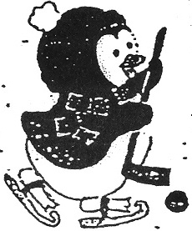 CHILDREN’S SKATING PROGRAM 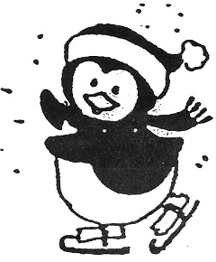
William Thayer Arena, Warwick RI

CLASSES FOR AGES 3 YEARS THROUGH ADULT
Learn to Skate Program
www.childrensskating.com
childrensskating.wixsite.com/warwick
Hockey Skating Skills and Basics Skills for figure skaters

THURSDAYS 5-6PM
8 Week Session – October 17-December 19 (no lesson Halloween night) $120.00
10 Week Session – January 2 – March 5, 2020 - $150.00
9 week Session March 14, 2020 – May 9, 2020 - $135.00
Discounted price for ALL 3 Sessions $370.00 per child
ONLY One Parent may skate during practice time with child - $25.00 per session
(must sign release form/maximum parents 10)

Check our Easy Registration Using Google Form or Please Fill Out the Form Below childrensskating.wixsite.com/warwick

The Basic Learn-To-Skate for hockey and figure skaters will provide a 25 minute lesson and 25 minute practice session. Classes are grouped according to age and ability. IT IS REQUIRED THAT ALL CHILDREN SEVEN YEARS AND UNDER WEAR HELMET and GLOVES. Children eight years and older MUST wear knitted hats.

Child’s Name ________________________________________________ Age: ___________________

Address: _____________________________________________________ Zip Code: _______________

Email address___________________________________________________________________________
Phone: ________________________________________________________________________________

New to Program: __________ Badge level last attained: _________________
The undersigned acknowledges that each applicant is physically capable to participate in this program; and that the risk of injury exists but such risk is hereby accepted and that the responsibility of medical insurance coverage is upon the applicant.

SIGNATURE (Parent or Guardian): _______________________________________________________
FULL PAYMENT AT TIME OF REGISTRAION *NO REFUNDS AFTER FIRST LESSON.
*$20.00 SERVICE CHARGE ON RETURNED CHECKS.

MAIL FORM AND COMPLETE PAYMENT Payable TO:
Children’s Skating Program
Ms. Lee Horner 10 Hill Side Street, Saunderstown, RI 02874
Cell phone 508-274-5218 lee.lmh2006@gmail.com, childrensskating.wixsite.com/warwick
In case of inclement weather, the program will be held unless the rink closes. There are NO MAKE_UP LESSONS.

