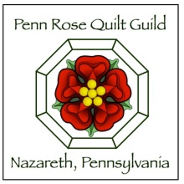
2026-2027 Membership Renewal Form
Please complete this form and return with payment to:
Penn Rose Quilt Guild
P.O. Box 575
Nazareth, Pa. 18064

Name____________________________________________

Address__________________________________________

E- Mail Address____________________________________

Home Phone _____________ Cell Phone: _______________

Dues Payment – (checks payable to Penn Rose Quilt Guild)
returning members $35.00
New members - $45.00
--------------------------------------------------------------------------------------
For use by PRQG 1st VP:
Check # _________ Cash Payment: _____________

Date RCVD: __________ Date to Treasurer: __________

