Activity 1

# **Personal Training Experience Reflection**

**Think of the very best training session you’ve ever attended. Now, think of the very worst training session you’ve ever attended. What are the traits and characteristics of each session? What made it the best session? What made it the worst session?**

## **Traits of the BEST training session Traits of the WORST training session**

Activity 2

# **Adult Learning – Test Your Knowledge**

**Complete the following statements by circling True (T) or False (F)**

**1) T F Adults are typically self-directed and need to be involved with both *what* and *how* they learn.**

**2) T F Adults need practical application of a concept or skill to feel good about the training.**

**3) T F Adult learners are often skeptical about new information and prefer to try it out before accepting it.**

**4) T F Adult learners like to share examples of their life and work experiences.**

**5) T F Adults all learn pretty much the same way.**

**6) T F To illustrate points, real work-life examples mean a lot more than simple non-work-related examples.**

**7) T F An adult’s life experiences affect expectations and responses in the classroom or training workshop.**

**8) T F Adults require a respectful environment, in which all individuals and ideas are valid and valued.**

# **Visual Learner Handout**

# **Auditory Learner Handout**

# **Read/Write Learner Handout**

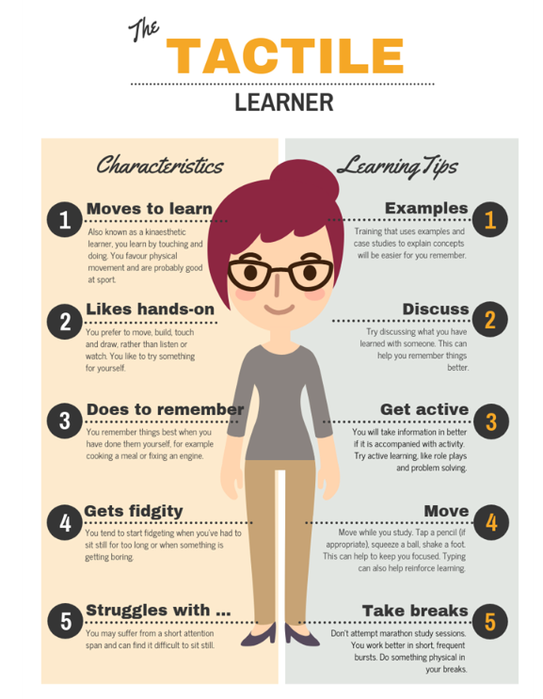**Kinesthetic (AKA Tactile) Learner Handout**

Activity 3

# Summarizing the VARK Learning Styles

**Work with a partner for this activity. Write down two training strategies for each learning style.**

VISUAL

AUDITORY

READ/WRITE

­­­­­­­­­

KINESTHETIC