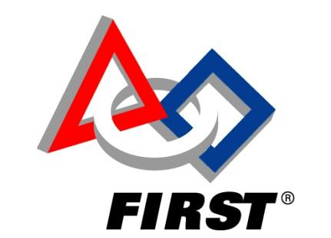
For Inspiration and Recognition of
Science and Technology

Team 1100
The T-Hawks

Advancing STEM Education AND Fundraising:

How to Host a
Build Your Own Robot
Event in Your Community

Updated Spring 2013

Forward

In an effort to advance STEM (Science, Technology, Engineering, and Math) education in our community combined with an effort to raise funds for our team, Team 1100 hosted a Build Your Own Robot event for students in grades 3 through 6. Pre-registered kids visited the team’s Robotics rooms at Algonquin Regional High School, and the high school students provided them with individualized tours and instruction to each build a mechanical dog robot from a kit. Dan Strickland, lead mentor for Team 1100, and the high school students worked with the children to explain engineering terms such as gears, gearboxes, linkage rods, motors, and switches, and to show them how each works with hands-on opportunities. The children were thoroughly engaged and very much enjoyed their experience. And they were very proud of the robots they built.

The high school students who volunteered were absolutely fantastic! They worked on Friday evening to prepare for the event and each of them exhibited great patience and guidance while sharing their enthusiasm for science, engineering and robotics. When picking up their children, the parents shared their awe, noting how impressed they are with the high school students and with how willing and comfortable the older students are sharing their knowledge with the younger kids. Many of them asked to be informed of future events such as this.

This manual is intended to be a guide and used as reference for other FIRST teams planning to host such an event in their community. We’ve included some of the resources we used and provide some advice on what worked well and what we might do differently next time.

If you have any questions, please contact us at FIRST.Team1100@gmail.com. We are happy to share our experience with you. We wish you the best of luck with your event!

Table of Contents

Choosing a Project to Build
Selecting a time/date/location
Publicizing the Event and Collecting Registrations
Ordering kits
Advanced Preparation
Timing for the event
Following up

Choosing a Project to Build

We wanted to find something which students in grades 3-6 could actually build with some help from us. So we searched for “robot kits for beginners”. We found a number of different options, varying in difficulty level and in cost. After some evaluation, we decided to try the Tamiya Robocraft Series, finding kits available from both www.hobbyengineering.com and www.scientificsonline.com. We chose the Mechanical Dog - the description for the mechanical dog as described in Scientifics Online is:

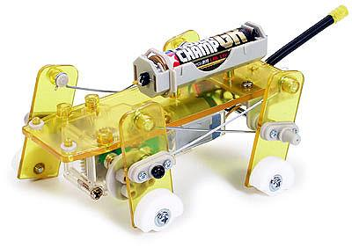
Part of Tamiya's Robocraft series, this four-legged mechanical dog with various speed controls walks by transferring motor revolution to reciprocating motion via crank and linkage rod. Main body and legs are made of transparent yellow parts to allow viewing of internal mechanisms. Construction is simple as parts can easily be attached with screws. Wiring has also been made simple. Clear switch with yellow transparent parts adds a cool, futuristic look.
Kit lets you become familiar with the mechanics of the dog's movement. All the parts needed to construct a mechanical dog are provided. Assembly and wiring have been made simple. 4 types of strides can be selected by changing the position of the holes on crank. Put this together with 2 types of gear ratios and you've got an 8-speed puppy. Cross link rods to make movement even more fluid and real. Gripping parts at the end of each leg to change position according to speed for smooth movement. Run on flat, smooth surfaces.

Some of the other options in this series include a beetle, an ostrich, and a car.

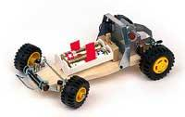
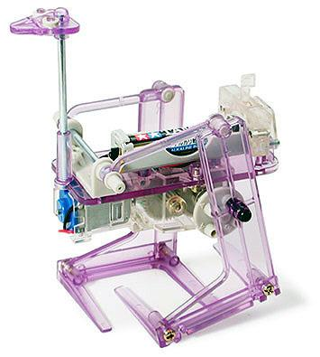
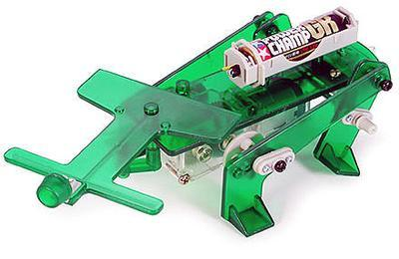

There are other products that might better fit your needs and/or budget. This kit seemed like a good starting kit for us.

Whichever kit you find that you think you’d like to use, ORDER ONE TO TRY YOURSELF FIRST!

We recommend ordering one kit before you make your final decision on whether that is the one you will use for your event. Building one yourself gives you an opportunity to evaluate whether you think the kit is appropriate for your needs. This trial also gives you an idea of some of the challenges you might face when building it with younger students. As a result of our evaluation, we decided that the Mechanical Dog would be good for our needs, but that we would make some adjustments to our plan. For example, we decided to pre-build a couple of the more intricate parts (such as the gearbox) because there were many very small pieces involved and it might have been frustrating and time consuming for some of the kids in a limited amount of time. (See Pre-Building Some Parts and Preparing for the Event.)

Selecting a time/date/location

Once you have decided on an appropriate kit/project, you should decide when and where you will host your event. You will need to seek whatever approval and permission your planned location requires, and you will need to ensure that enough team members will be available on that date to help. (For example, you should avoid SAT/ACT dates, and any major school or community events.) Once the event date and location are set, you can begin creating your event flyer. We recommend that you begin to publicize the event at least 6-8 weeks prior to the event date. You should allow 2-4 weeks for publicity and registrations, then another 3-4 weeks after the registration due date for ordering the number of kits you will need and allowing time for delivery and preparation.

Before preparing your flyer, you will also need to determine how much you will charge each registrant. We reviewed the costs of some other local programs and considered the cost of the kit, which each registrant would keep to take home with him/her. Purchasing kits under $20 each and hosting the event for three hours, we determined that $50 was an appropriate fee for the opportunity to work one-on-one with a high school robotics student, receive a tour and demo, and build the kit to take home.

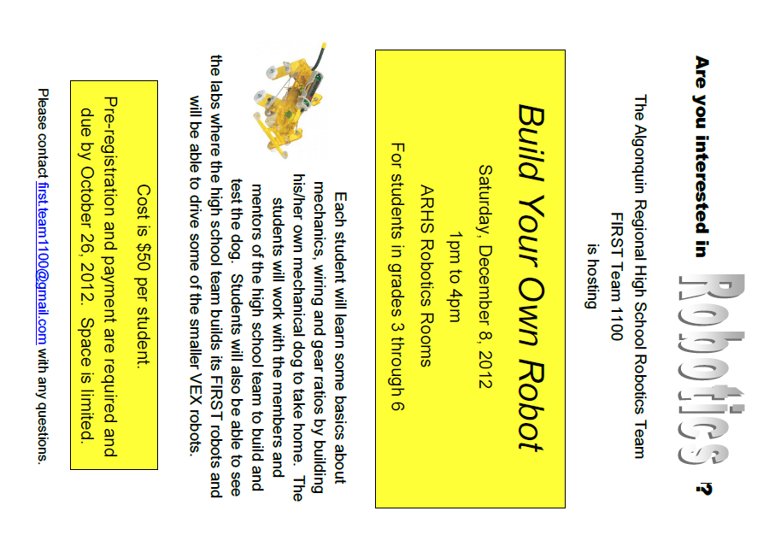
Your flyer should include information describing what the event is, who the event is for, and where and when the event will be. It should also include how much the event will cost and how someone could find more information. Our flyer is shown in Fig. 1.

Fig. 1 The Publicity Flyer

Publicizing the Event and Collecting Registrations

Send to local elementary schools: Contact the administration at each school to ask if they send out a weekly electronic backpack to their students. Many schools no longer send hard copies of flyers home with students but will either post community flyers on their website or will send digital flyers home in a weekly email. Ask how you can request approval for your notice to be included in that distribution. You can create a pdf of your flyer and send it to the person in charge of coordinating these at each school. Remember to say Please and Thank You! (We recommend sending a two page pdf with the flyer as the first page and the registration form as the second page.)

Post your flyer at your public library: Again, be sure to ask a librarian if there is a dedicated location for community notices and what the rules are regarding what can be posted.

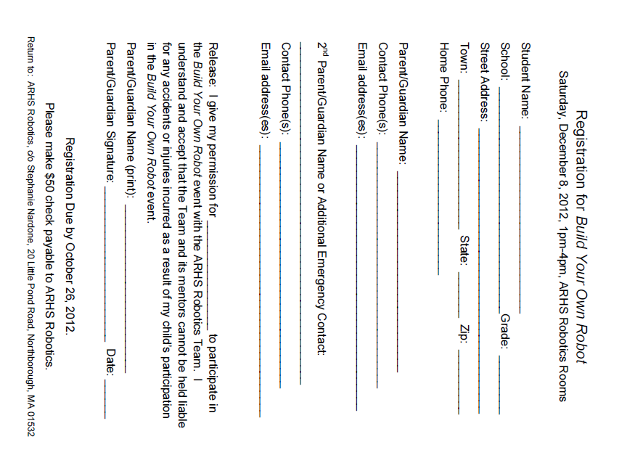
Advertise at other events you are involved in: Team 1100 participates in our town’s annual fall festival. We host a large demonstration and provide opportunities for visitors to drive our robots. At our ticket table, we displayed our Build Your Own Robot flyer in a clear frame next to the one sample kit we built. When kids came over to buy tickets, we turned the mechanical dog on, showed them how it works, and told them and their parents that if they’d like to build one themselves, they could sign up for a class with us. We then handed out miniature versions of our flyer with the info needed for them to request a registration form.

NOTE: For our first Build Your Own Robot event, we only advertised at our fall festival event. We purposely wanted to limit the number of registrants the first time.

Fig. 2 The Registration Form

The registration form should include:
- the title of the event
- the time/date/location
- a space for the registrant’s name and contact info, especially the parent’s name, email and phone
- the cost and to whom the check should be made payable
- the registration due date
- instructions on how the registration and payment should be returned

The registration form we used is pictured in Fig. 2.

When a registration is received, a notification should be emailed indicating that you received the registration and payment. Our notification email simply stated:

Hello -
Thank you for registering for the Build Your Own Robot event to be held December 8! We look forward to meeting you. We will send a reminder and directions to you as the date nears, but we just wanted to let you know that we have received your registration.
- ARHS FIRST Robotics Team 1100

Five to ten days prior to the event, we emailed the following reminder to all participants:

Hello!

We are looking forward to meeting each of you at our Build Your Own Robot event this weekend! As a reminder, you are registered for:

what: Build Your Own Robot
when: Saturday, December 8, 1pm to 4pm
where: Algonquin Regional High School Robotics Rooms C110 and C111

Please enter Robotics room C110 directly from the outside of the school by the tennis courts. Look for the Team 1100 sign. Please see the attached map and let us know if you have any questions.

Thank you!
ARHS FIRST Robotics Team 1100

** NOTE: When sending emails to all participants, we recommend blind copying the participants. Many participants would prefer that their email addresses not be shared with a large group. Blind copying also eliminates any problems with a recipient “replying to all” with a question.

Ordering kits

A couple of days after your registration due date, you should compile your list of registrants and contact information and order the number of kits you will need. We recommend ordering at least one extra so that you have extra parts in case one breaks or is misplaced.

Advanced Preparation

Preparing the Kits: Prebuilding some parts?

Based on your analysis of the level of difficulty in building the kit you have selected, you might decide to pre-build some of the parts in order to save some time and to eliminate some frustration with small pieces.

The Tamiya© Mechanical Dog kit included plastic parts that were secured to sheets. We decided to detach the pieces from their sprues prior to the arrival of the participants. Using sorting containers (see Fig. 1), we labeled each compartment prior to separating the pieces and then placed the separated pieces into the appropriate section. (The pieces themselves were not individually labeled. Once they were separated from the sheet it would have been difficult to differentiate the pieces as they were indicated in the included instructions. So, we wanted to be sure that each compartment was clearly labeled and included the correct part(s).)

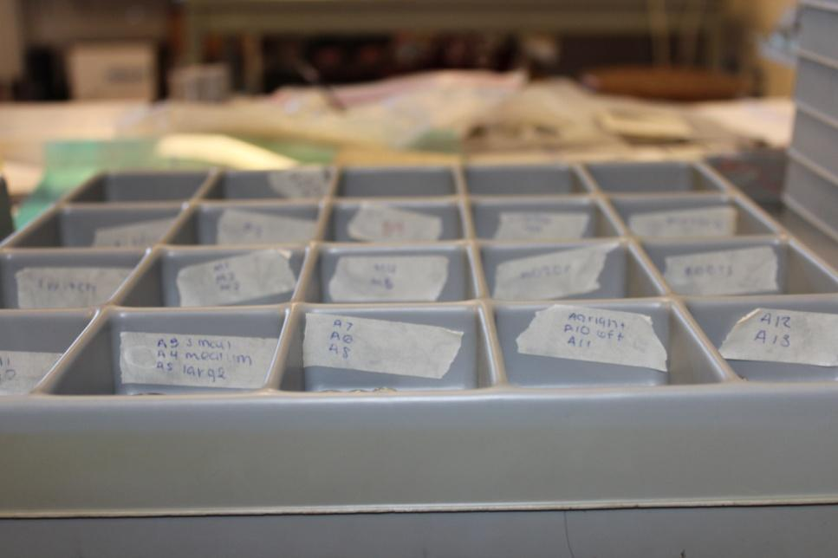
Once the pieces were separated and organized (we ensured that each sorted container was identically organized in order to ease our assisting all participants), we inspected each piece to determine that there were no sharp areas where some of the material from the sprue was still attached. If needed, we used a fine knife or sandpaper to remove the excess plastic material from the area.

Fig. 3 The Sorting Container

Preparing Some Teaching Material

We wanted the students to become familiar with some of the terms we were going to use throughout the day, and we wanted them to have something to do when they arrived while they waited for everyone to arrive and for us to begin as a group. We decided to create a word search puzzle. See Fig. 5.

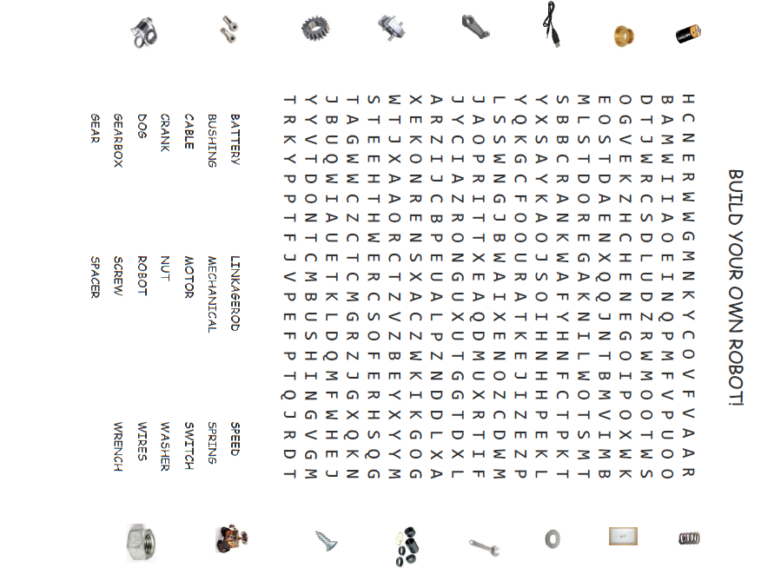
(There are many free online tools you can use to create word searches, crossword puzzles, etc. A few notable sites are: www.puzzlemaker.com, www.armoredpenguin.com, and www.edhelper.com.)

Fig. 5 The Word Search

Prior to beginning to build, we also wanted to explain some of the terms with hands-on teaching materials. We decided to focus on introducing two concepts: gears and electricity/switches.

Gears
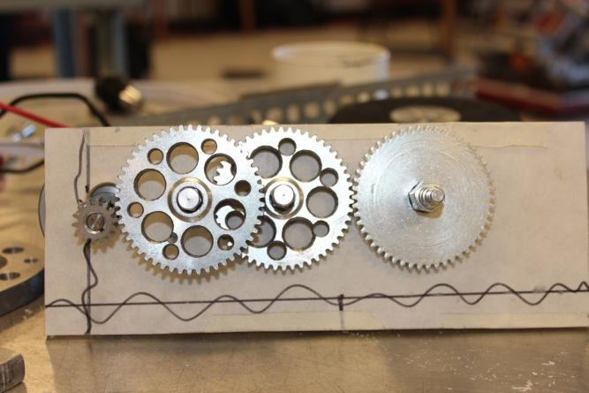
We gave a brief explanation of gears and talked about what they are generally used for:
- To reverse rotational direction
- To change the speed of rotation
- To switch rotational motion to a different axis
- To keep the rotation of two axis synchronized

We did not show a video to the kids in our class, but there are many science videos for kids available online. We found one at http://www.sciencekids.co.nz/videos/physics/gears.html that is very good, but a little long. We recommend explaining gears and how they work in simple terms, and having a hands-on example of gears similar to the one we built (see Fig. 6). Allow the participants to turn one gear to see how it turns the others.
Fig. 6 Gears

We then showed them a pre-built gearbox for the robot they were going to build, pointed out the different gears in the gear box, and asked them what they thought the purpose of the gears were in this example.

Electricity/Switches

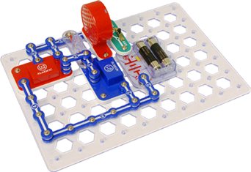
Following our brief discussion about gears, we gave a simple explanation about electricity and switches. We used Snap Circuits © as an example and allowed the participant to turn the switch on and off and to disconnect one of the sections (which we told them represents the wires in the Mechanical Dog setup.

The picture in Fig. 7 is similar to the setup we created but the credit for this picture is http://www.snapcircuits.net.

Fig. 7 Electricity and Switches - SnapCircuits©

Timing for the event

Note that the following times are approximate and are relative to the kit we chose and the grade levels of the participants. Whatever timing you plan for your event, we recommend that you be flexible and be prepared for some things to take longer/shorter than expected.

- 0-20 minutes: Arrival, introduction, seating, word search
  - As participants arrive, introduce them to and “assign” them to a high school student who will be working primarily with them. (We planned a minimum ratio of 1:1, one high school student per one participant.)
  - Show the participants their workspace (we placed nametags on each desk).
  - While the high school students chat with them, the participants, together with the high school student, work on the word search.
- ~10 minutes: Group Introduction, Explaining the Day
  - The Lead mentor should introduce himself/herself and welcome the group. He/she should ask how they are doing with their word searches, and maybe show the answer key at the front of the room using a document camera. Finally, he/she should explain what you will be doing: for example, that you would first talk about some of the terms and concepts listed in the word search, then build the robot, tour the facility, and, time permitting, drive some of the FIRST team’s robots.
- 20-30 minutes: Hands-on Learning
  - Talk briefly about the first concept. You could show a short video or project pictures from files/presentations or use actual objects and a document camera.
  - Depending on the number of participants, gather them around a table to see/touch your hands-on teaching tool or pass the tool around to each work station for each participant to have a turn.
  - Repeat for the second concept.
- 60-90+ minutes: Building the Robot
  - Each participant should be given a container with parts and an instruction sheet. He/she should work with his/her assigned team member (high school student) to build the robot. We allowed each pair to work at their own speed and did not try to build the robots as a group. Additional team members and adult mentors walked around to the different work stations to assist as needed.
  - When completed, label each robot (using masking tape or label and a marker) with the participant’s name or the name he/she chooses to give his/her creation.
  - Allow the participant to play with his/her robot for a few minutes.
- 30-60 minutes: Tours and Demos
  - Each participant can be given a tour of the area either by the same team member who worked with him/her or by another volunteer. The young students in our group enjoyed seeing some of the machines we use to cut and drill parts for our robots. They might also enjoy seeing on a computer screen how a CAD program works or how code is written.
  - In a sectioned off area, each participant can be allowed to drive or control a robot. We allowed the participants to be the operators of our Rebound Rumble robot and control the shooting of basketballs.
- 10 minutes: Wrap Up
  - During the last 10 minutes, address the participants as a group. Thank them for coming. Tell them you hope they enjoyed their time with you. And ask if they have any questions.
  - Finally, check off on your list that they are leaving with their designated adult.

Following up

After the event, we sent an email requesting feedback from the parents of our participants:

Hello -

We hope your children enjoyed spending the afternoon with us last weekend during our Build Your Own Robot event. We definitely enjoyed the experience of sharing our passion with them!

As you may know, the founder of FIRST, Dean Kamen, has a "passion and determination to help young people discover the excitement and rewards of science and technology". (www.usfirst.org) Through events such as Build Your Own Robot, we, the members of Team 1100, are trying to further the mission of FIRST by providing STEM learning opportunities to the younger people in our community.

We would love to hear some feedback from you, the families of our first class. What was your child's favorite part of the day? What do you think we might be able to add/change to make the class more interesting/fun/worthwhile? Do you think the activity was age appropriate? Would you recommend this class to a friend if we were to host another similar event?

Thank you!
Algonquin Regional High School Robotics FIRST Team 1100

We received positive replies, including
- “Great Job!!”
- “XXX just loved it…Already mentioned it to a few friends and they are hoping it will be offered in the spring again”
- “Our son __ attended this even and had a great time! … We would recommend it to others”
- “Nice to see a focus on something other than sports for the kids.”

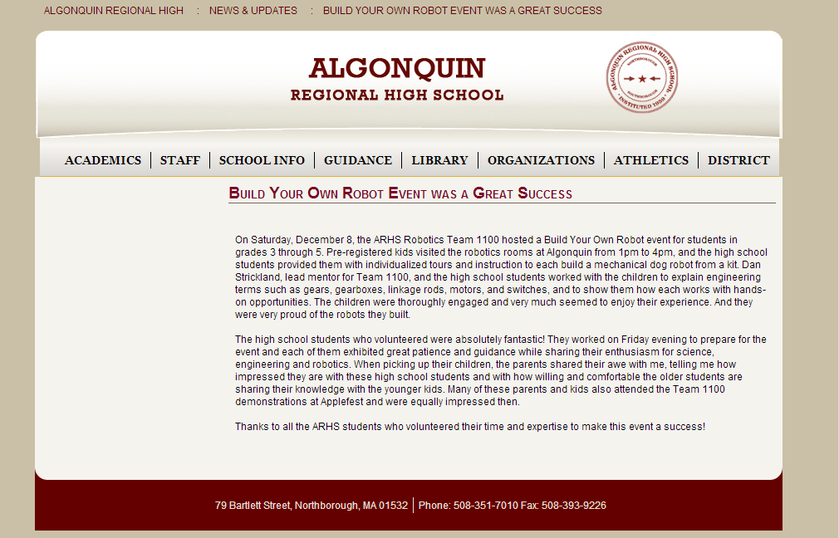
Finally, share your success with your school administration. We did and they congratulated us both directly and by sharing our story via the school’s website (Fig. 8).

Our superintendent wrote: “Thanks for letting me know this fantastic news about the ARHS Robotics Team 1100. We are tremendously proud of their efforts to share their enthusiasm for science, engineering, and robotics with our younger students. Great job!”
Fig. 8 School Website Notice

