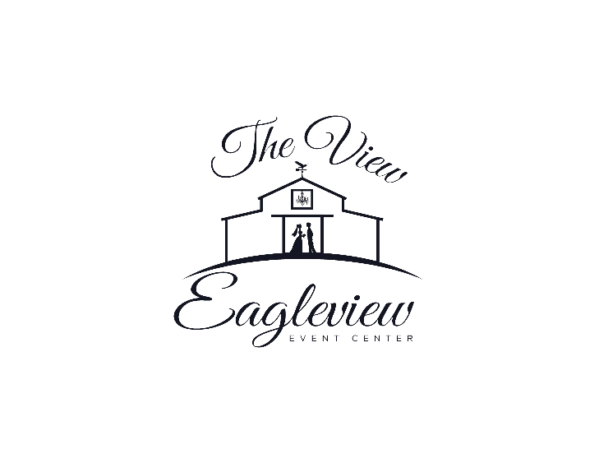

Eagleview Event Center WEEKEND Venue Rental Agreement

This Venue Rental Agreement (“Agreement”), is entered into on this day **______________ 2022**, by and between Eagleview Event Center, LLC, of 639 Wagon Wheel Rd, Elk Creek, Virginia, 24326 (“Lessor”) and **_______________________________________________________** (“Lessee”). The parties hereto, intending to be legally bound, and in consideration of the mutual covenants hereinafter contained, agree as follows:

**GRANT**

Lessor, on the dates and times set forth herein, and subject to the terms and conditions of this Agreement, hereby grants to Lessee a license to use Eagleview Event Center, LLC (“Facility”) for the **________________________________________** (“Event”) to be held on **_______________________** at **_______________________**.

**DATES AND TIMES OF PERMITTED USE**

Access to the Facility for the Event will commence on Friday, 11:00AM on the day before the Event and will end Sunday, 11:00AM the day after the event. All personal belongings must be removed by Sunday, 11:00AM. Property left after that time is not the responsibility of Eagleview Event Center, LLC.

**RENTAL FEE**

Lessee shall pay to Lessor as a rental fee for the use by Lessee of the Facility, the sum of **_________**, plus all other charges to be paid by Lessee under this Agreement (the “Rental Fee”). **Lessee shall deposit a non-refundable sum of $750.00 with Lessor upon the execution of this Agreement**, which sum shall be applied by Lessor to the Rental Fee upon completion of this Agreement. Half of the balance must be paid within six months of the event date, with the balance of Rental Fee shall be paid in full by Lessee 90 days PRIOR to the event. And additional fee of $250 will be deposited by the Lessee as a security deposit to cover any damage to the facility. This fee is **fully refundable** if no damage is caused during the event. Normal wear and tear is expected and does not constitute damage. Deposits and payments will be made by cash or personal check (made payable to Eagleview Event Center). A receipt from Eagleview Event Center will be provided for each.

**INCLUDE AMENITIES**

Tables, chairs, and white table linens are included in this rental agreement, unless noted otherwise.

**WEDDING REHEARSAL**

Rehearsals may be held on-site. The date and time is to be coordinated with and approved by Eagleview Event Center.

**REHEARSAL DINNER**

Rehearsal Dinners are permitted to be held in the Small Event Center/Brides Suite under a separate agreement. Discounts may apply for Customers contracting with Eagleview Event Center for their main Reception Venue.

**CONDITIONS OF USE**

Lessee’s activities during the Rental Period must be compatible with use of the building/grounds and activities in areas adjacent to the Rental Space and Building. This includes but is not limited to playing loud music or making any noise at a level that is not reasonable under the circumstances. With the exception of background music during an outdoor wedding ceremony, there is to be NO LIVE MUSIC or speakers on the deck, all music must originate inside of the event space. Smoking is not permitted anywhere in the buildings, on the porches or decks and within 30 feet of any building. **All music must stop by 10:30 pm and the barn must be evacuated by 11:00 pm.**

**ALCOHOL**

Eagleview Event Center does not have a liquor license and will not provide alcohol of any kind for your event. Beer and wine are permitted to be served inside the buildings and on the porches or decks, no mixed drinks or hard liquor are permitted. No guest is allowed to bring their own alcohol on site for private consumption, any alcohol served must be purchased by Lessee. Any Lessee having beer/wine at their event will be required to procure a single day banquet event license from the Virginia Alcoholic Beverage Control Authority. The single day banquet license must be presented to Eagleview Event Center 60 days prior to the event, with the final payment.

**INSURANCE**

Lessee agrees that it shall, at its sole cost and expense, procure and maintain a policy of commercial general liability insurance (including contractual liability) in an amount no less that $1,000,000.00 per occurrence, $1,000,000.00 in the annual aggregate. Such insurance policies shall be carried with companies licensed to do business in the state, reasonably satisfactory to Lessor and shall be non-cancelable and not subject to material change except after thirty (30) days written notice to Lessor. Lessee shall deliver to Lessor duly executed certificates of insurance upon request. Lessor shall not at any time be liable for damage or injury to persons or property in or upon the Facility. If beer and wine will be served at the event, an alcohol waiver must be included in the insurance. If Lessee does not present insurance proof to Eagleview Event Center 60 days prior to event, with final payment, Eagleview Event Center, LLC will procure said insurance and deduct it from Lessee’s security deposit.

**INDEMNIFICATION**

Lessee shall indemnify, defend and save harmless Lessor, its officers, agents and employees from and against any and all loss, cost (including attorney’s fees), damage, expense and liability (including statutory liability and liability under workers’ compensation laws) in connection with claims, judgments, damages, penalties, fines, liabilities, losses, suits, administrative proceedings, arising out of any act or neglect by Lessee, its agents, employees, contractors, Lessees, invitees, representatives, in, on or about the Facility. This indemnity shall survive the termination of this Agreement. Lessee hereby releases Lessor from any and all liability or responsibility to Lessee or anyone claiming through or under Lessee by way of subrogation or otherwise for any loss or damage to equipment or property of Lessee covered by any insurance then in force.

**“AS-IS” CONDITIONS**

Lessee agrees to accept the Facility in its “as-is” condition “with all faults”.

**ASSIGNMENT AND SUB-LICENSING**

Lessee shall not assign any interest in this License Agreement or otherwise transfer or sub-license the Facility or any part thereof or permit the use of the Facility to any party other than the Lessee.

**TERMINATION**

Lessor may terminate this Agreement based upon any one or more of the following events:

A. Failure of Lessee to pay the Rental Fee or any other charges due hereunder when the same is due.

B. Lessee fails to perform any of its covenants hereunder. In any of the aforesaid events, and in addition to any and all rights and remedies available to Lessor by law or in equity, Lessor may, with or without further notice, forthwith terminate this Agreement and expel and remove Lessee, or any other person or persons in occupancy from the Facility, together with their goods and personal possessions, using such force as may be necessary in the judgment of Lessor or its agents in so doing, without evidence or notice or resort to legal process or becoming liable for any loss of damage which may be occasioned thereby, and repossess and enjoy said Facility, and in addition to any other remedy it may have, Lessor may recover from Lessee all damages it may incur by reason of such breach by Lessee.

**INTERFERENCE**

Lessee shall use the Facility in a manner which shall not cause interference with the use or occupancy of the other portions of the Building by Lessor or others in any way. Lessee’s use hereunder will be done in such a manner so as not to interfere with or impose any additional expense upon Lessor in maintaining the building.

**RESTORATION**

If any damage occurs to the Facility, or if any repairs or replacements need to be made to the Facility as a result of the Lessee’s exercise of its rights under this License, Lessee shall pay Lessor for any such damage, repairs, or replacements upon demand by Lessor. Normal “wear and tear” is expected.

**CANCELLATION**

Lessee may cancel this Agreement at any time up to 90 days prior to the Event Date by providing written notice of such election to Lessor, the Lessor will keep the $750 deposit. Since final payment is not required until 90 days prior to the event, any cancellations of the event from time final payment is made, up to the day of the event, will result in the Lessee being charged 100% of the Rental Costs and any expenses incurred by Lessor (such as any special-order table linens, etc.…)

**OTHER INFORMATION**

**Other than service animals**, only pets of the Lessee that are used during the ceremony are allowed on premises and must be on a leash and tended to at all times.

**Wedding/Event Planner**: Eagleview Event Center, LLC has several wedding/event planners that we work with and can work with lessee during their event. The planners are contracted and paid for under a separate contract, directly with the planner. If a Wedding/Event Planner is not procured, it will be the responsibility of the lessee to coordinate with Eagleview Event Center a minimum of 30 days in advance of your event as to whom will be doing all responsibilities contained in the information presented with this contract.

**GOVERNING LAW**

This Agreement shall be governed by and construed in accordance with the laws of the Commonwealth of Virginia. Any legal actions, claims or demands shall be handled in a court of competent jurisdiction within the Commonwealth of Virginia.

**SIGNATORIES**

This Agreement shall be signed by Joy C. Butler

info@eagleviewevents.com  
276-768-8511  
www.eagleviewevents.com on behalf of Eagleview Event Center, LLC

**and by _____________________________.**

IN WITNESS THEREOF, the parties hereto have executed this Agreement as of the day and year first above written.

LESSOR

Eagleview Event Center, LLC

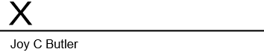

LESSEE



Print Name:

____________________________

**NOTES:**

**Officiant –**

**Photo Booth –**

**360 Video Booth –**

**Linens -**