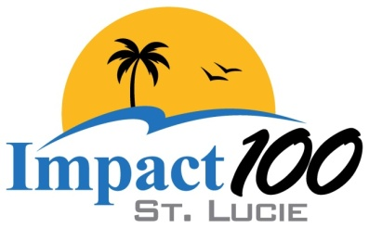

“Women are stronger together!”

**Membership Scholarship Parameters**

Scholarships may be offered if funds are available with the objective of meeting or exceeding membership goals.

**Eligibility**: Applicants must be women who are interested in philanthropy, volunteerism and community involvement and who live and/or work in St. Lucie County. Young women pursuing undergraduate or graduate degrees with the same interests may apply for scholarships.

**Community Service:** Scholarship applicants must demonstrate a willingness and disposition to serve and volunteer at Impact 100 St. Lucie events. Demonstration of previous community service with Impact 100 St. Lucie and/or organizations whose mission aligns with that of Impact 100 St. Lucie is preferred.

**Leadership Potential:** Documented evidence of leadership potential and experience by **two written references** must be submitted.

**Application:** Scholarship applicants must apply to the Scholarship Committee outlining personal goals, aspirations and describing current and/or proposed community involvement. Emphasis on alignment with Impact 100 St. Lucie’s mission should be clearly outlined.

**Interview:** Scholarship applicants must participate in an “in person” interview with two or more members of the Scholarship Committee.

**Scholarship Terms:** Scholarships covering partial membership dues of $550 will be provided for one fiscal year beginning in July 2025. The partial scholarships may be renewable based on 1) availability of sponsorship funds and 2) continued compliance with all scholarship parameters.

**Community Member Sponsor:** Community members are welcome to sponsor an Impact 100 St. Lucie member by providing financial support to cover the membership fee of $1100. Scholarship parameters should be taken into consideration for community-sponsored members.