A Benchtop Suction Assessment of B-Rex Bronchoscope Prototypes Against Currently Marketed Single-Use Bronchoscopes

Benjamin Heck, Founder/Chief Engineer, *Rex Instruments™*

*Introduction*

Single-use flexible bronchoscopes (SUFBs) are increasingly becoming more prevalent in hospitals and clinics1. The reduced risk of infection1-4 and potential cost savings1-4 compared to reusable scopes are major contributors to the growing use of SUFBs. The suction of SUFBs is a critical aspect of its performance, enabling clear visualization2,4 and therapeutic removal of foreign bodies, blood clots, and thick secretions1,2. Prototypes designed to enhance suctioning capabilities have been developed with functioning flexion control and suctioning. The suction capabilities of these SUFB prototypes are tested against current SUFBs on the market.

*Methods*

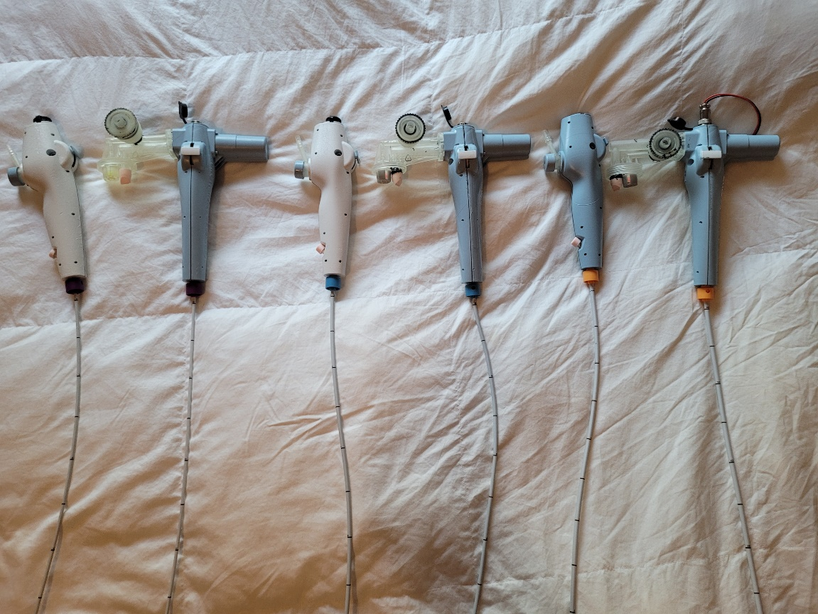

Figure 1: A Picture of the B-Rex Prototypes. Slim scopes are on the left, Regular scopes are in the middle, Large scopes are on the right

A benchtop suction comparison of slim, regular, and large SUFBs on the market and Bronchoscopus Rex™ (B-Rex™) prototypes was performed.

SUFBs come from the top 3 brands in the United States market. For all currently marketed SUFBs and prototypes not featuring built-in suction, a portable suction machine (Drive Medical) was used to generate the negative pressure. A smart scale Arduino-based system was used to measure the amount of liquid suctioned from each scope over a 30 second time window.

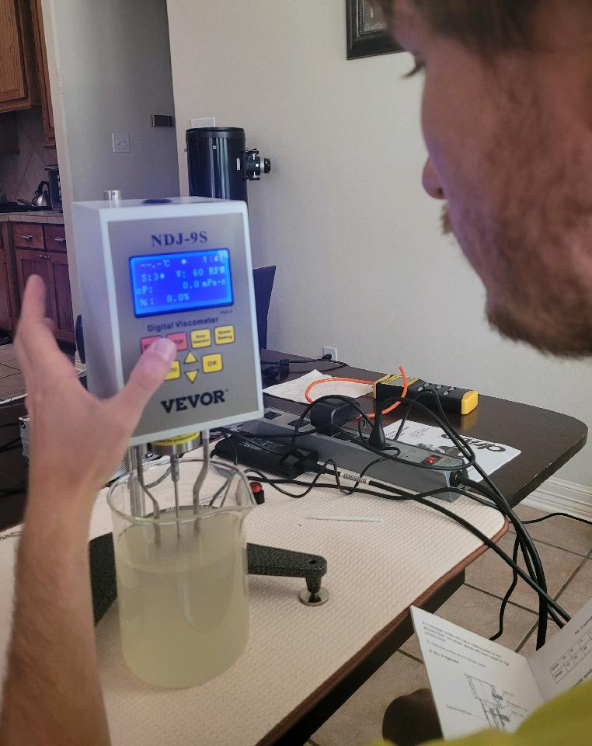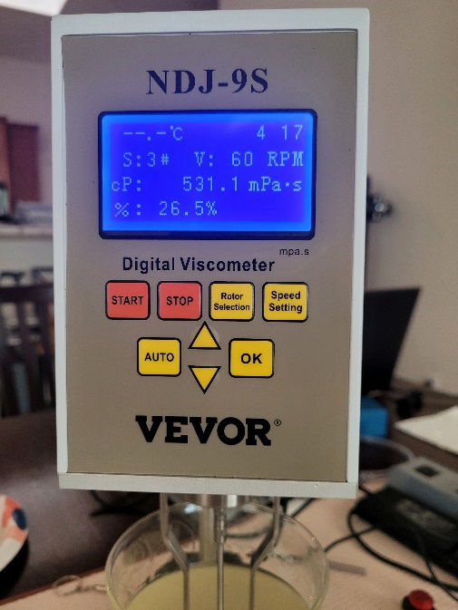

Figure 3: The NDJ-9S Viscometer used to measure the viscosity of the pseudo-mucus solutions.

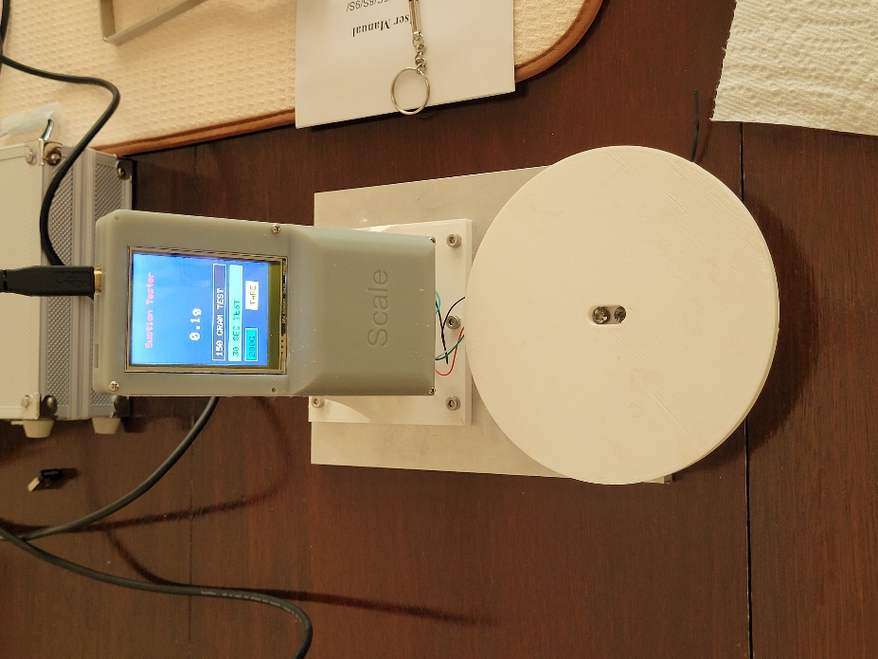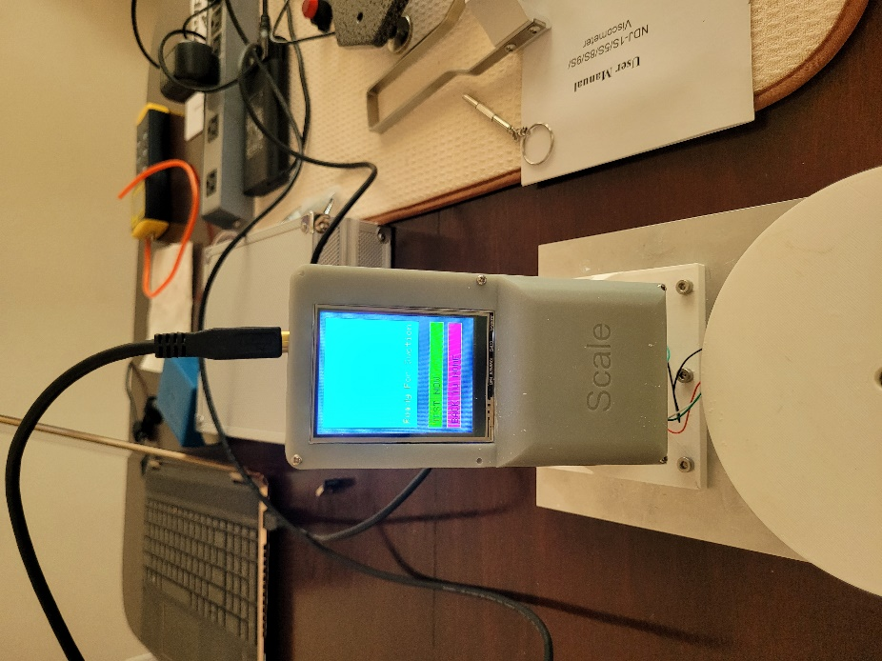

Figure 2: Pictures of the Smart Scale System Used to Measure the Amount of Pseudo-mucus Suctioned in 30 s.

A pseudo-mucus solution of ~20 cP viscosity was prepared by thoroughly mixing 2.2 g guar gum with 1000.0 g water to assess slim SUFB performance. A pseudo-mucus solution of ~531 cP viscosity was prepared by mixing 5.2 g guar gum with 1000.0 g water to assess regular and large SUFB performance. Mucus solutions were placed in a vacuum chamber to degas and remove bubbles prior to measuring the viscosity. Viscosities were measured using the NDJ-9s Digital Viscometer.

The pseudo-mucus solution was placed in a beaker. For each trial, the beaker with the pseudo-mucus solution was placed on the platform of the smart scale. The tip of the tested bronchoscope was submerged in the pseudo-mucus solution and kept at roughly the same level beneath the surface throughout the trial. When the bronchoscope operator was ready, they pressed a button on the smart scale and the smart scale would notify the operator when it was ready to collect data. Upon notification, the operator began suctioning with the bronchoscope. After a drop in 2 g has been detected, the smart scale detects that suctioning has commenced and begins a 30 second timer. At the end of the 30 s, the smart scale provides the amount suctioned over the 30 s time frame and the operator stopped suctioning and recorded the data. This was performed 5 times for each SUFB tested.

Figure 4: Testing Bronchoscope Suctioning. B-Rex prototypes can be seen in the 2 images on the left. Currently marketed SUFBs can be seen in the 2 images on the right.

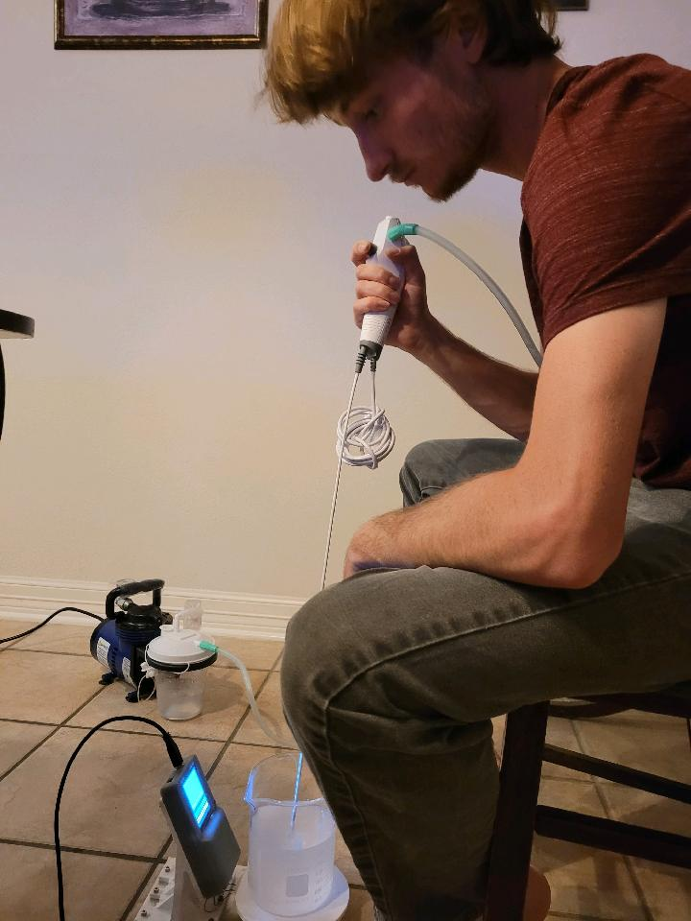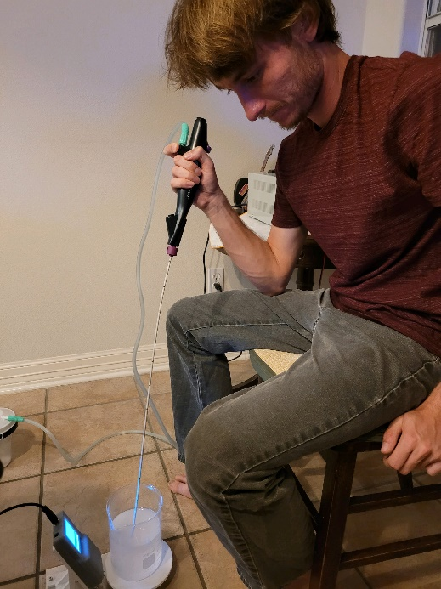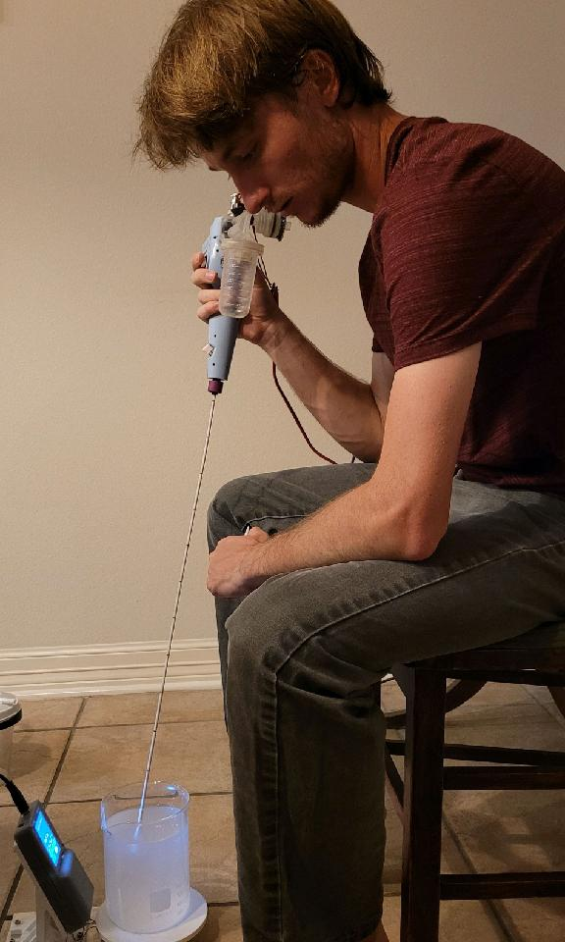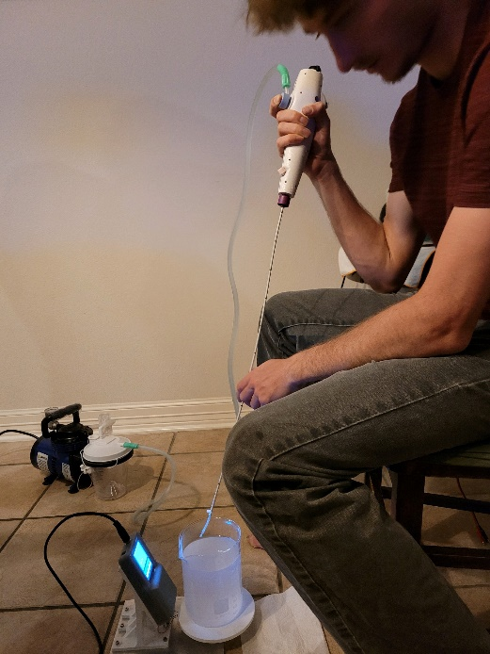

Between each trial, the operator cleared the bronchoscope with only air suction. On any occasion that a new bronchoscope was used or a fluid line disconnected, the suction pressure of the suction machine or the Bronchoscopus Rex with built-in suction was verified as being set to -200 mmHg using the General Tools DM8215 manometer.

Figure 5: The DM8215 manometer was used to ensure the suction pressure was set to -200 mmHg on the suction machine and on the B-Rex prototypes with built-in suction.

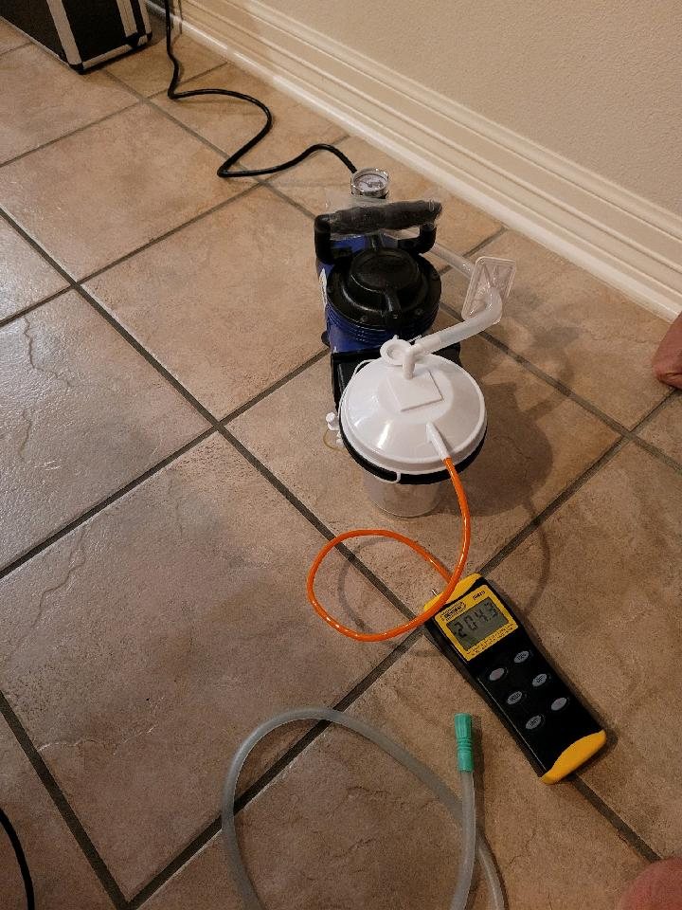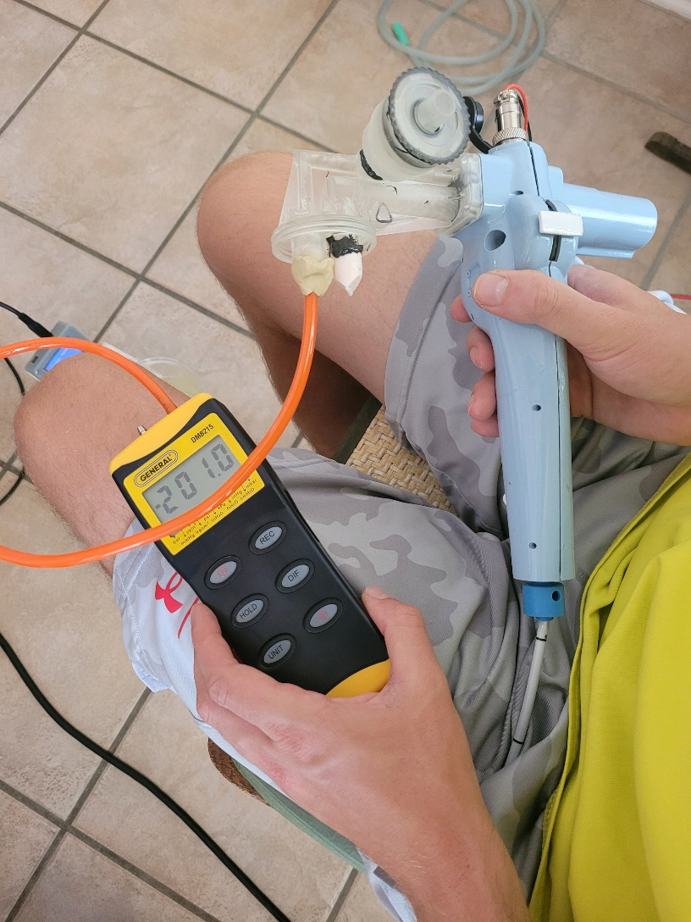

After obtaining the results, statistical analysis was performed. The scopes in each size were ranked based on how much pseudo-mucus they suctioned. Then, a one-way t-test was performed for each bronchoscope comparing it with the next best scope in its size category. Statistical significance was identified if the p-value returned from the t-test was less than 0.05. The percentage increase in suction from the next best scope was calculated as well.

*Results*

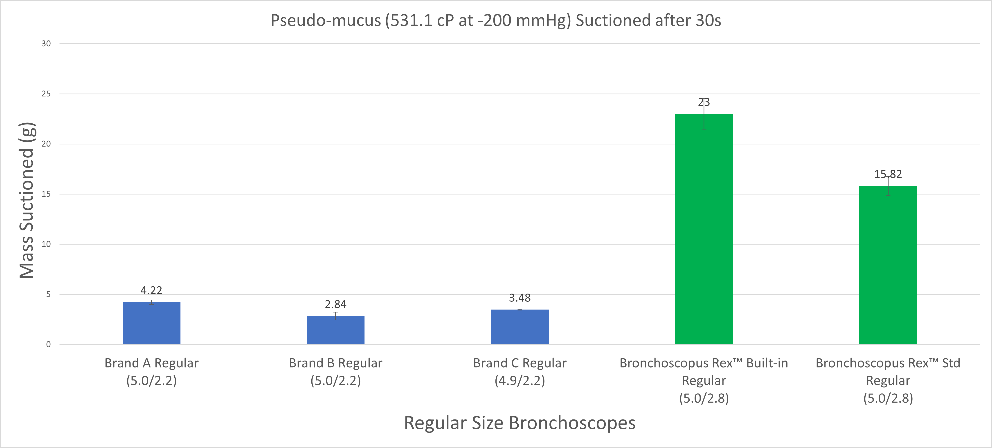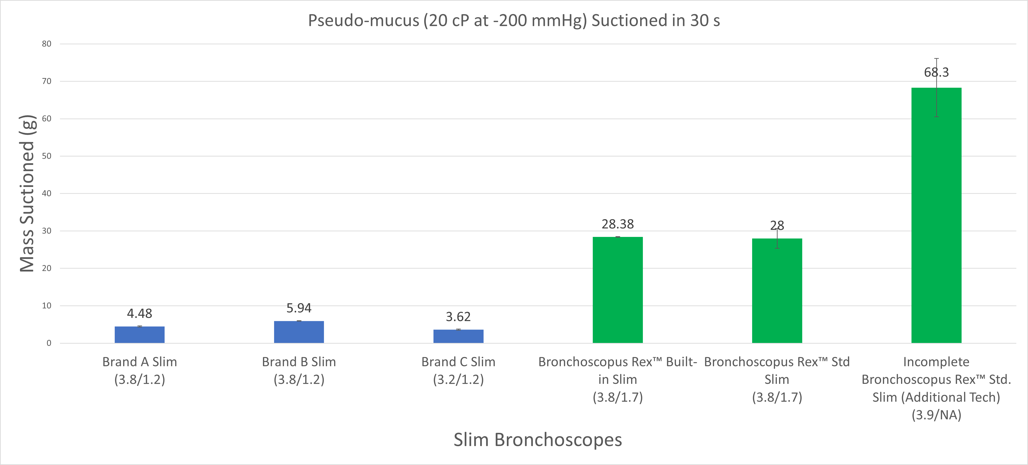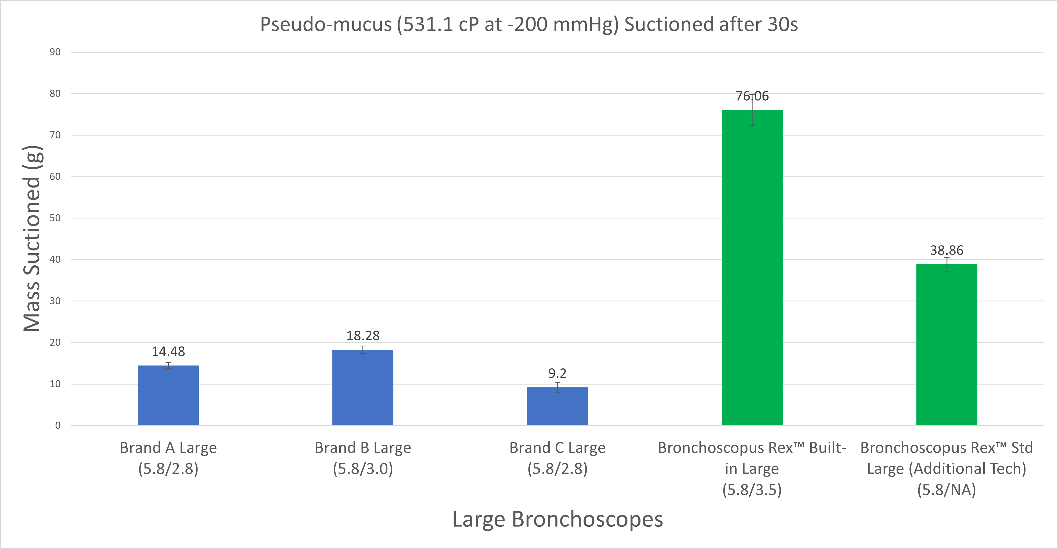

Figure 6: Bar charts showing the amount of pseudo-mucus suctioned in 30 s in slim bronchoscopes (top), regular bronchoscopes (middle), and large bronchoscopes (bottom).

The Bronchoscopus Rex™ (B-Rex™) prototypes significantly outperformed all other tested scopes in all size categories. All SUFBs were found to suction a statistically significantly higher amount of mucus than the next scope in each size category with exception to the Bronchoscopus Rex Slim prototype with built-in suction when compared to the Bronchoscopus Rex Slim standard (Std) prototype without built-in suction. The test results were very consistent owing to repeatable protocols and a mostly automated and highly precise smart scale system.



Table 1: A table of slim bronchoscope suction performance with statistical analysis results

The B-Rex Slim Std and Built-in Suction prototypes suctioned 28.0 ± 2.6 g and 28.4 ± 0.1 g of the 20 cP pseudo-mucus within 30 seconds, respectively. This was significantly higher (p = 2.43×10-5, ~371%) than the next highest amount from Brand B, which suctioned 5.9 ± 0.1 g of the same pseudo-mucus solution. The difference between the two completed prototypes was not statistically significant. An incomplete B-Rex Std Slim prototype was included using experimental additional technology that may enable forceps to pass through the scope. It remains to be determined if the experimental technology gets implemented in the final product.



Table 2: A table of regular bronchoscope suction performance with statistical analysis results

The B-Rex Regular Std and Built-in Suction prototypes suctioned 15.8 ± 0.9 g and 23.0 ± 1.5 g of the 531 cP pseudo-mucus within 30 seconds, respectively. The B-Rex Regular Built-in Suction prototype suctioned a statistically significant amount more (p = 2.14×10-5, ~45%) than the B-Rex Regular Std prototype. The B-Rex Regular Std prototype still suctioned a significant amount more (p = 5.6×10-6, ~275%) than the next SUFB from brand A, which managed to suction 4.2 ± 0.2 g of the pseudo-mucus solution.

The B-Rex Large Std and Built-in Suction prototypes suctioned 38.9 ± 1.6 g and 76.1± 3.8 g of the 531 cP pseudo-mucus within 30 seconds, respectively. The B-Rex Large Built-in Suction prototype suctioned a statistically significant amount more (p = 2.75×10-6, ~96%) than the B-Rex Large Std prototype. The B-Rex Large Std prototype still suctioned a significant amount more (p = 1.4×10-7, ~113%) than the next SUFB from brand B, which managed to suction 18.3 ± 0.9 g of the pseudo-mucus solution.

It is worth noting that the pseudo-mucus solution used for Regular and Large bronchoscopes were the same and that the B-Rex Regular with Built-in Suction prototype outperformed all tested currently marketed large SUFBs and that the B-Rex Regular Std prototype outperformed all tested currently marketed large SUFBs except for the Brand B large scope.



Table 3: A table of large bronchoscope suction performance with statistical analysis results

*Conclusion and Discussion*

The Bronchoscopus Rex™ (B-Rex™) prototypes provide significantly increased suctioning capabilities compared with SUFBs currently on the market across all sizes. Based on the results and the currently available data from previous studies, the Bronchoscopus Rex family of bronchoscopes is anticipated to have by far the greatest suction capabilities of any bronchoscope available. The B-Rex prototypes have several features that augment the suctioning capabilities. Some features include built-in suction, while others enable maximizing the cross-sectional area of the working channel and minimizing unused space in the bronchoscope. The presence of at least one of the novel features in the B-Rex prototypes is the reason for their superior suction performance.

The built-in suction was shown to have minimal to no effect on suction performance in the slim models, but significantly improved performance in the regular and large SUFB prototypes. This is likely because the vast majority of the fluid resistance in the slim bronchoscopes comes from the small diameter working channel tube running through the length of the insertion cable in slim bronchoscopes. In regular and large bronchoscopes, the diameter of the working channel through the insertion cable is larger than those in the slim bronchoscopes. As a result, the length of the tubes going from the bronchoscope to the external suction source is a more substantial contributor to the fluid resistance. By including the built-in suction, those tubes going to an external suction source are eliminated and fluid resistance is reduced substantially. The elimination of external tubing and the need for an external suction source also reduces costs associated with implementation, maintenance, inspection, sterilization, and setup needed for each procedure6,7. Furthermore, with built-in suction the movement of clinicians is unimpeded and the likelihood of a workplace injury caused by tripping over tubing in the workplace can be reduced8-10. Because versions with built-in suction also provide a built-in suction regulator, the suction pressure can be adjusted frequently throughout a procedure without requiring another person to adjust the regulated suction pressure at the wall outlet. This is advantageous as different suction pressures are required during a procedure for different regions of the airways. For instance, due to the cartilage structure in the upper airways, trachea, and larger bronchi, greater suction pressures can often be achieved without collapsing the airway. In small bronchi and bronchioles, suction pressures need to be lowered to prevent airway and alveolar collapse and to collect samples as in bronchoalveolar lavage (BAL).

The assembly of the B-Rex prototypes also includes features that maximize working channel inner diameter. The tip eliminates the size restriction on the working channel caused by the camera at the bronchoscope tip. In addition, the assembly of components reduces unused space throughout the insertion tube, thereby maximizing the available space for the working channel. This increases suction capabilities and the size range of compatible instruments.

A bronchoscope’s suction is an important aspect of its performance. Bronchoscopes, particularly of regular and large sizes use suction to improve visualization2,5 and to therapeutically remove thick secretions, mucus plugs, blood clots, and foreign bodies1,2. Single-use bronchoscopes are becoming more widely adopted due to the reduced risk of hospital-acquired infections1-4 (0% vs 2.8%3) and lower cost per procedure1-4(savings of $1574) than reusable bronchoscopes. Current single-use flexible bronchoscopes (SUFBs) use external tubing to derive their suction from the hospital wall suction source or portable suction machines. Such external tubing can impede physician movement, causing workplace injuries8-10, and increase fluid resistance as evident when assessing the resistance of a fluid circuit using Poiseuille’s Law.

The B-Rex prototypes have features designed to increase suction performance. By increasing suction performance in each size, smaller diameter bronchoscopes are able to expand their range of applications. For example, the regular B-Rex prototypes can be used as efficaciously as the best large SUFBs on the market meaning smaller endotracheal tubes can be used to intubate patients and navigation into deeper, more peripheral airways is possible. With the slim B-rex, the suction performance may come close to that of currently marketed regular SUFBs meaning that greater success can be achieved in pediatric patients and those who are challenging to intubate.

Some aspects of the Bronchoscopus Rex™ design are not yet finalized, which may result in the actual device having suctioning capabilities even greater than what was observed in this study. Further bench studies will be performed to assess overall performance of the SUFBs and Bronchoscopus Rex prototypes. Such bench studies may include a simulated use study requiring navigation of a model resembling the anatomical lung airways, removal of thick pseudo-mucus plugs, and advancement of forceps to remove mock abnormal growths.

*Citations:*

1. Deasy KF, Sweeney A-M, Danish H, O’Reilly E, Ibrahim H, Kennedy MP. Single use or disposable flexible bronchoscopes: Bench top and preclinical comparison of currently available devices. Journal of Intensive Care Medicine. 2023;38:519–28.

2. Lamb CR, Yavarovich E, Kang V, Servais EL, Sheehan LB, Shadchehr S, et al. Performance of a new single-use Bronchoscope versus a marketed single-use comparator: A bench study. BMC Pulmonary Medicine. 2022;22.

3. Mouritsen JM, Ehlers L, Kovaleva J, Ahmad I, El‐Boghdadly K. A systematic review and cost effectiveness analysis of reusable vs. single‐use flexible bronchoscopes. Anaesthesia. 2019;75:529–40.

4. Sohrt A, Ehlers L, Udsen FW, Mærkedahl A, McGrath BA. Cost comparison of single-use versus reusable bronchoscopes used for percutaneous dilatational tracheostomy. PharmacoEconomics - Open. 2018;3:189–95.

5. Paradis TJ, Dixon J, Tieu BH. The role of bronchoscopy in the diagnosis of airway disease. Journal of Thoracic Disease. 2016;8:3826–37.

6. Say SD. Why every small hospital needs portable suction [Internet]. dark-header.jpg. [cited 2023 Aug 8]. Available from: https://blog.sscor.com/why-every-small-hospital-needs-portable-suction

7. Ohio Medical. [cited 2023 Aug 8]. Available from: <https://www.ohiomedical.com/wp-content/uploads/Principles-of-Vacuum-Clinical-Application-in-the-Hospital-Environment-SOT645.pdf>

8. Cappell MS. Injury to endoscopic personnel from tripping over exposed cords, wires, and tubing in the endoscopy suite: A preventable cause of potentially severe workplace injury. Digestive Diseases and Sciences. 2009;55:947–51.

9. Ofori E. Occupation-Associated Health Hazards for the gastroenterologist/ endoscopist. Annals of Gastroenterology. 2018;

10. Cappell MS. Accidental occupational injuries to endoscopy personnel in a high-volume endoscopy suite during the last decade: Mechanisms, workplace hazards, and proposed remediation. Digestive Diseases and Sciences. 2010;56:479–87.