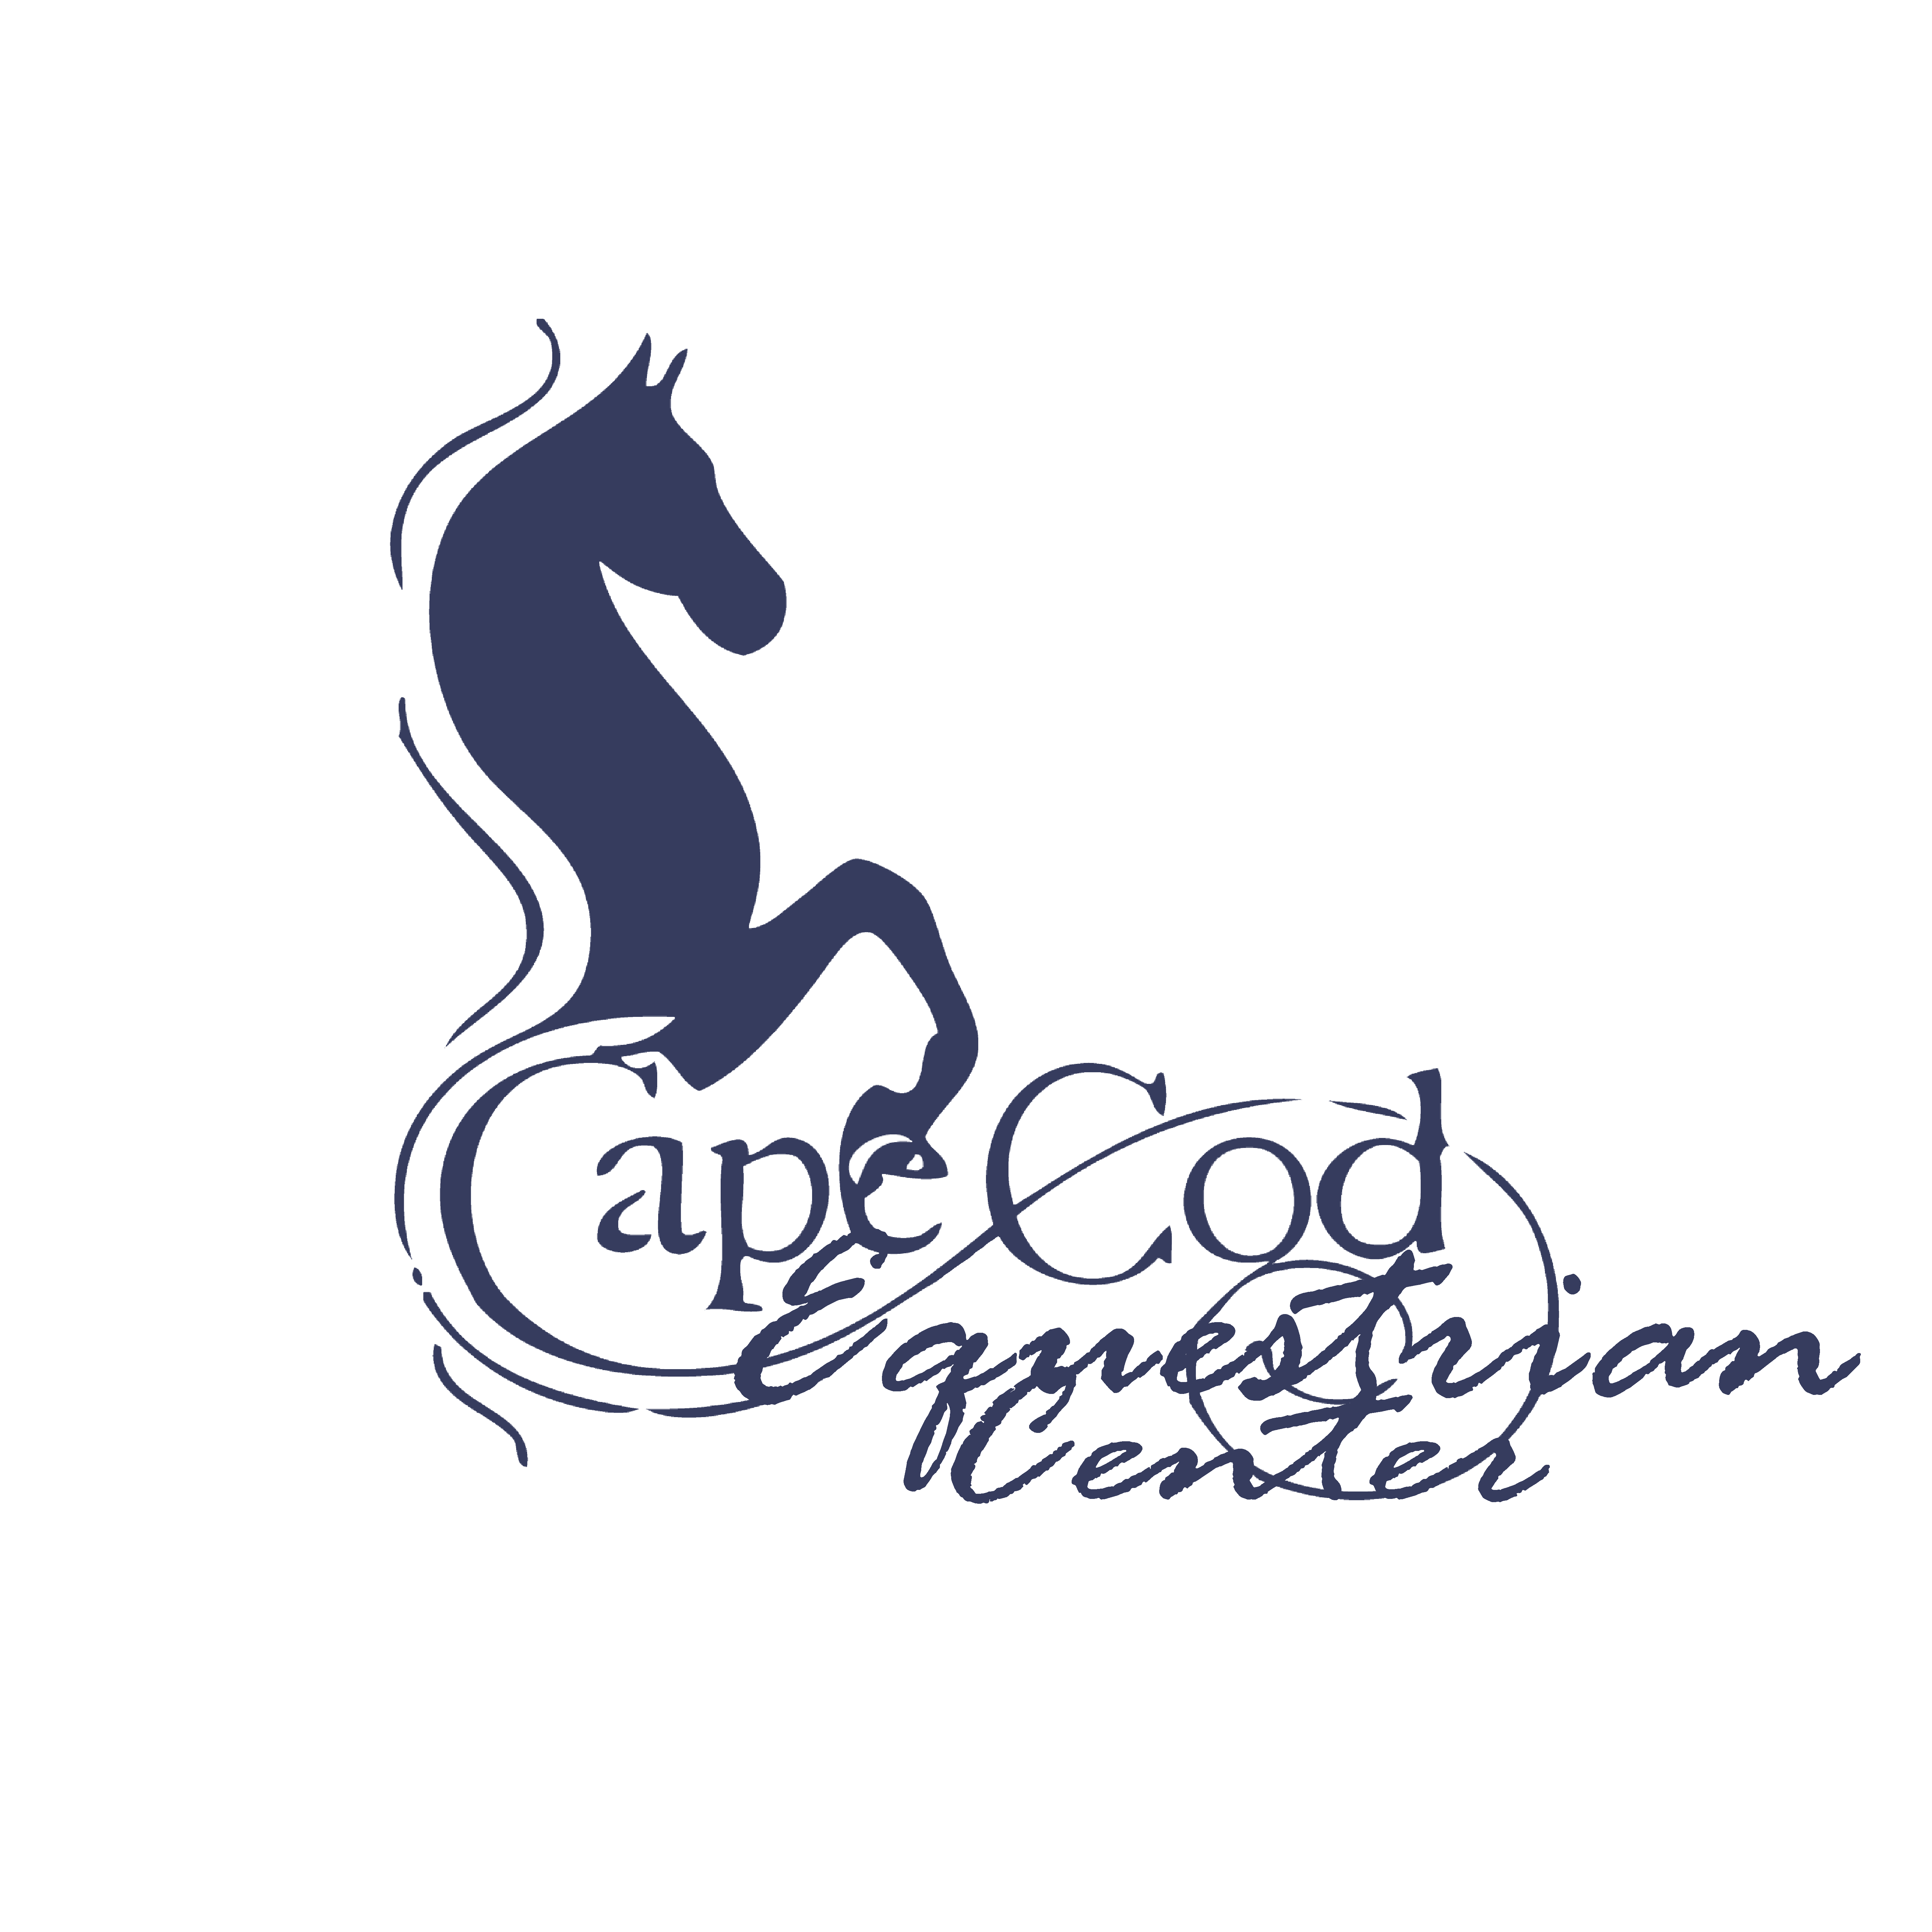
WAIVER OF EQUINE ACTIVITY LIABILITY

Rider Name:______________________________________Date:____________________

The undersigned, does hereby agree that I am, or my child/ward is, an equine activity participant. An equine activity participant is subject to the inherent risks of equine activity as defined in Ohio Revised Code 2305.321 including, but not limited to, any or all of the following:

(a) The propensity of an equine to behave in ways that may result in injury, death or loss to persons or property including the unpredictability of an equine's reaction to sounds, movements, objects, persons or other animals, which proximately causes harm to the equine activity participant.

(b) An equine activity sponsor, equine activity participant, equine professional, veterinarian, farrier, or other person who provides faulty or defective equipment or tack and knows or should know that the equipment or tack is faulty or defective, and the fault or defect in the equipment or tack proximately causes harm to the equine activity participant.

(c) An equine activity sponsor, equine activity participant, equine professional, veterinarian, farrier, or other person provides an equine to an equine activity participant, and fails to make reasonable and prudent efforts to determine his or her ability to safely engage in the equine activity or to safely manage the equine based on the participant's ability; the equine activity participant fails to safely engage in the equine activity or to safely manage the equine; and that failure proximately causes harm to the equine activity participant.

(d) Harm is proximately caused to the equine activity participant by a dangerous latent condition of the land on which, or the premises at which, the harm occurs, and an equine activity sponsor, other equine activity participant, equine professional, veterinarian, farrier, or other person owns, leases, rents, or otherwise lawfully possesses and controls the land or premises and knows or should know of the dangerous latent condition, but does not post conspicuously prior to the time of the harm involved one or more signs that warn of the dangerous latent condition.

(e) An act or omission of an equine activity sponsor, equine activity participant, equine professional, veterinarian, farrier, or other person which constitutes a willful or wanton disregard for the safety of the equine activity participant, and proximately causes harm to the equine activity participant.

(f) An equine activity sponsor, equine activity participant, equine professional, veterinarian, farrier, or other person intentionally causes harm to the equine activity participant.

By signing this written Waiver, I acknowledge that the equine activity participant who is subject of this Waiver, as well as his or her parents, guardian, custodian or other legal representatives, does not have a claim or cause of action on which a recovery of damages may be based against, and may not recover damages in court or other civil action against, any equine activity sponsors, other equine activity participants, equine professionals, veterinarians, farriers, or other persons associated with this equine activity, including, but not limited to, Cape Cod Equestrian Center, LLC, its members, representatives, officers, directors, volunteers, successors and assigns.
I voluntary agree to assume the full risk of any and all injuries, damages, or loss, regardless of severity, that I or my minor child/ward may sustain as a result of participating in this equine activity. I waive and relinquish all claims I and my minor child/ward may have, or which may accrue, as a result of participating in any equine activity, against Cape Cod Equestrian Center LLC, its members, representatives, officers, directors, volunteers, successors and assigns. I hereby fully release and agree to hold harmless, indemnify and defend Cape Cod Equestrian Center, LLC, its members, representatives, officers, directors, volunteers, successors and assigns from any and all claims or liabilities of any kind whatsoever arising out of my participation, or my child/ward's participation, in this equine activity.
I am fully authorized to execute this Waiver on behalf of myself and my child/ward, my, his or her estate and all other persons who may be entitled to claim damages as a result of any harm, loss, injury or death.

I have fully and carefully read and understand this Waiver and CCEC’s Cancellation policy and do hereby voluntarily execute the same as of the date written below. This document shall be governed by the laws of the State of Ohio.

I understand that all payments are final, and that refunds will not be issued.

Participant's Name: _______________________________________________________
(Please note – Participant is Parent or Legal Guardian if child(ren) is/ are under 18 years)

Participant's Signature: ____________________________________________________

Date: ____________________________________

Participant's Relationship if signing on behalf of a minor/ward:

Witness Signature: ________________________________________________________
CCEC RIDER INFORMATION

Rider’s Name_____________________________________________Age ____________

Address:________________________________________________________________

City:____________________________________State:__________ Zip:_____________

Email Address:___________________________________________________________
**Please provide valid email so that we may contact you about weather, cancellations, scheduling, etc.**

How Did you hear about us? ____ Internet (Google) ____ Facebook
____ Referral : Who Referred You? _________________________________
____ Other: ____________________________________________________

Phone Numbers (That Apply)

Home: (______________) ________________ - ________________________

Cell: (______________) ________________ - ________________________

Mother’s Cell: (______________) ________________ - ________________________

Mother’s Work: (______________) ________________ - ________________________

Father’s Cell: (______________) ________________ - ________________________

Father’s Work: (______________) ________________ - ________________________

EMERGENCY CONTACT IF MOTHER AND/OR FATHER ARE UNAVAILABLE

Name:__________________________________________________________________

Relationship to Student:____________________________________________________

Phone : (______________) ________________ - ________________________

Allergies if any:_____________________________________________________

If rider has special needs or is taking medication that would impair judgment please explain:

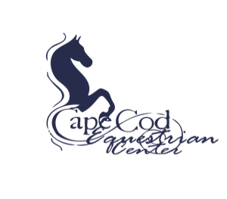

PHOTO RELEASE FORM

☐ I do not grant permission to Cape Cod Equestrian Center, LLC to use photographs and/or video of me and/or my minor child on-line or in publications

☐ I hereby grant permission to Cape Cod Equestrian Center, LLC to use photographs and/or video of me and/or my minor child in publications, news releases, online, website and in other communications related to the mission of Cape Cod Equestrian Center, LLC.

(Printed Name)

(Signature of Adult, or Guardian of Children under age 18)

__________/__________/___________
Date

Thank you!

Cancellation policy

Keeping in mind the care of our horses, we ask that if you need to cancel your lesson you give us at least 24 hours in advance. A failure in doing so will leave you responsible for paying for the missed lesson. We do understand that unforeseen situations do occur, but if you could, please let us know as soon as possible.

Inclement weather policy:
We do have to occasionally cancel lessons due to hot or cold weather. In the summer, we will not teach lessons when it is above 95 degrees. If this is the case, we will notify you as soon as possible and reschedule your lesson. In cold weather, the same rules apply; we will not teach when it is below 20 degrees. Regardless, if you are ever in question, please feel free to contact your instructor or send us an email at capecodequestriancenterllc@gmail.com!

Here are important numbers for you to know(texting is usually best way to reach us)

Elise Hagenow (M/W/F) Hannah Cooper (Sundays)
(603)-759-2532 (304) 549-6816

capecodequestriancenterllc@gmail.com

