CCEC Tiny Tot Camp
The following agreement is made and entered into this ____________ day of ______________, 2020 by and between Cape Cod Equestrian Center, LLC, hereinafter referred to as “Stables”, and _______________________. Parent/Guardian agrees to pay the sum of $100 per day or $275 for 3 days to enroll __________________________, thereinafter referred to as “Rider”, in CCEC Tiny Tot Camp. Please fill out and return signed forms and payment (checks made payable to CCEC. If you wish to pay by Credit Card, please fill out the Credit Card Authorization Form.) to Elise or Angie, or mail to:

CCEC Tiny Tot Camp
3187 E Centerville Road
Spring Valley, OH 45370

Camp Dates Attending:
____ July 27th 2020 10:00 AM – 3:00 PM
____ July 28th 2020 10:00 AM – 3:00 PM
____ July 29th 2020 10:00 AM – 3:00 PM

A $50 Non-Refundable deposit and completed registration are required to secure a spot. Balance is due the first day of Summer Horsemanship. Ages 4 - 7. Long pants and close-toed hard-soled shoes required for riding. All riders are required to wear a helmet while mounted. Helmets may be provided by the stables, so long as the helmet properly fits. Stables STRONGLY RECOMMENDS rider provide their own certified protective head gear. Rider will be assigned a horse for his/her use during the hours set forth above. Activities will include riding and grooming as well as instruction in the proper care and handling of saddles, bridles, and other riding equipment. The rider is to bring a lunch. Parent certifies that he/she is aware of the dangers and risks of accident inherent in riding and attendance of horses and fully assumes all such risks of loss, damage, injury or accident.

UNDER OHIO LAW, AN EQUINE ACTIVITY SPONSOR OR EQUINE PROFESSIONAL IS NOT LIABLE FOR AN INJURY TO OR THE DEATH OF A PARTICIPANT IN EQUINE ACTIVITIES RESULTING FROM THE INHERENT RISKS OF EQUINE ACTIVITIIES.
Ohio Revised Code 2305.321

Signature:___________________________________________________________________________

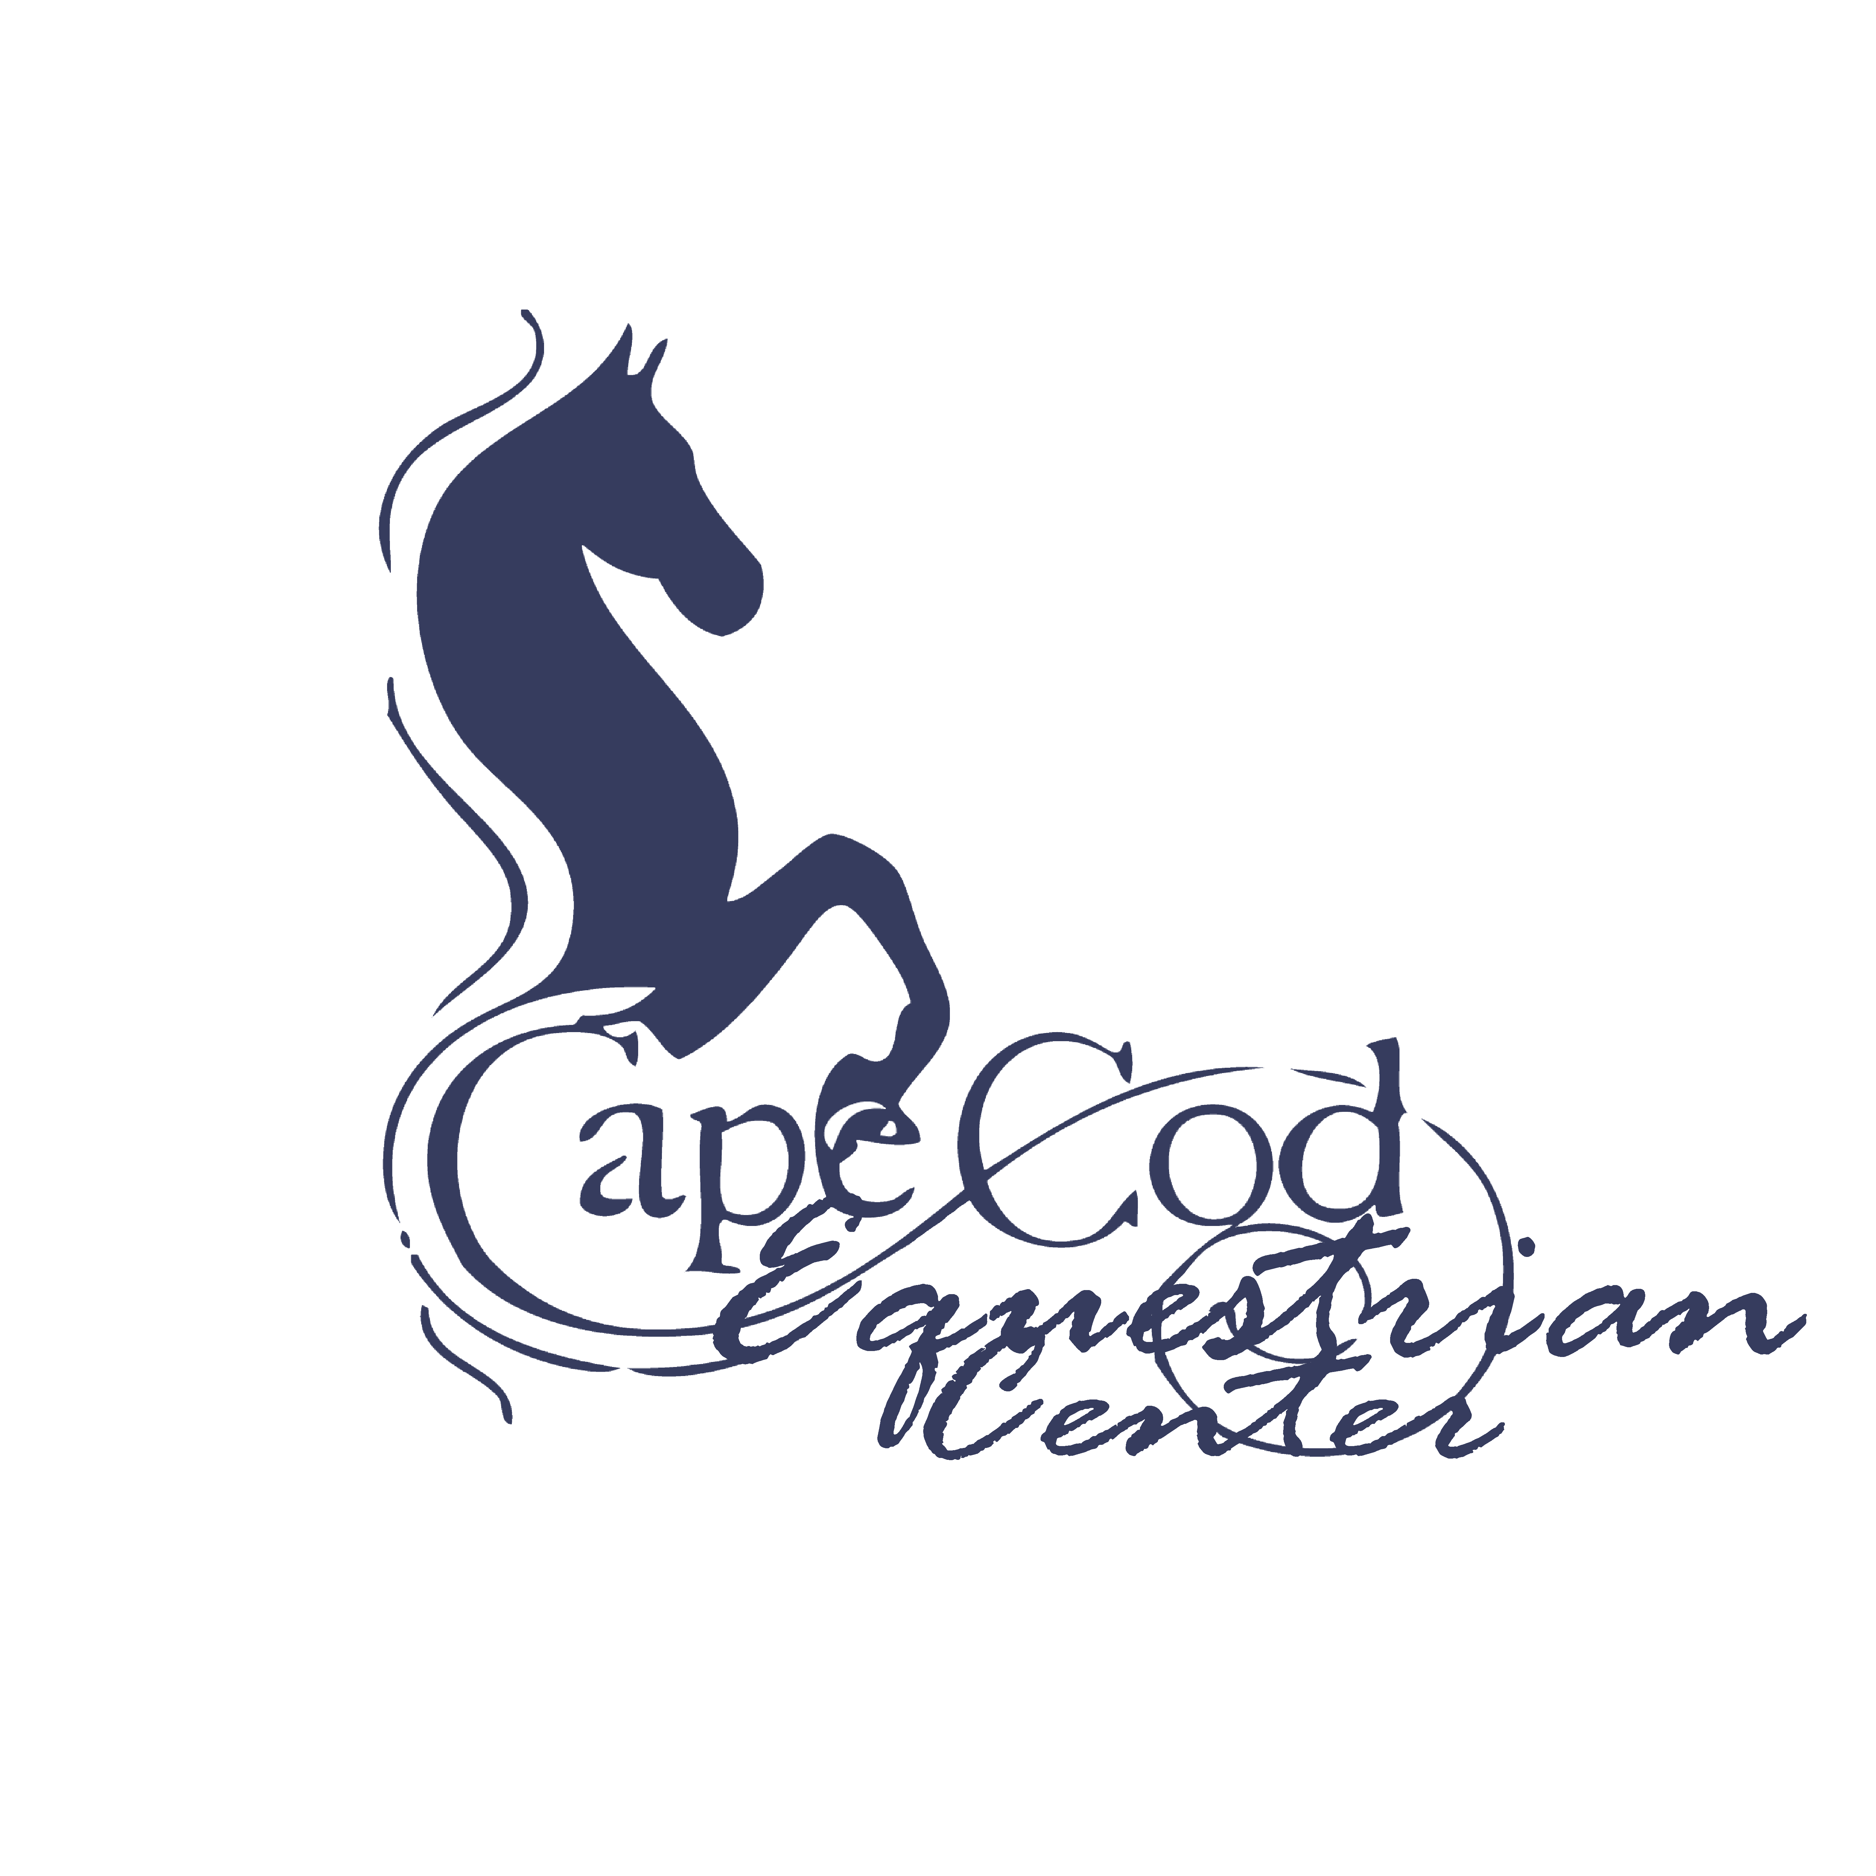
WAIVER OF EQUINE ACTIVITY LIABILITY

Rider Name:______________________________________Date:____________________

The undersigned, does hereby agree that I am, or my child/ward is, an equine activity participant. An equine activity participant is subject to the inherent risks of equine activity as defined in Ohio Revised Code 2305.321 including, but not limited to, any or all of the following:

(a) The propensity of an equine to behave in ways that may result in injury, death or loss to persons or property including the unpredictability of an equine's reaction to sounds, movements, objects, persons or other animals, which proximately causes harm to the equine activity participant.

(b) An equine activity sponsor, equine activity participant, equine professional, veterinarian, farrier, or other person who provides faulty or defective equipment or tack and knows or should know that the equipment or tack is faulty or defective, and the fault or defect in the equipment or tack proximately causes harm to the equine activity participant.

(c) An equine activity sponsor, equine activity participant, equine professional, veterinarian, farrier, or other person provides an equine to an equine activity participant, and fails to make reasonable and prudent efforts to determine his or her ability to safely engage in the equine activity or to safely manage the equine based on the participant's ability; the equine activity participant fails to safely engage in the equine activity or to safely manage the equine; and that failure proximately causes harm to the equine activity participant.

(d) Harm is proximately caused to the equine activity participant by a dangerous latent condition of the land on which, or the premises at which, the harm occurs, and an equine activity sponsor, other equine activity participant, equine professional, veterinarian, farrier, or other person owns, leases, rents, or otherwise lawfully possesses and controls the land or premises and knows or should know of the dangerous latent condition, but does not post conspicuously prior to the time of the harm involved one or more signs that warn of the dangerous latent condition.

(e) An act or omission of an equine activity sponsor, equine activity participant, equine professional, veterinarian, farrier, or other person which constitutes a willful or wanton disregard for the safety of the equine activity participant, and proximately causes harm to the equine activity participant.

(f) An equine activity sponsor, equine activity participant, equine professional, veterinarian, farrier, or other person intentionally causes harm to the equine activity participant.

By signing this written Waiver, I acknowledge that the equine activity participant who is subject of this Waiver, as well as his or her parents, guardian, custodian or other legal representatives, does not have a claim or cause of action on which a recovery of damages may be based against, and may not recover damages in court or other civil action against, any equine activity sponsors, other equine activity participants, equine professionals, veterinarians, farriers, or other persons associated with this equine activity, including, but not limited to, Cape Cod Equestrian Center, LLC, its members, representatives, officers, directors, volunteers, successors and assigns.
I voluntary agree to assume the full risk of any and all injuries, damages, or loss, regardless of severity, that I or my minor child/ward may sustain as a result of participating in this equine activity. I waive and relinquish all claims I and my minor child/ward may have, or which may accrue, as a result of participating in any equine activity, against Cape Cod Equestrian Center LLC, its members, representatives, officers, directors, volunteers, successors and assigns. I hereby fully release and agree to hold harmless, indemnify and defend Cape Cod Equestrian Center, LLC, its members, representatives, officers, directors, volunteers, successors and assigns from any and all claims or liabilities of any kind whatsoever arising out of my participation, or my child/ward's participation, in this equine activity.
I am fully authorized to execute this Waiver on behalf of myself and my child/ward, my, his or her estate and all other persons who may be entitled to claim damages as a result of any harm, loss, injury or death.

I have fully and carefully read and understand this Waiver and do hereby voluntarily execute the same as of the date written below. This document shall be governed by the laws of the State of Ohio.

I understand that all payments are final, and that refunds will not be issued.

Participant's Name: _______________________________________________________
(Please note – Participant is Parent or Legal Guardian if child(ren) is/ are under 18 years)

Participant's Signature: ____________________________________________________

Date: ____________________________________

Participant's Relationship if signing on behalf of a minor/ward:

PHOTO RELEASE FORM

☐ I do not grant permission to Cape Cod Equestrian Center, LLC to use photographs and/or video of me and/or my minor child on-line or in publications

☐ I hereby grant permission to Cape Cod Equestrian Center, LLC to use photographs and/or video of me and/or my minor child in publications, news releases, online, website and in other communications related to the mission of Cape Cod Equestrian Center, LLC.

(Printed Name)

(Signature of Adult, or Guardian of Children under age 18)

__________/__________/___________
Date

Thank you!
CCEC CAMPER INFORMATION

Rider’s Name____________________________________________________Age(s)____________

Address:__________________________________________________________________________

City:____________________________________State:__________ Zip:_______________________

Email Address:_________________________________________________________________

Phone Numbers (That Apply)

Home: (______________) ________________ - ________________________

Cell: (______________) ________________ - ________________________

Mother’s Cell: (______________) ________________ - ________________________

Mother’s Work: (______________) ________________ - ________________________

Father’s Cell: (______________) ________________ - ________________________

Father’s Work: (______________) ________________ - ________________________

EMERGENCY CONTACT IF MOTHER AND/OR FATHER ARE UNAVAILABLE

Name:_____________________________________________________________________________

Phone : (______________) ________________ - ________________________

Cell: (______________) ________________ - ________________________

Physician:__________________________________________________________________________

Phone: (______________) ________________ - ________________________

Allergies if any:________________________________________________________________________

If rider has special needs or is taking medication that would impair judgment please explain:

Cape Cod Equestrian Center Credit Card Authorization Form

Please compete all fields. You may cancel this authorization at any time by contacting us. This authorization will remain in effect until cancelled.

Credit Card Information

Card Type: ☐ Master Card ☐ Visa ☐ Discover ☐ AMEX

☐ OTHER ______________________________________

Cardholder Name (As shown on card): ____________________________________________________

Card Number: _______________________________________________________________________________

Expiration Date (MM/YY) : _________________________________________________________________

CCV Code (On back of card): _____________________________

ZIP Code (From Billing Address): _______________________________

I, ________________________________________________, authorize Cape Cod Equestrian Center, LLC to charge my credit card above for agreed upon purchases. I understand that my information will be saved to file for future transactions on my account.

____________________________________________________________ _________/____________/___________
Customer Signature Date

