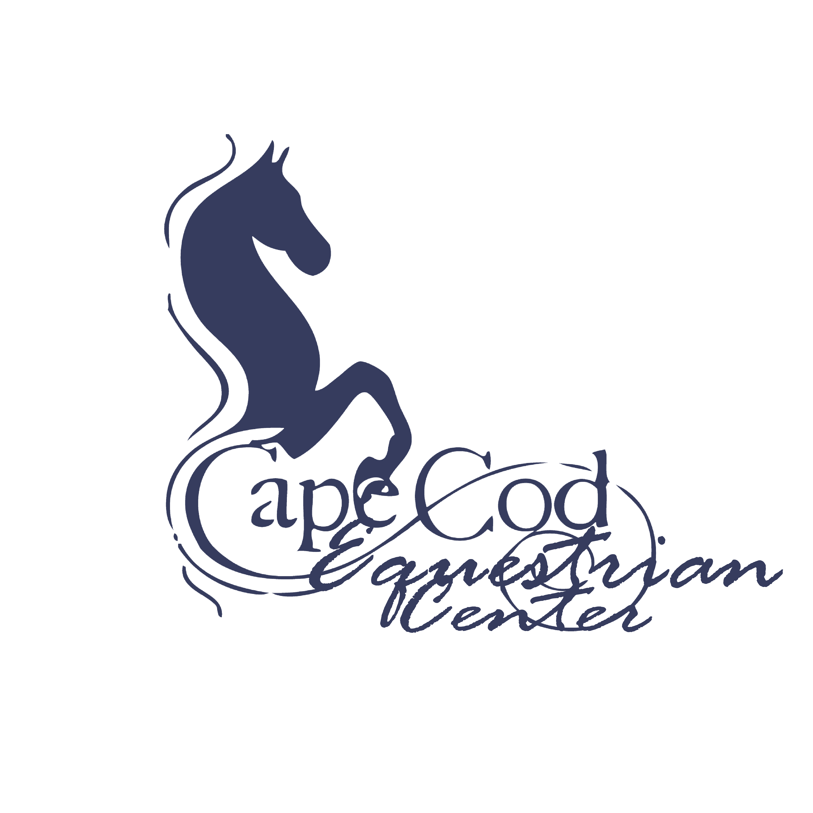
Birthday Party Hold Harmless Agreement

Name(s) of Child(ren) attending: ______________________________________________________________________________________________________________________________________________________
E-Mail Address:____________________________________________________________
Birthday Party Host Last Name: ______________________________________________

The undersigned, does hereby agree that I am, or my child/ward is, an equine activity participant. An equine activity participant is subject to the inherent risks of equine activity as defined in Ohio Revised Code 2305.321 including, but not limited to, any or all of the following:

(a) The propensity of an equine to behave in ways that may result in injury, death or loss to persons or property including the unpredictability of an equine's reaction to sounds, movements, objects, persons or other animals, which proximately causes harm to the equine activity participant.

(b) An equine activity sponsor, equine activity participant, equine professional, veterinarian, farrier, or other person who provides faulty or defective equipment or tack and knows or should know that the equipment or tack is faulty or defective, and the fault or defect in the equipment or tack proximately causes harm to the equine activity participant.

(c) An equine activity sponsor, equine activity participant, equine professional, veterinarian, farrier, or other person provides an equine to an equine activity participant, and fails to make reasonable and prudent efforts to determine his or her ability to safely engage in the equine activity or to safely manage the equine based on the participant's ability; the equine activity participant fails to safely engage in the equine activity or to safely manage the equine; and that failure proximately causes harm to the equine activity participant.

(d) Harm is proximately caused to the equine activity participant by a dangerous latent condition of the land on which, or the premises at which, the harm occurs, and an equine activity sponsor, other equine activity participant, equine professional, veterinarian, farrier, or other person owns, leases, rents, or otherwise lawfully possesses and controls the land or premises and knows or should know of the dangerous latent condition, but does not post conspicuously prior to the time of the harm involved one or more signs that warn of the dangerous latent condition.

(e) An act or omission of an equine activity sponsor, equine activity participant, equine professional, veterinarian, farrier, or other person which constitutes a willful or wanton disregard for the safety of the equine activity participant, and proximately causes harm to the equine activity participant.

(f) An equine activity sponsor, equine activity participant, equine professional, veterinarian, farrier, or other person intentionally causes harm to the equine activity participant.

By signing this written Waiver, I acknowledge that the equine activity participant who is subject of this Waiver, as well as his or her parents, guardian, custodian or other legal representatives, does not have a claim or cause of action on which a recovery of damages may be based against, and may not recover damages in court or other civil action against, any equine activity sponsors, other equine activity participants, equine professionals, veterinarians, farriers, or other persons associated with this equine activity, including, but not limited to, Cape Cod Equestrian Center, LLC, its members, representatives, officers, directors, volunteers, successors and assigns.
I voluntary agree to assume the full risk of any and all injuries, damages, or loss, regardless of severity, that I or my minor child/ward may sustain as a result of participating in this equine activity. I waive and relinquish all claims I and my minor child/ward may have, or which may accrue, as a result of participating in any equine activity, against Cape Cod Equestrian Center LLC, its members, representatives, officers, directors, volunteers, successors and assigns. I hereby fully release and agree to hold harmless, indemnify and defend Cape Cod Equestrian Center, LLC, its members, representatives, officers, directors, volunteers, successors and assigns from any and all claims or liabilities of any kind whatsoever arising out of my participation, or my child/ward's participation, in this equine activity.
I am fully authorized to execute this Waiver on behalf of myself and my child/ward, my, his or her estate and all other persons who may be entitled to claim damages as a result of any harm, loss, injury or death.

I have fully and carefully read and understand this Waiver and do hereby voluntarily execute the same as of the date written below. This document shall be governed by the laws of the State of Ohio.

Participant's Name: _______________________________________________________
(Please note – Participant is Parent or Legal Guardian if child(ren) is/are under 18 years of age)

Participant's Signature: ____________________________________________________

Date: ______________/________________/_________________

Participant's Relationship if signing on behalf of a minor/ward:

______________________________________________________________
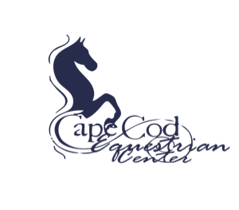
PHOTO RELEASE FORM

☐ I do not grant permission to Cape Cod Equestrian Center, LLC to use photographs and/or video of me and/or my minor child on-line or in publications.

☐ I hereby grant permission to Cape Cod Equestrian Center, LLC to use photographs and/or video of me and/or my minor child in publications, news releases, online, website and in other communications related to the mission of Cape Cod Equestrian Center, LLC.

(Printed Name)

(Signature of Adult, or Guardian of Children under age 18)

__________/__________/___________
Date

Thank you!

