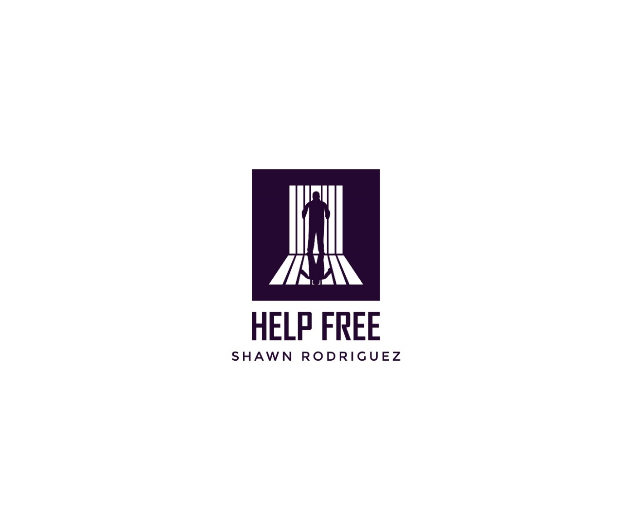
January 1, 2024

District Attorney Gire and The Honorable Judge Pineschi:

Thank you for reading this letter. We sincerely appreciate your time.
Shawn Rodriguez has been imprisoned since he was a 19-year-old teenager and has already served over 20 years of a sentence, which today might have received a total sentence of around 9 years at the absolute maximum. Shawn is still in prison today.
In Shawn’s case, the victim has recanted his testimony.
In addition to this, the Natural and Probable Consequences Doctrine has been withdrawn; Shawn was sent to prison over a now invalid theory of law. Shawn should have been released from prison more than a decade ago.
In the included slide deck, we have provided you with evidence from the trial transcripts, statements made by jurors, and details of the changes to our laws. Combined, these paint a clear picture that Shawn qualifies for resentencing and release from any further incarceration.
At the time of the crime, Shawn was an orphaned, homeless teenager in extremely difficult circumstances. Shawn is now an adult; he is ready to take his place in society, with professional qualifications and prospects for jobs.
We are asking that you choose to exercise your authority and, pursuant to penal code 1170, as well as a variety of Senate and Assembly Bills that are now law in California, please resentence Shawn without delay. We need your help.
Thank you very much. We sincerely appreciate your time.

Thank you,

Dr. Angela Cotellessa
Director of the Help Free Shawn Rodriguez Campaign
(213) 804-5151 / ACotellessa@gwmail.gwu.edu

CC: Dan Koukol

