THE COMMON TYPES OF REAL ESTATE

Single Family Homes
Single-family homes are freestanding residential buildings. A single-family home doesn’t share a wall with another building. A single-family homeowner typically owns the building and the land the building sits on.

Semi-Attached Home
A semi-detached home is a single-family dwelling that shares one common wall. Unlike a townhome, where you may have a neighbor on both sides of your home, semi-detached homes share only one wall, and the home design typically mirrors each dwelling.

Multi-family Homes
A multifamily home is a residential property that consists of more than one housing unit. Each unit will likely have its own main entrance, kitchen space and bathroom.

Townhomes
Townhomes are multi-floor homes with their own entrance, bathroom and kitchen space. Townhomes share two walls with neighbors unless the townhome is located at the end of a building. In some markets, the terms “townhome” and “townhouse” are used interchangeably.

Apartments
An apartment is a unit inside of a building structure composed of similarly styled individual units. A tenant rents an apartment from a landlord, so the tenant isn’t building any equity while paying rent. While lease agreements vary, many landlords are responsible for making repairs and upgrades to the leased unit. Some apartment communities include common area amenities like a laundry room, gym or pool.

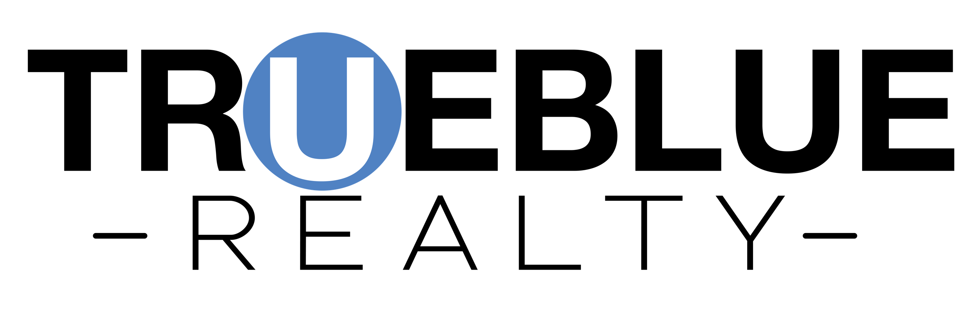

854 South Willow Avenue, Cookeville TN 38501
www.truebluerealty.net

Condos
Condominiums, or condos for short, are buildings made up of individual units that are owned. They can look and feel like an apartment building or community. Unlike with an apartment, a condo owner owns the interior space of their unit and is building equity with every mortgage payment. The common area is usually managed by a homeowners association, with fees being assessed to homeowners for common area expenses.

Co-ops
A co-op may physically resemble an apartment or condominium building, but on paper, a co-op is very different. People who invest in the co-op are called shareholders. Shareholders who live in the co-op have a proprietary lease giving them the right to live in a specific unit in the building.
Co-op housing is typically owned by a cooperative corporation. A co-op owner is a shareholder of a corporation, and the corporation owns and manages the building. The cooperative corporation is run by a board of directors who are elected by the shareholders and are responsible for common area maintenance and repair.
Tiny Homes
What is a tiny house? Tiny homes are homes that are generally 60 – 400 square feet in size but may go up to just under 600 square feet. Since becoming popular, tiny homes are available in a wide range of styles. Many are prefabricated with custom interior and exterior features and benefits that can make tiny living livable.

Manufactured Homes
Manufactured homes are homes built in factories, according to standards set by the U.S. Department of Housing and Urban Development (HUD). Manufactured homes are affixed to a permanent chassis with wheels and can be installed in both permanent and temporary locations.
Manufactured homes built before June 15, 1976, are called mobile homes and feature looser construction standards. As a result, through Rocket Mortgage®, you can get a conventional loan, FHA or VA loan on a manufactured home built on or after that date if you have real property permanently affixed to the land. FHA loans will require foundation inspections in accordance with the Permanent Foundations Guide for Manufactured Homes, but you can use a previous inspection if you've had one in the past.

854 South Willow Avenue, Cookeville TN 38501
www.truebluerealty.net

