Auxiliary to the
Military Order of the Cootie
of the United States
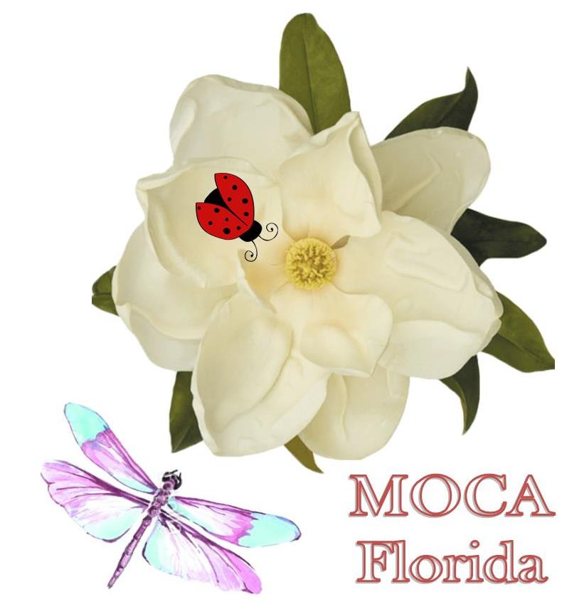
President Kathy Godard
2018-2019

PRESIDENT: Kathy Godard
THEME: Working Together for our Veterans
SPECIAL PROJECT: VA Hospitals with emphasis on Diabetes
FLOWER: Magnolia’s
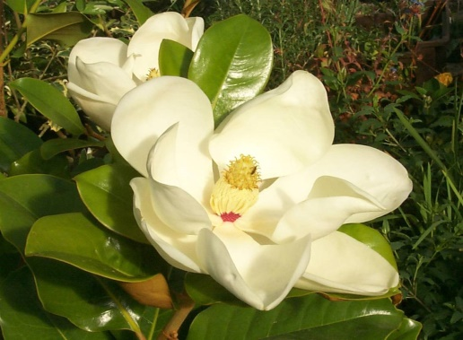

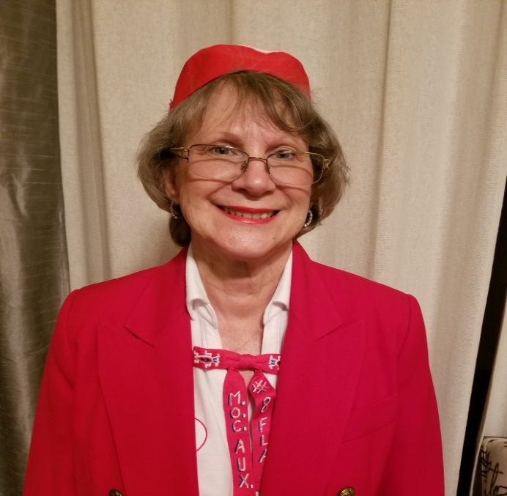

DATES TO REMEMBER 2018-2019

Bug Swarm/Council of Administration September 27 - 29, 2018
Orlando Marriott Lake Mary 1501 International Parkway Lake Mary, FL 32746 Reservations: 855-272-5207 (Mention MOC) Room Rate: $115.00 plus tax.
Tomb Trek/Arlington National Cemetery November 1 - 6, 2018
Sheraton Pentagon City Hotel
900 S. Orme St
Arlington, VA 22204
Reservations: 703-521-1900
King or 2 Doubles $109.00 (Group rate available until Oct 2, 2018

Mid-Winter Council of Administration January 17 - 20, 2019
The Plantation on Crystal River
9301 West Fort Island Trail
Crystal River, FL 34429
Reservations: (800) 632-6262, Mention MOC/MOCA
Standard Hotel Rooms are $119 plus tax
Patio Garden View Rooms $139 plus tax
Patio Water View Rooms $159 plus tax

Grand Convention June 6 - 9, 2019
Sheraton Orlando North Hotel
600 N. Destiny Road
Maitland, FL 32751
Reservations: 407-660-9000, Mention MOC/MOCA
Room Rate: $99.00 plus tax

BROWN BAG & CHINESE AUCTIONS TO BE HELD AT EACH FLORIDA
EVENT TO DEFRAY THE COST OF THE HOSPITALITY ROOM
MORE DONATED ITEMS FOR THE BROWN BAG AUCTION WOULD BE APPRECIATED

M.O.C. GRAND OF FLORIDA
www.mocgrandofflorida.com

GRAND COMMANDER: GARY GODARD
122 Queens Court
Sanford, FL 32771
407-271-9467
godard52@gmail.com

GRAND ADJUTANT: KEN THIE
13622 Serena Drive
Largo, FL 33774
727-580-7485
kthie33774@gmail.com

GRAND QUARTERMASTER: STEVE SURFACE
12460-91st Way, North
Largo, FL 33773
727-580-5040
Fire1@tampabay.rr.com

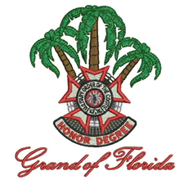

SUPREME OFFICERS 2018-2019

SUPREME PRESIDENT: Pat Potter
2633 West Adams
St. Charles MO 63307
Cell: 314-420-3756
Email: ppotter1293@gmail.com

SUPREME SECRETARY: Georg Jean Zimmerman
304 Hilltop Lane
Chestertown PA 21620
Cell: 443-480-5656
Email: gzimmerman@atlanticbb.com

SUPREME TREASURER: Penny Howard
P.O. Box 34
Flora Visa NM 87415
Home: 505-334-8605
Cell: 505-330-1023
Email: moca-supreme-treas@comcast.net

FLORIDA’S PAST SUPREME PRESIDENTS

1963-1964 Mildred Sanford Deceased

1977-1978 L. Frankie Capp O’Hearn Deceased

1992-1993 Chris Murphy Deceased

1999-2000 Anita Scott Deceased

2015-2016 Peggy Bell
P.O. Box 120533
Ft. Lauderdale, FL 33312-0009

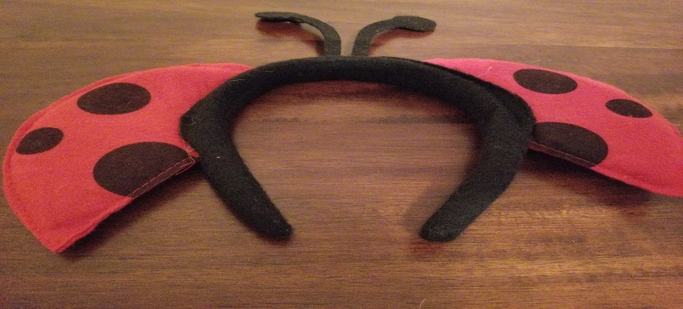

In memoriam of Past Grand Presidents who have left us a lifetime
of memories through their dedication to our great organization.

1961-1962 Vi Frost 2000-2001 Sarah Smith
1962-1963 Vi Frost 2003-2004 Jan Barclay
1963-1964 Elinor Dunn 2006-2007 Marilyn Ann Eggert
1964-1965 Helen Jerry Wall 2011-2012 Fran Gault
1965-1966 Helen Jerry Wall
1966-1967 Mary O’Neal
1967-1968 Clara Wells
1968-1969 Gwen Wright
1969-1970 Betty Piper
1970-1971 Mildred Pulver
1971-1972 Jessie Ganoe
1972-1973 Annie O’Grady
1973-1974 Betty Decker
1974-1975 Monolene Cowen
1975-1976 Virginia K. Abernathy
1976-1977 Dorothy L Latwatis
1977-1978 Beulah S. Brown
1978-1979 Joan Hoag
1979-1980 L. Frankie Capp O’Hearn
1980-1981 Ida Disken
1981-1982 Margaret Machin
1982-1983 Chris Murphy
1983-1984 Mary Ann Ash
1984-1985 Ruby Jackson Stapleton
1985-1986 Sally Westerman
1987-1988 Evelyn Furhman
1988-1989 Shirley Greene
1989-1990 Mary Grubbs
1991-1992 Virginia Frankenburg
1992-1993 Alberta Liddle Craig
1993-1994 Anita Scott
1996-1997 Helen Camarato
1998-1999 Bertha Karos *Supreme Senior Vice*
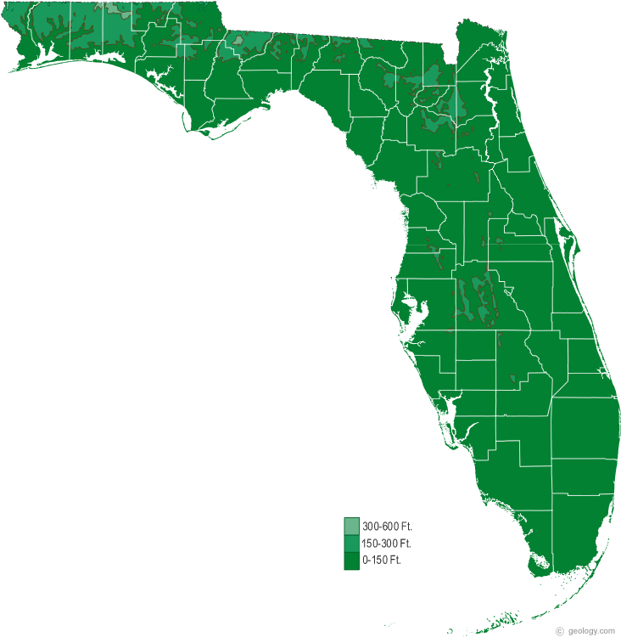 PAST GRAND PRESIDENTS

To you, we look for guidance. Thank you for all you have done for our Organization, past and present. Your support of our Organization helps us to continue to grow and prosper.

1984-1985 Millie O’Neill (NY-Transplant) STATUE OF LIBERTY
6070 Arlene Way
Bradenton FL 32407
941-753-9670

1986-1987 Dorothy Sandhoff DOLLS
2303 50th Street
Bradenton FL 34209

1994-1995 Inez Brown HUMMING BIRD
P.O. Box 388
Mathis, TX 78468
361-547-2537

1995-1996 Betty Lou Garrabrant BUDHA
617 Lomand Drive
Port Charlotte FL 33953

1997-1998 Sharon Puentes HORSE
10230 Oak Drive
Hudson FL 34669

1999-2000 Sandra McKinley ELEPHANT
13440 126TH Avenue
Largo FL 33774
727-596-2789

2001-2002 Sandy Cass CHIHUAHUA
12910 Missouri Woods Drive
Orlando FL 32893
407-851-8493

2002-2003 Mary Frederick DEER
206 Branscomb Road
Green Cove Springs FL 32043
904-282-4721

2004-2005 Jerry-Ann Henry CLOWN WITH SHELLS
405 Lillian Drive
Fern Park FL 32730
407-830-9340

2005-2006 Peggy Bell DOLL
P.O. Box 120533
Ft. Lauderdale FL 33312
954-609-9489

2007-2008 Jane Kibler TEAPOT
379 Hidden Pines Circle
Casselberry FL 32707
727-482-8553

2008-2009 Carolyn Ramsdell STAR
11 Power Lane
E. Hampton MA 01027

2010-2011 Jean Clark TURTLE
5350 Beatle Court
Jacksonville FL 32244
904-551-4096

2012-2013 Audrey F. Goodman SHOE
3324 Bonfire Drive
Milton FL 32583
850-994-9130

2013-2014 Lorrie Smith BLUE BUTTERFLY
P.O. Box 545
Sorrento FL 32776
352-551-0035

2014-2015 Patricia “Pat” Sistrand ARTIST PALETTE
20451 Powell Road
Dunnellon Square Lot 58
Dunnellon FL 34431
352-465-1308

2015-2016 Susan Haines CAT
11270 NW 86 Court
Chiefland FL 32626
352-949-3992

2016-2017 Debora “Debbie” Thie FAIRY
13622 Serena Drive
Largo FL 33774
727-463-4783

2017-2018 Kathy Browne STETHOSCOPE
745 NE 200th Avenue
Old Town FL 32680
352-356-3161

MOCA OFFICERS AND APPOINTMENTS

President Kathy Godard
122 Queens Court Cell: 407-271-9467
Sanford FL 32771 E-mail: godard62@gmail.com

Sr. Vice President Judy Surface Home: 727-584-2901
12460-91st Way, North Cell: 727-515-6751
Largo FL 33773 E-mail: ssurface@tampabay.rr.com

Jr. Vice President Joyce Rose Home: 352-873-0144
84365 W 84th Loop Cell: 850-240-4079
Ocala FL 32784 E-mail: joyrose29vfw@gmail.com

Secretary Jerry-Ann Henry Home: 407-830-9340
405 Lillian Drive Cell: 407-310-6260
Fern Park FL 32730 E-mail: flcharm@aol.com

Treasurer Sandra McKinley Home: 727-596-2789
13440 126th Avenue Cell: 727-403-1612
Largo FL 33774 E-mail: sanmckin@aol.com

Chaplain Jennie Parks Home: 352-489-2955
2298 W. Tee Circle Cell: 352-812-0679
Citrus Springs FL 34434 E-mail: jparks26@tampabay.rr.com

Conductress Denise Sutterfield Home: 850-944-8607
5858 Dahoon Drive Cell: 850-449-0515
Pensacola FL 32526 E-mail: sutterfieldd@bellsouth.net

Guard Tela Harbold
12130 Lake Allen Drive Cell: 727-366-8143
Largo FL 33773 E-mail: winkingstar@aol.com

Trustee Peggy Bell Cell: 354-609-9489
PO Box 120533 E-mail: peggythomasbell626@att.net
Ft. Lauderdale FL 33312-0009

Trustee Mary Frederick Home: 904-282-4721
206 Branscomb Road E-mail: fred43@bellsouth.net
Green Cove Springs FL 32043

Trustee Debora “Debbie” Thie
13622 Serena Drive Cell: 727-463-4783
Largo FL 33772 E-mail: dlthie33774@aol.com

PAST GRAND PRESIDENTS (ON COUNCIL)

Five Year Kathy Browne Home: 352-542-8981
745 NE 200th Avenue Cell: 352-356-3161
Old Town FL 32680 E-mail: bellyacres239@gmail.com

Four Year Debora “Debbie” Thie
13622 Serena Drive Cell: 727-463-4783
Largo FL 33772 E-mail: dlthie33774@aol.com

Three Year Susan Haines
11270 N.W. 86 Court Cell: 352-949-3992
Chiefland FL 32626 E-mail: susanslechat@gmail.com

Two Year Patricia “Pat” Sistrand Home: 352-465-1308
20451 Powell Road Cell: 352-422-1182
Dunnellon Square Lot 58 E-mail sistrand1@aol.com
Dunnellon FL 34431

One Year Lorrie Smith Home: 352-383-5771
PO Box 545 Cell: 352-551-0035
Sorrento FL 32776 E-mail nitelor@aol.com

APPOINTED OFFICERS AND CHAIRMEN

Parlimentarian Jerry-Ann Henry Home: 407-830-9340
405 Lillian Drive Cell: 407-310-6260
Fern Park FL 32730 E-mail: flcharm@aol.com

Chief of Staff Susan Haines Home: 352-493-0298
11270 N.W. 86 Court Cell: 352-949-3992
Chiefland FL 32626 E-mail: susanslechat@gmail.com

Inspector Jean Clark Home: 904-551-4096
5350 Beatle Court Cell: 904-576-3512
Jacksonville FL 32244 E-mail: jalberta@bellsouth.net

Hospital Mary Frederick Home: 904-282-4721
206 Branscomb Road Cell: 904-923-7150
Green Cove Springs FL 32043 E-mail: fred43@bellsouth.net

Fun Chairman Jane Kibler
379 Hidden Pines Circle Cell: 727-482-8553
Casselberry FL 32707 E-mail: janekibler60@gmail.com

National Home Debora “Debbie” Thie
13622 Serena Drive Cell: 727-463-4783
Largo FL 33772 E-mail: dlthie33774@aol.com

Scholarship Patricia “Pat” Sistrand Home: 352-465-1308
20451 Powell Road Cell: 352-422-1182
Dunnellon Square Lot 58 E-mail sistrand1@aol.com
Dunnellon FL 34431

Supreme President Lorrie Smith Home: 352-383-5771
Special Project PO Box 545 Cell: 352-551-0035
Sorrento FL 32776 E-mail nitelor@aol.com

Grand President Jani Ramsey
Special Project 1711 Shadow View Circle Cell: 407-474-1724
Maitland FL 32751 E-mail: janirmom@aol.com

Mama Clown Jean Clark Home: 904-551-4096
5350 Beatle Court Cell: 904-576-3512
Jacksonville FL 32244 E-mail: jalberta@bellsouth.net

Clown Table Peggy Bell Cell: 954-609-9489
PO Box 120533 E-mail: PeggyThomasBell626@att.net
Ft. Lauderdale FL 33312-0009

Soloist Peggy Bell Cell: 954-609-9489
PO Box 120533 E-mail: PeggyThomasBell626@att.net
Ft. Lauderdale FL 33312-0009

Historian Patricia McQuaig Home: 904-268-3086
9751 Viceroy Dr E Cell: 904-868-1722
Jacksonville FL 32257 E-mail: mcquaigwt@gmail.com

Supreme Officers Theresa Cerniglia Home: 772-229-0585
Table 9650 S. Ocean Dr. Apt. 709 Cell: 772-485-1149
Jensen Beach FL 34957 E-mail: mattpt19@aol.com

Ways & Means Judy Surface Home: 727-584-2901
(Chair) 12460-91st Way, North Cell: 727-515-6751
Largo FL 33773 E-mail: ssurface@tampabay.rr.com

Ways & Means Dorothy Sullivan
(Table) 6580 Seminole Blvd. #312 Cell: 727-688-0403
Seminole FL 33772 E-mail: VFWDOT@aol.com

Tomb Trek Susan Haines
11270 N.W. 86 Court Cell: 352-949-3992
Chiefland FL 32626 E-mail: susanslechat@gmail.com

Budget Committee Mary Frederick Home: 904-282-4721
206 Branscomb Road E-mail: fred43@bellsouth.net
Green Cove Springs FL 32043

Members Judy Surface, Joyce Rose

Resolutions Kathy Browne Home: 352-542-8981
745 NE 200th Avenue Cell: 352-356-3161
Old Town FL 32680 E-mail: bellyacres239@gmail.com

Kootie Kitchen Jerry-Ann Henry Home: 407-830-9340
405 Lillian Drive Cell: 407-310-6260
Fern Park FL 32730 E-mail: flcharm@aol.com

Grievance Judy Surface Home: 727-584-2901
12460-91st Way, North Cell: 727-515-6751
Largo FL 33773 E-mail: ssurface@tampabay.rr.com

Members Joyce Rose, Jenny Parks

Credentials Sandra McKinley Home: 727-596-2789
13440 126th Avenue Cell: 727-403-1612
Largo FL 33774 E-mail: sanmckin@aol.com

Asst Conductress Louise Koser Home: 321-600-4007
2700 N. Hwy A1A, #4-101 Cell: 321-243-7117
Indialantic FL 32903 E-mail: lkoser51@yahoo.com

Asst Guard Mary Martin Home: 352-489-2009
261 W Homeway Loop Cell: 352-249-6574
Citrus Springs FL 34434 E-mail: luluhondahopper@aol.com

Liaison to VFWA Linda Burnette
9700 Gene St. Cell: 727-378-8189
Hudson FL 34669 E-mail: lburnette13@gmail.com

Flag Bearer Betty Dawson Home: 352-669-6520
PO Box 545
Sorrento FL 32776

Banner Bearer Nancy Cone
1751 SW 30th Place Cell: 954-806-5660
Fort Lauderdale FL 33315 E-mail: nac9360@att.net

Hospitality Room Jerry-Ann Henry Home: 407-830-9340
Chairman 405 Lillian Drive Cell: 407-310-6260
Fern Park FL 32730 E-mail: flcharm@aol.com

Shirt & Pin Louise Koser Home: 321-600-4007
Chairman 2700 N. Hwy A1A, #4-101 Cell: 321-243-7117
Indialantic FL 32903 E-mail: lkoser51@yahoo.com

V.A.V.S. REPRESENTATIVES

James A Haley Vacant
(Tampa)

Gainesville Patricia “Pat” Sistrand Home: 352-465-1308
20451 Powell Road Cell: 352-422-1182
Dunnellon Square Lot 58 E-mail sistrand1@aol.com
Dunnellon FL 34431

Lake City Mary Frederick Home: 904-282-4721
206 Branscomb Road E-mail: fred43@bellsouth.net
Green Cove Springs FL 32043

C W Bill Young Sandra McKinley Home: 727-596-2789
(Bay Pines) 13440 126th Avenue Cell: 727-403-1612
Largo FL 33774 E-mail: sanmckin@aol.com

Miami Peggy Bell Cell: 354-609-9489
PO Box 120533 E-mail: peggythomasbell626@att.net
Ft. Lauderdale FL 33312-0009

West Palm Beach Carol “Kitty” Noll Home: 561-586-0365
1102 Florence Road
Lantana FL 33462

Orlando Hospital Jerry-Ann Henry Home: 407-830-9340
405 Lillian Drive Cell: 407-310-6260
Fern Park FL 32730 E-mail: flcharm@aol.com

Broward Pauline Duffy Home: 954-232-4707
9140 C SW 23rd Street E-mail: paulinemduffy@comcast.net
Davie FL 33324

Biloxi Denise Sutterfield Home: 850-944-8607
5878 Dahoon Drive Cell: 850-449-0515
Pensacola FL 32526 E-mail: sutterfieldd@bellsouth.net

AUXILIARY OFFICERS

#2 Missile Bugs Traveling Gavel, 3rd Saturday, 3 PM
Location: Titusville Post
PRES. Karen Northcutt, 950 Glenda Drive, Titusville, FL 32780; 321-863-8460;
karendenali62@gmail.com
SEC. Clare Ross, 2094 Bradway Street NE, Palm Bay, FL 32905; 215-906-3225
TREAS Patricia Gosselin, 2301 Bronco Drive, St. Cloud, FL 34771; 407-504-8572;
msgoose2000@gmail.com
CHAP. Ciel (Chickie) Henderson, 300 Bottlebrush Court, Cocoa, FL 32926;
321-433-3085; chh135@aol.com
HOSP. Clare Ross (see Secretary)

#8 Bo-Weevil Traveling Gavel, 3rd Sunday, 2:01 PM
Location: VFW Post #5405 Winter Springs
420 N. Edgemon Avenue, Winter Springs, FL 32708-2539
PRES. Sandra Clatchey, 3837 Spring Lake Village Court, Kissimmee, FL;
407-931-6505; potato55@hotmail.com
SEC. Jerry-Ann Henry, 405 Lillian Drive, Fern Park, FL 32730; 407-830-9340,
407-310-6260; flcharm@aol.com
TREAS. Jerry-Ann Henry (see Secretary)
CHAP. Carol McLaughlin, 726 Logan Drive, Longwood, FL 32750; 407-492-9780; carolmclaughlin46@outlook.com
HOSP. Kathy Godard, 122 Queens Court, Sanford, FL 32771; 407-271-9467; godard62@gmail.com

#19 Frei Jensen Beach, FL, 2nd Saturday, 12:01 PM
Location: VFW Post 10066 Maurice K. Langberg, 1805 NE Savannah Road,
Jensen Beach, FL 34957
PRES. Theresa Cerniglia, 9650 S. Ocean Drive #709, Jensen Beach, FL 34957;
772-229-0585; mattpt19@aol.com
SEC. Beverly J. Brier, 331 NE Turquoise Tr., Jensen Beach, FL 34957; 772-208-5958
TREAS. Dorothea Wiley, 6275 SE Charleston Pl B-102, Hobe Sound, FL 33455;
772-546-2719; wiley6275@comcast.net
CHAP. Shirley Opperman, 6956 SE Amendment St., Hobe Sound, FL 33455;
772-546-0932; SJOTO95@comcast.net
HOSP. Carol Riley, 1401 NE Chardon St., Jensen Beach, FL 34957; 772-334-5869

#23 Catfish Jacksonville, FL, 3rd Tuesday, 7:01 PM Location: VFW Post 7909 Wesconnett – 6204 Blanding Blvd., Jacksonville, FL 32244
PRES. Rolanda Maas, 1135 Pangola Dr, Jacksonville, FL 32205; 904-783-2643,
904-252-7038; rolanda@arroyoprocess.com
SEC. Jean Clark, 5350 Beatle Court, Jacksonville, FL 32244; 904-551-4096,
904-576-3512; jalberta@bellsouth.net
TREAS. Linda Seiler,, 6602 Dove Creek Drive, Jacksonville, FL 32244; 904-779-2550;
hlseiler@comcast.net
CHAP. Kathy Wright, 5867 111th Street, Jacksonville, FL 32244; 904-771-6445,
757-685-1837; kathy_wright@bellsouth.net
HOSP. Jean Clark (see Secretary)

#25 Cootieville Chiefland, FL, 4th Thursday, 6:30 PM
Location: VFW Post 5625 Rebel – 6850 NW 137th St. Chiefland, FL 32626
PRES. Susan Haines, 11270 NW 86 Court, Chiefland, FL 32626; 352-493-0298,
352-949-3992; susanslechat@gmail.com
SEC. Kathy Browne, 745 NE 200th Avenue, Old Town, FL 32680; 352-542-8981,
352-356-3161; bellyacres239@gmail.com
TREAS. Charlene “Char” Zelnak, 2690 NW CR 345, Chiefland, FL 32626; 352-493-1894
CHAP. Carol Bennett, PO Box 338, Chiefland, FL 32644-0338; 352-493-4550
HOSP. Deanna “Dee” Bazar, PO Box 937, Old Town, FL 32680; 352-542-8697;
cootieclown25@yahoo.com

#32 Sons of Beaches Indian Rocks Beach, 1st Wednesday, 6 PM
Location: VFW Post 10094 Indian Rocks, 14450 Washington Road, Largo, FL 33774
PRES. Judy Surface, 12460 91st Way N, Largo, FL 33773; 727-584-2901, 727-515-6751;
ssurface@tampabay.rr.com
SEC. Elma Perry, 708 Canterbury Lane, Largo, FL 33770; 727-422-4447
TREAS. Sandra McKinley, 13440 126th Avenue, Largo, FL 33774; 727-596-2789,
727-403-1612; sanmckin@aol.com
CHAP. Theresa (Terri) Holderness, 546 Plaza Seville #85, Treasure Island, FL 33706,
727-360-0044; EDHTAH@msn.com
HOSP. Sandra McKinley (see Treasurer)

#36 Scratching Eustis, FL, 1st Sunday, 12:01 PM Location: VFW Post 8087 Golden Triangle, 4065 N. Hwy. 19A, Mount Dora, FL 32757 PRES. Lorrie Smith, PO Box 545, Sorrento, FL 32776; 352-551-0035;NiteLOR@aol.com SEC. Betty Dawson, 16985 SE 249th Avenue, Umatilla, FL 32784; 352-669-6520
TREAS. Wendy Harmon, 32312 Avington Road, Sorrento, FL 32776; 757-335-1015
CHAP. Tammy Shannon, 1090 Bay Rd., Mt. Dora, FL 32757; 352-434-1235
HOSP. Betty Dawson (see Secretary)

#59 Scratch Ankle Milton, FL, 1st Saturday, 10:01 AM
Location: VFW Post 4833 John O. Connor – 5918 Carroll Road, Milton, FL 32583-2821
PRES. Carrie Messer, 5330 Barcelona Street, Pace, FL 32571; 850-206-0751;
messerca@gmail
SEC. Regina Atchison, 5975 Last Chance Road, Milton, FL 32570; 850-449-4120;
reginaatchison@yahoo.com
TREAS. Zarah Lewis, 5756 Brownfield Rd, Pensacoa, FL 32526
CHAP. Virginia Fincher, 5176 Delmontes St, Milton, FL 32583; 850-698-3901;
virginiabobby2011@gmail.com
HOSP. Carrie Messer (see President)

#66 Sea Oats Pensacola, FL, 2nd Saturday, 3:02 PM
Location: VFW Post 706 Thomas F. Welch, 5000 W. Lillian Hwy, Pensacola, FL 32506
PRES. Phyllis Carnley Smith, 28 Janet Street, Pensacola, FL 32506; 850-455-6791;
Phyllis.c@cox.net
SEC. Linda Jordan, 3039 Creole Way, Pensacola, FL 32526; 850-455-7162,
850-490-0850; jord2030@cox.net
TREAS. Linda Jordan (see Secretary)
CHAP. Bonnie Vanlandingham, 4147 Painter Ranch Rd., Crestview, FL 32539
850-398-6652; dancingmoonbeam9@yahoo.com
HOSP. Linda Jordan (see Secretary)

#69 Fudduckers Sunrise, FL, 2nd Sunday, 10:31 AM
Location: VFW Post 1966 Robert L. Agee, 350 S.W. 25th Street, Ft. Lauderdale, FL 33314
PRES. Patricia Duffy, 2200 SW 92nd Terrace, Unit 2802, Davie, FL 33324
954-236-2388, pfduf@aol.com
SEC. April Barfus, 860 NW 98th Place, Plantation, FL 33324; 954-249-3333;
fdaf@att.net
TREAS. Mary Dembecki, 5830 NW 64th Avenue, #202, Tamarac, FL 33319, 954-720-4534
CHAP. Peggy Bell, PO Box 120533, Ft. Lauderdale, FL 33312, 954-609-9489;
peggythomasbell626@att.net
HOSP. Peggy Bell (see Chaplain)

#75 Mealy Bugs Daytona Beach, FL, 1st Monday, 2:01 PM
Location: VFW Post 3282 John E. Mealy Memorial, 5810 S. Williamson Blvd.,
Port Orange, FL 32128-7537
PRES. Helen L. Brown, 153 Oakwood Drive, Daytona, FL 32117, 386-252-3846,
386-560-1285
SEC. Leree Nicholls, 621 Touchstone Circle, Port Orange, FL 32127, 386-788-2891
TREAS. Marie Martine, 307 Joan Street, Edgewater, FL 32132, 386-428-6353
CHAP. Mary Ann Smith, 2277 Laflor Lane, Port Orange, FL 32129, 386-872-3205,
570-793-7169
HOSP. Nora Polk, 1279 Flintlock Drive, Daytona Beach, FL 32119, 386-761-7218

#76 Withlacoochee Hernando, FL, 1st Sunday, 1:00 PM
Location: VFW Post 4252 Leroy Rooks, Jr., 3190 N. Carl G. Rose Hwy. (Hwy. 200),
Hernando, FL 34442-4312
PRES. Beverly Reiss, 5232 S. Riverview Circle, Homosassa, FL 34448
352-503-7700, rbreiss11@yahoo.com
SEC. Joyce Rose, 8463 SW 84th Loop, Ocala, FL 34481, 352-873-0144, 850-240-4079,
joyrosevfwa29@gmail.com
TREAS. Mary Martin, 261 W. Homeway Loop, Citrus Springs, FL 34434-8109
352-489-2009; luluhondahopper@aol.com
CHAP. Doris E. Crist, 4725 E. Shorewood Drive, Hernando, FL 34442, 352-344-8994,
352-422-8567
HOSP. Patricia A. Sistrand, 20471 Powell Road, Lot 58, Dunnellon, FL 34461
352-462-7063, 352-422-1182; sistrand1@aol.com

#86 Middlebugs Middleburg, FL, 4th Wednesday, 7:31 PM
Location: VFW Post 8255 Middleburg, 2296 Aster Avenue, Middleburg, FL 32068-6871
PRES. Carol D. Meadows, 727 Hazelwood, Green Cove Springs, FL 32043
904-282-2023; cdanddy@bellsouth.net
SEC. Mary Frederick, 206 Branscomb Road, Green Cove Springs, FL 32043
904-282-4721; 904-923-7150; fred43@bellsouth.net
TREAS. Mary Frederick (see Secretary)
CHAP. Lillian Harbaugh, 2876 Sprin Drive, Middleburg, FL 32068, 904-413-3916;
lillybettyboop@yahoo.com
HOSP. Mary Frederick (see Secretary)

#98 Midway Mites Gulf Breeze, FL, 2nd Monday, 6:01 PM
Location: VFW Post 4407 Gulf Breeze, 1783 Abercrombie Rd., Gulf Breeze, FL 32563
PRES. Denise Sutterfield, 5878 Dahoon Dr., Pensacola, FL 32526, 850-944-8607,
850-449-0515; sutterfieldd@bellsouth.net
SEC. Angela Owens; 4370 Clair Court; Gulf Breeze, FL 32563, 850-450-7172
TREAS. Deborah Smith, 5327 Stagecoach Trail, Gulf Breeze, FL 32563, 217-502-0843,
smithdeb001@yahoo.com
CHAP. Mark James, 1254 College Parkway #F, Gulf Breeze, FL 32563, 850-572-5720;
majames65@yahoo.com
HOSP. Denise Sutterfield (see President)

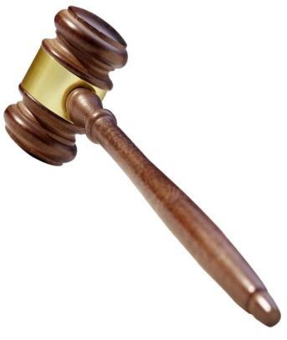

GRAND OF FLORIDA
REPORTING FORMS

The following are some of the reports for Supreme and Grand. Your audit needs to be completed quarterly and sent to our Grand Treasurer. The President or Chaplain will need to file the Chaplain’s report and needs to be sent to the Grand Chaplain by the 10th of each month.

The reports for the donations to Supreme and Grand need to be filed as follows: Original with check to Grand Treasurer. PLEASE, PLEASE, send a copy of each donation made by your Auxiliary to each Grand Chairman. Be sure to do this every time you send a check to the Grand Treasurer. This is where your credit comes from and the awards presented at Grand Convention are from these reports that are sent to the Chairman. Grand Hospital Chairman, Mary Frederick will have the forms you need to file your hospital reports. Be sure to review the additional forms in the Supreme book or the hospital book prepared by the Grand Hospital Chairman.

ALSO be sure you write a check to the Grand of Florida for Grand projects and to Supreme MOCA for Supreme projects.

Supreme has made available forms on their website which you can use. Go to www.lotcs.org and click on MOCA and select forms. The original report and a copy should go to the Grand Treasurer when you are sending a report with a check.

Auxiliary Presidents, when you are preparing your yearend reports, please go to your Supreme handbook and complete every report form that applies to your Auxiliary. Your Auxiliaries do a lot of work for our veterans and we do not want these to go unreported. You deserve to receive recognition for all of the hard work that you do for our veterans.

All of the Line Officers, Past Grand and Auxiliary Presidents will give you any assistance you need and will be happy to get answers for your questions. DON’T hesitate to ask, we are all here for you. Let’s keep Florida #1!

Please don’t hesitate to contact me with any questions or concerns, and I will be happy to assist you in any way possible.
Kathy Godard
Grand President, 2018-2019
AUXILIARY TO THE MILITARY ORDER OF THE COOTIE 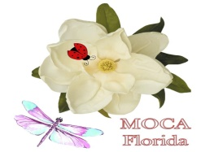
SUPREME PROGRAM DONATIONS

Please use this form when making donations to Supreme Programs. You may send donations for more than one program using only one check. Be sure to earmark the form for the amount you want credited and to what program. Make your check payable to the Supreme Treasurer M.O.C.A., mail it with this completed form to the Grand Treasurer. It will be recorded and forwarded to Supreme. Send a copy to the Grand Chairman for each project your check covers. (Please make a note for any other special project that may be happening.) Make copies of blank forms for your use during the year.

AUXILIARY NAME: NUMBER: #
CHECK #: DATE: AMOUNT: $

SUPREME HOSPITAL FUND $

SUPREME SCHOLARSHIP FUND $

SUPREME PRESIDENTS SPECIAL PROJECT (SPSP) $

NATIONAL HOME $

NATIONAL HOME SPECIAL PROJECT $

NATIONAL HOME $

RECEIVED BY SUPREME TREASURER:

AUXILIARY TO THE MILITARY ORDER OF THE COOTIE
GRAND OF FLORIDA PROGRAM DONATIONS

Please use this form when making donations to the Grand of Florida for our programs. You may send donations for more than one program using only one check. Be sure to earmark the form for the amount you want credited and to what program. Make your check payable to the Grand of Florida M.O.C.A., mail it with this completed form and send a copy to the Grand Chairman for each project your check covers. (Please note line for any other special project that may be happening.) Make copies of blank forms for your use during the year.

AUXILIARY NAME: _ NUMBER: #

CHECK #: DATE: AMOUNT: $

CONTRIBUTIONS TO:

GRAND PRESIDENTS SPECIAL PROJECT (GPSP) $
(VA Hospitals, Clinics & Nursing homes.)

GRAND WAYS & MEANS $

CLOWN PROGRAM $

GRAND HOSPITAL PROGRAM $

SUPREME OFFICERS FUND $

TOMB TREK ($25.00) $

5th SUPREME DISTRICT DUES X 25¢ $
(25¢ per MEMBER BASED on JUNE 30 MEMBERSHIP of the PREVIOUS YEAR.)

ANY OTHER PROJECT: $
(Love Gift for Grand President; Ways & Means)

RECEIVED BY GRAND TREASURER:

AUXILIARY TO THE MILITARY ORDER OF THE COOTIE 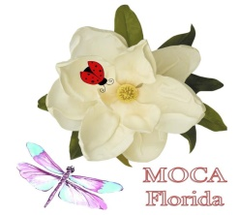
GRAND OF FLORIDA HOSPITAL DONATIONS

Please use this form when you are making donations from your Auxiliary to the VAMC Hospitals. You may send donations for more than one hospital using only one check. Just be sure to earmark the form for the amount you want credited and to which hospital. Make your check payable to the Grand Treasurer M.O.C.A.; V.A.V.S. funds, and fill out the form below. Make copies of this form for donations you will make during the year. (i.e. HALLOWEEN; THANKSGIVING; CHRISTMAS; SUPREME VISIT; VALENTINES DAY; EASTER; JULY 4th )

AUXILIARY NAME: NUMBER: #

CHECK #: DATE: AMOUNT: $

DONATIONS TO: BAY PINES $

GAINSVILLE $

JAMES A. HALEY (TAMPA) $

LAKE CITY $

MIAMI $

ORLANDO $

WEST PALM BEACH $

BROWARD $

RECEIVED BY GRAND TREASURER:
QUARTERLY AUXILIARY AUDIT FORM

Period of: 20 Through: 20
Auxiliary Name & Number:
FUND | OLD BALANCE | +  RECEIVED | -  DISPERSED | NEW BALANCE
General
Hospital
National Home
Scholarship
GPSP
SPSP
TOTALS

OUTSTANDING CHECKS Treasurer’s Book Balance: $
# $ Bank Statement: $
# $ Plus Deposits: $
# $ Plus Cash: $
# $ Minus Checks: $
#_ $ Total Balanced Statement: $
Total: $ Items 1; 2 & 3 should all agree in total amounts.
We find the books of the Secretary & Treasurer in proper order as audited on this date:

Trustee #1 Date:

Trustee #2 Date:

Trustee #3 Date:

Return to: Sandra McKinley, 13440 126th Avenue, Largo FL 33774

GRAND OF FLORIDA
MONTHLY CHAPLAIN REPORT
Check One: MONTHLY _____ YEAR-END _____
(Due 5th of Month) (Due immediately following Grand Convention)

Mail To: Jennie Parks, Grand Chaplain OR E-mail: jparks26@tampabay.rr.com
2298 W. Tee Circle
Citrus Springs, FL 34434

Date: Auxiliary Name & Number: ______________________________
Membership on June 30, 2018:

AS GRAND CHAPLAIN:
Cards sent by YOU: $ Amount Spent on:
Get Well:_____ Phone Calls:$______
Sympathy:_____ Memorials: $_______
Thinking of You:______ Flowers, Gifts, Food______
(include e-mail messages in the card count) Postage: $_______

Number of Phone Calls made to the sick: _____
Number of Visits made to the sick:_____
Number of Funerals attended:_____

AUXILIARY REPORTS:
Cards sent by Members: Get Well:_____ $ Amount Spent on:
Sympathy:_____ Phone Calls: $______
Thinking of You:_____ Memorials: $______
(include e-mail messages in the card count) Flowers, Gifts, Food: $______
Postage: $______
Number of Phone Calls made to the sick:
Number of Visits made to the sick:
Number of Funerals attended:

Please PRINT the name and address of ill members in your auxiliary. (Please state illness)

Please PRINT names of deceased members. Include Date of Death and name and address to send
cards.

Use reverse side to list names and addresses and to give a short summary of your activities as Chaplain.

Chaplains Name:__________________________ Email: _________________________
Address:_________________________________ Phone:_______________________
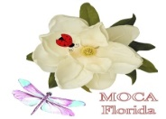
GRAND HOSPITAL YEAR END REPORT
GRAND OF FLORIDA MOCA

DATE DUE: April 15, 2019
MAIL TO: MARY FREDERICK, 206 BRANSCOMB DRIVE, GREEN COVE SPRINGS 32043
OR EMAIL TO: fred43@bellsouth.net

This is a Florida program to award the local auxiliary and chairman. Supreme awards are based on the reports that the chairman send monthly to report member hours, visits, project hours and credits.

AUXILIARY NAME & # ____________________________________________________________

CHAIRMAN:______________________________________________________________________

MEMBERSHIP AS OF JUNE 30, 2018 ________________________________________________

- Number of reports made by chairman to the Grand by Hospital Chairman this year: _____

- Did you make monthly reports? YES___ NO___ IF NOT, WHY?___
___________________________________________________________________________________

- Hospital hours worked by you as the Chairman this year:_____________________________________

- Did you make plans at each meeting for the hospital visits and parties? YES_______NO________

- Did your Auxiliary participate in the Grand President’s Special Project? YES_______NO________

- Did you donate money to the Grand President’s Special Project? If so, how much $___________

- Did you and your Auxiliary donate items to the GPSP table at Grand? YES_______NO_________

- Did your Auxiliary donate to the Supreme Presidents Special Project? YES_______NO_________

Please attach a resume of the hospital work and hour completed by you and your Auxiliary this term. Explain your most outstanding program/visit. (Use the back of this report and an extra sheet if necessary.)
GRAND M.O.C. AUXILIARY of FLORIDA 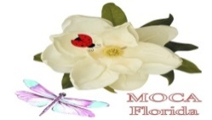
GRAND PRESIDENT’S SPECIAL PROJECT YEAR END REPORT
Due to Chairman: April 15, 2019
Send to:
AUXILIARY NAME___________________________________#___________
Grand Presidents Special Project is the VA Hospitals/Clinics with an emphasis on Diabetes. There is 7 VA Hospitals, and many clinics in Florida and, but if one is not close to you, you may report visits to local nursing homes and hospitals where there are Veterans & you can still receive credit for this program.
1. Number of visits (reported by Hospital chairman) to VA Hospitals & CLC’s?______
2. Number of hours both visits & project for the same period ____________________ (VAVS hours do not count)
3. Give a brief resume of gifts, cash or articles donated to the VA Medical Centers or CLC’s. Include your parties & special projects. (You may use a separate sheet, if necessary)
______________________________________________________________________________________________________________________________________________________________________

4. Donations of gifts, cash & articles to VA Medical centers patients this year. $___________________________________gifts $___________________________________cash (canteen books) $___________________________________articles
5. Donations of gifts, cash & articles to local hospitals & nursing homes this year. $___________________________________gifts $___________________________________cash $___________________________________articles
6. Value of items donated to the GPSP table at our meetings $_________________
7. Amount contributed by check or cash to Grand for GPSP this year. $__________
Auxiliary Chairman ___________________________________________________
E-mail address________________________________________________________

GRAND FUNDRAISER
ANGEL PINS

The Grand of Florida, MOCA will be continuing the fundraising efforts this year with the Angel Name Pins.

Place your order through the Grand Treasurer, Sandra McKinley, 13440 126th Avenue, Largo FL 33774, or Jean Clark, 7839 118th Street, Jacksonville, FL 32244.
Pins are custom made. Names with 6 letters or less will have a red heart. Limit names to 12 letters and spaces. Cost is $10.00. Include $.50 for shipping each pin.
Use this sheet for ordering (make copies as needed).

Name and address of person placing order:
____________________________________________
____________________________________________ ____________________________________________
NOTES:

