Grand of Florida

LESLIE D. (DOUG) WOOD

*Grand Seam Squirrel 2025 – 2026*

From the fertile Hunting grounds of Pup Tent 98 (MIDWAY MITES)

Listen Up Cooties! **7**/11/2025

I am very humbled and honored for being bestowed as your Grand Seam Squirrel for 2025-2026. To the crummy cooties from the fertile hunting grounds of the Great State of Florida, your trust in allowing me to command the largest and best Grand in the nation is such a privilege. I joined this crummy fraternity several years ago to serve others. I never imagined I would be in this position. Thank you, Trent Rundell and Tom Sutterfield (Past GRAND Commanders) for your guidance.

I’m beyond impressed with the efforts of the past Grand Seam Squirrels that have done their best in keeping our crummy organization focused on the future. We are still the largest Grand in membership and in the number of Pup Tents in the nation thanks to their efforts. They along with our MOCA Presidents and the men and women who run or Pup Tents deserve many accolades.

Lastly, we cannot forget where we come from and that’s the Veterans of Foreign Wars. Without our Posts we are nothing as an organization. Be grateful for our local VFW Posts that give us the membership to draw from and all the resources we gain from being part of our Posts. Some of our Post do not have Pup Tents or a MOCA and that’s concerning, for we cannot increase and multiply when there’s no seams to invade. We as Cooties and the MOCA need to do our diligence and look at these Post and spread the word of the good that we do for our hospitalized veterans.

In closing, let’s raise a cold glass of Cootie Milk to all that wear our funny hats

and have fun that only Cooties know how to!

Yours in L.O.T.C.S.

Leslie D. (Doug) Wood

Grand Seam Squirrel

2025-2056

DATES TO REMEMBER 2025 – 2026

**Grand School of Instruction** 5-6 Sep 2025

Fort Walton Beach, FL

Harvey F Eckhoff

VFW Post 7674

**Tomb Trek** 31 Oct -2 Nov 2025

Arlington, VA

Sheraton Pentagon City Hotel

900 South Orme Street, Arlington Virginia 22204  
1-888-325-3535

**Cootie Christmas** TBD ~ Dec 2025

Eaton Rapids, MI

**Grand Mid-Winter Conference** Jan 9 – 10 Dec 2026

Cross City, FL

Putnam Lodge

15487 Northwest Highway 19, Cross City, FL 32628

(352) 440-0414

**Florida Grand Convention** TBD ~ Jun 2025

TBD

**Supreme Convention** TBD Aug 2026

Reno NV

**GRAND OF FLORIDA SHAVETAILS 2024-2025**

**SEAM SQUIRREL:** Doug Wood(98) 850-499.2204

(COMMANDER) 2740 Dove Haven Ln [doug5483@yahoo.com](mailto:doug5483@yahoo.com)

 Navarre, FL 32566

**BLANKET BUM:** Daniel (Woody) Woodard (1) 808-561-4963

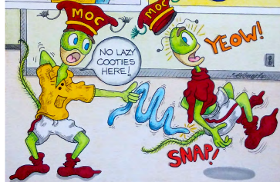(SR. VICE COMMANDER) 8200 Shooter Lane daniel.b.woodard@gmail.com

Laurel Hill, FL 32567

**HIDE GIMLET:**  David Hoffman (2) 321-408-0152

 (JR. VICE COMMANDER) 162 Uleta Rd SE dhoffman18@cfl.rr.com

Palm Bay, FL 32905

**CCDB :** Dan Giffin (98) 614-584-8814

(QUARTERMASTER) 6637 Kempton St. dan.giffin@outlook.com

Navarre, FL 32566

**SKY PILOT:** (CHAPLAIN)

Michael Roy (1) 850-398-2161

1238 Jeffreyscot Drive mdroy2@cox.net

Crestview, FL 32536

**SHYSTER:** (Judge Advocate)

 Steve Surface (32) 727-580-5040

12460 91st Way N. fire1@tampabay.rr.com

Largo, FL 33773

**PILL PUSHER:** (Surgeon)

 Stephen Orf (8) 770-330-9806

433 Lexingdale Dr. castleunion1863@aol.com

Orlando, FL 32828

___________________________________________________________________________________

**HUNGRY COOTIE**: Ron Holladay (98) 850-602-6395

(ADJUTANT) 5303 WOODLAKE TRACE rholladay1960@hotmail.com

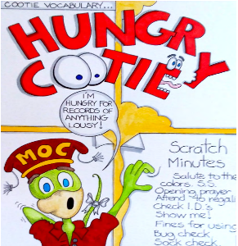 Gulf Breeze, FL 32563

**CHIEF of STAFF:**

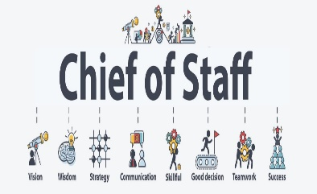 (Da-Boss) Trent Rundell (1) 850-420-1977

5788 Wildwood Rd tbluerundell141@yahoo.com

Crestview, FL 32536

KEEPER OF THE Steve Cassell (76) 808-341-4855

LOUSY RECORDS: 8999 SW 49th Circle cassellsc@outlook.com

(HISTORIAN) Ocala, FL 34476

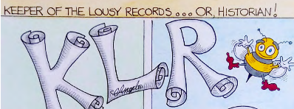

**FUN CHAIRPERSON**: (Clown)

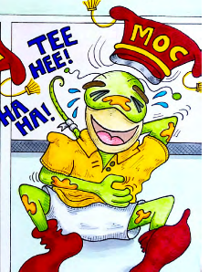 Jerry Bazar (25) 352-356-4911

P O Box 937 [cootieclown25@yahoo.com](mailto:cootieclown25@yahoo.com)

Old Town, FL 32680

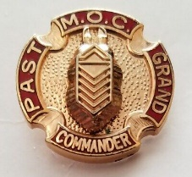**IMMEDIATE PGC:** Trent Rundell (1) 850-420-1977

5788 Wildwood Rd tbluerundell141@yahoo.com

Crestview, FL 32536

**MEMBERSHIP & LIFE MEMBERSHIP CO-CHAIRPERSON:**



Danny J Giffin (98) 614-584-8814

6636 Kempton St. dan.giffin@outlook.com

Navarre, FL 32566

Walter Smith (66) 850-455-6791

28 Janet St. [walt.smit@cox.net](mailto:walt.smit@cox.net)

Pensacola, FL 32505

**PROVOST MARSHALL**

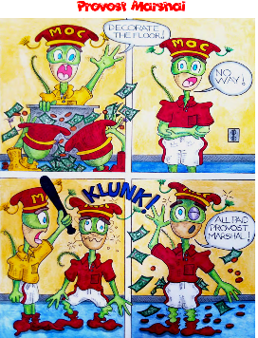 John Barber, Jr. (18) 727-492-8684

11206 67th Ave. N. [jbarber60@gmail.com](mailto:jbarber60@gmail.com)

Seminole FL 33772

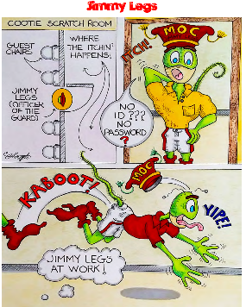**JIMMY LEGS**

David Hoffman (2) 321-408-0152

162 Uleta Rd SE. [dhoffman18@cfl.rr.com](mailto:dhoffman18@cfl.rr.com)

Palm Bay FL 32909

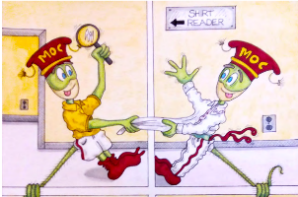**SHIRT READER**

Walter Smith (66) 850-455-6791 28 Janet St. [walt.smith@cox.net](mailto:walt.smith@cox.net)

Pensacola., FL 32506

**PUBLICITY:** Tom Sutterfield (98) 850-449-1309

5878 Dahoon Drive [sutterfieldt@bellsouth.net](mailto:sutterfieldt@bellsouth.net)

Pensacola, FL 32526

**VFW LAISONS:**

Steve Surface (32) 727-580-5040

12460 91st Way N. [fire1@tampabay.rr.com](mailto:fire1@tampabay.rr.com)

Largo, FL 33773

Danette “Dani” Hernandez (23) 904-762-9364

3294 Lake Effie Ct. N. [danihernandez3294@comcast.net](mailto:danihernandez3294@comcast.net)

Jacksonville, FL 32277

**MOCA ADVISOR TO GRAND COMMANDER:**

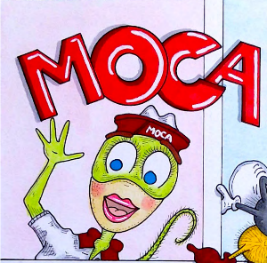Denise Sutterfield (66) 850-449-0515

5878 Dahoon Drive [sutterfieldd@bellsouth.net](mailto:sutterfieldd@bellsouth.net)

Pensacola, FL 32526

**VETERANS HOME LAISON:**



Kenneth Thie (32) 727-580-7485

13622 Serena Dr., [kthie33774@gmail.com](mailto:kthie33774@gmail.com)

Largo, FL 33774

Dani Hernandez (23) 904-762-9364

3294 Lake Effie Ct. N. [danihernandez3294@comcast.net](mailto:danihernandez3294@comcast.net)

Jacksonville, FL 32277

**GRAND INSPECTOR:**

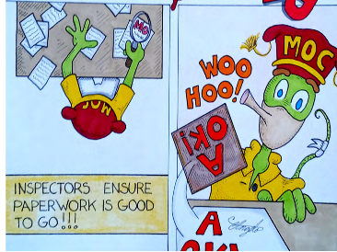Trent Rundell (1) 850-420-1977

5788 Wildwood Rd tbluerundell141@yahoo.com

Crestview, FL 32536

**DEPUTY INSPECTORS:**

Walter Smith (66) 850-455-6791 (PT’s 1. 41, 59, 66, 98)

28 Janet St. [walt.smit@cox.net](mailto:walt.smit@cox.net)

Pensacola, FL 32505

Tom Sutterfield (98) 850-449-130 (PT 23)

5878 Dahoon Dr. sutterfieldt@bellsouth.net Pensacola, FL 32526

Buddy Fowler (76) 352-563-1063 (PT’s 25, 29, 76)

970 N Hollywood Cir. [bfowler970@yahoo.com](mailto:bfowler970@yahoo.com)

Crystal River, FL 34429

Stephen Orf (8) 770-330-9806 (PT’s 2, 8, 11, 44)

433 Lexingdale Dr. castleunion1863@aol.com

Orlando, FL 32858

John Barber, Jr. (18) 727-492-8684 (PT’s 17, 18, 32, 55, 56)

11206 67th Ave. N. [jbarber60@gmail.com](mailto:jbarber60@gmail.com)

Seminole FL 33772

**HOSPITAL CHAIRPERSON:**

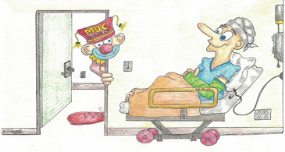

Ken Thie (32) 850-666-3643

462 Creekside Ct. [kthie33774@gmail.com](mailto:kthie33774@gmail.com)

Monticello, FL 32344

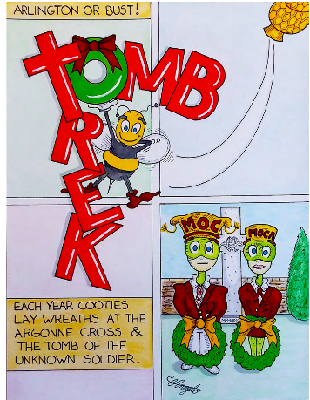**TOMB TREK CHAIRPERSON:**

Tom Sutterfield (98) 850-449-1309

5878 Dahoon Dr. sutterfieldt@bellsouth.net Pensacola, FL 32526

**NATIONAL HOME CO-CHAIRPERSON:**

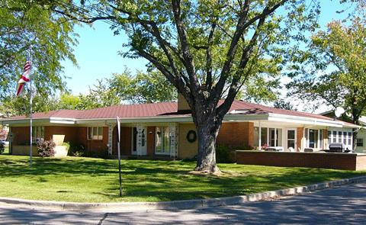

Ken Thie (32) 850-666-3643

462 Creekside Ct . [kthie33774@gmail.com](mailto:kthie33774@gmail.com)

Monticello, FL 32344

Steve Surface (32) 727-580-5040

12460 91st Way N. [fire1@tampabay.rr.com](mailto:fire1@tampabay.rr.com)

Largo, FL 33773

*Florida house pictured*

**BLOOD BANK CHAIRPERSON:**

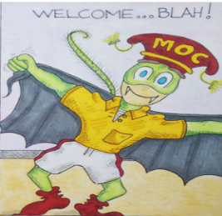 John Barber, Jr. (18) 727-492-8684

11206 67th Ave. N. [jbarber60@gmail.com](mailto:jbarber60@gmail.com)

Seminole FL 33772

**BUDGET AND FINANCE COMMITTEE:**

**CHAIRPERSON:**

 Daniel Woodard (1) 808-561-4965

8200 Shooter Lane [daniel.b.woodard@gmail.com](mailto:daniel.b.woodard@gmail.com)

Laurel Hill, FL 32567

**VICE CHAIRPERSON:**

David Hoffman (2) 321-408-0152

162 Uleta Rd SE dhoffman18@cfl.rr.com

Palm Bay, FL 32905

**MEMBERS:** Dan Giffin (98) 614-584-8814

6637 Kempton St [Dan.Giffin@outlook.com](mailto:Dan.Giffin@outlook.com)

Navarre, FL 32566

John P. Henry (8) 689-231-7515

405 Lillian Dr. [flchrm@aol.com](mailto:flchrm@aol.com)

Fern Park, FL 32730

Stephen Orf (8) 770-330-9806

433 Lexingdale Dr. castleunion1863@aol.com

Orlando, FL 32828

Tom Sutterfield (98) 850-449-1309

5878 Dahoon Drive sutterfieldt@bellsouth.net

Pensacola, FL 32526

**AWARDS CHAIRPERSON:** (Senior Vice Commander)

Daniel (Woody) Woodard (1) 808-561-4965

8200 Shooter Lane daniel.b.woodard@gmail.com

Laurel Hill, FL 32567

**NEW PUP TENT DEVELOPMENT:**

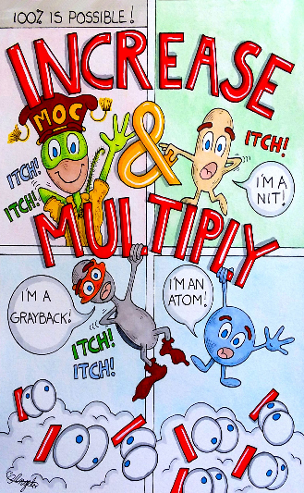**CHAIRPERSON:**

Trent Rundell (1) 850-420-1977

5788 Wildwood Road tbluerundell141@yahoo.com

Crestview, FL 32536

**MEMBERS:**

Steve Surface (32) 727-580-5040

12460 91st Way N. [fire1@tampabay.rr.com](mailto:fire1@tampabay.rr.com)

Largo, FL 33773

Jerry Bazar (25) 352-356-4911 P.O. Box 937, [cootieclown25@yahoo.com](mailto:cootieclown25@yahoo.com)

Old Town FL 32680

David Hoffman. (2) 321-408-0152

162 Uleta Rd SE. [dhoffman18@cfl.rr.com](mailto:dhoffman18@cfl.rr.com)

Palm Bay FL 32909

**BY-LAWS/GRAND POLICY & SPECIAL COMMITTEE:**

**CHAIRPERSON:**

 Tom Sutterfield (98) 850-449-1309

5878 Dahoon Drive sutterfieldt@bellsouth.net

Pensacola, FL 32526

**VICE-CHAIRPERSON:**

John Henry (8) 689-231-7515

405 Lillian Drive. flcharm@aol.com

Fern Park, FL 32730

**MEMBERS:** Buddy Fowler (76) 352-563-1063

970 N Hollywood Cir. [bfowler970@yahoo.com](mailto:bfowler970@yahoo.com)

Crystal River, FL 34429

Dan Giffin (98) 614-584-8814

6637 Kempton St. [Dan.Giffin@outlook.com](mailto:Dan.Giffin@outlook.com)

Navarre, FL 32566

**PAST SEAM SQUIRRELS CLUB:**

**PRESIDENT:**

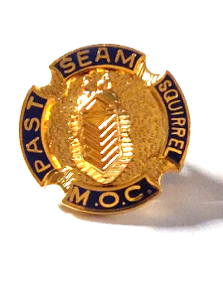 John Barber, Jr. (18) 727-492-8684

11206 67th Ave. N. [jbarber60@gmail.com](mailto:jbarber60@gmail.com)

Seminole FL 33772

**VICE-PRESIDENT:**

John Henry (8) 689-231-7515

405 Lillian Dr. [flchrm@aol.com](mailto:flchrm@aol.com)

Fern Park, FL 32730

**SECRETARY:**

Mike Roy (1) 850-398-2161

1239 Jeffreyscot Drive mdroy2@cox.net

Crestview, FL 32536

**TREASURER:**

Steve Surface (32) 727-580-5040

12460 91st Way N. [fire1@tampabay.rr.com](mailto:fire1@tampabay.rr.com)

Largo, FL 33773

**PAST GRAND COMMANDERS CLUB:**

**PRESIDENT**

 John Henry (8) 689-231-7515

405 Lillian Drive. flcharm@aol.com

Fern Park, FL 32730

**SECRETARY:**

Dani Hernandez (23) 904-762-9364

3294 Lake Effie Ct. N., [danihernandez3294@comcast.net](mailto:danihernandez3294@comcast.net)

Jacksonville, FL 32277

**TREASURER:**

Steve Surface (32) 727-580-5040

12460 91st Way N. [fire1@tampabay.rr.com](mailto:fire1@tampabay.rr.com)

Largo, FL 33773

**PROCESS IMPROVEMENT COMMITTEE:**



**CHAIRPERSON:**

Dan Giffin (98) 614-584-8814

6637 Kempton St [Dan.Giffin@outlook.com](mailto:Dan.Giffin@outlook.com)

Navarre, FL 32566

**MEMBERS:**

Steve Surface (32) 727-580-5040

12460 91st Way N. [fire1@tampabay.rr.com](mailto:fire1@tampabay.rr.com)

Largo, FL 33773

Buddy Fowler (76) 352-563-1063

970 N Hollywood Cir. [bfowler970@yahoo.com](mailto:bfowler970@yahoo.com)

Crystal River, FL 34429

David Hoffman. (2) 321-408-0152

162 Uleta Rd SE. [dhoffman18@cfl.rr.com](mailto:dhoffman18@cfl.rr.com)

Palm Bay FL 32909

Trent Rundell (1) 850-420-1977

5788 Wildwood Road tbluerundell141@yahoo.com

Crestview, FL 32536

GRAND OF FLORIDA VAVS REPRESENTATIVES



**CHAIRPERSON**

John Barber, Jr. (18) 727-492-8684

11206 67th Ave. N. [jbarber60@gmail.com](mailto:jbarber60@gmail.com)

Seminole FL 33772

**BAY PINES**

John Barber, Jr. (18) 727-492-8684

11206 67th Ave. N. [jbarber60@gmail.com](mailto:jbarber60@gmail.com)

Seminole FL 33772

**LAKE CITY**

Bob Hernandez (23) 904-524-2714

3294 Lake Effie Ct. N., rhernandez3294@comcast.net

Jacksonville, FL 32277

Dani Hernandez (23) 904-762-9364

3294 Lake Effie Ct. N., [danihernandez3294@comcast.net](mailto:danihernandez3294@comcast.net)

Jacksonville, FL 32277

GRAND OF FLORIDA – MOCA

AUXILIARY AIDES TO THE GRAND COMMANDER



***“Caring to Make a Difference “***

**PRESIDENT**

Denise Sutterfield (66) 850-449-0515

5878 Dahoon Drive sutterfieldd@bellsouth.net

Pensacola, FL 32526

**SECRETARY**

Kathy Browne 352-356-3161

745 N.E. 200th Ave Bellyacres239@gmail.com

Old Town, FL 32680

**TREASURER**

Sandra McKinley 727-403-1612

13440 1126th Ave, [sanmckin@aol.com](mailto:sanmckin@aol.com)

Largo FL 33774

PUP TENTS

**PT 1 YELLOW RIVER BELLIES**

**MEETING**: 3rd SATURDAY **TIME**: 09:31 A.M. **LOCATION**: VFW POST 4833

**Seam Squirrel:** Daniel Woodard **CCDB:** Stephanie Leisge

**Address:** 8200 Shooter Ln **Address:** 111 Pointer Ln

Laurel Hill, FL 32537 Crestview, FL 32536

**Phone:** 808-561-4965 **Phone:** 850-566-0926

**Email** daniel.b.woodard@gmail.com **E-Mail:** sleisge@plteautel.net

**________________________________________________________________________________**

**PT 2 MISSLE BUGS**

**MEETING**: 3rd MONDAY **TIME** 6:11 P.M. **LOCATION:** VFW Post 4643

**Seam Squirrel**: David Hoffman **CCDB:** Sean Farmer

**Address:** 162 Uleta Rd SE **Address:** 201 Lee Ave

Palm Bay FL 32909 Satellite Beach, FL 32937

**Phone:**  321-408-0152 **Phone:** 845-709-0434

**E-Mail:** dhoffman18@cfl.rr.com **E-Mail:** seaneriver@aol.com

**________________________________________________________________________________**

**PT 8 BO-WEEVIL**

**MEETING:** 3rd SUNDAY  **TIME**: 2:01 p.m. **LOCATION:** VFW Post 2093

**Seam Squirrel:** Stephen Orf  **CCDB:** Adam Zavardino

**Address:** 433 Lexington Drive **Address:** 420 N. Edgemon Ave

 Orlando, FL 32828 Winter Springs, FL 32708

**Phone:** 770-330-9806  **Phone:** 407-883-9615

**Email**: [castleunion1863@aol.com](mailto:castleunion1863@aol.com) **Email:** [adam@zavardino.net](mailto:adam@zavardino.net)

**________________________________________________________________________________**

**PT 17 MANATEE**

**MEETING:** 1st WEDNESDAY **TIME:** 6:01 P.M. **LOCATION**: VFW POST 10141

**Seam Squirrel:** John E Vawter Jr **CCDB:** Jaila Hallett

**Address:** 1300 Persimmon Ct Apt 22 **Address:** 6506 14th Ave W

Sebring, FL 33870 Bradenton, FL 34209

**Phone:** 863-840-7446 **Phone:** 941-761-8170/941-209-0596

**E-Mail:**  [jvavfw@yahoo.com](mailto:jvavfw@yahoo.com) **E-Mail:** jaila.hallett@gmail.com

**PT 18 GATOR**

**MEETING:** 1st SUNDAY **TIME:** 1:01 P.M. **LOCATION:** VFW POST 4256

**Seam Squirrel:** David Cain **CCDB:** John Barber Jr

**Address**: 15000 Gulf Blvd Unit 306 **Address:** 11206 67 Ave N

Maderia Beach, FL 33708 Seminole, FL 33772

**Phone:** 210-324-1775 **Phone:** 727-492-8684

**E-Mail:** cainda@tgti.net  **E**-**Mail:** [jbarber60@gmail.com](mailto:jbarber60@gmail.com)

**________________________________________________________________________________**

**PT 23 CATFISH 23**

**MEETING:** 3rd TUESDAY **Time:** 7:01 P.M. **LOCATION:** VFW POST 7909

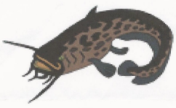**Seam squirrel**: Carl Ocampo **CCDB:** Glenn Wright

**Address:** 2202 Arlans Road **Address:** 5867 111th Street

Jacksonville, FL 32225 Jacksonville, FL 32244

**Phone:** 631-219-2699 **Phone:**  904-536-4802

**E-Mail: No email listed** **E-Mail:**  glenn_wright@bellsouth.net

**________________________________________________________________________________**

**PT 25 COOTIEVILLE**

**MEETING**: 3rd THURSDAY **TIME:** 7:31 P.M . **LOCATION:** VFW POST 5625

**Seam squirrel:** Thomas Browne **CCDB:** John C Crowley Jr

**Address:** 745 N.E. 200th Ave. **Address:** 2690 NW County Rd 345

Old Town, FL 32680 Chiefland, FL 32626

**Phone:**  352-356-7161  . **Phone:** 352-231-5597

**E-Mail:** bellyacres239@gmail.com **E-Mail:**  [jccjr_98@yahoo.com](mailto:jccjr_98@yahoo.com)

**________________________________________________________________________________**

**PT 29 Love Bugs**

**MEETING:** **TIME:** **LOCATION:** VFW POST 10209

**Seam squirrel:**  Jonathan Jones **CCDB: Michael Bogmenko**

**Address:** 4660 Marine Pkwy Unit 302 A**ddress:** 9540 Bonnett Lake Dr

New Port Richey, FL 34652 New Port Richey, FL 34654

**Phone:**  601-549-7606 **Phone:** 773-712-8255

**E-Mail**: [JJ1S33@aol.com](mailto:JJ1S33@aol.com) **E-Mail:** goosehouse2003[@yahoo.com](mailto:john.l.coleman79@gmail.com)

**________________________________________________________________________________**

**PT 32 SONS OF THE BEACHES**

**MEETING:** 1st WEDNESDAY **TIME:** 7:01 P.M. **LOCATION:** VFW POST 10094

**Seam Squirrel:** William Haynes **CCDB:** Steve Surface

**Address:** 12701 126 Ave Lot 76 **Address:** 12460 91 Way

Largo, FL 33770 Largo, FL 33773

**Phone:**  727-687-5604 **Phone:** 727-580-5040

**E-Mail:**  bhaynes66@gmail.com **E-Mail:** fire1@tampabay.rr.com

**PT 41 WHITE SANDS**

**MEETING:** 2nd MONDAY **TIME:** 6:01 P.M. **LOCATION:** VFW POST 7674

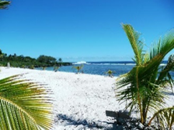

**Seam Squirrel:** Kevin Thurman **CCDB:** Jane Lowery

**Address:**  209 Holmes Blvd, NW **Address:** 259 Echo Circle

Fort Walton Beach, FL 32548 Fort Walton Beach, FL 32548

**Phone:**  850-803-7474 **Phone:** 850-974-1859

**E-Mail:** thurmankc@gmail.com **E-Mail:** janev523@cox.net

**_______________________________________________________________________________**

**PT 44 HO-BE HOBOS**

**MEETING:** 1st MONDAY **TIME:** 5:31 P.M. **LOCATION:** VFW POST 10132



**Seam Squirrel:** Thomas A. Hull **CCDB:** Gary Kolinski

**Address:** 8662 E Sandcastle Circle **Address**: 5940 Hwy 441

Hobe Sound, FL 33455 Okeechobee, FL 34947

**Phone:**  772-486-1626 **Phone:** 772-370-3111

**E-Mail:** thull49@gmail.com  **E-Mail:** post10539@vfwfl.org

**PT 51 VALLEY SUCKERS**

**MEETING:** 3rd SUNDAY **TIME**: 3:01 P.M. **LOCATION**: VFW POST 3270

**Seam squirrel:** John Paul (JP) Culin **CCDB:** Jim Dumal

**Address:** 2392 Huckins Court **Address:** 18 Cobia Street Jacksonville, FL 32225 Ponte Verde Beach, FL 32082

**Phone:** 904-803-6383 Phone: 904-761-1722

**E-Mail:** jpculin@gmail.com **E-Mail:** qmvp32082@gmail.com

**PT 55 RICHEYS**

**MEETING:** 3rd SUNDAY **TIME**: 3:01 P.M. **LOCATION**: VFW POST 7987

**Seam squirrel:** Dennis Schweitzer **CCDB:** Bierck Saxton

**Address:** 5003 Overlook Dr. **Address:** 4708 Eastwood Lane

New Port Richey, FL 34652 Holiday, FL 34690

**Phone:**  727-457-4812 **Phone:** 727-560-8565

**E-Mail:** [dennisallen5003@gmail.com](mailto:dennisallen5003@gmail.com) **E-Mail: Need email address**

**________________________________________________________________________________**

**PT 56 TRANSPLANTS**

**MEETING:** 2nd WEDNESDAY **TIME:** 6:31 P.M. **LOCATION:** VFW POST 8058

**Seam Squirrel:** Christopher Brucci **CCDB:** Bill Fitch

**Address:** 25050 Sandhill Blvd. Apt 132 **Address:** 2317 Hartley Ave

Punta Gorda, FL 33983 Port Charlotte, FL 33954

**Phone:**  941-504-0246 **Phone:** 941-380-1257

**E-Mail:**  [chrisjbrucci@gmail.com](mailto:chrisjbrucci@gmail.com) **E-Mail:** Need E-Mail address

**PT 59 SCRATCH ANKLE**

**MEETING:** 1st SATURDAY **TIME:** 2:01 **LOCATION:** VFW POST 4833

**Seam Squirrel**: Steve Mack **CCDB:** Judy Hartford

**Address:** 4208 Burbank Dr **Address:** 3605 Pebble Lane

Milton, FL 32583 Milton, FL 32583

**Phone:**  413-244-6665 **Phone:**  727-348-0171

**E-Mail:**  smackster11@yahoo.com **E-Mail:** tngconsultant@gmail.com

**________________________________________________________________________________**

**PT 66 SEA OATS**

**MEETING:** 1st SATURDAY **TIME:** 3:01P.M. (CT) **LOCATION:** VFW POST 706



**Seam squirrel:** Victor N. Looney Jr **CCDB:** Burke A. Burke

**Address:** 5383 Leesway Blvd **Address:** 62 North 17th Ave

Pensacola, FL 32504-7726 Pensacola, FL 32506

**Phone:**  850-982-0768 **Phone:**  850-736-7573

**E-Mail:**  [vnl53068@gmail.com](mailto:vnl53068@gmail.com) **E-Mail:**  JosephA.burke.jb@gmail.com

**PT 76 WITHLACOOCHEE**

**MEETING:** 1st SUNDAY **TIME:** 1:01 P.M. **LOCATION:** VFW POST 7122

**Seam Squirrel:** Daniel Dannecker **CCDB**: William Fowler

**Address:** 5383 Carl G Rose Hwy **Address:** 970 N Hollywood Cir.

Hernando, FL 34442 Crystal River, FL 34429

**Phone:** 352-613-8080 **Phone:** 352-613-6118

**E-Mail:**  **Does not have email** **E-Mail:** bfowler970@yahoo.com

**________________________________________________________________________________**

**PT 98 MIDWAY MITES**

**MEETING**: 2nd MONDAY **TIME**: 6:01 P.M. **LOCATION** VFW POST 4407

**Seam Squirrel:** Ron Holladay **CCDB: Michael Marcum Address:** 5303 Woodlake Trace **Address:** 1985 Refuge Circle

Gulf Breeze, FL 32563 . Navarre, FL 32566

**Phone:** 850-602-6395 **Phone:**  318-779-8342

**E-Mail:**rholladay1960@hotmail.com marcummichael@yahoo.com

Grand Policy

1. All matters of policy not herein contained shall be subject to a decision by the Grand Commander.
2. Any new project involving financial commitment of the Grand Pup Tent, including direct expenditures of financial contributions, must be brought before the Budget and Finance Committee and then the Grand Council for approval or disapproval.
3. The Grand of Florida MOC and the Grand of Florida MOCA will each receive, free of charge, a full-page ad in program books prepared in conjunction with the Grand Council and the Grand Scratch/Meeting.
4. Room and banquet tickets for MOC Supreme Representative to the Grand Scratch/Convention will be provided by the Grand MOC Quartermaster. Room for two (2) nights will be provided.
5. Room and banquet tickets for the Grand Commander at the Grand Scratch/Convention will be provided by the Grand MOC Quartermaster. Room for two (2) nights will be provided.
6. Rooms and banquet tickets for the Grand Commander for the School of Instruction (Bug Swarm), Fall Council of Administration and Mid-winter Council of Administration meetings, if not provided by the hotel, will be paid by the Grand of Florida MOC Quartermaster. *Note: Room and banquet tickets for MOCA Supreme guest and any other visiting MOCA VIPs are the responsibility of the Grand MOCA.*
7. Two banquet tickets for the VFW State Commander and his/her designated representative at the Grand Scratch/Convention will be provided by the Grand MOC QM.
8. For awards, Pup Tents will be placed in Grand Membership Divisions (Gold, Silver, Red and White) based on the prior year ending membership. Membership Division are listed below:

**GOLD DIVISION: 40 members and above**

**SILVER DIVISION: 30-39 members**

**RED DIVISION: 20-29 members**

**WHITE DIVISION: 10-19 members**

1. In determining the best Pup Tent in each Grand Membership Division, the following point system will be used by the Grand Awards Committee.

* **BEST PUP TENT BY DIVISION**

**MEMBERSHIP: POINTS:**

**15** – for reaching 100% by Dec 31

*OR:* ***10*** *– for reaching 100% by April 30*

**10** – for exceeding 100% in membership

**1** – for each new or reinstated member

**GENERAL: 35 -** If all pledges are paid by “Bug Swarm” (S.O.I.)

**15 -** If pledges are paid AFTER “Bug Swarm” (S.O.I)

**2 -** For every Quarterly Audit submitted (On-time & correct)

**1 -** For late Quarterly Audit

**HOSPITAL REPORTS: POINTS:**

1. - For 10+ reports (July thru Apr)

Less than 10 reports – **1** point each

**10** - For exceeding Pup Tent annual money goal

**PARTICIPATION:** Pup Tent Seam Squirrel or Line Officer must attend

2 of the 3 Grand Scratches (Bug Swarm, Mid-Winter, Grand Convention)

* **PUP TENT OBLIGATIONS**

1. The following obligations will be determined and distributed to all Pup tents by the Grand Quartermaster during the month of July or early August***. Pup tents are required to pay their obligations at the” Bug Swarm” in September and will receive 35 points for doing so. Paying them after September will result in only receiving 15 points.***
2. **TOMB TREK WREATH: $25.00 (NLT SEPTEMBER EACH YEAR)**
3. **NATIONAL HOME SPECIAL PROJECTS: $1.00 per member**
4. **SUPREME SCHOLARSHIP FUND: $1.00 per member**
5. **GRAND HOSPITALITY ROOM FUND: $1.50 per member**
6. **DELEGATE FEES**

**Grand Convention: $3.00 per delegate + $3.00 for the Seam Squirrel.**

(One delegate = 10 members or fraction thereof) These fees will be added to the PT Obligation form

provided to each Pup Tent by the Grand Quartermaster during the month of July or early August.

**Supreme Convention:** Advance registration fees as determined by Supreme Headquarters. Currently all Pup Tents must pre-register 1 delegate to Supreme. This Registration fee will also be added to the Pup Tent Obligation form provided by the Grand Quartermaster who will forward these fees to Supreme, and the Delegate submitted will be the Pup Tent Seam Squirrel unless the Pup Tent submits another name to the Grand QM at the time the fee is paid.

* **BUDGETS:**

11. The Supreme and Grand operate on a Budget each year which is generated by estimating the amount of money the Supreme and Grand hope to receive through membership dues, Pup Tent obligations and other fund raisers planned throughout the year. When these expected funds are not received, then the Supreme and Grand must find ways to make up for the shortages. These fund shortages are the biggest problems faced each year and are why it is so important for all Pup Tents to make a maximum effort in collecting dues from their annual members and to pay their obligations as quickly as possible. For the Grand to meet their obligation in sending the Supreme these funds, it must have received them from the Pup Tents on a timely basis.

1. Any proposed changes in the approved budget must be referred to the Grand Budget & Finance Committee for recommendation to the Grand Council of Administration prior to the Grand Council action.

* **JUDGING FOR AWARDS**

1. The time frame of judging for the Grand Awards will be from June to the end of April. The Grand Awards judging will be completed within 30 days following the end of the award year (April 30) and the awards presented at the Grand Convention in June**. *The Grand Jr. Vice Cdr. will be responsible for conducting the judging and getting the awards made.***

**Awards will be given out in the following categories:**

1. The outstanding Pup Tent in each Grand Membership Division.
2. The Pup Tent which has reported the most Hospital work will qualify for the outstanding Grand Hospital award, based on quota.
3. Pup Tents **WILL NOT** receive credit for any pledges not sent through the Grand Quartermaster.
4. At all Grand Council of Administration Meetings/Scratches and at the Grand Scratch/Convention, **ALL FINES** received will be counted by the Grand Quartermaster and members of the Grand Budget & Finance Committee at the close of the meetings and the amount recorded.
5. The Grand Commander shall convene a meeting of the Grand Officers, both elected and appointed, Seam Squirrels, CCDB’s and all interested Cooties within three (3) months following installation for the purpose of holding a School of Instruction (Bug Swarm) The Bug Swarm will normally be conducted during the Fall C of A. This will save the membership the cost of attending two scratches versus only attending one.
6. A Fall Council of Administration meeting shall be held each year between September 1 and October 31. (Every effort will be made to hold this meeting in the month of September). A Mid-term (Winter) Council of Administration meeting shall be held each year between January 1 and February 28 (February 29 during a leap year). The exact dates and meeting place as directed by the Grand Commander subject to the approval of the Grand Council of Administration or the Delegates at the Grand Scratch/Convention. The Grand Scratch/Convention shall be held annually during the month of June and shall be awarded on a **BID** **BASIS** and approved by the Grand Council of Administration or the Delegates at the Grand Scratch/Convention.

**_______________________________________________________________________________________**

DUTIES OF A SEAM SQUIRREL

1. Preside over all Scratches of the Pup Tent.
2. Enforce the by-laws and usages of the organization and all orders from proper authority.
3. Appoint all officers and committees not otherwise provided for.
4. Approve all orders drawn upon the Custodian of the Crummy Duffel Bag (CCDB) for appropriations of money approved by the membership and countersign all checks.
5. Furnish the Commander of the Post a list of all members of the Pup Tent that are members of the Post as outlined in paragraph B of section 310, Supreme By-Laws dated August 28, 2010.
6. Attend all District and Grand meetings, or if unable, send a designated representative in his/her place.
7. Fill out the **Pup Tent Report Form** found in the back portion of the Grand Program Book and send it to Grand Adjutant at least every three (3) months as a minimum.
8. Assure that the office of the CCDB is bonded.
9. Work with the Pup Tent CCDB on getting all the annual member dues of the Pup Tent paid on time. **(NLT 31 December each year)**
10. Develop a system to notify members of a Pup Tent Scratch. Phone calls appear to get the best results. Use the buddy system.
11. Always be on the lookout for potential new members at your VFW Post meetings and functions.
12. Set up the Pup Tent visits to the VA Hospital, Domiciliary or Veterans clinics.
13. Show your Cootie colors at all VFW Post functions.
14. Keep your Grand Commander well informed on your Pup Tent status and functions.

DUTIES OF THE CCDB

The duties of the CCBD are outlined in the Supreme By-Laws, Section 314.

MEMBERSHIP DUES:

**Supreme Fee: $9.00 plus $1.00 for a new member**

**Grand Fee: $9.00 plus $1.00 for a new member** (NEW - Voted on at 2024 Grand Convention)

The CCDB is responsible for collecting the dues from the Pup Tent **ANNUAL** membership. The CCDB should start collecting these fees as early as possible **BEFORE** the start of the new year and **MUST** forward the proper amount to the Grand Quartermaster to cover the Grand and Supreme portion of dues collected as quickly as possible.

**PUP TENT OBLIGATIONS:**

The CCDB is responsible for sending in all Pup Tent Obligations listed in Section 9 of the Grand Policy to the Grand Quartermaster as early as possible and not later than the Grand Fall Council of Administration Scratch.



**PAST SUPREME COMMANDERS**

Jim Grow 1951 Deceased

Raymond Burk 1954 Deceased

Owen Ball 1972 Deceased

Eugene D. Thomas, Jr. 1979 Deceased

John E. Hamilton 1993 127 Old South Rd. Crestview, FL 32536

***FLORIDA GRAND SEAM SQUIRREL***

**PAST GRAND COMMANDERS**

Max Thrower 1937 Deceased

William Littlenfelt 1937-1938 Deceased

Elmer Williams 1938-1939 Deceased

A. B. Wilson 1939-1940 Deceased

William Claypool 1940-1941 Deceased

Charles Bell 1941-1942 Deceased

Charles Morris 1942-1943 Deceased

Ernest Kates 1943-1944 Deceased

Leroy Gillies 1944-1945 Deceased

Hugh Leopard 1945-1947 Deceased

Lee Millican 1947-1948 Deceased

A. T. Jabe 1948-1949 Deceased

Rus Prater 1949-1950 Deceased

Horace Hedgepath 1950-1951 Deceased

Sherman Bennett 1951-1952 Deceased

A. A. Scott 1952-1953 Deceased

Carl Malmquest 1952-1954 Deceased

L. B. Dupree 1954-1955 Deceased

Werner Y. Chapman 1955-1955 Deceased

Jack McClung 1955-1956 Deceased

Peter Madereius 1956-1957 Deceased

Leroy Debay 1957-1958 Deceased

Fred Stanton 1958-1960 Deceased

Louis Mundel 1960-1961 Deceased

Al Andretta 1961-1962 Deceased

Peter Camacho 1962-1963 Deceased

Paul Saniford 1963-1964 Deceased

Don Pulver 1964-1965 Deceased

James Murphy 1965-1966 Deceased

Robert Echols 1966-1967 Deceased

Robert Brockman 1967-1968 Deceased

Owen Ball 1968-1970 Deceased

Michael O’Hearn, Jr. 1970-1971 Deceased

Al Dryfus 1971-1972 Deceased

Eugene E. Thomas Jr. 1972-1973 Deceased

Carl Jackobson 1973-1974 Deceased

Robert B. Wright 1974-1975 Deceased

Allen Cameron 1975-1976 Deceased

RJ Schlafke, Sr. 1976-1977 Deceased

Ken Westermand 1977-1978 Deceased

Robert C. Hoag 1978-1979 Deceased

Chester Ashe 1979-1980 Deceased

Harry Hess 1980-1981 Deceased

Guy Murphy 1981-1982 Deceased

Sam Maganaro 1982-1983 Deceased

Stanley Futch 1983-1984 Deceased

John E. Hamilton 1984-1985 127 Old South Rd. Crestview FL 32536

Carl C. Tinsley 1985-1986 Deceased

Gene Fehrmann 1986-1987 Deceased

Mike Walter 1987-1988 Deceased

Wendell A. Sandhoff 1988-1989 Deceased

Charles Green 1989-1990 Deceased

Stephen J. Kennedy 1990-1991 Deceased

Joseph F. Renaldo 1991-1992 Deceased

Carrol E. Shupe 1992-1993 Deceased

Samuel Sidoni 1993-1994 Deceased

Peter Puentes 1994-1995 Deceased

Jackson K. Scott, Jr. 1995-1996 Deceased

James E. Gasper 1996-1997 P O Box 676, Chipley, FL 32428

William F. Kennion, Jr. 1997-1998 Deceased

William H. Mayo 1999-2000 Deceased

John J. Clark, III 2000-2001 Deceased

Norman L. Cass, Sr. 2001-2002 12910 Missouri Woods Ct., Orlando, FL 32824

Chris Brewer 2002-2003 Deceased

Delana C. Oliver 2003-2004 Deceased

Charles “Johnny” Thompson 2004-2005 Unknown Address

John P. Henry 2005-2006 405 Lillian Dr., Fern Park, FL 32730

James W. Walker 2006-2007 Deceased

John S. Barber, Jr. 2007-2008 11206 76th Ave. N., Seminole, FL 33772

Chester Pyatt 2008-2009 711 Kenmoore Ct., Eustis, FL 32726

Edward F. Silva 2009-2010 Deceased

Robert McKinley 2010-2011 Deceased

William “Joe” Gault 2011-2012 Deceased

Danette “Dani” Hernandez 2012-2013 3294 Lake Effie Ct. N., Jacksonville, FL 32277

Robert “Bob” Hernandez 2013-2014 3294 Lake Effie Ct. N., Jacksonville, FL 32277

William “Bill” Haynes 2014-2015 112701 126th Ave, Lot 76, Largo, FL 33774

Thomas “Tom” Browne 2015-2016 745 NE 200th Ave., Old Town, FL 32680

Kenneth “Ken” Thie 2016-2017 13622 Serena Dr., Largo, FL 33774-5338

Thomas “Tom” Browne 2017-2018 745 NE 200th Ave, Old Town, FL 32680

Gary Godard 2018-2019 1585 Blossom Terrace, The Villages FL 32162

Al Pristera 2019-2020 55 Palm Forrest Drive, Largo, FL 33770

Tom Sutterfield 2020-2021 5878 Dahoon Drive, Pensacola, FL 32526

Jerry Bazar 2021-2022 P.O. Box 937, Old Town, FL 32680

John E Vawter Jr 2022-2023 1300 Persimmon Ct Apt 22, Sebring, FL 33870

Tom Sutterfield 2023-2024 5878 Dahoon Drive, Pensacola, FL 32526

Trent Rundell 2024-2025 5788 Wildwood Road, Crestview, FL 32536