**Elvis Birthday Bash**

**Sunday, Jan 5, 2020 @** [**Ruth Eckerd Hall**](https://www.rutheckerdhall.com/ruth-eckerd-hall)

**Arrive at Ruth Eckerd around 11:30 AM.**

**Brunch served upon arrival and the show will begin at 1PM.**

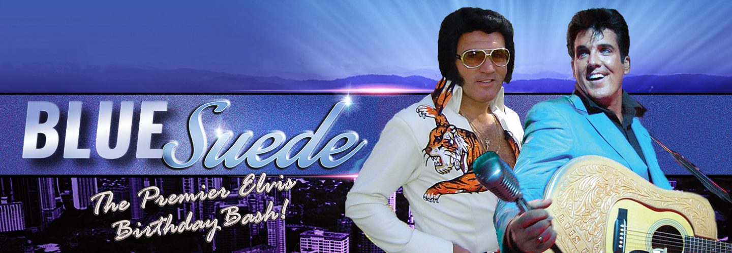

**World-class Elvis impersonators Mike Albert and Scot Bruce, along with the Big E Band, return to the Ruth Eckerd Hall to celebrate Elvis' 85th Birthday**! **From his sexy sneer to his gyrating guitar playing, Scot Bruce is one of the world’s finest “Young Elvis” impersonators, while Mike Albert presents a stunningly accurate and respectful portrayal of the latter-day “Vegas” Elvis. Backed by the Big E Band, the two performers will trace Elvis from his rockabilly days to some of his final recordings. A must see for Elvis lovers everywhere.**

**The Brunch will include breakfast and lunch offerings, buffet style, along with complimentary coffee, tea, juice and water. In addition to the cash bar, Mimosas, Bloody Mary’s and Screwdrivers will also be available for purchase.**

**Refer to “Special Parking” map on reverse side for this event**

Leave 10:30AM Return to Church 4:00PM Cost $56 includes Bus Trip, Show Ticket and Buffet brunch

|  |  |  |  |  |
| --- | --- | --- | --- | --- |
| **Checks payable to: CENTER 4LIFELEARNING** | **Additional Names** | | | |
| **Sorry, No refunds unless class/trip is cancelled** |  | |  | |
| **Name** |  | |  | |
| **Full Address** |  |  |  |  |
| **City, State, Zip** | | | |  |
| **Phone** | | | |  |
| **Email Address** | | | |  |
| **Cash: _______ Check # _____ Credit Card (PayPal) Cashier Initials ________Date _____** | | | |  |

