How To Install And Set Up STB On Your Firestick

Please note: If you have a 1st generation firestick the app will most probably be unstable so best to use another app.
If you have not already make sure you go into settings, device then turn on allow apps from untrusted sources to make sure the app can install.
Ok, you will need to press the home button on firestick remote then go to the top and press left to the magnifying glass and type in Downloader to search for the app then install Downloader and open it.

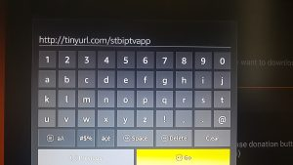

Next, you will want to put this web address in the address bar http://tinyurl.com/stbiptvapp which will allow you to download and install the app then you just want to open the app.

