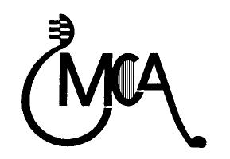**Mesaba Concert Association (MCA)**

**Sponsor or Friend Benefits**

**Platinum “Hallelujah Chorus” Sponsor ($5000 +)___ ___ \***

* Name printed in program for all Hibbing concerts (or anonymous)
* Ticket package (optional), please circle one:

1. 10 MCA Household Season Passes + 25 single tickets to any Hibbing concert ($1600 value)

b) 4 MCA Adult Season Passes + 70 single tickets to any Hibbing concert ($1600 value)

c) 80 single tickets to any Hibbing concert ($1600 value)

d) Custom combination not to exceed $1600 value (we will contact you to arrange)

**Gold Sponsor ($1000-$4999) \***

* Name printed in program for all Hibbing concerts (or anonymous)
* Ticket package (optional), please circle one below:

a) 2 MCA Household Season Passes + 29 single tickets to any Hibbing concert ($800 value)

b) 4 MCA Adult Season Passes + 30 single tickets to any Hibbing concert ($800 value)

c) 40 single tickets to any Hibbing concert ($800 value)

d) Custom combination not to exceed $800 value (we will contact you to arrange)

**Silver Sponsor ($500-$999) \***

* Name printed in program for all Hibbing concerts (or anonymous)
* Ticket package (optional), please circle one below:

a) 1 MCA Household Season Passes + 15 single tickets to any Hibbing concert ($410 value)

b) 2 MCA Adult Season Passes + 15 single tickets to any Hibbing concert ($400 value)

c) 20 single tickets to any Hibbing concert ($400 value)

d) Custom combination not to exceed $410 value (we will contact you to arrange)

**Bronze Sponsor ($250-$499 \***

* Name printed in program for all Hibbing concerts (or anonymous)
* Ticket package (optional), please circle one below:

1. 1 MCA Household Season Passes + 5 single tickets to any Hibbing concert ($210 value)
2. 2 MCA Adult Season Passes + 5 single tickets to any Hibbing concert ($200 value)
3. 10 single tickets to any Hibbing concert ($200 value)
4. Custom combination not to exceed $210 value (we will contact you to arrange)

**Iron Friend ($100-$249) \***

* Name printed in program for all Hibbing concerts (or anonymous)

**Taconite Friend (Up to $99) \***

* Name printed in program for all Hibbing concerts (or anonymous)

*\* Option to donate “In memory of” at the bottom of the reverse page.*

Dear Mesaba Concert Association (MCA) supporter,

MCA has 9 exciting concerts for our 2025-26 season, 5 at the historic Hibbing High School auditorium and 4 in Virginia! Our organization has been in existence for almost 75 years and brings a wide variety of exceptional live music to Hibbing audiences at affordable prices. Please help us keep MCA thriving.

Besides joining us as a Member, Friend, or Sponsor, here are some other ways to support MCA:

- If you are a Thrivent client, please consider directing your Thrivent Choice Dollars to MCA.

- If you have a Required Minimum Distribution (RMD), please consider making a

Qualified Charitable Distribution (QCD) to MCA.

Feel free to reach out to us if you want to make any other form of planned giving through your estate or financial planning such as bequests, charitable remainder trusts, charitable gift annuities, or naming MCA as a beneficiary of a life insurance policy or retirement plan.

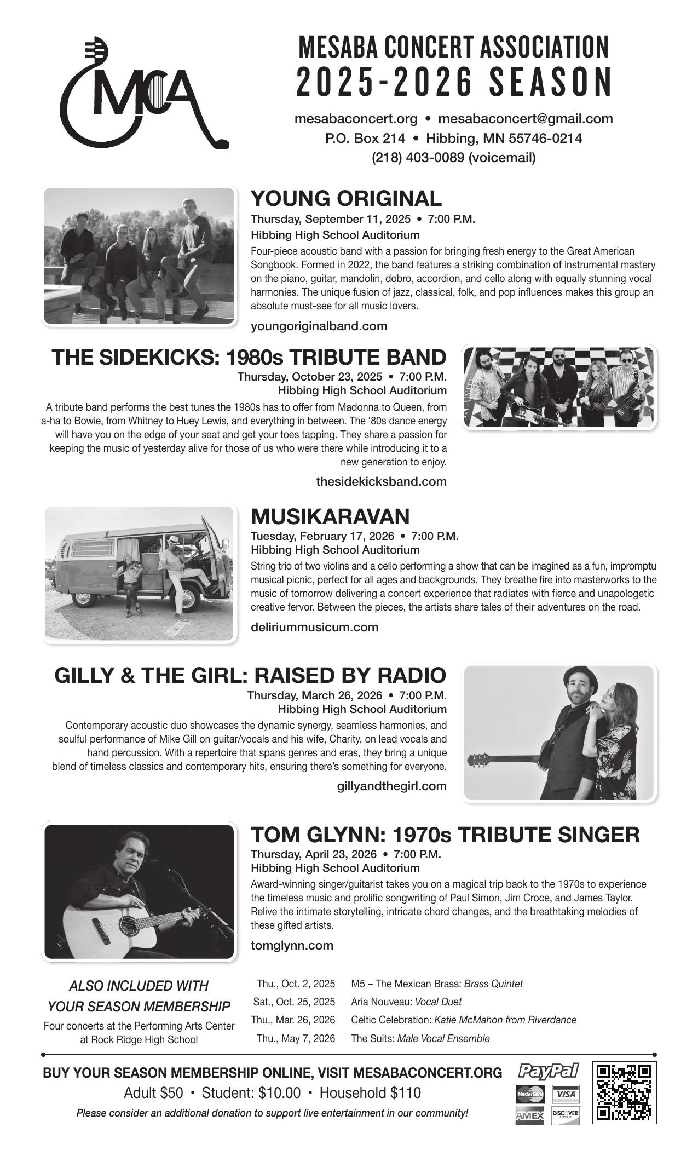Thank you from the bottom of our hearts!

*Your MCA Board*

___________________________________________________________________

**2025-2026 Mesaba Concert Association (MCA)**

Please fill in completely, scan the QR code, or go online to [www.mesabaconcert.org](http://www.mesabaconcert.org).

Questions: [mesabaconcert@gmail.com](mailto:mesabaconcert@gmail.com)

Name ______________________________ __ Address __________________________________

City ________________________________ State ___ Zip code _______ Phone ___________

Email ________________________________ Referred by _______________________________

**MEMBER TICKETS**

Adults ________@ $50 = $________

Students________ @ $10 = $________

Household_______@ $110 = $________

**FRIEND DONATIONS:**

Iron Friend ($100-$249) $________ *

Taconite Friend (up to $99) $________ **\***

**Total Enclosed $________**

___ Please list my donation as anonymous

**SPONSOR DONATIONS**

Platinum “Hallelujah” Sponsor ($5000+) $______ *

Gold Sponsor ($1000-$4999) $______ *

Silver Sponsor ($500-$999) $______ *

Bronze Sponsor ($250-$499) $______ *

___ **YES**, I have circled a ticket package

on the other side

___ **NO**, I am not interested in tickets, just

Sponsoring

**Total Enclosed $________**

___ Please list my donation as anonymous

**Make checks payable and mail to: MCA (Mesaba Concert Association)**

**PO Box 214, Hibbing MN, 55746-0214**

***\**** *To donate “In memory of” someone, please list that information on the line below:*

__________________________________________________________________________________