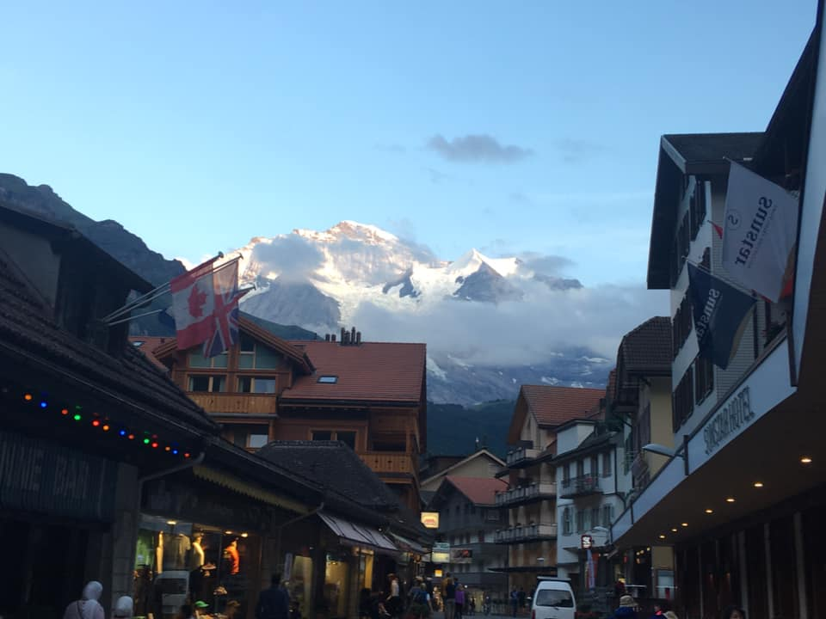**D&W**

WELCOME!

Thank you to all who have liked my page. If you have not done so, I welcome you to my page [www.dandwtravels.com](http://www.dandwtravels.com) where you can view pictures, and blogs.

2020 TRAVEL PLANS

We have another busy year of travel plans this year both domestic and international travel

-Page 1-

TRAVEL PLANS

Learn how to cope with a sudden change in travel plans and how to overcome adversity.

-Page 2A-

FESTIVALS

With some research, anyone can find local festivals.

-Page 2B-

-Page 2B-

NEWSLETTER

VOLUME 2, 2020

**TAVELS**

-INTRODUCTION-

D&W travels was created to give the opportunities of fellow travelers to share their experiences, advice, pictures. This site is also to motivate, assist, or just live vicariously on other people’s experience, (there is nothing wrong with that by the way!)

During our many traveling experiences, I always thought it would be interesting to start a blog about our travels, what mistakes we made and how we could have done things differently, and what experiences worked for us.

Planning a trip can be frustrating for some, but for us it is a vital start to our trip. We will share with you some of the steps we do to plan our adventures.

We hope we can help out with your next adventure and look forward to seeing your pictures.

*“To my mind, the greatest reward and luxury of travel is to be able to experience everyday things as if for the first time, to be in a position in which almost nothing is so familiar it is taken for granted.”*

-Bill Bryson

VOLUME 2 2020

*“Live with no excuses and travel with no regrets*”

-Oscar Wilde

TRIP LIST OF 2020

San Diego:

Australia-New Zealand:

Sydney

Queenstown

Dunedin

Miami- Caribbean:

Wales?

To be determined

Irish Fest:

Milwaukee Wisconsin

Washington State:

Train travel

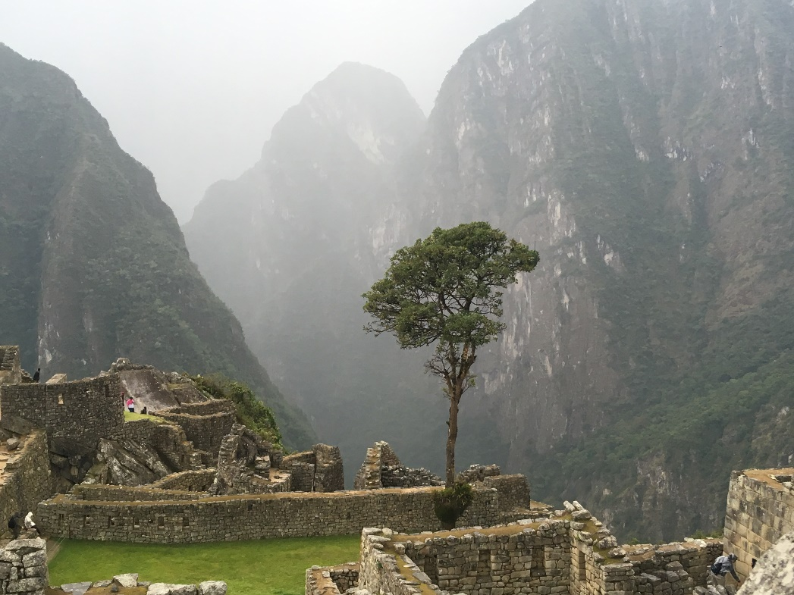

*“TRAVEL ISN’T ALWAYS PRETTY. IT ISN’T ALWAYS COMFORTABLE. sOMETIMES IT HURTS, IT EVEN BREAKS YOUR HEART.BUTTHAT’S OKAY. THE JOUNEY CHANGES YOU- IT SHOULD CHANGE YOU. IT LEAVES MARKS ON YOUR MEMORY, ON YOUR CONSCIOUSNESS, ON YOUR HEART, ON YOUR BODY. YOU TAKE SOMETHING WITH YOU… HOPEFULLY, YOU LEAVE SOMETHING GOOD BEHIND.”*

- ANTHONY BOURDAIN

FESTIVALS

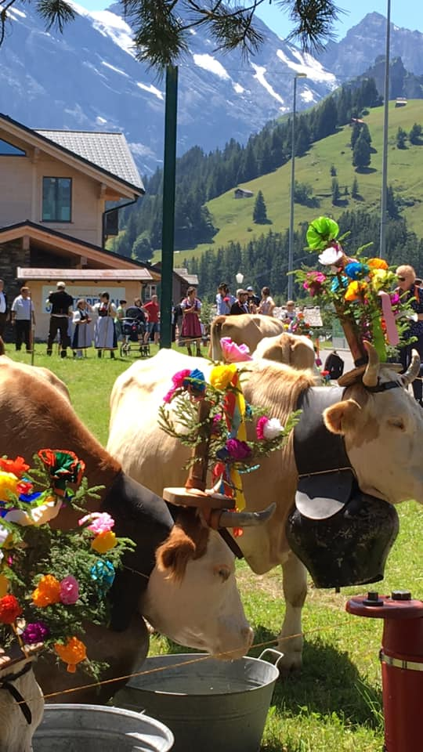

So, you think you have everything planned for your trip? Did you check to see if there were any festivals perhaps? It’s easy to overlook. Here are some steps to do to look for festivals.

You can start by looking at the town’s local website, or Facebook page.

Local festivals are often the best way to see the locals and get to know the local culture. The picture above is a festival in Murren Switzerland called DorfFeset. Festivals often enhance your travel experience.

There is time when you are just at the right place at the right time and this yet furthers the trip. Keep your ears and your eyes out. You may see something that changes everything about your trip!

TRAVEL PLANS

We all have dreams of travel plans going smoothly and then just like that, you are confronted with a cancellation. What do you do, what is your first reaction? This happened to me and my husband this year. Here are some tips to avoid costly mistakes…actually one!

Get travelers insurance! You will save yourselves sometimes thousands of dollars if you do this. It will save you the hassle of paperwork, and frustration. This is the least thing you want to do. With this case there was an impending death in the family.

We came to a decision that we still wanted to do a smaller trip. We wanted to go some place familiar so we didn’t have to waste time doing research on a new destination.

Travel isn’t easy sometimes, but there are ways to overcome adversity, which gives you time to ponder our beautiful planet!

