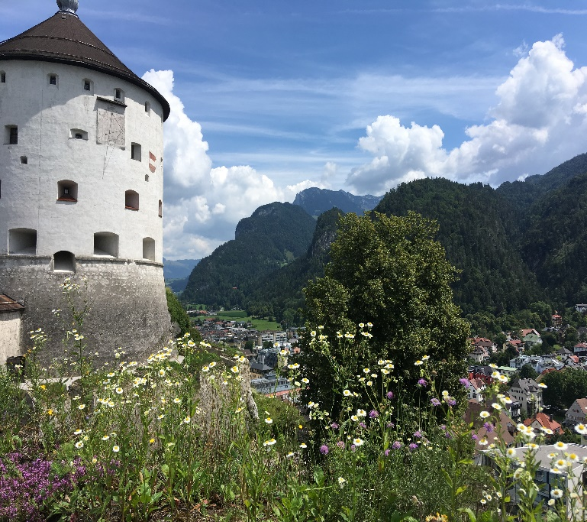**D&W**

WELCOME!

Thank you to all who have liked my page. If you have not done so, I welcome you to my page [www.dandwtravels.com](http://www.dandwtravels.com) where you can view pictures, and blogs.

2019 TRAVEL PLANS

We have another busy year of travel plans this year both domestic and international travel

-Page 1-

“BROWN SIGNS”

Learn how these signs can help you make your traveling experience even better.

-Page 2A-

WORLD FOOD MARKETS

Learn how markets around the world thrive and influence world cultures.

-Page 2B-

NEWSLETTER

VOLUME 1 2019

**TAVELS**

-INTRODUCTION-

D&W travels was created to give the opportunities of fellow travelers to share their experiences, advice, pictures. This site is also to motivate, assist, or just live vicariously on other people’s experience, (there is nothing wrong with that by the way!)

During our many traveling experiences, I always thought it would be interesting to start a blog about our travels, what mistakes we made and how we could have done things differently, and what experiences worked for us.

Planning a trip can be frustrating for some, but for us it is a vital start to our trip. We will share with you some of the steps we do to plan our adventures.

We hope we can help out with your next adventure and look forward to seeing your pictures.

*“We travel because distance and difference are the secret tonic of creativity. When we get home, home is still the same. But something inside our minds has changed, and that changes everything.”*  -Jonah Lehrer

VOLUME 1 2019

[Sidebar Title]

*“To Travel is to live*”

-Hans Christian Anderson

TRIP LIST OF 2019

Ireland:

Sligo

Donegal

Athlone

Switzerland:

Lucerne

Lauterbrunnen

Wengen

Interlaken

Irish Fest:

Milwaukee Wisconsin

Rose Bowl Parade:

Pasadena California



*“TRAVELING IS A Brutality. it forces you to trust strangers and to lose sight of all that is familiar comforts of home and friends. you are constantly off balance. nothing is yours except the essential things. air, sleep, dream, the sea, the sky- all things tending toward the eternal or what we imagine of it.”*

- CESARE pAVESE

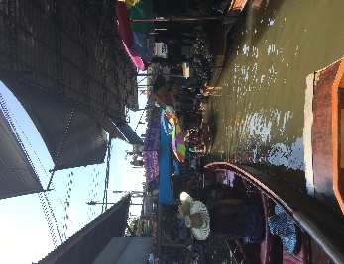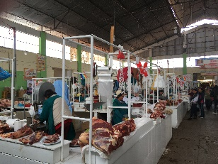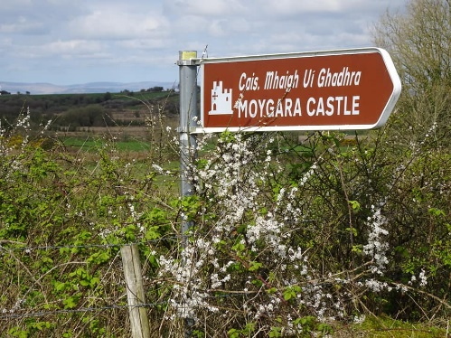

enjoy life, travel often!

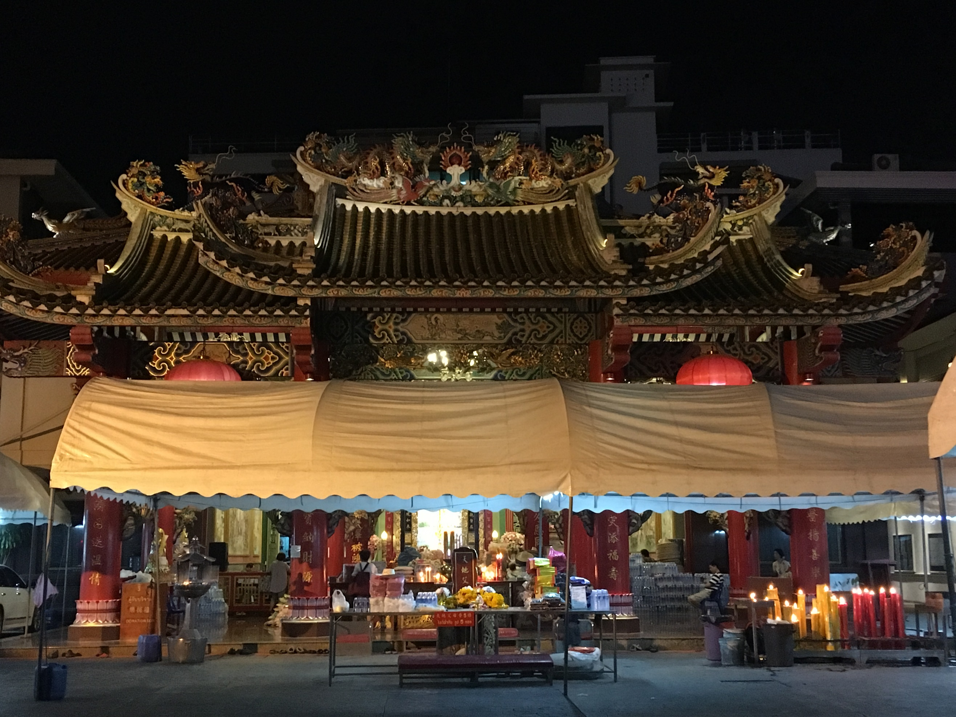

WORLD

MARKETS

With traveling abroad, chances are you will see a market! While they may be different from country to country, they are also very similar.

It’s amazing how many people rely on the markets for their produce.

In Asia, you may see a religious shrine, many types of street food which is very delicious!

The aromas in the markets are also very similar, some great smells and not so great smells.

Markets also are great for any world traveler or tourist to experience different cultures first hand!

“BROWN SIGNS”

When it comes to planning a trip, keep in mind that you are likely to see one of these signs in your travels. If you are traveling on your own, chances are you will most likely come across this. When we travel, we make sure to make time enough for any unexpected surprises. In many countries, you will see signs like this. These are for attractions and can be for multiple types. So, if you like castles and other types of attractions, keep an open itinerary. You may be surprised what you can find.

And with any experiences, it may be a positive one or a lesson learned and to pass on the information to someone who you think may be interested in that attraction.