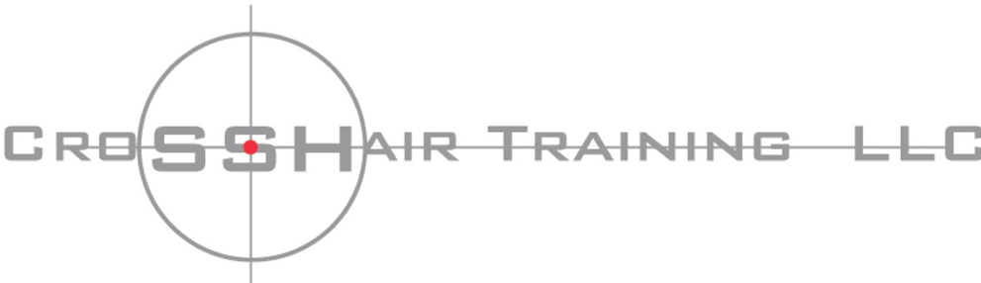

CCW Renewal Training

Time:
Action Bay #
Date:
Gate Code

Location:
Richmond Rod & Gun Club. 3155 Goodrick Ave. Richmond, CA 94801
This is live-fire range training. After a Safety briefing, we will be doing practical defensive training that will include.
- Draw
- Proper Grip
- Marksmanship Fundamentals
- Point Shooting vs Sighted Fire
- Shooting on the move
- Proper use of cover and concealment
- And more

Each student must have:
  - Ear/Eye protection,
  - Firearms.
  - Holsters made for your specific make/model. Outside the Waist Band (OWB) kydex styles are recommended. No soft or collapsible universal holsters will be allowed. Bring your
concealment holster if you have one, to practice your concealed draw. *Live fire training will be done from OWB and not from concealment.

  - 350-rounds of ammunition for your primary weapon & 50-rounds for each additional weapon you plan to qualify with.
  - 3-Magazine pouches or speed loaders per firearm.
  - Sturdy Belt a minimum of 1” wide
  - Range attire adequate for training:

We will be outdoors, and you should dress appropriately depending on the weather. We will train rain or shine.
  - Shirt with high collar.
  - Long pants required. No shorts, skirts, or dresses.
  - Baseball cap
  - Quality footwear designed for walking or hiking. No open toed shoes or sandals

After qualification we will return to the classroom and do the lecture on mental health and take the required examination.

Range Map
Please Park in the designated are by the clubhouse or action range. Eye protection is mandatory when entering the action rage.
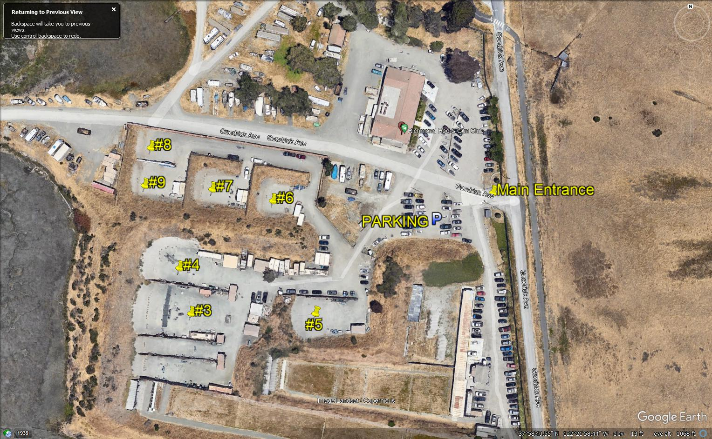
All firearms need to be cased and unloaded when you arrive. If you are carrying concealed when you arrive there is a clearing trap located just inside the gate to the action range. Please unload your firearm before entering the training bay.

