

*2018 Rule Book*

*In-Town Soccer*

*Revised/Approved 6.1.2018*

*Westfield FC Town Soccer follows the National Federation of State High School Associations rules book for soccer. Specific exceptions and amendments for Westfield FC Town Soccer are included & noted in this rules book.*

*These rules are applicable for all divisions unless otherwise noted.*

*1*

**INDEX**

1. The Ball………………………………………………………………………………………………………….3

2. Player Equipment…………………………………………………………………………………………….4

3. The Players and Substitutions…………………………………………………………………………..5

4. Practices and Games……………………………………………………………………………………….7

5. Coaches…………………………………………………………………………………………………………8

6. Injury Timeouts……………………………………………………………………………………………..9

7. Ball In and Out of Play…………………………………………………………………………………..10

8. Scoring…………………………………………………………………………………………………………11

9. Throw-In………………………………………………………………………………………………………12

10. Goal Kick…………………………………………………………………………………………………….13

11. The Corner Kick…………………………………………………………………………………………..14

12. Penalty Kick………………………………………………………………………………………………..15

13. Offsides………………………………………………………………………………………………………17

14. Direct and Indirect Free Kicks……………………………………………………………………….22

15. Fouls, Misconduct, Yellow/Red Card Offenses……………………….……..…………………25

16. Head Balls…………………………………………………………………………………………………..28

17. Boys 6-7 and Girls 6-7 Division Rules…………………………………………………………….29

18. Playoff Format………………………………………………..……………………………………..……30

19. The Officials…..…………………………………………………………………………………………..31

2

**1. The Ball**

* Before the start of the game, team coaches will provide suitable, properly inflated game balls. The referee will inspect and make the final determination as to the ball that will be used for the match.
* Seniors Division – A size 5 ball will be used.
* All Other Divisions – A size 4 ball will be used.

3

**2. Player Equipment**

* The required player equipment includes a jersey, shorts, socks, suitable shoes, and shin guards. The shinguards shall provide adequate and reasonable protection, be professionally manufactured, age and size appropriate, not altered to decrease protection, worn under the socks, and worn with the bottom edge no higher than 2 inches above the ankle.

Westfield FC rules amendments:

* No player in any division will be allowed to play wearing metal cleats.
* No player in any division will be allowed to play without shinguards.
* No player in any division will be permitted to wear any jewelry. This includes earrings, studs, wrist bands, necklaces, rope, bracelets, yarn, or barrettes, etc.
* Covering jewelry with items such as tape/band aids will not be permitted.
* Sunglasses may not be worn by any player.
* Mouth guards are not required but permitted.
* Prescription eyewear and/or prescription eyewear protective goggles will be allowed.
* Soft casts will be allowed with parental approval. No hard casts allowed.
* Non-metal hair bands/hair ties will be allowed.
* No player in any division will be allowed to play on game day without a team issued jersey.
* No player in any division will be allowed to play with a jersey that has been altered (ex. sleeves cut off).

4

**3. The Players and Substitutions**

I. Players

* The game shall be played by two teams, each consisting of not more than 11 players, one of whom shall be the goalkeeper.
* The game shall not be started with fewer than 7 (seven) properly uniformed players on each team. After the game begins, it may not continue with fewer than seven players on either team. If a team has fewer than 7 players, the game shall be terminated and a forfeit shall be declared. (Since the space and time is reserved for that game, if coaches are in agreement, the time may be used to scrimmage.). If a team has less than 7 players before the game starts, the referees will wait 10 minutes after the scheduled start time before calling the forfeit if either team has less than seven players.

Westfield FC rules amendments:

* Boys 6-7 and Girls 6-7: Each team shall consist of 7 players (6 field players and a goalie)
* Boys 8-9: Each team shall consist of 9 players (8 field players and a goalie)
* Girls 8-10: Each team shall consist of 9 players (8 field players and a goalie)
* Boys 10-12: Each team shall consist of 9 players (8 field players and a goalie)
* Girls 11-13: Each team shall consist of 11 players (10 field players and a goalie)
* Seniors Division: Each team shall consist of 11 players (10 field players and a goalie)
* All Westfield FC Town teams will start/continue a game with the exact number of players as the opposing team (with a minimum of 7). If a team is short a player/players and has fewer players to play due to absence or injury, the opposing team must play with the same number of players. This will continue until more players arrive and the teams can put players into the game until reaching the number of players required for a game in their division. Exceptions to this rule:

1. A coach requesting to play with fewer players than needed (minimum 7).

2. A player(s) receiving a red card that disqualifies a player from further play. In this instance the opposing team does not have to reduce the number of players on the field as a result of that infraction.

● In all divisions, coaches must make all efforts to give all present and eligible players fair and equal playing time either during game time or during substitutions.

5

II. Substitutions

* Time for substitutions – either team may substitute an unlimited number of players from the bench, during these times:

1. At the end of quarter or period – either team may substitute.

2. After the ball leaves the end field of play that results in a either a goal kick or

corner kick – either team may substitute.

3. After a goal is scored – either team may substitute.

4. During any injury play stoppage – either team may substitute.

5. After a side field out of bounds occurs, resulting in a throw in – If the team

awarded possession of the throw in substitutes, either team may substitute.

6

**4. Practices and Games**

I. Practices

● It is Westfield FC policy that practice sessions are limited to two (2) per week, Monday through Friday with a maximum of two (2) hours per session for all divisions except Boys/Girls 6-7.

● Boys/Girls 6-7 divisions are limited to one (1) practice per week.

● No practices are allowed in any division on Saturdays or Sundays, these days are reserved for games only.

● A session is defined as any practice, game, or meeting.

II. Games

1. Playing Time of Games for all divisions:

A. Boys/Girls 6-7: The first three quarters will be ten minutes long. The last (4th quarter) will run until 10 minutes before the hour (i.e. games stop at 9:50am, 10:50am, etc)

B. Boys 8-9 and Girls 8-10: 10 minute quarters running time, with 1 minute rest between quarters and 3 minutes rest at halftime.

C. Boys 10-12 and Girls 11-13: 12 minute quarters running time, with 1 minute rest between quarters and 3 minutes rest at halftime.

D. Boys/Girls Senior Division – 25 minute halves running time and a five (5) minute rest at half time.

(Note: Running time means the clock will stop for injuries, cards, or penalty shots)

III. The Start of Play

* A coin toss between team appointed captains will take place at mid-field prior to the start of play, moderated by the referee.
* The team winning the coin toss will be given first choice of either retaining possession of the ball at kickoff, or choice of field side to start the game.
* When the referee signals with a whistle, a kickoff shall initiate play at the start of each period and after goals.
* Teams will alternate field sides at the end of each quarter and/or half.
* At the start of play at midfield (to start a quarter or after a goal is scored), the player starting the kickoff may kick the ball in ANY direction (forward or backward). The ball must be touched by another player before the player starting the kickoff can come in contact with the ball again.

7

**5. Coaches**

* In all divisions: There are up to 3 (three) coaches allowed in the coach’s box during games. If a team has more coaches, they must be on the opposing sideline with the parents and cannot coach from that location. Coaches and teams must stay in their own designated coach’s box. This will allow the coach the freedom to move up and down the 20 yard box without spectators hindering his/her movements. Parents occupy opposite sides of the field.
* No parents or spectators are allowed in any areas behind the goals or ends of the fields.
* Disciplinary Action in the event any coach is yellow/red carded by a referee:

A coach who receives a yellow card is given a warning by the referee. A coach who receives a red card by a referee must leave the playing field immediately. He/she is also suspended from coaching the next scheduled game in that division. Failure to leave the field will result in the game being forfeited. If the team does not have an approved coach to take over, the game will be suspended until a coach is provided. This may be within minutes or it could be days before the game is resumed. The Board will be advised and approve the game being rescheduled. When three (3) yellow cards are given to a coach or assistant for his or her infractions in that division in one season, he/she will be suspended for 1 (one) game. If the coach/assistant gets another card of wither color (red or yellow) he/she will be suspended for the remainder of the season. If any of these situations occur during the last game of the season, the penalty will carry over to the next season.

8

**6. Injury Timeouts**

* If a player becomes injured during a game, the running time will be stopped by the referee. Running time does not stop until the referee has blown their whistle indicating an injury timeout.
* All games in all divisions will be stopped as soon as possible in accordance with the rules of the game when an injury occurs. A coach can come on the field and attend to the injured player when called by the referee. The player must be removed at that point. The player may return as the next legal substitution. This also applies for a team playing with less than 11 players.
* For all injury timeouts, play will resume under these guidelines:

1. Regardless of which team had possession before the injury, the referee will restart play with a drop ball at the ball’s last known location.

2. At the drop of the ball and the referee’s whistle, play running time will resume.

* **PLEASE REPORT ANY INJURY THAT REQUIRES MEDICAL ATTENTION TO YOUR COORDINATOR AS SOON AS POSSIBLE.**

9

**7. Ball In and Out of Play**

* The ball is out of play when it has **COMPLETELY** crossed a goal or touch line, whether on the ground or in the air.



* Unlike other sports such as football**, the white lines are a PART of the field of play**. Therefore, the ball is not considered “out of bounds” or a “goal” until it has COMPLETELY crossed over the line whether on the ground or in the air.

10

**8. Scoring**

* A goal is scored when the entire ball passes beyond the goal line, between the goal posts and under the crossbar provided it has not been deliberately thrown, carried, or propelled by the hand or arm of a player of the attacking team.
* A goal MAY be scored directly from a:

A. kickoff;

B. direct free kick;

C. penalty kick;

D. goal kick;

E. corner kick;

F. drop ball;

G. goalkeeper’s throw, punt, or kick

* A goal MAY NOT be scored directly from a/an:

A. indirect free kick;

B. throw-in;

C. direct free kick into a team’s own goal;

D. goal kick into a team’s own goal;

E. Corner kick into a team’s own goal;

F. kickoff into a kicking team’s own goal

Westfield FC Amendment:

* Scores and standings will not be officially recorded in the following divisions:

1. Boys 6-7

2. Girls 6-7

3. Boys 8-9

4. Girls 8-10

11

**9. Throw-In**

* A throw-in shall be awarded to a team when the ball last touched a member of the opposing team before the entire ball passes beyond the touchline either in the air or the ground. A goal may not be scored directly from a throw-in.
* The ball shall be thrown in any direction from the point where it crossed the touchline by a player who is facing the field of play and has both feet on the ground on or behind the touchline. The thrower shall use both hands (unless a physical impairment would limit use to one hand) and shall deliver the ball from behind and over the head in one continuous movement.
* While a throw-in is being taken, an opponent shall neither interfere with nor in any way impede the actions of the thrower, and shall stand at least two yards from the point at which the throw-in was taken.
* During the throw-in, the ball must move directly over the player’s head who is throwing the ball.
* Failure to properly throw the ball, keep both feet down, or have a foot cross onto the field of play shall result in change of possession and the opposing team is awarded a throw-in.

Westfield FC rules amendments:

* For Boys/Girls 6-7: two (2) throw-ins allowed all season per player
* For Boys 8-9 and Girls 8-10 Divisions:

For the first two weeks of the season, the thrower is allowed one (1) repeat of the throw-in if he/she commits an infraction (This will end after the 2nd Sunday of the season).

12

**10. Goal Kick**

* A goal kick shall be awarded to the defending team when the entire ball crosses the goal line, excluding the portion between the goal posts and under the crossbar, either in the air or on the ground, having last been touched or played by the attacking team. A goal may be scored directly from a goal kick, but only against the opposing team.
* Players opposing the kicker shall remain outside the penalty area until the ball has cleared the penalty area.
* Once spotted, the ball shall be kicked from the ground from any point within the goal area by a player of the defending team. A goal kick shall clear the penalty area and enter the field of play. If the ball is not kicked beyond the penalty area, the goal kick shall be repeated.
* After the goal kick leaves the penalty area, the ball may be played by any player except the one who executes the goal kick. The kicker may not play the ball until it has been touched by another player.

13

**11. The Corner Kick**

* A corner kick shall be awarded to the attacking team when the entire ball passes over the goal line, excluding the portion between the goal posts and under the crossbar, either in the air or on the ground, having been last touched or played by the defending team. A goal may be scored from a corner kick, but only against the opposing team.
* Players of the defending team shall be at least 10 yards from the ball until it is kicked.
* The ball shall be kicked from the ground within the quarter circle, including on the lines, nearest where the ball left the field of play. The ball is in play when it is kicked and moves. Failure to kick the ball as specified shall result in a re-kick.
* An offensive player who is not offside during the corner kick may be put in an offside position during a subsequent play.
* After the corner kick, the ball may be played by any player except the one who executed the corner kick. The kicker may not play the ball until it has been touched or played by another player.

14

**12. Penalty Kick**

* A penalty kick shall be awarded when a foul, which ordinarily results in the awarding of a direct free kick, occurs within the offending team’s penalty area.
* All players except the kicker and the opposing goalkeeper shall be within the field of play but outside of the penalty area and at least 10 yards from and behind the penalty mark until the ball is kicked.
* The opposing goalkeeper shall stand on the goal line, facing the kicker, between the goal posts, until the ball is kicked. Lateral movement is allowed, but the goalkeeper is not permitted to come off the line by stepping or lunging forward until the ball is in play
* The ball shall be kicked while it is stationary on the ground from the spot or any place on the penalty mark. To be in play, the ball shall be moved forward. The player taking the penalty kick is permitted to use a stutter-step or a hesitation move provided there is no stopping and there is continuous movement toward the ball. Failure to kick the ball as specified shall be considered a violation by the attacking team and the appropriate penalties shall be applied. Stutter-stepping is not an interruption in movement. A player who starts his/her approach and does not kick the ball shall be cautioned, and the kick will be retaken by another player.
* After the penalty kick is properly taken, the ball may be played by any player except the one who executed the penalty kick. The kicker may not play the ball until it has been touched or played by another player on the team.
* If the ball touches the goalkeeper before passing between the goalposts, when a penalty kick is taken at or after the expiration of time, it does not nullify any goal. If necessary, play may be extended so that the penalty kick may be taken. If a penalty kick is taken after the expiration of time: (a) only the kicker may play the ball and he/she may only play the ball once, (b) the ball is in play until its momentum is spent, it goes out of bounds, or is retouched by the kicker.

15

Penalty Kick Situations

|  |  |  |  |  |
| --- | --- | --- | --- | --- |
| **Result of Penalty Kick** | **No Violation** | **Violation by Attacking Team Only** | **Violation by Defense Only** | **Violation by Both** |
| **Enters Goal** | **Goal** | **Rekick** | **Goal** | **Rekick** |
| **Goes Directly Out of Bounds** | **Goal kick** | **Goal kick** | **Rekick** | **Rekick** |
| **Rebounds into Play from Goal / Goalkeeper** | **Play Continues** | **Indirect Free Kick** | **Rekick** | **Rekick** |
| **Saved and Held by Goalkeeper** | **Play Continues** | **Play Continues** | **Rekick** | **Rekick** |
| **Deflected Out of Bounds by Goalkeeper** | **Corner Kick** | **Indirect Free Kick** | **Rekick** | **Rekick** |

16

**13. Offsides**

* A player is in an offside position when nearer to his/her opponent’s goal line than the ball, unless:

A. the player is in his/her own half of the field, or:

B. the player is not nearer to the opponent’s goal line than at least two opponents.

* A player shall not be penalized for being in an offside position if the ball is received directly from a goal kick, a corner kick, or a throw-in.
* It is not an offense in itself to be in an offside position.
* Player is offside and penalized if, at the time the ball touches or is played by a teammate, the player is involved in active play and interferes with play or with an opponent or seeks to gain an advantage by being in that position. A player in an offside position receiving the ball from an opponent, who deliberately plays the ball (except from a deliberate save), is not considered to have gained an advantage.

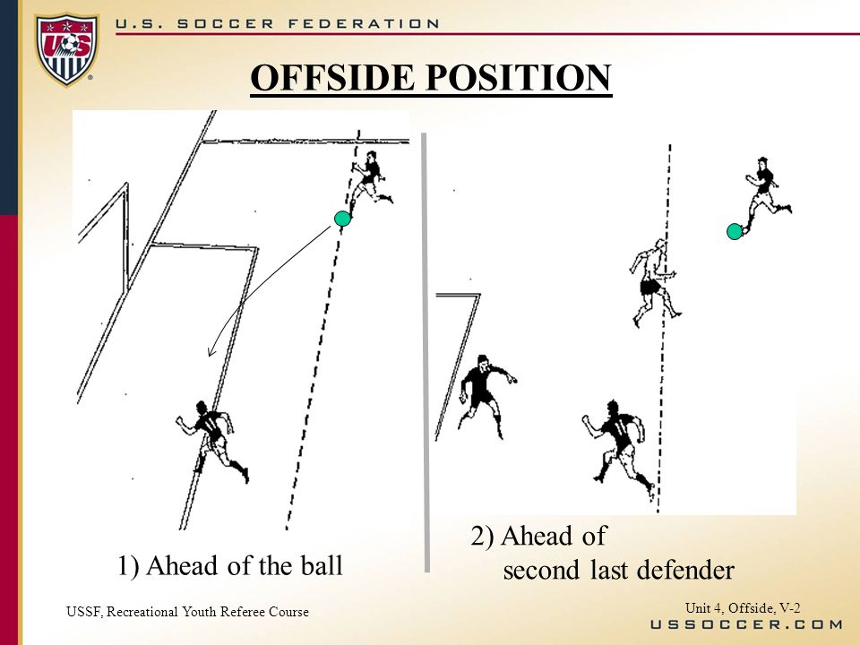

17

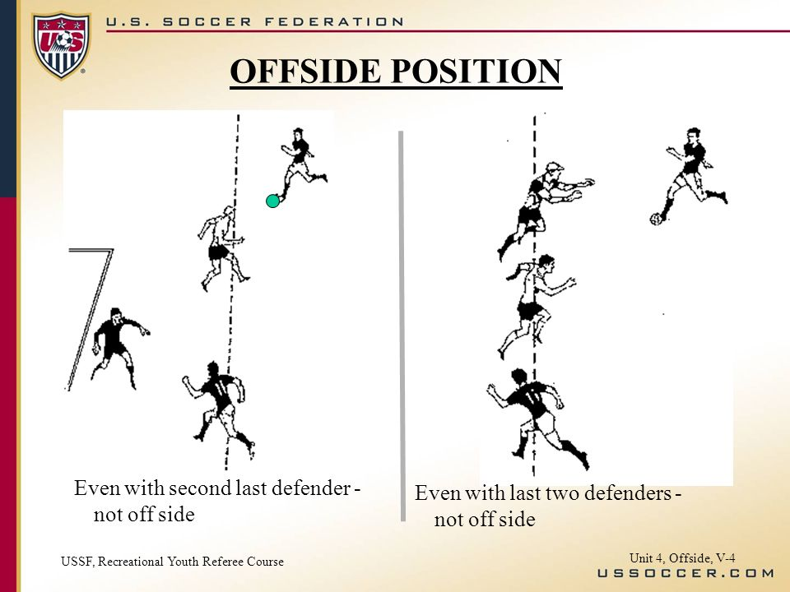

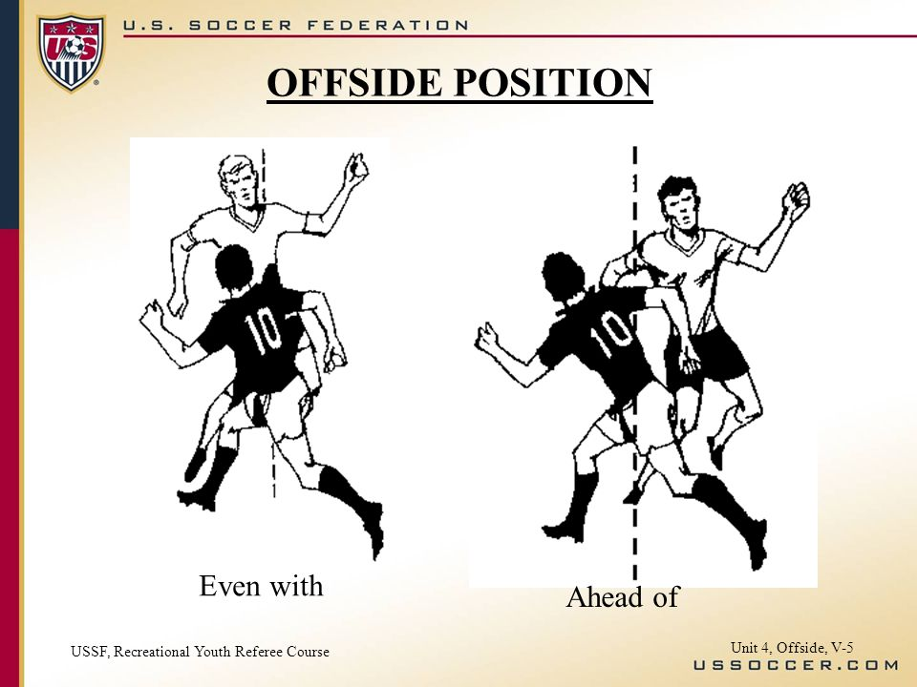

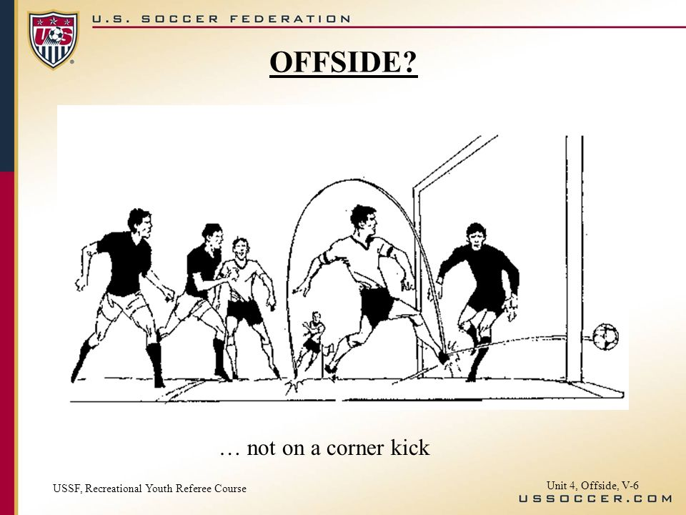

18

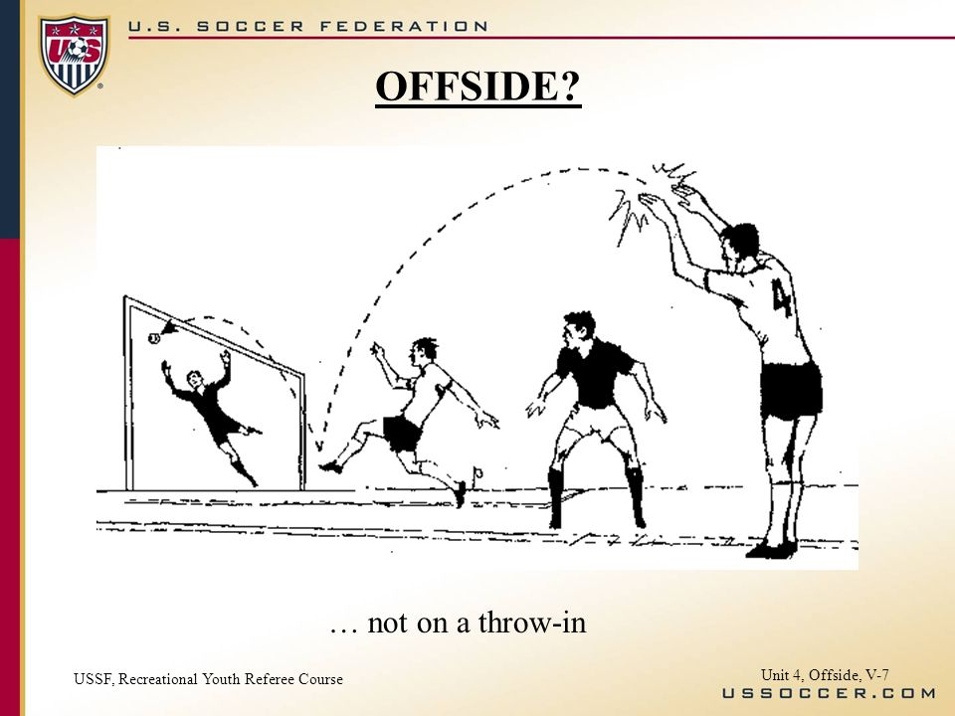

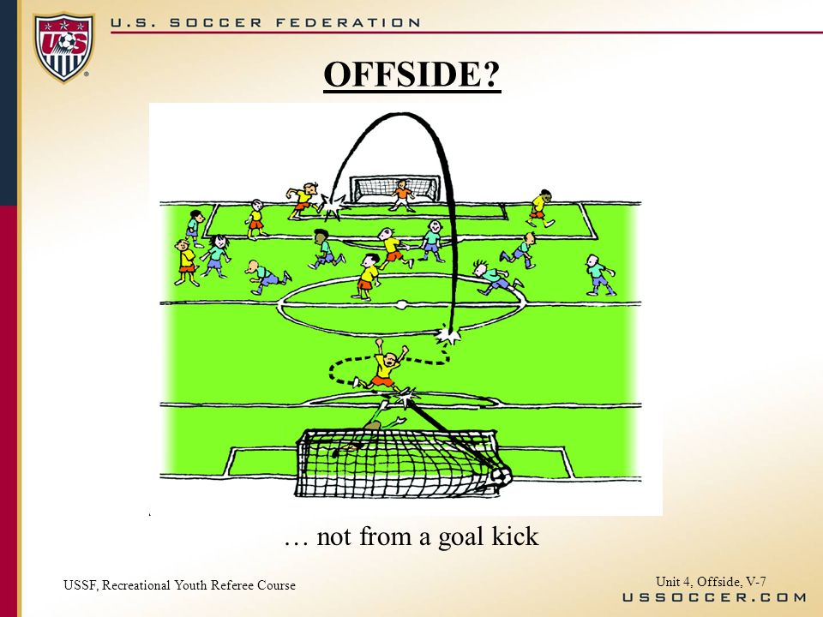

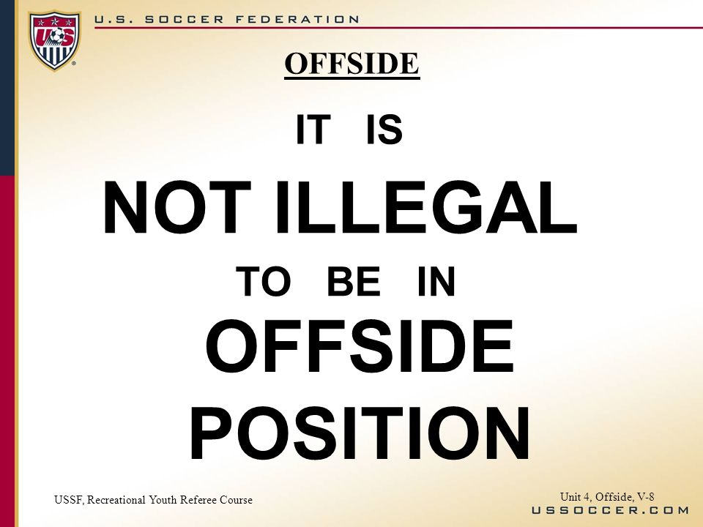

19

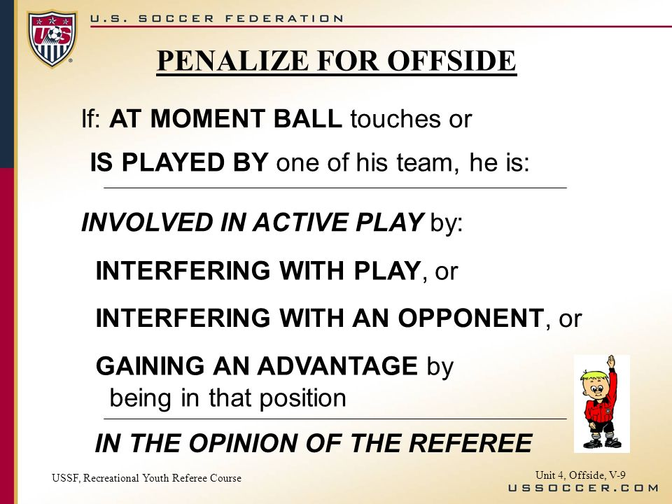

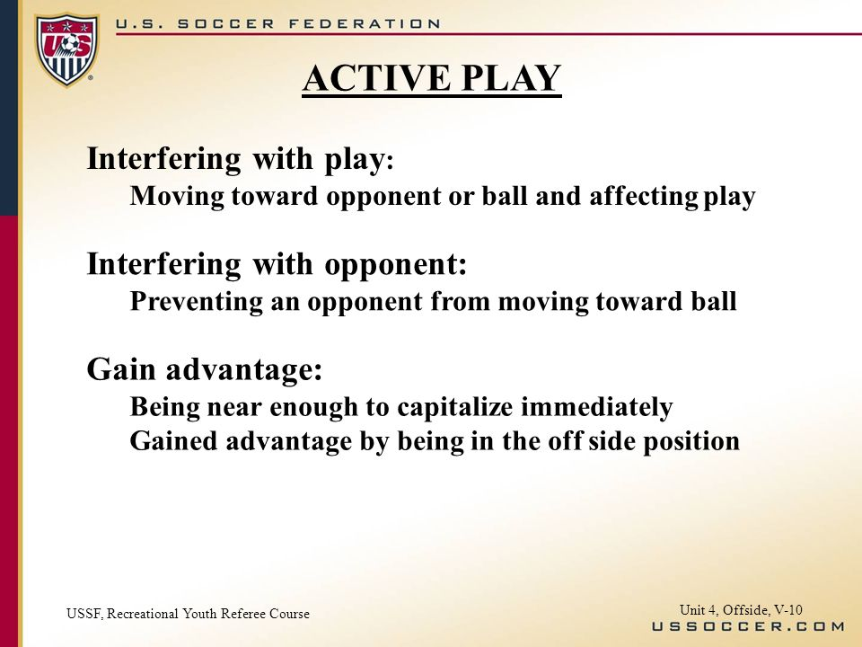

20

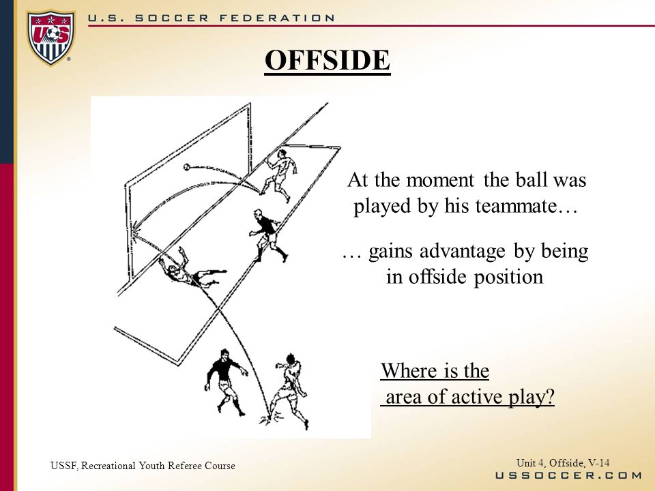

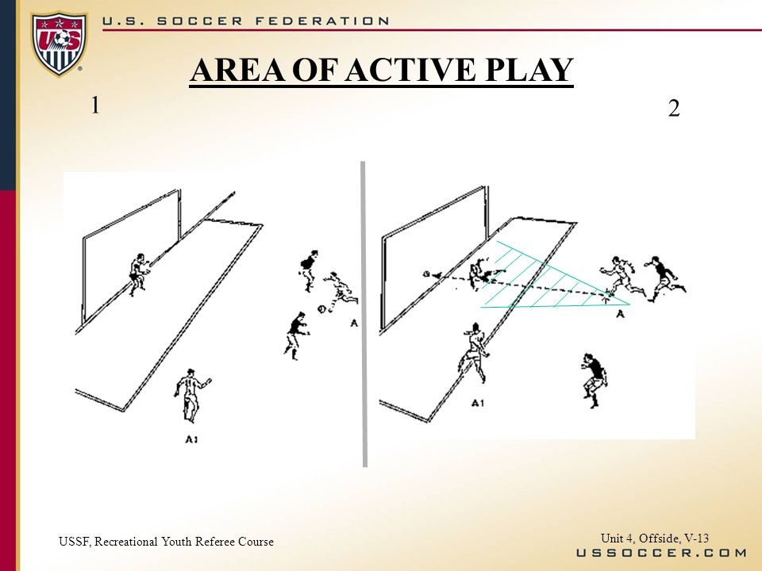

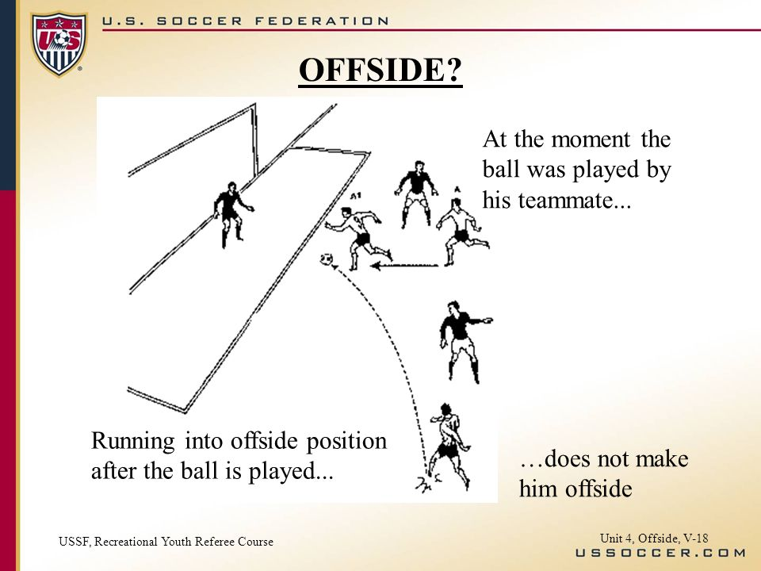

21

**14. Direct and Indirect Free Kicks**

* Free kicks shall be classified as “direct” from which a goal may be scored against the offending team or “indirect” from which a goal may not be scored unless the ball is touched or played by another player from either team.
* All free kicks, with the exception of penalty kicks (see Chapter “12. Penalty Kicks”), may be taken in any direction. Free kicks are taken from the spot of the foul except for restarts, which are taken from the location of the ball when the referee stopped play. Indirect free kicks for offside are taken from the spot where the offending player interfered with play, interfered with an opponent, or gained an advantage by being in that position.
* Any free kick awarded to the defending team within its own goal area may be taken from any point within the goal area.
* Any indirect free kick awarded to the attacking team within its opponent’s goal area shall be taken from the part of the goal-area line which runs parallel to the goal line at the point nearest to where the offense was committed.
* Any player on the offended team may take a free kick.
* Unless otherwise noted above, direct free kicks and indirect free kicks are awarded and taken from the point of the infraction.
* Players opposing the kicker shall be at least 10 yards from the ball until it is kicked.
* After kicking, the kicker may not play the ball until it has been touched or played by another player.

22

|  |  |
| --- | --- |
| *Major Direct Free Kick Offenses* | |
| OFFENSE | DEGREES |
| *TRIPPING* | **1.Careless 2. Reckless 3. Excessive** |
| *PUSHING* | **1.Careless 2. Reckless 3. Excessive** |
| *JUMPING* | **1.Careless 2. Reckless 3. Excessive** |
| *STRIKING* | **1.Careless 2. Reckless 3. Excessive** |
| *KICKING* | **1.Careless 2. Reckless 3. Excessive** |
| *CHARGING* | **1.Careless 2. Reckless 3. Excessive** |
| *TACKLING* | **1.Careless 2. Reckless 3. Excessive** |
| *SPITTING* | **There are no degrees for this offense. Automatic Red Card.** |
| *HOLDING* | **There are no degrees for this offense.It is just a "committed" offense. Direct Free Kick is Awarded.** |
| *HAND BALL* | **There are no degrees for this offense.It is just a "committed" offense. Direct Free Kick is Awarded.** |

* This chart indicates the degrees of the infraction the referee will use to determine if a yellow/red card is warranted.
* Prior to 2018, a hand ball in the goal box area was awarded a direct free kick as well as an automatic red card for the offender. Due to rules interpretations changes in NFHS Soccer and US Soccer, a hand ball that occurs in the goal box area that is deemed by the referee to be unintentional can be motioned to “play on”, or can still be awarded a free kick without the accompanying automatic red card. If the referee deems that the hand ball was intentional and/or denied an obvious goal scoring opportunity, a red card would apply as well as the direct free kick.

23

|  |  |  |  |  |
| --- | --- | --- | --- | --- |
| **THE 8 MAJOR OFFENSES FOR AN INDIRECT DIRECT FREE KICK** | | | | |
| *Use the chart below to know the major offenses that warrant an indirect free kick.* | | | |  |
| *\*\*\*Indirect Free Kicks can only occur as a DIRECT RESULT OF A FOUL* | | | |  |
| *OF THE 8 OFFENSES FOR AN INDIRECT FREE KICK:* | |  |  |  |
|  | ***4 CAN BE COMMITTED BY THE GOALIE*** |  |  |  |
|  | ***4 CAN BE COMMITTED BY THE PLAYER*** |  |  |  |
|  |  |  |  |  |
|  | GOALKEEPER OFFENSES |  |  |  |
|  | **1. Taking more than 6 seconds to release the ball** |  |  |  |
|  | **2. Releases ball and regains hand control of the ball before another player touches the ball** |  |  |  |
|  | **3. Touches the ball w/hands after a kick by a teammate** |  |  |  |
|  | **4. Touches the ball first with hands after a throw in by a teammate** |  |  |  |
|  | PLAYER OFFENSES |  |  |  |
|  | **1. Plays in a dangerous manner in PROXIMITY to other players that creates a dangerous situation (ex. high foot)** |  |  |  |
|  | **2. Impedes the progress of an opponent** |  |  |  |
|  | **3. Prevents the goalkeeper from releasing the ball** |  |  |  |
|  | **4. If play is stopped due to a player guilty of dissent, using offensive, insulting, or abusive language and/or gestures/verbal offenses** |  |  |  |

24

**15. Fouls, Misconduct, Yellow/Red Card Offenses**

* A penalty will be explained by the referee especially in the Boys 8-9 and Girls 8-10 divisions. The referee will clearly state the infraction to the player committing it. Referees will be sure to the player making the infraction understands the call. Remember, this is still an instructional league on the Boys 8-9 and Girls 8-10 level.
* A player who is cautioned will be given a yellow card. That player must leave the game at that point and cannot re-enter until the next substitution can be made. The coach can replace this player at the time of the infraction. The team does not play short-handed. A player receiving a red card during a game must be removed and cannot re-enter that game. The team now plays with one less player (short-handed) from that point on for the remainder of the game. This action will be reported by the referee to the referee coordinator who will in turn notify the league coordinator and President. Also, he/she cannot play in the next game in the league. Failure to leave the field will result in the game being forfeited. When three (3) yellow cards are given to a player for his/her infractions in that division in one season, he/she will be suspended for one (1) game. If that player gets another card of either color (yellow/red) he/she will be suspended for the remainder of the season. If any of these situations occur on the last game of the season, the penalty will carry over to the next season.
* A player shall not kick, attempt to kick, strike, attempt to strike, spit at, or jump at an opponent.
* A player shall not trip, or attempt to trip, an opponent. This includes tripping or attempting to trip an opponent by use of the legs, or by stooping in front or behind and opponent in such a manner as to cause a fall or loss of balance.
* A goalkeeper shall not strike or attempt to strike an opponent by throwing or kicking the ball at an opponent or by pushing an opponent with the ball while holding it.
* A player shall not hold or push an opponent with the hand(s) or arm(s) extended from the body. 25
* A player shall be penalized for charging an opponent in a dangerous or reckless manner, or using excessive force.
* A player shall not, in any manner, charge the goalkeeper in the penalty area unless the goalkeeper is obstructing the player or dribbling the ball with the feet.
* The goalkeeper in possession of the ball shall not be interfered with or impeded in any manner by an opponent.
* A player shall not participate in dangerous play, which is an act of official considers likely to cause injury to any player. This includes playing in such a manner which could cause injury to self or another player (opponent or teammate).

**YELLOW CARD OFFENSES**

1. "unsporting behavior" - this includes hard fouls; holding an opponent or deliberately handling the ball for the purpose of preventing an opponent from gaining possession of the ball; faking an injury; saying things that are designed to confuse or distract an opponent; harassment (such as jumping around, shouting or making gestures to intentionally distract an opponent; jumping in front of a corner kick, free kick or throw-in; worrying the goalkeeper or trying to prevent him from putting the ball into play; & adopting a threatening posture), gaining an unfair advantage by leaning on, climbing on the back of, or holding a teammate or the goal; blatant cases of holding and pulling an opposing player or his uniform; any action designed to deceive the referee; and behavior which in the Referee's judgment is unsporting or causes an unfair advantage,
2. dissent by word or actions,
3. persistently breaking the rules,
4. delaying the restart of play,
5. defenders failing to stay the proper distance away from the kicker on a corner kick, free kick or throw-in,
6. entering or re-entering the field without the referee's permission
7. deliberately leaving the field without the referee’s permission

26

**RED CARD OFFENSES**

1. Serious foul play: includes any use of excessive force or brutality against an opponent when challenging for the ball. Examples include a dangerous slide tackle from behind, or an "over the top tackle" in which a player raises his foot so the cleats could hit a player, or a two footed tackle that takes down the opponent. Any player who lunges at an opponent in challenging for the ball from the front, from the side or from behind using one or both legs, with excessive force and endangering the safety of an opponent is guilty of serious foul play. A tackle, which endangers the safety of an opponent, must be sanctioned as serious foul play.
2. violent conduct,
3. spitting at anyone,
4. deliberately touching the ball with a hand in order to prevent a goal or to deny an obvious goal scoring opportunity (such as to prevent a "Breakaway".... this does not apply to the goalkeeper within his own Penalty Box)
5. fouling an opponent to prevent an obvious goal scoring opportunity (e.g., holding to stop a breakaway),
6. using offensive, insulting or threatening language and/or gestures,
7. or receiving a second yellow card in one game.

27

**16. Head Balls**

Concussions continue to be a focus in soccer at all levels of competition. The NFHS has been at the forefront of national sports organizations in emphasizing the importance of concussion education, recognition, and proper management.

Discussion of proper concussion management at all levels of play in all sports has led to the adoption of rules changes and concussion-specific policies by multiple athletic organizations, state associations, and school districts. Coaches and game officials need to become familiar with the signs and symptoms of concussed athletes so that appropriate steps can be taken to safeguard the health and safety of participants.

Westfield FC rules amendments:

* Head balls are NOT PERMITTED in ANY divisions except Boys/Girls Seniors.
* Penalty for a head ball (considered a dangerous play) will be an award of an indirect kick to the opposing team at the spot of the infraction.

28

**17. Boys 6-7 and Girls 6-7 Division Rules**

* Game time:

1rst quarter – 10 minutes

2nd quarter – 10 minutes

3rd quarter – 10 minutes

4th quarter – Will run until 10 minutes before the hour (ex. game stops 9:50am)

* Players – 6 total on the field consisting of a goalie and 5 field players (3 front line and two on defense)
* Substitutions – On your team’s throw-in’s, if the throwing team with the ball subs players then both teams may substitute, after a goal, or on any goal kick or corner kick
* Throw-ins – Two (2) all season
* Penalties – Will be called and explained by the coach or referee if present
* Penalty shots inside goal box – NONE will be taken in this division. Any foul in the penalty box result in an indirect kick from the top of the penalty box.
* Offsides – NONE in this division
* Time stoppage – After goals, red/yellow cards, and for injuries
* PLAYERS MUST REMOVE ALL JEWELRY SUCH AS EARRINGS, STUDS, WRIST BANDS, ETC. SEE “SECTION 2. PLAYER EQUIPMENT”.
* Practices – One (1) per week

29

**18. Playoff Format**

Westfield FC rules amendment:

* Only Boys 10-12, Girls 11-13, and Boys/Girls Senior Divisions have playoffs.
* If a playoff game ends in a tie at the end of regulation the following procedures will be used:

1. Overtime – first team to score wins:

A. One (1) 10 minute period for Boys 10-12 and Girls 11-13

B. Two (2) 10 minute periods for the Seniors Division.

2. If no team scores in overtime, the game moves to penalty kicks

* Penalty kick procedures according to the Federation Rule Book.

a. Head referee designates a goal at which all kicks from the penalty mark are taken

b. Each coach selects 5 players, including the goalkeeper, on or off field (except those who have been disqualified) to take the kicks. Goalkeepers may be changed prior to each kick.

c. A coin toss decides the order of kicks – team winning the toss chooses whether they want to kick first or second

d. Team alternate kicks. There is no follow up on kicks. The ball remains alive until its’ momentum is spent, it goes out of bounds, or is retouched by the kicker. After five kicks, the team scoring the most goals wins.

e. if the score remains tied after five kicks, each coach selects five DIFFERENT players than the first five. (If there are less than 10 players available, all players are to be used before a player can be chosen to kick twice). This is now a sudden victory situation: each team gets 1 kick at a time: if one team scores and the other does not, the game ends with no more kicks taken.

f. The penalty kick sudden victory procedure continues until there is a winner.

30

**19. The Officials**

* The officials shall be a head referee and a referee, or a single head referee based on divisional requirements
* The jurisdiction of the official(s) shall begin on their arrival at the field of play and its immediate surroundings (to begin their official responsibilities) which shall be no later than 15 minutes prior to the start of the game and end with their leaving the field of play and its immediate surroundings.
* The officials shall perform all pregame inspections and meet with coaches.
* They shall enforce the rules, and their decisions on points of fact are final.
* The officials can only correct a decision so long as the game has not been restarted.
* The officials shall sound the whistle to stop, start, or restart play.
* The officials shall determine whether a goal should count.
* The officials shall administer yellow and/or red cards as deemed necessary for infractions by any players or coaches.
* The officials shall act as official time keepers.

Westfield FC rules amendment:

* Coaches, players, and spectators will not engage in any unsportsmanlike conduct with any official. As final authority, the coaches, players, and spectators will respect the authority of the officials during the game and will never question, discuss, or confront the officials at the game field, and will direct all inquiries to the Westfield FC Referee Coordinator or the Division Coordinator.

In diffusing disruptive situations, referees are trained to ASK…..TELL….DISMISS. Ask, Tell, Dismiss is intended to provide referees with a practical and flexible approach to resolve behavior issues with team officials. It is important to note that dismissing a coach, player, or other team official does not require that each step of the process be followed. In cases where behavior is overly disruptive, blatant, or serious, the referee is always authorized to bypass any warning and immediately issue a dismissal. 31