Technical documentation

A50 MOTOR

Requests for quotation to : [contact@rov-expert.fr](mailto:contact@rov-expert.fr)

***Description :***

The A50 motor is designed for easy integration on any type of ROV, USV, or AUV. Robust and durable, it has been engineered for maximum longevity and easy maintenance. Assembled in France. 2-year warranty. Worldwide exclusive distribution by ROV EXPERT.

**Advantages:**

✅ **Ball bearing motor** — Increased reliability and durability, with reduced heat generation

✅ **Optimized cleaning** — Front and rear vents for easier cleaning and lubrication

✅ **Rotating cone without support arms** — Ensures more stable laminar flow and reduces turbulence

✅ **Aluminum propellers available as an option** — Enhanced robustness and reduced risk of entanglement with algae or debris

✅ **Repair-friendly design** — Simplified maintenance and easy parts replacement

✅ **2-year warranty** — Covers parts and labor in case of breakage under normal usage conditions

***Photos :***

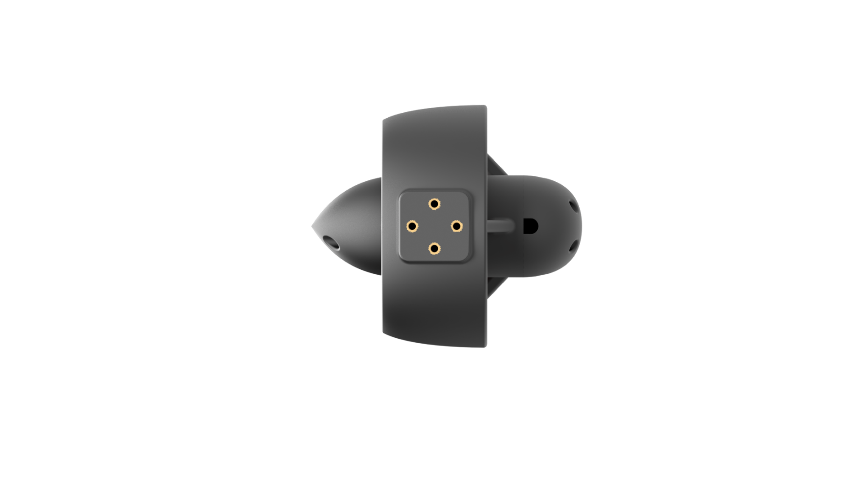 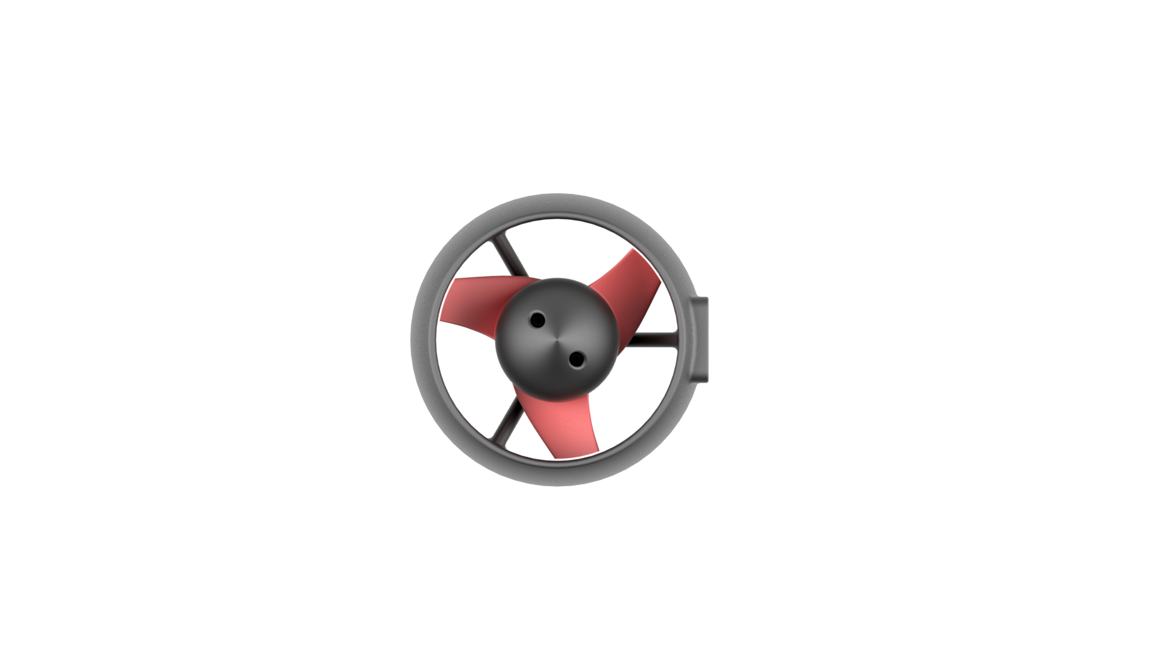

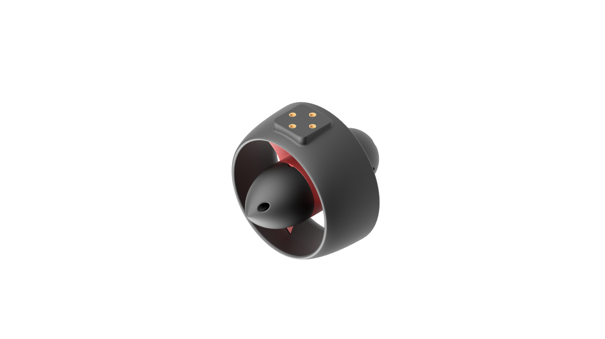 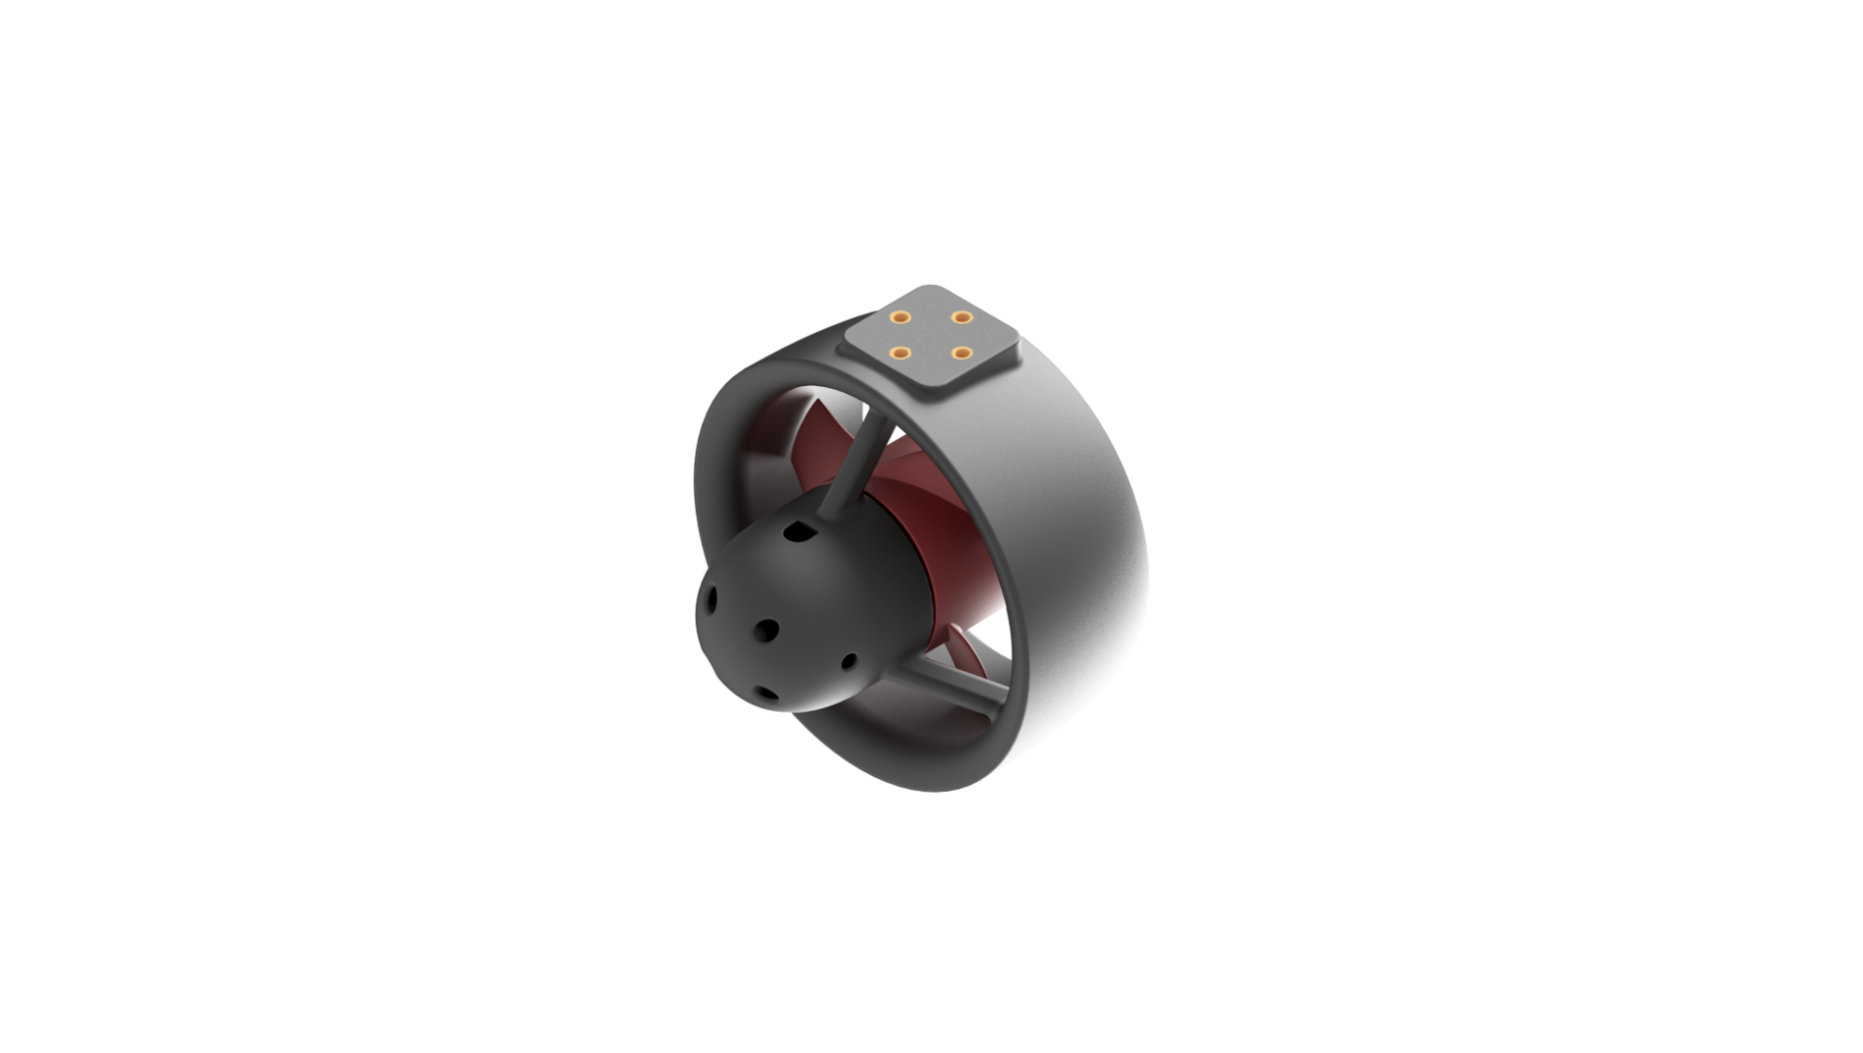

*A50 Motor*

***Technical diagram :***

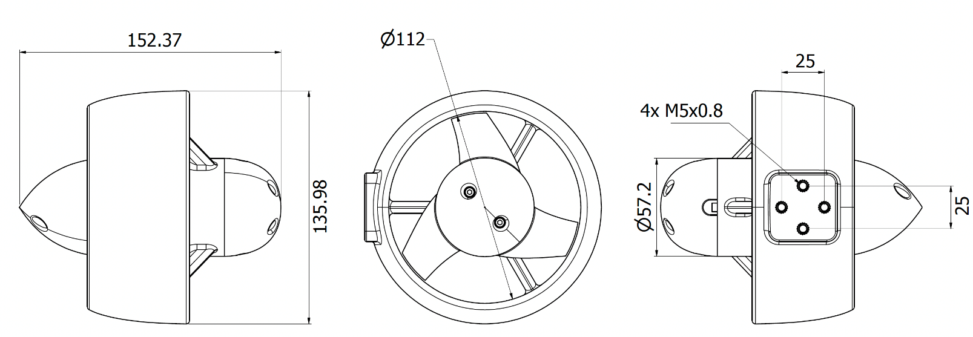

*A50 Motor*

**Specifications:**

|  |  |
| --- | --- |
| Cable | 1 meter – 3*12 AWG |
| Propeller Material | Anodized aluminum or Polycarbonate with 30% glass fiber, depending on selected option |
| Body Material | Polycarbonate with 30% glass fiber |
| Fastener material | Titanium Grade 2 |
| Continuous Power | 1000 W – 12 to 24V |
| Peak Power | 1300 W |
| Speed | 2000 - 8000 RPM |
| KV Rating | 300 |
| Overall Dimensions | Length 152.37 mm – Diameter 135.00 mm |
| Core Diameter | 58.00 mm |
| Propeller Diameter | 110.00 mm |
| Mounting Hole Spacing | 25 mm - 25 mm en M5 |
| Termination options | - None (1m pigtail)  - Bluetrail Cobalt 14 3 Pins  - Overmolding  *Note : Not compatible with Wetlink* |

**Contact:**

For any quote request or information about the full Subseatronics range (thrusters, ROVs, accessories), contact ROV Expert at the following address: [contact@rov-expert.fr](mailto:contact@rov-expert.fr)

