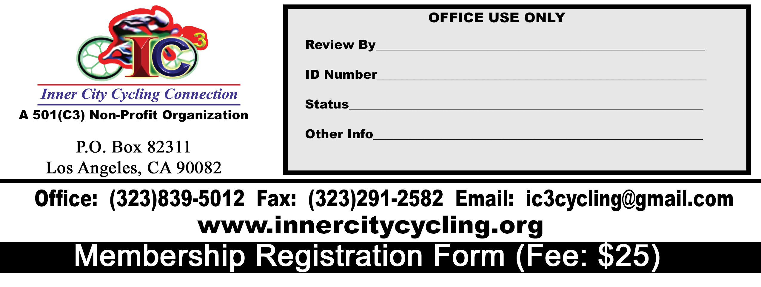
TODAY’S DATE: _____________________________________________
MAKE ALL CHECKS/MONEY ORDER PAYABLE TO INNER CITY CYCLING CONNECTION, INC.

APPLICANT INFORMATION (Please Print Clearly)
Applicant Name
 | Mr./Ms./Mrs. |  |  |  |  |  | First Name M.I. |  |  |  |  | Last Name
Mailing Address
 | Address |  |  | Street |  |  |  |  |  |  |  |  |  |  |  | Apt. #
 | City |  |  |  |  |  |  |  |  |  |  |  | State |  |  | Zip Code
Contact Information
 | ( ) |  |  |  |  |  |  |  | ( ) |  |  |  |  | ( )
 | Day Time Phone No. |  |  |  |  |  |  | Evening Phone No. |  |  |  |  |  |  | Cell Phone No.
 | Fax No.: ( ) --
 | Email Address:
 | Birthday:
Are You A Cyclist? | Yes [ ] No [ ] |  |  |  |  |  | Payment Type: Online Pay Via IC3 Website [ ] Cash [ ] Check [ ] Money Order [ ]
QUESTIONAIRE
(Please take a moment and answer the questions below so that we can continuously improve on our quality of service)
How did you hear about us?
Do you have any prior professional bicycle racing experience? If yes, how many years?
Name of professional races you participated
Are there any professional cyclist in your family? |  |  |  |  | Yes [ ] No [ ]
Other service(s) or races you would like to see IC3 develop
Additional comment(s)
MEMBERSHIP FEE IS $25 ANNUALLY. YOU CAN PAY THIS FEE AND FILL OUT A MEMBERSHIP APPLICATION ON OUR WEBSITE. JUST CLICK THE MEMBERSHIP LINK LOCATED UNDER APPLICATION FORMS. THE PAYPAL PAYMENT BUTTON IS ON THE BOTTOM OF THAT PAGE. YOU MAY ALSO PAY IN PERSON BY CASH, CHECK, OR MONEY ORDER.

After filling the form out, please email it to ic3cycling@gmail.com or drop it off at a designated location.

I HAVE READ ALL THE TERMS AND CONDITIONS SET FORTH IN THIS CONTRACT AND UNDERSTANDS THEM FULLY

Signature of Applicant_______________________________________________________________________________DATE______________________________

