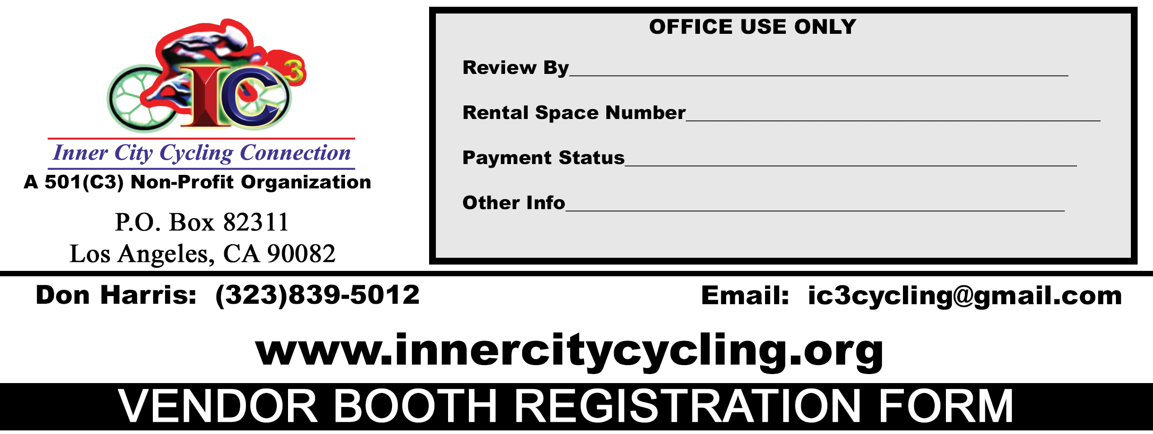
COMPANY INFORMATION (Please Print Clearly)
Company Name/Name of Booth (DBA)
Name of Owner

Name and Date of Event

COMPANY CONTACT INFORMATION (Please Print Clearly)
Mailing Address
 | Address |  | Street |  |  |  |  |  |  |  | Suite #
 | City |  |  |  |  |  |  | State |  |  | Zip Code
Contact Information
 | ( ) -- |  |  |  | ( ) -- |  |  |  | ( ) --
 | Day Time Phone No. |  |  | Night Time Phone No. |  |  |  |  |  | Cell Phone No.
 | Fax No.: ( ) --
 | Email Address:
Booth Type | Arts & Crafts Booth/Other Business Payment Amount: $ Food Booth Payment Amount: $
Special Notes

****NOTICE****

I ACKNOWLEDGE THAT I, MY EMPLOYEES OR VOLUNTEERS WILL NOT BE COVERED UNDER ANY OF THE SPONSOR LIABILITY INSURANCE FOR ANY INJURY INCURRED OR CAUSE AS A RESULT OF MY PARTICIPATION IN THE ABOVE MENTIONED EVENT/ACTIVITY BUT WOULD BE RESPONSIBLE THROUGH PERSONAL INSURANCE FOR ANY AND ALL MEDICAL EXPENSES INCURRED AS A RESULT OF INJURIES FROM THIS PARTICIPATION.

I UNDERSTAND I AM COMPLETELY RESPONSIBLE FOR ALL LIABILITIES, DAMAGES, AND INJURIES I, MY EMPLOYEES, MY VOLUNTEERS OR MY PARTICIPANTS MAY CAUSE TO INNER CITY CYCLING CONNECTION, INC. & ITS ASSOCIATES, ITS MEMBERS, EMPLOYEES, AND ALL THIRD PARTIES (E.G.: SPECTATORS, BUYERS, ETC.) AS PART OF MY PARTICIPATION IN THIS EVENT INCLUDING DAMAGES OR INJURIES CAUSE BY MY EQUIPMENT, FOOD, DISPLAYS, VEHICLES, AND SUPPLIES AND INCLUDING ANY AND ALL INJURIES OF ILLNESS MY PRODUCTS MAY CAUSE.

I HEREBY EXPRESSLY WAIVE AND RELEASE INNER CITY CYCLING CONNECTION, INC. (IC3) AND IT ASSOCIATES FROM ANY AND ALL RIGHTS OR CLAIMS OF ANY NATURE WHATSOEVER I MAY HAVE AGAINST INNER CITY CYCLING CONNECTION, INC., ITS ASSOCIATES, ITS MEMBERS, EMPLOYEES ARISING OUT OF, IN CONNECTION WITH, OR RESULTING FROM THE ABOVE EVENT/ACTIVITY.

IN ADDITION, BY SIGNING THIS CONTRACT/REGISTRATION FORM, I AM AGREEING TO ALL TERMS AND CONDITIONS SET FORTH WITHIN.

- ___________ (MEDIA RELEASE) I give permission for photos, video footage, and voice of you and your employees taken at INNER CITY CYCLING CONNECTION, INC. and it related functions to be used for all promotional purposes (website, myspace, facebook, magazine, flyers, posters, television, radio, etc.)

I HAVE READ ALL THE TERMS AND CONDITIONS SET FORTH IN THIS CONTRACT AND UNDERSTAND THEM FULLY

Vendor Booth Representative Signature_____________________________________________________________________DATE____________________

