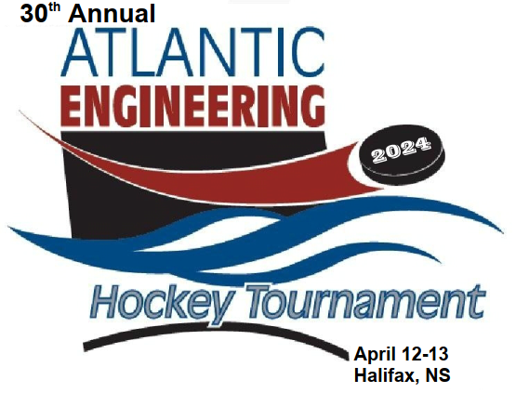
2024 ATLANTIC ENGINEERING HOCKEY TOURNAMENT (AEHT)
Introduction
We are pleased to announce that the 2024 Atlantic Engineering Hockey Tournament (AEHT) will be held in Halifax, Nova Scotia on April 12th-13th, 2024.
This annual hockey tournament has been held at various locations throughout the Atlantic Provinces over the past thirty (30) years. It was last hosted by Halifax in 2017. Prior to that, Halifax hosted the event back in 2011.
This year, we are hoping that there will be sixteen (16) teams - teams from Newfoundland, New Brunswick, Prince Edward Island and Nova Scotia.
Last year’s (2023) tournament was successfully held in Charlottetown, Prince Edward Island (PEI), with fifteen (15) teams competing.
Please contact the organizing committee members (next page) if you want to play and/or enter a Team.
The first sixteen (16) Teams to register are eligible to play.
In order to deliver a hockey tournament of this size here in Nova Scotia, the 2024 AEHT organizing committee is seeking financial support to help offset some of the associated costs that will be incurred.
Posters and banners listing all tournament sponsors will be displayed at the Arena facility, as well as at the tournament social banquet, to acknowledge all companies that have provided support to this event. In addition, each player participating in the tournament will receive a flyer/pamphlet containing the logos of all sponsors.
This tournament provides a very affordable and good promotional opportunity/exposure for companies - as previous organizers have received positive feedback from the sponsors.
There are different levels of sponsorship, depending on the amount given (shown below). Any and all financial support is much appreciated.
Sponsorship Levels
Bronze | Up to $250
Silver | $251 - $500
Gold | $501 - $1000
Platinum | $1001 or more

If you are interested in playing, entering a Team and/or providing financial support to this event, please contact one of the following members of the tournament organizing committee:
Tournament Organizing Committee
Name | Email address | Phone #
Scott Moore | smoore@dillon.ca | 902-223-8350
Mike Nicholson | mike.nicholson@eastpoint.ca | 902-440-8165
Adam McCarthy | adam.mccarthy@stantec.com | 782-774-2711

A member of our committee will call you within the next three (3) weeks to follow up this request.
Thank you for your attention and consideration.

Yours truly,
2024 Atlantic Engineering Hockey Tournament (AEHT)
Organizing Committee Members

Catch the Action
Teams from PEI, NB, NS & NL

Friday, April 12, 2024
+
Saturday, April 13, 2024

Halifax Forum & Civic Centre
Halifax, Nova Scotia

(Website name to follow)
+
(Hotel Accommodations to follow)

