8. Concluding Comments and Some Poems

In closing, I want to remind everyone that my second book about the Texas coast titled A Texan Plan for the Texas Coast has been published by Texas A&M Press and is available from them directly as well as from Amazon and various book shops around Texas. This book focuses upon private sector action and creative thinking to discover new ways to protect this wonderful coast of ours that we cannot depend upon our state government to protect. The reality is that we must take responsibility for its future. That’s just the way it is in 2018 on the Texas coast. Also, for those of you who enjoy my bird poems and the art of Isabelle Scurry Chapman, we have a new book of bird poems and paintings titled Hill Country Birds and Waters: Art and Poems. This book is about Hill Country birds and the springs and seeps upon which they depend, the same springs that provide water needed for freshwater inflow to our bays and estuaries. Please contact me at jbb@blackburncarter.com to find out about getting a copy which should be available in early January if not before.
Every year, I close my Coastal Newsletter with some poems that are not yet included in any of these books, and this year I have added a couple of paintings by Isabelle Scurry Chapman. I hope you enjoy these. And if you liked this newsletter, please pass it on to others. Happy holidays.

Black Tern

At the flats behind Rollover Pass in the spring
With environmental lawyer Oliver Houck.

The wind is blowing strong, in from the Gulf, Pushing water though the pass,
Creating turbulence and feeding flats For the beautiful dark tern that dives Into the water and pops up swallowing.

A banquet of birds sits on the sand spit –
Avocets and plovers, gulls and terns,
A white phase reddish egret running here, The great blue heron fishing there,
All part of the chapel I call Earth Church, A place where I come to renew my soul, Reopening the clotted arteries, Circulating into the essence that is me, Spiritual nourishment I inhale
To realign my compass in the hope
Of clearly seeing the path forward
To make better use of this gift of life
Given to me upon arrival on Earth,
A holy place I share with the black tern That helps me in ways I cannot explain, And I recommit to protect this church
That I rejoin at Rollover Bay in the spring 2018.
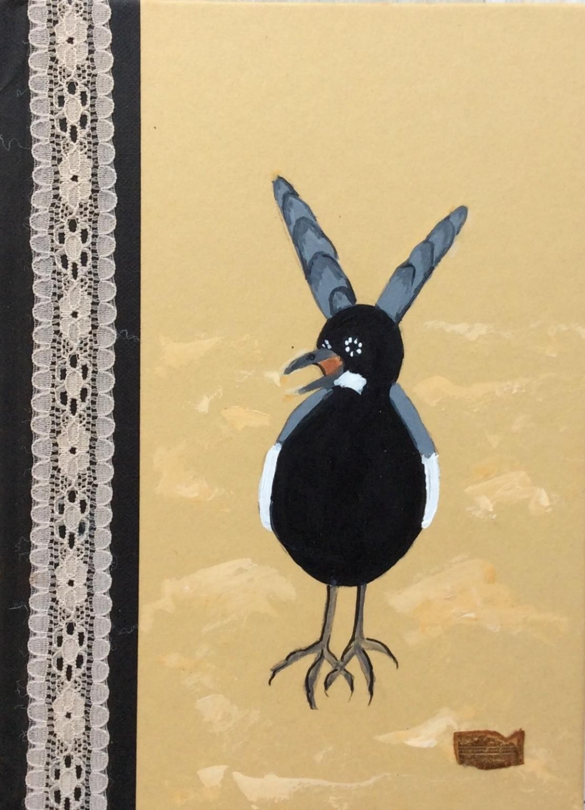
Figure 8. Black tern by Isabelle Scurry Chapman.

29
Chestnut-Sided Warbler

On South Padre Island during migration
In the spring of 2018.

The island is full of warblers of all description, Small birds of varied yellows and grays,
Birds often hard to tell one from another,
But then the small bird lands above my head
And my eyes feast upon a slash of chestnut color
Along the breast, below the wing,
The chestnut side proclaiming the name of the bird.

My mind leaps from the chestnut stripe To what is often missing from society, The ability to believe in what one sees,
A gift seldom to rarely found among humans,
Honesty and its partner integrity, descriptive
Terms of who and what I seek to be, Honesty and integrity often missing from
The day-to-day hustle of Houston post-Harvey, Honesty that would lead us to call out the crooks, The sycophants, the false voices pursuing money In spite of harm to others,
In spite of harm to the environment,
In spite of our best information, In spite of knowing better.
I turn back to gaze at the chestnut slash
And smile that today I found honesty In the name of the migrating warbler And it made me feel better
On South Padre Island in the spring.

The Black Rail

The sound comes from within the marsh, Answered immediately by a kindred soul
In the tall wet grass on the other side of the bayou,
Luring the shy little marsh chicken into the air,
The relatively small black form awkwardly flapping
Across the bayou to quickly hide away again.

The black rail is threatened, struggling to survive, Challenged by the loss of habitat,
Challenged by the sea level that is rising slowly,
Creating the need for the marsh to expand
Into the adjacent land that is claimed and occupied, A conflict between the past and the future,
A conflict that the black rail may not survive, A war being played out across the Earth
That we have changed by our actions,
The warming climate evidence of the harm Done by my species, done by me and us all, A change that reaches far and wide.
The black rail calls again, asking me to act, Asking me to find the spiritual strength to Push the oil giants and the gas producers and All of us to do better, to be
Stewards of the Earth that gives us gifts
Like the black rail flying to meet its mate
On the other side of the bayou.

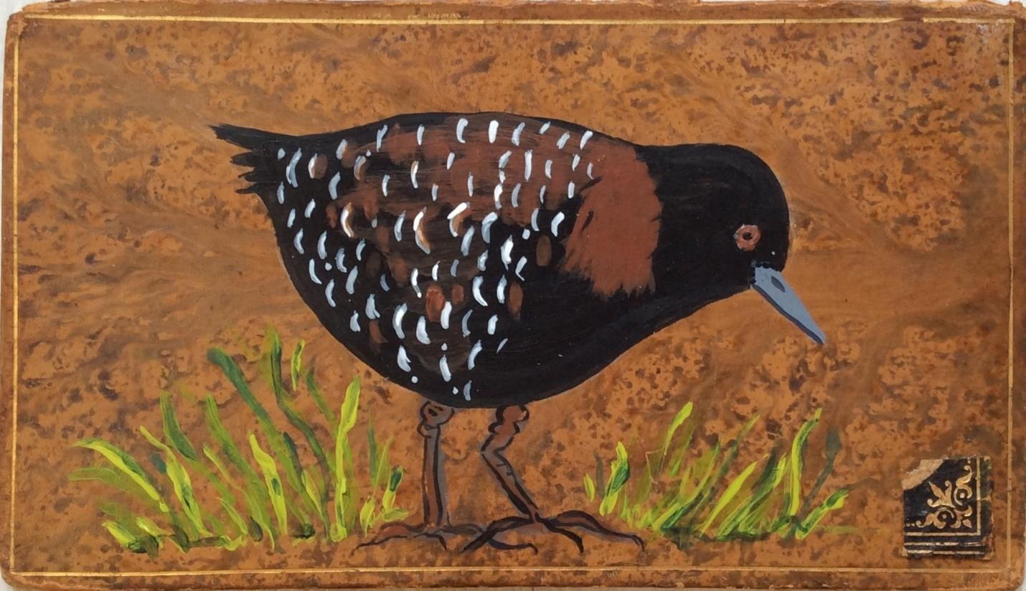
Figure 9. Black rail by Isabelle Scurry Chapman.

Marsh Hawk (nee Harrier Hawk)

At Anahuac and again at Atwater National
Wildlife Refuge, searching for my spirit
As the wind blows across the prairie grasses. The light hits the tops of the brown grasses,
Amplifying the color, telling me it is winter, The time of retreat, of shelter, of refuge,
Cold weather trying to keep me from the outdoors That I love and will not abandon during the short Days in the time of the remote sun.

The hawk flies low over the grasses,
Eyes fixed for any movement indicating food, Wings caressing the air, floating in motion, Coaxing buoyancy from the nothingness, Then altering its feathers and crashing down
To land upon an unsuspecting, foraging field mouse.

The marsh hawk speaks to me Of the timelessness of nature, Of the absence of clocks,
Of the absence of records,
Representing constancy,
Reminding me of when I was a boy who saw
The low-flying hawk with the white-banded tail, A hawk that talked to my soul
About connection, about linkage, about life,
A hawk that today speaks to my spiritual essence
In a language that I understand but cannot explain,
My spiritual-self contacted, resurrected and revitalized
By the simple sight of the marsh hawk flying over
The golden prairie grasses in the winter. Until next year. Blackburn

