**Archer's Edge Broadhead Target**



**Makers of The Morpheus Mechanical Broadhead**

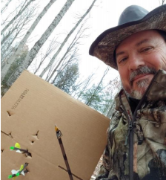Field testing of the **Archer's Edge Broadhead Target System** was recently completed. A small production run using 3D printed parts will be completed to have others test the concept before I commit to a larger production run of injection molded parts.

The idea behind the concept is to use cheap cardboard boxes, (all of equal size) and which you purchase separately. A special holder allows mechanical broadhead users the opportunity to practice with their actual hunting heads. As any mechanical broadhead user knows there is currently no good solution out

there for this....**until now**!

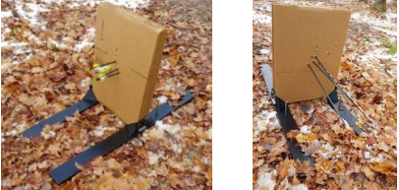Some mechanical broadhead manufacturers provide a special practice tip or two which are said to fly like the real tip, but you usually get no more than 2 of these in a package. This means that when you set up to practice at 30 yards you have to walk 60 yards every two shots!. No shooting rhythm is possible, and two arrows do not constitute a “grouping”. You

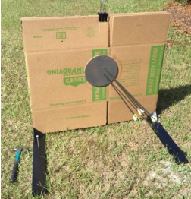also never really know how the real tip will fly until you take the crucial shot. I believe it is important to have every confidence in your equipment and in your ability to use it. This can only truly happen when you are shooting actual broadheads in practice.

The cardboard also tells the tale of how the head is deploying its blades at both entrance, through wound channel creation, and exit locations.

The multiple layers let you see just how the blades are deploying through the entire thickness, layer by layer, something that cannot be done in a

conventional target and something you really

want to know.

Cardboard of any size can be used up to about 3’ x 3’. The holding brackets will accept the heavy-duty boxes (dish packs) as well for those who need more material to shoot into like cross bow users. If you need a barn door sized target starting out, well, so be it. You’ll get better as you practice:

The cardboard layers make extracting the broadheads easy and safe from damage which is impossible to do in a bale of hay or other conventional archery targets. Everyone knows you can’t pull a mechanical broadhead out of a target backwards without risk of damaging it in some way.

You will soon learn just how many layers you will need for your particular bow/broadhead combo. Full penetration but not all the way through as you see in the images above is the ideal. No tools are required to assemble the device and everything packs away into a small box which can be used over and over. The base is made of identical slats that fit together to form a plank. Generally, 3 slats is sufficient, but if you are using larger targets, four slats might be needed.

Patent Pending

Here some of the key features:

• Make your target the size you want it to be or buy our replacement target panels from www.morpheusbroadhead.com!

• Know how your mechanical broadhead performs in blade deployment, from impact through wound channel creation and exit.

• Easily extract your mechanical broadhead due to multiple layers of cardboard.

• Folds up and fits into a small package 7” x 3 5/8” x 24 inches.

• ABS plastic parts are easily replaced if an errant shot takes one out. (Each sold separately on web site.)

• No tools are required for assembly.

* Corner reinforcer/target clips are used to ensure the target package arrives without corner damage and serves as a clip which grasps the 24” x 24” target paper.

Assembly instructions.

1. Remove the parts from the box. There should be the following:
   1. Eight identical base segment pieces.
   2. Four spikes. (lollipops).
   3. A pair of metal rods on a carpet

      Description automatically generatedTwo female end caps:
   4. Two male end caps:
   5. A black vent on a carpet

      Description automatically generatedTwo bottom brackets:
   6. One top comb:

When all four segments are attached and end caps installed and bottom bracket slid onto the newly created “plank”, it will look like this:

The comb is used to keep the layers of cardboard equally spaced and secure during target proactice.

The spikes are used to anchor the two assemblies to the ground and to serve as a stop to keep the target bracket from walking back after arrow impacts.