TRAINING SITUATION DOCUMENT

FOR

PROGRAM NAME
PROJECT NAME

SECURITY CLASSIFICATION: UNCLASSIFIED

Day Month Year

Issuing Government Activity:
Name

Prepared by:
Name
Address
Address

Controlled by: Department of the Navy
Controlled by: Command Name
CUI Category: PRVCY
Distribution/Dissemination Control: FEDCON
POC: First Last Name
email, phone number

CONTROLLED UNCLASSIFIED INFORMATION
DISTRIBUTION D. DISTRIBUTION AUTHORIZED TO DOD AND U.S. DOD CONTRACTORS ONLY FOR ADMINISTRATIVE OR OPERATIONAL USE, 25 APRIL 2016. OTHER REQUESTS FOR THIS DOCUMENT SHALL BE REFERRED TO: COMMANDING OFFICER, <Name of Executing Organization>
DESTRUCTION NOTICE - FOR CLASSIFIED DOCUMENTS, FOLLOW THE PROCEDURES IN DoD 5220.22-M, NATIONAL INDUSTRIAL SECURITY PROGRAM OPERATING MANUAL (CHANGE 2 MAY 18, 2016), CHAPTER 5, SECTION 7 OR DoDM 5200.01 VOL 3 ENCLOSURE 3. NON-RECORD FOUO DOCUMENTS MAY BE DESTROYED BY ANY OF THE MEANS APPROVED FOR THE DESTRUCTIONS FOR UNCLASSIFIED, LIMITED DOCUMENTS, DESTROY BY ANY METHOD THAT WILL PREVENT DISCLOSURE OF CONTENTS OR RECONSTRUCTION OF THE DOCUMENTS.

This page intentionally left blank.

(U) EXECUTIVE SUMMARY (Executing Organization)

The United States Navy has recognized a need to modernize its training to meet the requirements of the rapidly changing 21st century battle space through Sailor 2025 (S2025) Ready Relevant Learning (RRL). Today’s Sailors must be able to fight and win against all adversaries now and in the future. A highly trained and dynamic Naval Force is essential to increasing and maintaining Fleet readiness. Today’s training needs to be agile, mobile, and dynamic to teach the essential knowledge and skills in the current environment. A modernized integrated content development process and delivery system provides a competitive advantage over our adversaries. Integrating brick and mortar schoolhouses with hands-on labs, flexible waterfront training, and mobile distance learning with current content, modern technology, and complete learning continuums is the focus of RRL. One such rating undergoing transformation is the <Add Project Name.> Example Steelworker (SW), which is supported by S2025 RRL Steelworker - Accelerated Delivery (SW-AD) referred to as “SW project.”

<Name of Executing Organization> was requested to produce and deliver RRL Analysis products for the <Project Name> Maintenance Accession training. The analysis consists of multiple analyses that will be used to determine the current “As Is” state of the existing training and to recommend the “To Be” training. A Needs Assessment (NA) was conducted that identified a Training Situation Analysis (TSA) should be conducted and documented in this Training Situation Document (TSD). The TSD is the first of several documents that provide required documentation for the current and future training. This TSD informs the subsequent documents, the Instructional Performance Requirements Document (IPRD), the Instructional Media Requirements Document (IMRD), the Military Characteristics Document (MCD), and the Instructional Media Design Package (IMDP).

This TSD will baseline current training and related training materials, training equipment and facilities, and an assessment of current and emerging training technologies.

(U) Purpose (Executing Organization)
The purpose of the TSD is to define the “As Is” current state of training and current-emerging training technologies. The TSD is an acquisition document outlining the current state “As Is” state of training that will be used as a reference of what is current to the new “To Be” state in the acquisition of the new training products that will be purchased on content conversion contracts.

This TSD was developed In Accordance With (IAW) tailored Data Item Description (DID) DI-SESS-81517C, Department of Defense (DoD) Training Data Products Military Handbook (MIL-HDBK)-29612 associated volumes, and other policy documents specified in the methodology. This TSD is Executing Organization’s culminating analysis and Type Commander (TYCOM)-approved requirement for the <Project Name> (XX) modernization, which includes <Add content> Example XX “A” School, Block 0, A-711-0005A CH 2, and XX “A” School, Block 1, A-711-0006.

(U) Background (Executing Organization)
The primary mission of the <Project Name> is <Add content>. Other missions include <Add content>

Per the <Project Name> Naval Training System Plan the <Project Name> <Add content>.

The <Project Name> operates from <Add content> locations
The <Project Name> training program consists of <Add content> training for <Add content> personnel.

The <Project Name> ships/squadrons/etc. are situated at locations that currently operate from the Continental United States (CONUS), forward bases overseas, and aboard Naval vessels.

(U) Methodology (Executing Organization)
Thorough analysis is key to design, development, and acquisition of effective training and performance support systems. The TSA was conducted by the Analysis Team comprised of research psychologists, instructional designers, and subject matter experts (SME). The Analysis Team worked collaboratively to capture needed data from <Add name> “X” School instructors and Learning Center <Add name> personnel. All attendees are noted in Table 3X. The Analysis Team-related activity was IAW the following United States Navy (USN) guiding documents:

- Navy Training Process (NTP)
- Plan, Analyze, Design, Develop, Implement, Evaluate, and Maintain (PADDIE+M) Process
- Instructional Systems Development (ISD)/Systems Approach to Training (SAT)
- Military Handbook (MIL-HDBK-29612-2A)

The methodology used for this analysis was a Training Situation Analysis (TSA) for the <Project Name> training and related training materials, a review of currently utilized training equipment and facilities, and an assessment of current and emerging training technologies.

In determining the current state of training, the training and facilities were analyzed to gain an appreciation of the challenges associated with today’s <Project Name> training environment. The analysis tracked what is currently taught, including each method from schoolhouse training and computer-based training. Based on the analysis data, recommendations are provided. Further analysis will occur during the Task Analysis and Media Selection to determine the appropriate Maintenance Training improvements for modernization.

Training Situation Analysis (Executing Organization)
The TSA provided the existing “As Is” training state to better evaluate the impact of the training challenges facing the maintenance forces, several high-impact issues facing the <Project Name> maintainer, and issues that the warfighters themselves have identified for resolution. The discussion that follows serves to recap some of the major issues with potential recommendations for resolution--recommendations made in collaboration with the warfighter to help them build an effective maintenance training environment.

Title
<Add content see example>

Title
<Add content see example>

Technology Assessment (Executing Organization)
Once the TSA and impacts were determined, an initial assessment of the state-of-the-art capabilities was conducted. This assessment included items such as features under development, electronic classrooms, and virtual and synthetic training systems, as well as human factors associated with learning networks, which will be further analyzed during the media selection. The review of equipment requirements resulted in development of a Training System Risk Assessment and Mitigation Plan (RAMP). Risk management--in the context of this study--is the recognition, assessment, and attempted control of training system situations that may result in additional training costs, schedule delays, performance problems, or other undesired consequences affecting the ability of the <Project Name> community to perform its mission and conduct training.

(U) Summary (Executing Organization)
With the completion of the TSD, the analysis moves to the Task Analysis and Learning Analysis, which will be documented in the Instructional Performance Requirements Document (IPRD), and the Media Selection, which will be documented in the Instructional Media Requirements Document (IMRD). The analyses that result in the IPRD and IMRD will be based on careful assessments of training requirements (tasks, learning objectives, and general training environment), constraints to the training system, and initial curriculum design. Careful and effective design practices produce curricula that can be analyzed to determine the best choices for supporting instructional media.

The results of the analyses will permit decision-makers to determine which knowledge and skills need to be trained and to what level.

It is clear after reviewing the current state of the <Project Name> training in this TSA that the training system for the <Project Name> has potential to look significantly different from the current training system.

Recommendations, solutions, and alternatives were made throughout the report. The TSD concludes with a consolidated Recommendations Section. The following provides a summary of the recommendations.

(U) Table of Contents
(U) EXECUTIVE SUMMARY (Executing Organization) iii
(U) Table of Contents vi
(U) List of Tables viii
(U) List of Figures viii
(U) List of Embedded Files viii
(U) Change LOG (Executing Organization) ix
(U) Safety/Hazard Awareness Notice (Executing Organization) x
(U) Data Item Requirements (Executing Organization) xi
1.0 (U) INTRODUCTION (Executing Organization) 1
1.1 (U) Purpose (Executing Organization) 2
1.2 (U) Principal Result (Executing Organization) 3
1.3 (U) Main Assumptions (Executing Organization) 3
1.4 (U) Major Restrictions (Executing Organization) 3
1.5 (U) Scope of Study (Executing Organization) 3
1.6 (U) Study Objectives (Executing Organization) 4
1.7 (U) Intended Use of the Training Situation Document (Executing Organization) 4
1.8 (U) Study Sponsor (Executing Organization) 4
1.9 (U) Study Proponents (Executing Organization) 4
1.10 (U) Agency Performing the Study (Executing Organization) 5
1.11 (U) Data Sources (Executing Organization) 5
1.12 (U) Background (Executing Organization) 5
1.13 (U) Methodology (Executing Organization) 5
1.13.1 (U) Training Situation Analysis (Executing Organization) 8
1.13.2 (U) TSD Development (Executing Organization) 10
2.0 (U) Existing Situation Analysis (Executing Organization) 12
2.1 (U) Training Mission Statements (Executing Organization) 12
2.1.1 (U) Naval Education and Training Command 12
2.2 (U) Historical Background – Needs Assessment Overview (Executing Organization) 12
2.3 (U) General Description of Existing Training Situation – FRD Scope of RRL Analysis (Executing Organization) 12
2.3.1 (U) Training Pipelines – Course Analyzed (NETC) 12
2.3.2 (U) Course Data Site Visit (Executing Organization) 15
2.3.3 (U) Performance Measurement Methods (Executing Organization) 16
2.3.4 (U) Feedback and Evaluation Procedures (Executing Organization) 16
2.4 (U) Training Locations (NETC) 16
2.5 (U) Student Population Enrolls Data (NETC) 16
2.5.1 (U) Student Entry Level Requirements (Executing Organization) 17
2.5.2 (U) Personnel Qualification Standards (Executing Organization) 17
2.5.3 (U) Pipeline Sources (Executing Organization) 17
2.5.4 (U) Student Throughput and Attrition Rates (Executing Organization) 17
2.6 (U) Manpower (NETC) 17
2.6.1 (U) Instructors (Executing Organization) 17
2.6.2 (U) Administrative Personnel (Executing Organization) 18
2.6.3 (U) Support Personnel (Executing Organization) 18
2.7 (U) Facilities (NETC) 18
2.8 (U) Training Equipment and Materials (NETC and Executing Organization) 20
2.9 (U) Future Development (Executing Organization) 20
2.9.1 (U) Upgrades to <Project Name> (Executing Organization) 20
2.9.2 (U) Future Training Initiatives (Executing Organization) 20
2.10 (U) Environment Considerations (Executing Organization) 20
2.11 (U) Situation Analysis (Executing Organization) 21
2.11.1 (U) Impact Statements (Executing Organization) 21
2.12 (U) Solutions and Alternatives (Executing Organization) 21
2.13 (U) Recommendations (Executing Organization) 21
3.0 (U) Training Technology Assessment Data (Executing Organization) 22
3.1 (U) Similar System Analysis (Executing Organization) 22
3.2 (U) Associated Training (Executing Organization) 22
3.3 (U) Associated Training Equipment (Executing Organization) 23
3.4 (U) Commonality Analysis (Executing Organization) 23
3.5 (U) State of the Art Assessment (Executing Organization) 23
3.6 (U) Simulation and Instructional Features (Executing Organization) 24
4.0 (U) RECOMMENDATIONS (Executing Organization) 25
5.0 (U) Next Steps (Executing Organization) 26
(U) Appendix A: Integrated Product Team (IPT) (Executing Organization) 27
(U) Appendix B: Acronyms and Abbreviations (Executing Organization) 28
(U) Appendix C: REFERENCES (Executing Organization) 30
(U) Appendix D: NTP Requirements Workbook (Executing Organization) 31

(U) List of Tables
Table 1. (U) Location of DID Items in TSD xi
Table 2. (U) TSD Methodology (Executing Organization) 8
Table 3. (U) Site Visit Participants (Executing Organization) 10
Table 4. (U) Commonalities for Potential Reuse 16
Table 5. (U) Manpower Figures – XXX (BL 0) 18
Table 6. (U) Manpower Figures – XXX (BL 1) 18
Table 7. (U) Associated Training 22
Table 8. (U) Associated Training Equipment 23

(U) List of Figures
Figure 1-1: (U) Navy Training Process (NTP) Map, TSA 7
Figure 1-2: (U) Training Situation Document Process Flow (Executing Organization) 11
Figure 2-1: (U) "As-Is" [Rating Abbreviation] Rating Training Path (FRD Figure 1-1) 14

(U) List of Embedded Files
Embedded File 1. (U) JDTA 15
Embedded File 2. (U) NTP Requirements Workbook (Tabs 2-8) 31

(U) Change LOG (Executing Organization)

No. | Description of Change | Effective Date

<Note:
DELETE this paragraph if document is not being used as a template.
COLOR KEY:
Black text throughout TSD is boiler-plate.
Blue style “Directions” applies to text giving information to the writer.
Red style “Example” applies to text that are examples, including individual words within boiler-plate text. >

(U) Safety/Hazard Awareness Notice (Executing Organization)

<Add content.>

<EXAMPLE: This notice promulgates safety precautions to the staff and students of the <Project Name> XXX Course. The safety precautions contained in this report are applicable to all personnel. They are basic and general in nature. Personnel who operate or maintain equipment in support of training analysis must be thoroughly familiar with all aspects of personnel safety, and strictly adhere to every general as well as specific safety precautions contained in all applicable operating and emergency procedures and applicable governing directives.

2.8. SAFETY/HAZARD AWARENESS NOTICE PAGE(S): Under the heading
Safety/Hazard Awareness Notice:
• Identify hazards to personnel and equipment.
• Provide special direction to personnel concerning safety.
• Provide safety precautions for the protection of personnel
and equipment.
• Provide specific policy on Training Time Out (TTO).
• Provide for designated Volunteer High Risk Courses specific
policy on Drop on Request (DOR).
• Describe the purpose of the Emergency Action Plan (EAP).
• Provide instructions for the reporting of safety and hazard
violations.
• Specify safety and hazards found in the course.
• Identify relevant documentation containing specific
precautions and preventive measures>

(U) Data Item Requirements (Executing Organization)

This section provides quick reference of where data items are covered within this Training Situation Document (TSD). This TSD was developed in accordance with (IAW) tailored Data Item Description (DID) DI-SESS-81517C, Department of Defense (DoD) Training Data Products Military Handbook (MIL-HDBK)-29612B (and associated volumes), and other policy documents specified in the methodology. The table that follows lists the DID item and the corresponding TSD section number.
Table 1. (U) Location of DID Items in TSD
DI-SESS-81517C | TSD Section
2.2.1.a. Reason for Doing the Study |  | 1.0, 1.1
2.2.1.b. Principal Result |  | 1.2
2.2.1.c. Main Assumptions |  | 1.3
2.2.1.d. Major Restrictions |  | 1.4
2.2.1.e. Scope of Study |  | 1.5
2.2.1.f. Study Objectives |  | 1.6, 1.7
2.2.1.g. Basic Methodological Approach |  | 1.12, 1.13
2.2.1.h. Study Sponsor |  | 1.8
2.2.1.i. Study Proponents |  | 1.9
2.2.1.j. Agency Performing the Study |  | 1.10
2.2.1.k. Data Sources |  | 1.11
2.2.3. Existing Situation  2.2.3.a. Training Program Mission Statement |  | 2.0  2.1
2.2.3.b. Historical Background of The Existing Training Situation |  | 2.2
2.2.3.e. General Description of Existing Curriculum for Each Training Phase or Course  2.2.3.e.(1) Major goals, content length, and integration into curriculum |  | 2.3
2.2.3.e. (2) Each Phase with Subsections Describing Academic, Synthetic, Operational Equipment, and Practical Job Training Instructional Units |  | 2.3.1
2.2.3.e. (3) Performance Measurement Methods and Applications |  | 2.3.3
2.2.3.e. (4) Feedback and Evaluation Procedures |  | 2.3.4
2.2.3.f. Data Relating to Student Population  2.2.3.f.(1) Entry Level Requirements and Noted Exceptions |  | 2.5, 2.5.1
2.2.3.f. (2) Personnel Qualification Standard |  | 2.5.2
2.2.3.f. (3) Pipeline Source(s) |  | 2.5.3
2.2.3.f. (4) Attrition Rates |  | 2.5.4
2.2.3.f. (5) Current Class Size and Range of Anticipated Size |  | 2.5.4
2.2.3.f. (6) Prerequisite Deficiencies to Include Learning Deficiencies or Problem Levels including Reading Readiness, Academic Background, and Aptitude |  | 2.5.1.1
2.2.3.g. A Description of Training Equipment and Materials Presently Used in the Program of Instruction |  | 2.8
2.2.3.g. (1) Training Simulators to Include Types, Locations, Numbers, Capability Assessment, Deficiencies and Planned Modifications, and Procurement |  | 2.8
2.2.3.g. (2) Operational Equipment to Include Types, Number Available, Utilization Rates, and Availability |  | 2.8
2.2.3.g. (3) Major Weapon Systems to Include Availability in Terms of Training Requirements and Schedules |  | 2.8
2.2.3.g. (4) Instructional Media to include Types, Count, Capability, Configuration, Reliability, and Maintainability |  | 2.8
2.2.3.g. (5) Instructional Materials to include Types, Subject Content, Authoring Language, Capability, Authoring Systems, Version, and Adequacy in Terms of Curriculum Requirements |  | 2.8
2.2.3.g. (6) Media Support Capabilities to include Facilities and Maintenancein Terms of Specific Categories of Media |  | 2.8
2.2.3.g. (8) Related Task Identifier for Each Item |  | 2.8
2.2.3.h. A Brief Description of Each Facility Presently Used for the Conduct of Training Programs |  | 2.7
2.2.3.h (1) The Demand (Use) for a Specific Facility |  | 2.7
2.2.3.h (5) Training Ranges to include Types, Capabilities, Utilization, and Planned Modifications |  | 2.7
2.2.3.j. A Description of any Future Development Anticipated |  | 2.9
2.2.3.k. A Description of Environmental Considerations for Training Equipment Currently Used |  | 2.10
2.2.4 Situation Analysis |  | 2.11
2.2.4.1. Situation Statement |  | 2.11
2.2.4.2 Impact Statements |  | 2.11.1
2.2.4.2.a.(1) Instructors |  | 2.6.1
2.2.4.2.a.(2) Administrative Personnel |  | 2.6.2
2.2.4.2.a.(3) Support Personnel |  | 2.6.3
2.2.4.2.a.(4) Students |  | 2.5
2.2.4.2.b. Training Equipment |  | 2.8
2.2.4.2.c. (1), (2), (3) Facilities – Instructional, Administrative, Support |  | 2.7
2.2.4.2.d. Training Material |  | 2.8
2.2.4.2.e. Specific Mission Impacts |  | 2.12
2.2.4.6. Solutions and Alternatives |  | 2.12
2.2.4.7 b, c (1), (2), (3), (4), d, g. Recommendations |  | 2.13, 4.0
2.2.4.8. Summary |  | 4.0
2.2.4.9. Appendices |  | Appendices
2.3, 2.3.1. Training Technology Assessment Data – Similar System Analysis |  | 3.0, 3.1
2.3.2 Associated Training |  | 3.2
2.3.3. Associated Training Equipment |  | 3.3
2.3.4. a, b, c, d, e. Commonality Analysis |  | 3.4
2.3.5. a, b, c, d, e. State of the Art Assessment |  | 3.5
2.3.6 Simulation Features |  | 3.6

(U) INTRODUCTION (Executing Organization)

This section describes the purpose, scope, and intended use of the Training Situation Document (TSD) data, background of the <Project Name>, and the methodology for collecting and analyzing the data.

The United States Navy (USN) has recognized a need to modernize its training to meet the requirements of the rapidly changing 21st century battle space through Sailor 2025 (S2025) Ready Relevant Learning (RRL). Today’s Sailors must be able to fight and win against all adversaries now and in the future. A highly trained and dynamic Naval Force is essential to increasing and maintaining Fleet readiness. Today’s training needs to be agile, mobile, and dynamic to teach the essential knowledge and skills in the current environment. A modernized integrated content development process and delivery system provides a competitive advantage over our adversaries. Integrating brick and mortar schoolhouses with hands-on labs, flexible waterfront training, and mobile distance learning with current content, modern technology, and complete learning continuums is the focus of RRL. One such rating undergoing transformation is the <Project Name>.

<Name of Executing Organization> was requested to produce and deliver <Project Name> Analysis products for the <Project Name> Maintenance Accession training. The analysis consists of multiple analyses that will be used to determine the current “As Is” state of the existing training and to recommend the “To Be” training. This TSD is the first of several documents that will provide the required documentation for the current and future training, and will inform the subsequent documents, including the Instructional Performance Requirements Document (IPRD), the Instructional Media Requirements Document (IMRD), the Military Characteristics Document (MCD), and the Instructional Media Design Package (IMDP).

The TSD is an acquisition document outlining the current state “As Is” state of training that will be used as a reference of what is current to the new “To Be” state in the acquisition of the new training products that will be purchased on content conversion contracts.

This TSD was developed in accordance with (IAW) tailored Data Item Description (DID) DI-SESS-81517C, Department of Defense (DoD) Training Data Products Military Handbook (MIL-HDBK)-29612 associated volumes, and other policy documents specified in the methodology.

This TSD is <Name of Executing Organization> culminating analysis and Type Commander (TYCOM)-approved requirement for the <Project Name> (XX) modernization, which includes <Add content>.

The <Add content> course provides the proposed levels of instructional complexity and timing of training necessary to enable effective training and bolster Fleet readiness. This TSD recommends modernized training solutions for the current state that will be used in the Instructional Performance Requirements Document (IPRD) as a baseline of current to future state of training for a preliminary career-long learning continuum starting with accession training content. The remainder of the Apprentice, Journeyman, and Master-level training will be analyzed in a follow-on program phase.

(U) Purpose (Executing Organization)
The purpose of the TSD is to define the “As Is” current state of training and current-emerging training technologies. The TSD identifies and documents the efficiency of a training system to meet existing training needs and to survey training programs and technologies for applicability to new training needs.

Following the TSD, a Task Analysis and Learning Analysis is conducted and documented in the IPRD that defines what is to be trained and in what sequence. The Task Analysis specifies tasks and subtasks that warrant training, leading to the identification of requisite skills, knowledge, and attitudes, and the development of learning objectives conducted as part of the Learning Analysis. The analysis results provide the initial foundational task-based groundwork that informs follow-on activities and decision-making. This includes determining general delivery strategy requirements and media design specifications, which in turn drive the character and construction of training interventions, performance support alternatives, instructional strategies, and curriculum paths. The IPRD provides essential data required to support the design and development of lean, targeted, and effective training program and performance support alternatives. The IPRD determines the optimal training system requirements by conducting/developing:

- Task Analysis – Job Duty Task Analysis (JDTA) – This analysis yields a delineation of maintenance performance tasks, subtasks, and associated task hierarchies in the form of a Master Task List (MTL) that shows task/subtask relationships. It also provides for the identification of specific task and subtask performance characteristics (i.e., attributes) that influence and guide ensuing training design, training delivery strategy, and performance support decisions. Task Analysis (TA) – This analysis provides preliminary recommendations regarding the tasks identified in the MTL that warrant training and inclusion in the Training Task List (TTL). The TA also serves to identify performance support treatments other than training – e.g., job aids, Electronic Performance Support Systems (EPSS), On-the-Job Training (OJT) – that may be engaged to treat potential human performance deficiencies.

- Learning Analysis (Terminal Learning Objective [TLO]/Enabling Learning Objective [ELO]) – This analysis provides for the conversion of TTL tasks and subtasks to specific Learning Objectives (LO) that form the foundational structure and design of training events (including media selection) and performance support interventions. It also provides a basis for determining supporting Knowledge, Skills, and Attitudes (KSA) essential to learning and/or acquiring performance proficiencies.

Following the TA, Learning Analysis, and IPRD, Media Selection is conducted and documented in the IMRD. This analysis draws on select outputs from the IPRD, and provides a baseline for determining instructional and performance support delivery system requirements, the recommended mix of instructional media, and primary and alternate training media options. The focus of the IMRD is on how to train or support performance. The IMRD determines the optimal instructional system requirements by developing/conducting:

- Media Selection Model
- Instructional Delivery System and Media Selection
- Instructional Delivery System Functional Descriptions for Complex Media

If, during the IMRD, complex media is selected, the appropriate MCD is developed. The MCD expands on IPRD and IMRD by providing detailed functional requirements and design specifications for identified complex media. The focus of the MCD is on how to build identified complex media, specifically those that are hardware training devices. The MCD determines the optimal physical and functionality requirements by developing:

- How the Complex Media and performance support systems will be used
- What the Complex Media systems must do versus how they should do it

Complementing the above documents is the IMDP. The IMDP determines the design strategy and technical specifications by developing:

- Style Guide design documentation for the development and production of Interactive Multimedia Instruction (IMI).
- Additionally, IMDP design considerations are developed as part of the acquisition of the training.

Collectively, these documents specify the optimal instructional training system. The data generated from this series of documents will aid the Government in identifying system capabilities requirements that, when implemented, will support the acquisition of an optimal training system to support the <Project Name>.

(U) Principal Result (Executing Organization)
The TSD principal result was to …
Add content

(U) Main Assumptions (Executing Organization)
The following assumptions were used in developing this TSD:
Add content

(U) Major Restrictions (Executing Organization)
Add content

(U) Scope of Study (Executing Organization)
The scope of this study focuses in two parts: Existing Situation Analysis and Training Technology Assessment Data.

- Existing Situation -- “The Training Situation Analysis (TSA) takes a broad look at all aspects of an existing or emerging training situation or program. The process is scaled as necessary to fit the scope of the training system under review.” An analysis of the current “As Is” Existing Situation of training to include resource documents and curriculum occurred. The Existing Situation Analysis looks at the current training situation, providing a description of the history, organizations, personnel, training equipment, and facilities to establish the baseline. The existing maintenance training situation and environment will be documented (as a baseline).

- Training Technology Assessment -- A training technology assessment reviews current training materials and training equipment to thoroughly understand the target training program. Training System Alternatives are identified and evaluated as appropriate from other Government training organizations and/or commercial products. Current and evolving instructional technologies are reviewed and their training capabilities and effectiveness are determined. Considers existing similar training systems using a qualitative evaluation of the similar system’s training devices, equipment, and technologies with regard to simulation features, instructional features, performance measurement capability, training effectiveness, and facility support requirements. The findings of the technology assessment will be compared to the Government-provided course materials to develop various possible alternatives to training integration challenges. A Risk Assessment and Mitigation Plan (RAMP) will be conducted to identify potential risks to the training program.

(U) Study Objectives (Executing Organization)
Add content

(U) Intended Use of the Training Situation Document (Executing Organization)
The TSD is intended to provide….. Add content

This TSD provides the foundation for… Add content

The results of this TSD provide specific insight into…. Add content

The deliverables herein meet the requirements for Analysis products IAW Naval Education and Training Command (NETC) policy. The following policy documents apply:

- Department of Defense Handbook, Instructional Systems Development/Systems Approach to Training and Education, MIL-HDBK-29612, Parts 1-5
- Naval Training System Requirements, Acquisitions, and Management, OPNAVINST 1500.76

(U) Study Sponsor (Executing Organization)
The study sponsor is the Commander, United States Fleet Forces Command (CUSFFC) Norfolk, VA 23551-2487.

(U) Study Proponents (Executing Organization)
Study proponents include:
- United States Fleet Forces Command (USFFC)
- Commander Naval Systems Command (COMNAVSYSCOM)
- TYCOM
- Training System Program Offices (TSPO)
- NETC
- Center for Seabees and Facilities Engineering (CSFE) Learning Centers (LC)
- Naval Construction Training Center (NCTC) Learning Sites (LS)
- Executing Organization Project Manager (PJM)
- Executing Organization Instructional System Specialist Lead
- Instructional Systems Designers (ISD)

(U) Agency Performing the Study (Executing Organization)
The agency performing this study is the <Name and address of Executing Organization>.

(U) Data Sources (Executing Organization)
In-depth, open-ended interviews with Government-designated training personnel and supervisors. The major Government or military organizations that made data contributions are:

- Add Names of Commands

(U) Background (Executing Organization)
Add content

(U) Methodology (Executing Organization)
Thorough analysis is key to design, development, and acquisition of effective training and performance support systems. The methodologies engaged to determine the instructional performance requirements include: the types of data gathered, data sources and how the data were gathered, and analysis strategies engaged to guide training decision-making and ensure the development of targeted and relevant training interventions for the specified <Project Name>.

The following Government instructions and guidance documents were used to guide IPRD processes:

- Department of Defense Handbook, Instructional Systems Development/Systems Approach to Training and Education, MIL-HDBK-29612, Parts 1-5 (August 2001)
- Naval Training System Requirements, Acquisitions, and Management, OPNAVINST 1500.76D (July 2021)
- NAVEDTRA M-142.2 Phase II: Requirements Development

The following process was followed in completion of the analysis. It shows engagement with Stakeholders, for example: Learning Center/Course Curriculum Authority (LC/CCA).

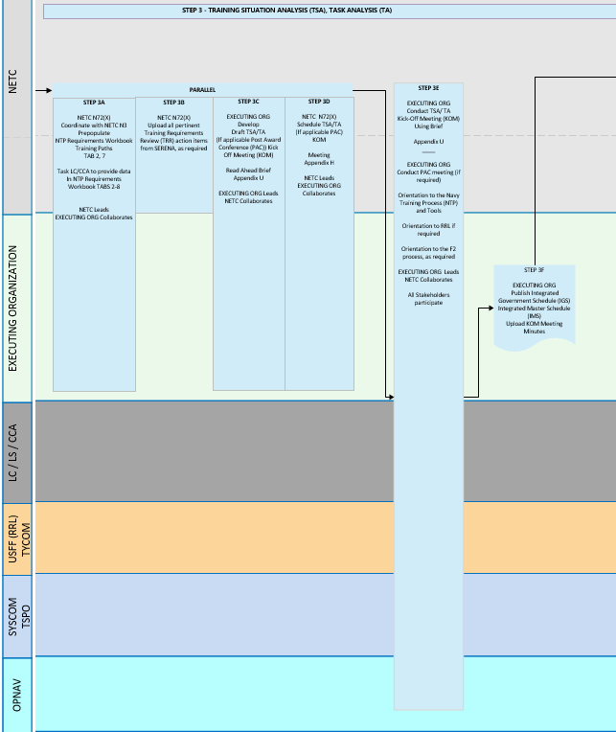

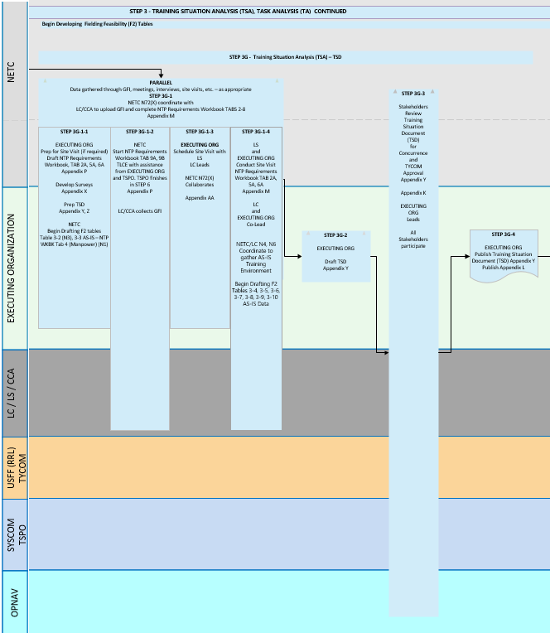
Figure 1-1: (U) Navy Training Process (NTP) Map, TSA

The methodology used to review and assess the training follows standard analytical procedures through a systematic and dynamic process, and is illustrated in the Table that follows and in Figure 1. They provide the process followed in the creation of this TSD.
Table 2. (U) TSD Methodology (Executing Organization)
Training Situation Analysis
- Review Needs Assessment Alignment Report, Outbrief, and Data
- NETC prepopulates NTP Requirements Workbook
- NETC gathers all Training Requirements Review (TRR) data and Action Items from SERENA
- NETC and Executing Organization develop Brief and conduct TSA and TA Meeting
- Executing Organization Integrated Government Schedule (IGS) confirmed
- LC/CCA provides Government-Furnished Information (GFI) and populates NTP Requirements Workbook
- NETC starts Total Life Cycle Cost Estimate (TLCE) sheet
- NETC and Executing Organization prepare and conduct analysis of Current Training Situation
- Executing Organization prepares for Site Visit, reviews GFI and courseware
- Executing Organization conducts Site Visit
- Executing Organization conducts Existing TSA and Risk Assessment
- Executing Organization documents Existing TSA and Risk Assessment in TSD
- Executing Organization conducts Training Technology Assessment
- Executing Organization documents Training Technology Assessment in TSD
TSD Development
- Executing Organization prepares TSD with inputs from NETC NTP Requirements Workbook Tabs
- Executing Organization conducts Internal Quality Assurance (QA) Review
- Executing Organization updates TSD with Internal comments
- Executing Organization delivers TSD for Stakeholder Review
- Executing Organization updates TSD with Stakeholder comments
- Executing Organization delivers Final TSD

(U) Training Situation Analysis (Executing Organization)
The TA is broken into two parts: the existing situation, and training technology assessment. The following provides further information.

- Existing Situation -- “The Training Situation Analysis (TSA) takes a broad look at all aspects of an existing or emerging training situation or program. The process is scaled as necessary to fit the scope of the training system under review.” An analysis of the current “As Is” Existing Situation of training to include resource documents and curriculum occurred. The Existing Situation Analysis looks at the current training situation, providing a description of the history, organizations, personnel, training equipment, and facilities to establish the baseline. The existing maintenance training situation and environment will be documented (as a baseline).

A literature review of curriculum documents and other available written documentation through GFI was conducted, which included <Project Name> curriculum materials, courseware materials, and other orders and instructions related to training and personnel management. In determining the current state of training for the <Project Name>, the maintenance training syllabi and pipelines were reviewed to gain an appreciation of the challenges associated with today’s training and associated environment. The review included not only what was taught, from basic to the highest levels of the training, it also looked at the time required to conduct the training along with the methods for achieving the desired training results. The <Project Name> maintenance-related data was also reviewed. This review provided context in how the current training occurs, and what support training documents exist. It was validated at site visits and interviews with Government Subject Matter Experts (SME).

The analysis utilizes Quantitative and Qualitative data. Quantitative data relies on numerical data to explain or justify conclusions or recommendations (e.g., how many, how much, what percentage). A quantitative approach facilitates comparison and statistical aggregation of the data. The quantitative analysis requires data collected in sufficient quantity and over a sufficient time period, to produce statistically valid results. Qualitative analysis relies on opinions and observations (in this study, from the Government-appointed SMEs, program management, contractors, and schoolhouse representatives), which typically produce a wealth of detailed information about a smaller number of people and cases. This attribute increases the understanding of the cases and situations, but reduces generalization of the data. The qualitative analysis requires no burden of proof; rather, it attempts to provide insight into attitudes that are conveyed to the researcher, resultant of the system or situation under study. Recommendations or suggestions based upon qualitative data that are not readily apparent are further validated by a quantitative data analysis.

- Training Technology Assessment -- A training technology assessment reviews current training materials and training equipment to thoroughly understand the target training program. Training System Alternatives are identified and evaluated as appropriate from other Government training organizations and/or commercial products. Current and evolving instructional technologies are reviewed and their training capabilities and effectiveness are determined. Assessment considers existing similar training systems using a qualitative evaluation of the similar system’s training devices, equipment, and technologies with regard to simulation features, instructional features, performance measurement capability, training effectiveness, and facility support requirements. The findings of the technology assessment will be compared to the Government-provided course materials to develop various possible alternatives to training integration challenges. A RAMP will be conducted to identify potential risks to the training program. The training system and equipment employed were analyzed utilizing:

  - Site visits to <Add content> were conducted. During these site visits, interviews of training personnel and review of the <Project Name> training system to include curriculum, courseware, training equipment, training spaces, and other support facilities was conducted. Direct observation of operational environments occurred during site visits. The data gathered from these information sources were used to document and baseline the current maintenance training. Appendix # contains the points of contact (POC), the unit/command to which assigned, and their assigned billet within the unit.

The following Table provides the list of SMEs who participated in the Site Visit.
Table 3. (U) Site Visit Participants (Executing Organization)
Date | Location | SMES | Analysts

(U) TSD Development (Executing Organization)
The TSD development was conducted IAW the tailored DID to ensure all criteria were met within the analysis as well as within the IPRD itself. It also included generating, drafting, and inserting the analysis reports and corresponding appendices.

The TSD in Draft form was delivered to the Internal QA Team for review. Updates were made based on the comments. The updated TSD was delivered to the Stakeholders for review. Stakeholder comments were incorporated into the final completed IPRD. The following Figure depicts a high level of the IPRD process.

Figure 1-2: (U) Training Situation Document Process Flow (Executing Organization)

(U) Existing Situation Analysis (Executing Organization)

This section describes the <Project Name> mission, historical background, and general description of the existing current “As Is” training environment.

(U) Training Mission Statements (Executing Organization)
<Add content see example>

(U) Naval Education and Training Command
The Mission of Naval Education and Training Command (NETC) is, “To educate and train those who serve, providing the tools and opportunities which enable life-long learning, professional and personal growth and development, ensuring fleet readiness and mission accomplishment; and to perform such other functions and tasks as assigned by higher authority. Additionally, serve as sole claimant for individual training and education, and as the Principal Advisor to the Chief of Naval Operations (CNO) and Commander, U.S. Fleet Forces Command (COMUSFLTFORCOM) on training and education related matters.”

(U) Historical Background – Needs Assessment Overview (Executing Organization)
<Add content
see example and Get from NTP Requirements Workbook – Tab 1, 1A-1, 1A-2, 1A-3, 1B, 1C >

(U) General Description of Existing Training Situation – FRD Scope of RRL Analysis (Executing Organization)
<Add content see example>

(U) Training Pipelines – Course Analyzed (NETC)
<Add content
see example and Get from NTP Requirements Workbook – Tabs 7 and 8. Describe Academic, Synthetic, Operational Equipment, and Practical Job Training Instructional Units >

The <insert rating abbreviation> rating includes <a single, unique training path comprised of ## accession training courses> OR <insert number of training paths comprised of ##-## accession training courses per path>. The current, or “As-Is,” relationship of existing training to the training path/Navy Enlisted Classification (NEC) requirements is illustrated in Figure 2-1.
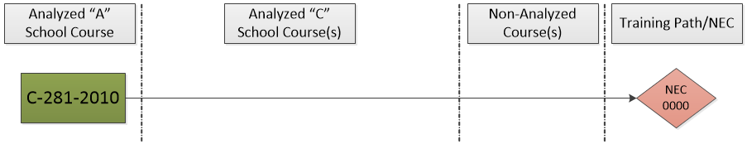
Or
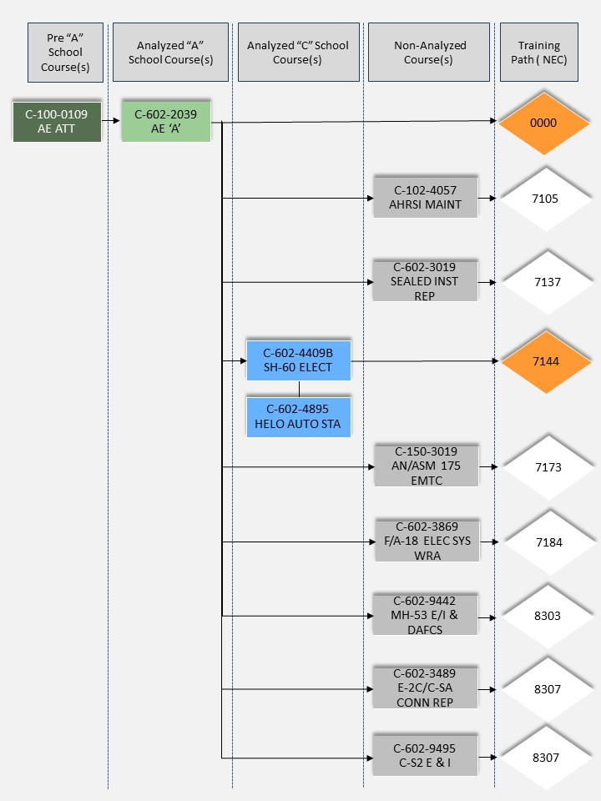
Figure 2-1: (U) "As-Is" [Rating Abbreviation] Rating Training Path (FRD Figure 1-1)

(U) Course Data Site Visit (Executing Organization)
<Add content
see example and Get from NTP Requirements Workbook – Tab 2, 2A, 8 >

(U) Courses within Paths (NETC)
<Add content
see example and Get from NTP Requirements Workbook – Tab 2, 7 >

(U) Rating Training Complexity (NETC)
<Add content>

(U) Course Versions/Revisions (NETC)
<Add content
see example and Get from NTP Requirements Workbook – Tab 2 >

(U) Current Version of OCCSTD (NETC)
<Add content
see example and Get from NTP Requirements Workbook – Tab 2 >

(U) Job Task Analysis /JOB DUTY TASK ANALYSIS DATA (NETC)

If a JDTA was provided as GFI, the file is embedded here. If no JDTA indicated no JDTA provided as GFI

Add File

Embedded File 1. (U) JDTA

(U) Learning Objective Traceabiiity Matrices (NETC)
<Add content
see example and Get from NTP Requirements Workbook – Tab 2 >

(U) Pending Training Requirements Review (TRR) Actions (NETC)
<Add content
see example and Get from NTP Requirements Workbook – Tab 2 >

(U) Identify Commonalities with Other Ratings or Across Training Paths with Implications for Reuse (NETC)
<Add content
see example and Get from NTP Requirements Workbook – Tab 2 >

<Example:
The two “A” School courses (A-711-0005: Block 0 and A-711-0006: Block 1) included in accession-level training for SWs are NOT shared with any other ratings. However, the Navy’s existing Hull Technician (HT) “A” School matched against certain SW “A” School topics.>

Table 4. (U) Commonalities for Potential Reuse
SW “A” School | HT “A” School
Shielded Metal Arc Welding  (Lesson 2.2 Block 0) | Shielded Metal Arc Welding Operations  Portable Engine Driven Welder Operations
Sheet Metal Fabrication  (Lesson 1.2 Block 1) | Manual Brake and Shear Operation  Sheet Metal Fabrication
Sheet Metal Fabrication  (Lesson 1.2 Block 1) | Sheet Metal Fabrication/Spot Welding Operations  Manual Brake and Shear Operation
Sheet Metal Fabrication  (Lesson 1.2 Block 1) | Manual Brake and Shear Operation  Sheet Metal Fabrication
Brazing, Oxy Gas Welding  (Lesson 2.1 Block 0) | Oxyacetylene Welding, Brazing, and Cutting Operations

(U) Performance Measurement Methods (Executing Organization)
<Add content >

(U) Feedback and Evaluation Procedures (Executing Organization)
<Add content>

(U) Training Locations (NETC)
<Add content
see example and Get from NTP Requirements Workbook – Tab 2 >

(U) Student Population Enrolls Data (NETC)
<Add content
see example and Get from NTP Requirements Workbook – Tab 3 >

(U) Student Entry Level Requirements (Executing Organization)
Prerequisite requirements …
<Add content>

(U) Prerequisite Deficiencies (Executing Organization)
<Add content>
<Example:
Instructors and Fleet noted trainee weakness in math. One explanation was high school not preparing trainees for “A” School math>

(U) Personnel Qualification Standards (Executing Organization)
<Add content>

(U) Pipeline Sources (Executing Organization)
<Add content>

(U) Student Throughput and Attrition Rates (Executing Organization)
<Add content
see example and Get from NTP Requirements Workbook – Tab 3 and collect from NETC >

<Example:
Trainee throughput and attrition summary:
- Average Yearly Throughput
  - Block 0: 128 trainees
  - Block 1: 122 trainees
- Attrition Month Year–Month Year
  - Block 0: 2 Trainees
  - Block 1: 1 Trainee>

(U) Manpower (NETC)
<Add content. Get from NTP Requirements Workbook – Tab 4 >

(U) Instructors (Executing Organization)
The as-is training situation for instructors is as follows:
- # Instructors are shared between Block 0/Block 1
- “A” School has a maximum size of:
  - Classroom: # Instructor to # Trainees
  - Lab: # Instructors to # Trainees
- Manpower for <add location> is shown below for Block 1 [CIN ###] and Block 0 [CIN ###]
- <Add content and additional locations as appropriate.>
Table 5. (U) Manpower Figures – XXX (BL 0)
Billet Title | BIN | Manpower Type | Enlisted Paygrade
INST A SW | 852226 | MIL | 7
 | 852227 | MIL | 6
 | 3623080 | CONTRACTOR (CNTR) | N/A
 | 3623081 | CNTR | N/A
 | 3623082 | CNTR | N/A

Table 6. (U) Manpower Figures – XXX (BL 1)
Billet Title | BIN | Manpower Type | Enlisted Paygrade
INST A SW | 852226 | MIL | 7
 | 852227 | MIL | 6
 | 3623080 | CONTRACTOR (CNTR) | N/A
 | 3623081 | CNTR | N/A
 | 3623082 | CNTR | N/A

(U) Administrative Personnel (Executing Organization)
<Add content>

(U) Support Personnel (Executing Organization)
<Add content>

(U) Facilities (NETC)
<Add content see example and Get from NTP Requirements Workbook – Tab 5, 5A >

<Example:
Facility summary of Building ###:
- Main building – built 2005
- Classrooms 105, 106, 107, 108, 109, 123, 125/126
- Lab/steel shop (adjacent to building) – shared space with Army, Air Force, and “C” School trainees
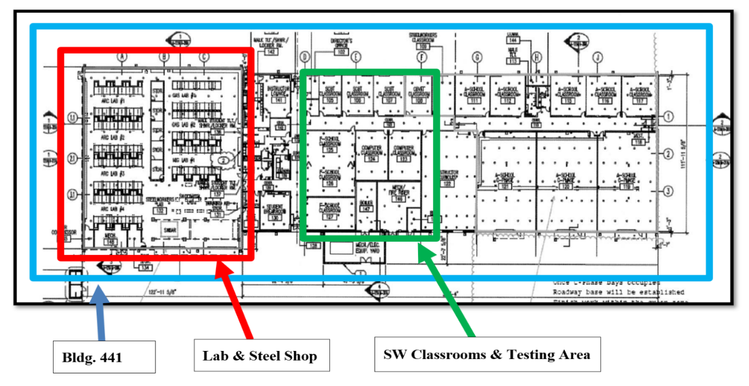
Recommendation: add climate control to cool lab/steel shop due to extreme heat conditions in summer months; alternatively, acquire welder cooling systems (helmets/vests) that meet National Institute for Occupational Safety & Health (NIOSH) standards for cooling

Facility summary of standard classrooms:
Instructors use 60-inch interactive SMART boards with PowerPoint, Trainee Guides, Lesson Plans, and blueprint paper copies.


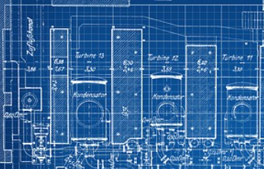
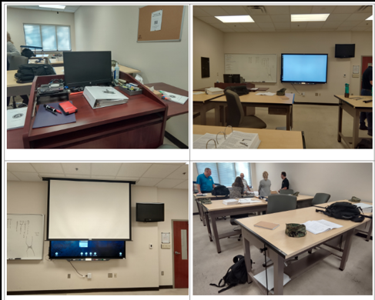
Recommend procuring tablets to import digital blueprints (or other technical publications) for ease of updates; alternatively, allow trainees to have their own hard copies of blueprints (without previous markings)>

Facility summary of Labs:
Lab equipment provides standard oxyacetylene torches, bottles, and carts; Miller 304 welders; and Miller plasma arc machines. Various hand tools are used to complete training objectives. Materials used are various types of metal, welding rods, filler rods, and classroom stationery.
- 24 new Miller 350 welders are on order to replace the 304s.
- Instructors would like to add MIG/GMAW to the “A” School curriculum.
- 8 new Miller plasma arc machines have been purchased to support cutting of material such as RST. Awaiting Public Works installation.

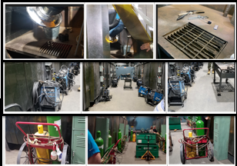
Current curriculum does not include familiarization with hand power tools (e.g., grinders, drills, and chop saws). Recommend adding to “A” School. As task exists in “C” School, leverage existing materials for tool introduction.>

(U) Training Equipment and Materials (NETC and Executing Organization)
<Add content
Provide description and photo of each, see example in section 2.7. Get from NTP Requirements Workbook – Tab 6, 6A >

(U) Future Development (Executing Organization)
<Add content
see example and NTP Requirements Workbook>

(U) Upgrades to <Project Name> (Executing Organization)
<Add content
see example and NTP Requirements Workbook, site visit data collection, interviews with stakeholders >

(U) Future Training Initiatives (Executing Organization)
<Add content
see example and NTP Requirements Workbook, site visit data collection, interviews with stakeholders >

(U) Environment Considerations (Executing Organization)
<Add content
see example and NTP Requirements Workbook, site visit data collection, interviews with stakeholders >

(U) Situation Analysis (Executing Organization)
<Add content
see example and NTP Requirements Workbook, site visit data collection, interviews with stakeholders >

(U) Impact Statements (Executing Organization)
<Add content and see example and NTP Requirements Workbook>

(U) Solutions and Alternatives (Executing Organization)
<Add content>

(U) Recommendations (Executing Organization)
See Section 4.0

(U) Training Technology Assessment Data (Executing Organization)

This section describes the Training Technology Assessment data on technology used to provide training for existing systems, which are similar to an emerging system.

(U) Similar System Analysis (Executing Organization)
<Add content – See example>

(U) Associated Training (Executing Organization)
<Add content >
Table 7. (U) Associated Training
Steelworker “A” School | Hull Technician “A” School | Civilian Topic Equivalent
Shielded Metal Arc Welding  (Lesson 2.2 Block 0) | Shielded Metal Arc Welding Operations  Portable Engine Driven Welder Operations | Introduction to Welding  Principles of Welding  Shielded Metal Arc Welding 1 and 2  Welding Application
 |  | Concrete Reinforcing Steel Institute:
Reinforcing Steel / (Lesson 2.3 Block 0) |  | Steel Reinforced Concrete: Essentials
Reinforcing Steel / (Lesson 2.3 Block 0) |  | Steel Reinforced Concrete: Floor Systems
Reinforcing Steel / (Lesson 2.3 Block 0) |  | Fundamentals of Reinforced Concrete Construction
 |  | Sheetmetal Ductwork Fabrication School:
Sheet Metal Fabrication / (Lesson 1.2 Block 1) | Manual Brake and Shear Operation  Sheet Metal Fabrication | Basic Principles of Sheet Metal Layout
 |  | Stratford Career Institute:
Construction Drawings |  | Construction Management for Blueprint Reading

Summary of key findings:
- Further investigation into the appropriateness of these topics to serve as enhancements to or replacement of <SW “A” School> topics should be conducted before decisions of this manner are made and should be used in relationship to findings from the IPRD.
- <Add content>
- <Example: Investigation of the Tooling-U COTS training alternative is required for consideration.>

(U) Associated Training Equipment (Executing Organization)
<Add content – See example >
<Example
Hull Technician “A” School trainees use the same welders as the SW “A” School trainees. Welders are Miller XMT 304 CC/CV dual process machines, capable of MIG, SMAW, TIG, FLUX CORE, and ARC air gouging/cutting. Miller XMT 304s were produced from 1995–2021 with shelf life 10-15 years.
During “A” School, these machines are utilized for the SMAW (Lesson 2.2) portion of the curriculum. The facility must provide 230/460 volts single or three-phase power to operate the machines.
Miller XMT 304 welders are no longer produced and have been replaced by Miller XMT 350 with purchase pending of 24 new XMT 350s.>
Table 8. (U) Associated Training Equipment
 | Miller XMT 304 CC/CV
Stock Number | 3431-01-368-8324
Mission Statement | Used to perform SMAW operations during “A” School
Associated Learning Objectives | Given tools, materials, and specifications, perform SMAW in accordance with applicable instructions and technical manuals.
Simulation Features and Training Effectiveness | Miller XMT 304 welders have no simulation features. However, they are extremely effective for training as they are standard commercial equipment. These machines are reliable, well built, and easy to use.
Instructional Features | Not applicable
Stock Number | 3431-01-368-8324

(U) Commonality Analysis (Executing Organization)
<Add content – See example >

(U) State of the Art Assessment (Executing Organization)
Assessment of the state-of-the-art capabilities was conducted.
- <Add content>
- <Examples: Electronic classrooms, virtual/synthetic training systems, and human factors will be analyzed during media selection.
- Similar System Analysis, Associated Training, and Associated Training Equipment identified similarities to other USN training such as Hull Technician (HT) “A” School.
- Civilian programs also provide similar task functions and certifications related to the SW skillset that could also be utilized to enhance training.
- Civilian programs includes (a) Universal Technical Institute, (b) Concrete Reinforcing Steel Institute, (c) Sheetmetal Ductwork Fabrication School, and (d) Stratford Career Institute>

The state-of-art comparative analysis will be used in consideration of enhancements to or replacement of <SW “A” School> topics in the IPRD.

(U) Simulation and Instructional Features (Executing Organization)
<Add content – See example >

(U) RECOMMENDATIONS (Executing Organization)

In summary, this report has documented the existing training situation of the current “As Is” state of training. The following provides a list of recommendations from the TSA for further consideration during the Task Analysis, Learning Analysis, and Media Selection for the new <Project Name> training.

- Recommendation: <Add content Title>
<Add content>

Current State of Training | Recommended Improvements

- Recommendation: <Add content Title>
<Add content>

Current State of Training | Recommended Improvements

- Recommendation: <Add content Title>
<Add content>

Current State of Training | Recommended Improvements

<Add content
Additional recommendations as applicable>

(U) Next Steps (Executing Organization)

With the completion of the TSD, the recommendation is to go to the next step, which is to conduct the Task Analysis, Learning Analysis, and Media Selection for the “To Be” training state. Completion of these analyses are documented in the IPRD, IMRD, and MCD (if appropriate), which together provide the necessary requirements to support the new training for the <Project Name>.

(U) Appendix A: Integrated Product Team (IPT) (Executing Organization)
The following is a list of the Integrated Product Team (IPT) that participated in this analysis.

USG |  | <Add Contractor Name>
Name | Organization/Role | Name | Organization/Role

(U) Appendix B: Acronyms and Abbreviations (Executing Organization)
The following is a list of acronyms and abbreviations used in this document.

Acronym | Term
ADDIE | Analyze, Design, Develop, Implement, and Evaluate
BL | Block Learning
CCA | Course Curriculum Authority | Curriculum Control Authority
CNATT | Center for Naval Aviation Technical Training
COMNAVAIRFOR | Commander, Naval Air Force
COMNAVIFOR | Commander, Naval Information Forces
COMNAVSUBFOR | Commander, Naval Submarine Force
COMNAVSURFOR | Commander, Naval Surface Force
COMNECC | Commander, Navy Expeditionary Combat Command
COMPACFLT | Commander, Pacific Fleet
CONAVRESFOR | Commander, Naval Air Reserve Force
CRM | Comment Resolution Matrix
DID | Data Item Description
DoD | Department of Defense
DSN | Defense Switched Network
EA | Executive Agent
ELO | Enabling Learning Objective
EPSS | Electronic Performance Support System
ESC | Executive Steering Committee
GFE | Government-Furnished Equipment
GFI | Government-Furnished Information
IAW | In Accordance With
IGS | Integrated Government Schedule
ILE | Integrated Learning Environment
IMDP | Instructional Media Design Package
IMI | Interactive Multimedia Instruction
IMRD | Instructional Media Requirements Document
IPRD | Instructional Performance Requirements Document
IPT | Integrated Product Team
ISD | Instructional Systems Design
JDTA | Job, Duty, Task Analysis
KSA | Knowledge, Skill, and Attitude (in the DID)
LC | Learning Center
LMS | Learning Management System
LS | Learning Site
NAVEDTRA | Naval Education and Training
NAVFAC | Naval Facilities Engineering Command
NAVIFOR | Naval Information Forces
NAWCTSD | Naval Air Warfare Center Training Systems Division
NeL | Navy eLearning
NETC | Naval Education and Training Command
NTP | Navy Training Process
OJT | On-the-Job Training
OPNAV | Office of the Chief of Naval Operations
OPNAVINST | Chief of Naval Operations Instruction
POC | Point of Contact
RAMP | Risk Assessment and Mitigation Plan
RCA | RRL Course Acquisition
RRL | Ready Relevant Learning
S2025 | Sailor 2025
SAT | Systems Approach to Training
SME | Subject Matter Expert
SYSCOM | (Navy) Systems Command
TA | Task Analysis
TD | Training Device
TLCE | Total Life Cycle Cost Estimate
TLO | Terminal Learning Objective
TRR | Training Requirements Review
TSA | Training Situation Analysis
TSD | Training Situation Document
TSPM | Training System Program Manager
TTA | Training Task Analysis
TTE | Technical Training Equipment
TTL | Training Task List
TYCOM | Type Commander
USFF | United States Fleet Forces

(U) Appendix C: REFERENCES (Executing Organization)
The following is a list of the Government-furnished information (GFI) provided for the project.

GFI# | Reference
GFI-1
GFI-2
GFI-3

(U) Appendix D: NTP Requirements Workbook (Executing Organization)

Add File

Embedded File 2. (U) NTP Requirements Workbook (Tabs 2-8)

OPNAVINST 5450.336C Missions, Functions, and Tasks, of NETC, 14 May 2012.

