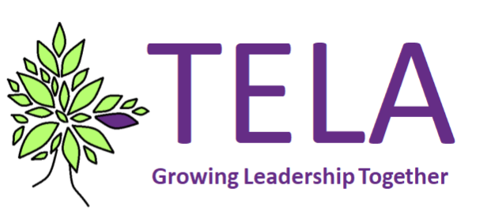

NPQsL application form SPRING ‘21

PERSONAL INFORMATION- Please fill in all fields

First name: (As stated on your passport) | Surname: (Also maiden name) | DOB:
Mobile phone number: | Email address used for NPQSL programme:
Teacher Reference Number (7-digit format)
Click here if you require support
Participants will need to know this for the NPQ to go ahead.
Contact the Teacher Qualification helpdesk on 020 7593 5394 or email QTS.ENQUIRIES@education.gov.uk

School position: | Length of time in role:
Gender: | Dietary requirements:
Ethnic group: | Asian, Black, Mixed, White, any other ethnic group, unknown
Ethnicity: | Asian –Bangladeshi, Chinese, Indian, Pakistani, any other Asian background  Black – Black African, Black Caribbean, any other black background  Mixed – White and Asian, White and Black African, White and Black Caribbean, any other mixed background  White – white British, White Irish, traveller of Irish heritage, gypsy / Roma, Any other white background  Any other ethnic group  Unknown
Any Disabilities? | Yes / No / Prefer not to say
SCHOOL INFORMATION: * required

*School name & address:
*School URN: | https://get-information-schools.service.gov.uk/
Percentage of pupils eligible for FSM | Can be found on Gov.uk
Local authority:
If you are a member of a Multi Academy Trust, please name it here:
If you are a member of a teaching school alliance, please name it here:
If you are a category 5/6 or opportunity area, please state which one:
*Email address to send NPQ invoice to:
*Head Teacher name:

*Head Teacher email address:

SPONSOR DETAILS

What is a sponsor and why do I need one?
The task you submit for final assessment will need to be verified by a senior leader in your school. For this purpose, you will need a sponsor who will verify your work and the evidence provided in your submission to help confirm your effectiveness as a senior leader. Your Head teacher will need to agree to the sponsor.

Who should I nominate as a sponsor?
Your sponsor is required to complete a form to verify that your evidence is accurate and to provide further testimony of how you demonstrated evidence of competence as a senior leader in undertaking the task. The form should therefore be completed by a senior leader (your line manager or a leader of equivalent seniority) who is in a position to know the work you have done well, has a good knowledge of how you lead your team and who is able to assess your achievements and the impact of your leadership. The additional evidence provided by your sponsor will be assessed alongside your submission. It is therefore important that you: ensure your sponsor reads the guidance provided carefully; discuss your task and your submission with your sponsor. Where your sponsor is not the Head teacher of your school, the Head Teacher will also need to sign the form to validate the evidence.
Sponsor’s Name and email address:

To be completed by the Head Teacher

I have agreed to support this NPQSL application:
I have agreed to release the applicant for the required days of training:
Head Teacher’s Supporting Statement:
Please explain how the applicant has demonstrated their readiness for this programme.
(Please complete in no more than 200 words)

Please confirm who will fund the NPQSL course fee

Self School/college Scholarship funded
I hereby confirm that the above named has my support in applying for this NPQSL programme

-------------------------------------------- --------------------------------------------
Signed by Head teacher Date

ELECTIVE MODULES
To achieve the NPQSL qualification you will need to successfully complete all essential content and elective modules.

PLEASE CHOOSE YOUR PREFERED ELECTIVE MODULE

Senior leadership within a faith school: Vision, values ethos & community

Senior leadership: A change towards transformation

Please note that non-attendance at elective modules may result in a £50.00 administration fee being charged
Assessment section: To be completed by the applicant

I agree to complete the NPQSL programme including 6 Face to Face days, Twilight sessions and submit my final assessment
YES……………..NO……………..
I am aware that my data will be shared with *key partners in connection with NPQSL in accordance with the TELA privacy notice * NPQOnline Assessors and Department of Education
YES……………..NO…………….
I am happy for my photo to be taken at some training days which may be used for marketing and social media
YES………………NO…………….

Personal Statement:
How has the experience and impact of your role or career made you eligible for NPQSL?
(Please complete in no more than 200 words)

Liability for fees

In the event that the programme is oversubscribed, applications will be prioritised on a first-come first-served basis so early application is advised. All applicants will receive acknowledgement of their application within 10 working days of our receipt and confirmation of their place.

Once an applicant has been offered a place on the programme and has accepted that place then the applicant or the school is liable for the full fee for the NPQSL programme. These are payable prior to commencing the induction session which starts the programme.

No refunds for deferrals or withdrawals will be made under any circumstances. If an applicant is eligible for an exemption from an elective module, it is at the applicant’s choice and discretion to apply that exemption to their learning programme and no refunds (partial or otherwise) will be applied under such circumstances.

I have read the Terms and Conditions………………………………………………………………….Date…………………………………….

Please return completed application forms to npq@thomasestley.org.uk

Deadline Thursday 17 December, 12 noon

