VE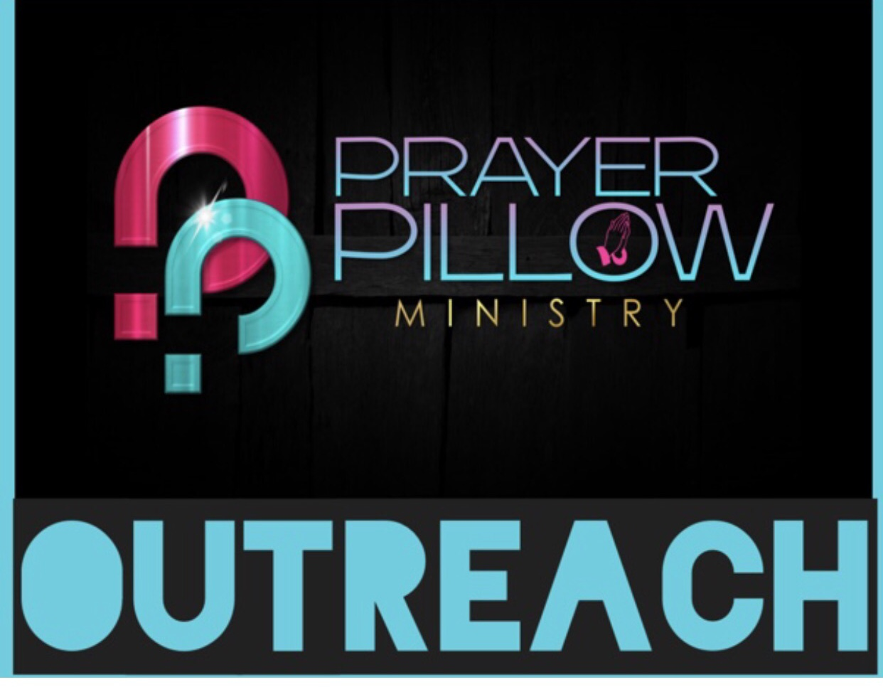
DIVERSITY AND INCLUSION

The Prayer Pillow Ministry aspires to create a world where equality and inclusion are achievable for all. Our goal is to reach all ethnic backgrounds & nationalities. We are better together.

