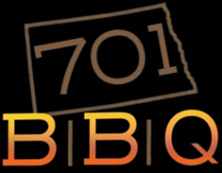
Food Truck On-Site Request Form
*Only operating in North Dakota*
Andy and Jill Elsberry, Owners
701-740-6135 ▪701bbq@gmail.com

Today’s Date:
Requestors Name:
Phone/Email:

EVENT DETAILS (circle)
Day of the week: M T W TH F S S
Do you have a specific date in mind? YES NO ___________
Is this a reoccurring event? YES NO ___________
Other dates requested: _________________________________
Is there a fee charged to vendors? YES NO ___________
Location of event: _______________________________ Business/Residential
_______________________________ Street Address
_______________________________ City or County
Type of event? _______________________________ Birthday/Luncheon/Etc.
Is the event open to the public? YES NO ____________
Approximate number of guests? YES NO ____________
Is 50-amp RV power available? YES NO ____________
*If no, it will be necessary for us to run a generator that does produce significant sound*
Is a clean water hookup available? YES NO ____________

PAYMENT DETAILS
Will individual guests be responsible for payment? YES NO
*If no, please provide the billing point of contact information below:

__________________ ____________ ______________ __________
Name Phone Method of Payment Budget

APPROVED | DENIED
______
INITIAL

