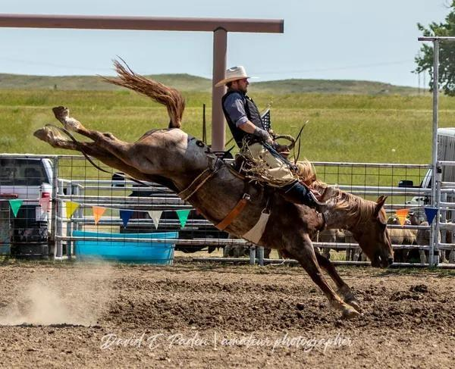

(Riverside Bronc Match)

Sponsorship options:

**PLATINUM - $1000 and up:**

* Post your banner at Events in arena
* Facebook/Website Advertisement
* Announced at all Events
* Free Admission to Jubilee Events up to

10 tickets

* Platinum Parking/Seating Area

**GOLD - $500 - $999:**

* Post your banner at Events in arena
* Facebook/Website Advertisement
* Announced at all Events
* Free Admission to Jubilee Events up to

5 tickets

**SILVER - $250 - $499:**

* Facebook/Website Advertisement
* Announced at all Events
* Posted at all Events

**BRONZE - $50 - $249:**

* Facebook/Website Advertisement
* Announced at all Events

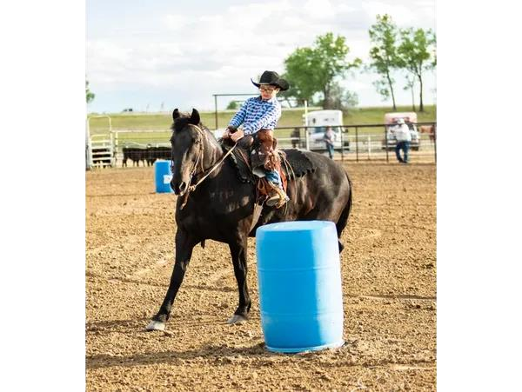

(Youth Rodeo)

**WITH YOUR GENEROUS DONATIONS**

**WE ARE ABLE TO PROVIDE A FUN**

**YOUTH RODEO EXPERIENCE FOR**

**OUR YOUNGER GENERATION, AN**

**EVENTFUL RANCH RODEO & BRONC MATCH DURING JUBILEE**

**CELEBRATION.**



(NAME)



(MAILING ADDRESS)



(PHONE NUMBER)

(SIGNATURE)

**HUGE THANK YOU**

**TO LAST YEARS AMAZING SPONSORS!**

**Without them we would not be able to bring these events to our town!**

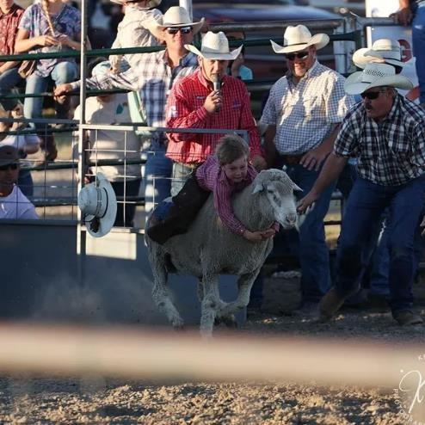

(Jubilee Mutton Buster)

**Please make checks payable to:**

**Moorcroft Rodeo Club**

**PO Box 582**

**Moorcroft, WY 82721**

**\*\* Please email Sponsor logos to: moorcroftrodeoclub@hotmail.com**

**Questions? Call:**

**Jobee Timberman, President**

**307-756-2160**

|  |  |
| --- | --- |
| **9TH ANNUAL**  **YOUTH RODEO:**    **FRIDAY, JUNE 27, 2025**    **Gates Open at 4:30 pm**  **Rodeo Starts at 6:00 pm**    **Spectator Admission FREE**      **JUBILEE RANCH RODEO MUTTON BUSTIN & RANCH BRONC:**    **FRIDAY, JULY 11, 2025**    **Gates Open at 5:00 pm**  **Calcutta at 6:00 pm**    **$10.00 Gate Fee – 12 & up**  **11 & under FREE** | **SCHEDULE OF EVENTS**  **2025**  **4TH ANNUAL**  **RIVERSIDE BRONC MATCH & STRAY GATHERING**  **SATURDAY, JULY 12, 2025**    **Gates Open at 2:00 pm**  **Match Starts at 3:00 pm**    **$10.00 Gate Fee – 12 & up**  **11 & under FREE**    **OTHER EVENTS:**  **ROPE & STROKE**  **AND**  **MONTHLY TEAM ROPINGS**  **DATES: TBD**  **~WATCH OUR WEBSITE FOR DATE DETAILS~** |

MOORCROFT

RODEO CLUB



**Moorcroft Rodeo Club is looking forward to this summer season.**

**Moorcroft Rodeo Club hopes with these events people will come to our hometown and surrounding**

**areas to support local businesses, while enjoying the outdoors and western lifestyle.**

**\*\*MRC is a non-profit organization**

**To enter an event, Go to** [**www.moorcroftrodeoclub.com**](http://www.moorcroftrodeoclub.com/) **for entry information!**