BOTTOM CONNECTION INSTALLATION SEQUENCE

- Mark out a square area (eg: for a 200 000L - 12m x 12m) and hammer in 4 x metal pegs 2m outside the edges of the bladders 12m x 12m area.
- Attach string to the metal pegs and form two diagonals which will give you the centre point. Dig a shallow trench for your feeder pipe from the middle of one side to the centre point where the connection to the bladder will be – NOTE: we supply the tank connector already attached to the bottom of the bladder, either LDPE, HDPE or PVC solvent fittings (you need to specify diameter that you require).
- Unfold bladder so that it is in half, exposing the centre connection.
- Connect the centre connection to your feeder pipe with a 90 degree bend – level off and hand compact the ground. A T-PIECE IS THEN CONNECTED TO THE FEEDER PIPE, outside of the perimeter of the bladder, ONTO WHICH YOU CAN ATTACH A BALL VALVE TO EXTRACT FROM.
- Unfold the bladder fully.
- Connect your string attached to the pegs onto the 4 lugs that are under each corner of the bladder, and pull each one taught – this will straighten the bottom of the bladder and remove creases.
- Start filling, and once +- 100mm full release the string on each corner and allow the bladder to fill and take it’s own shape. If the water pours out of the top centre pipe when you start to fill, push it over at an angle until the bladder is around 100mm full and then release it.
- When water starts to overflow from the top overflow pipe the bladder has stretched to capacity and is now full. Allow the CENTRE BREATHER PIPE to remain open at all times to allow air to escape. DO NOT ADD A LAY FLAT PIPE OR A FLEXI PIPE ONTO EITHER OF THE TOP PIPES, AND DO NOT CUT DOWN THE LENGTH OF EITHER PIPES – they are supplied at that length to prevent the bladder from over filling.

DIG SHALLOW TRENCH FOR FEEDER PIPE LAY OUT HALF OF BLADDER TO EXPOSE CONNECTOR
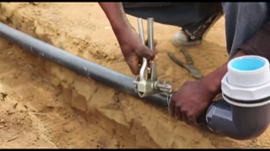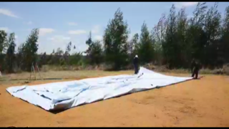

ONCE CONNECTED, ATTACH ROPE TO LUGS UNDER BLADDER & BILLOW BLADDER TO REMOVE MOST CREASES

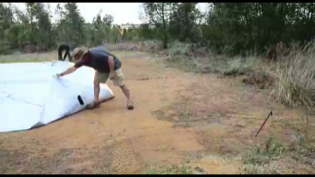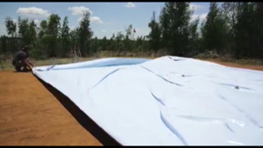

ATTACH ROPE FROM BLADDER TO PEGS & PULL. AFTER 100mm WATER IS IN BLADDER, REMOVE ROPE

