ADVANTAGES OF NEW RANGE

* 850g PVC identical to 700g in terms of manufacturing process – same MSDS
* PVC straps glued onto bladders all the way around, (from 20kl upwards), spaced at approx. 2m intervals, adding strength. These run perpendicular to the weld lines.

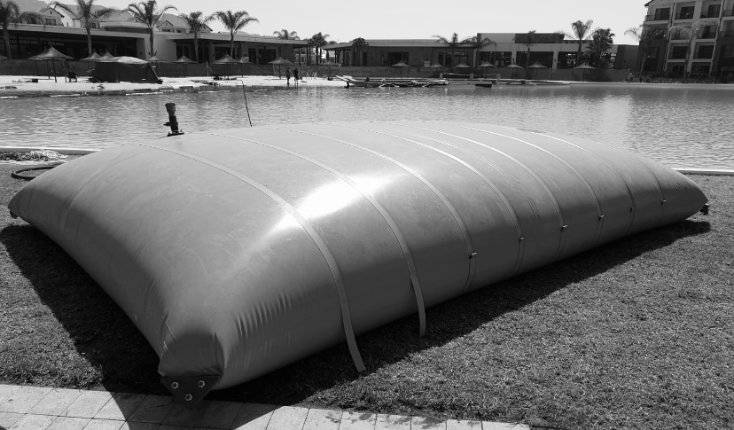

* Corners have plastic sections bolted on to act as a reinforcement or bracing to the corners.

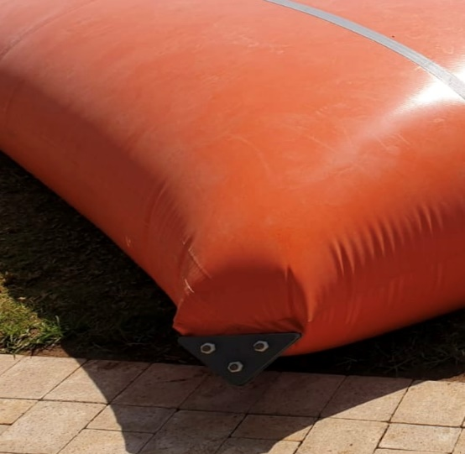

* Bottom connection point or side is a flange bolted on, which is much stronger than a normal bottom connector. Below is a 50mm & 80mm

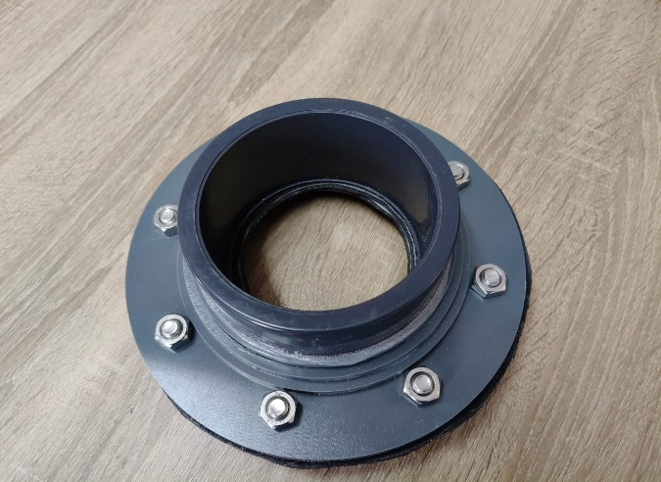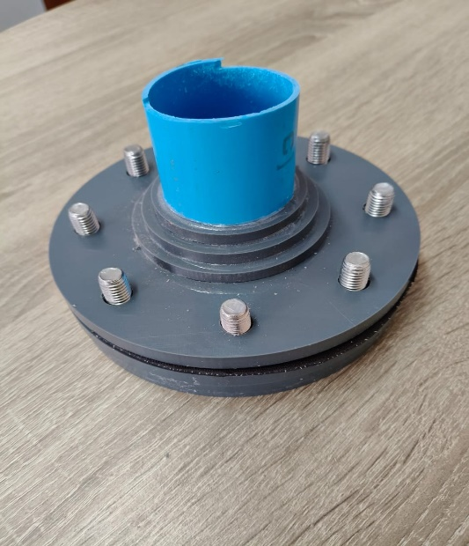

* Top pipe is a one way breather pipe so shuts off on capacity. When emptying, a vacuum is created allowing one to drain all water. A 500kl has 1 x 110mm one way. 330kl down to 150kl have 2 x 50mm one ways. 100kl down to a 35kl has 1 x 50mm one way. 20kl down has 1 x 32mm one way.

Below is a 50mm and a 110mm

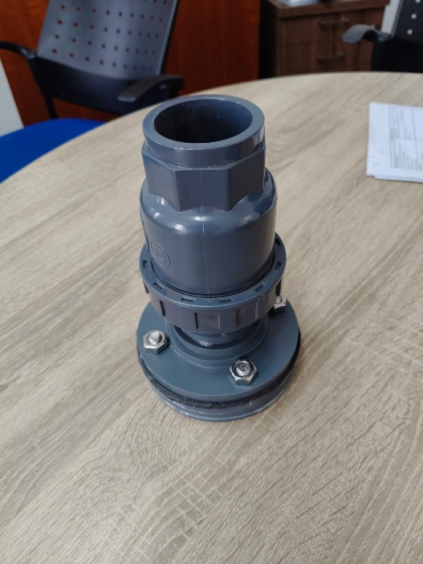 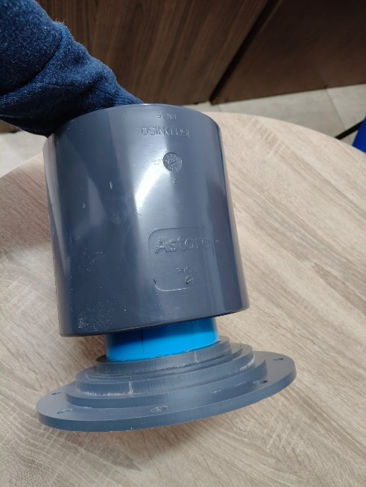

* Connection flanges up to 110mm diameter are all part of the price – we only charge extra from 125mm upwards.
* Cheaper than other bladders.