**SILVER SOLUTIONS**

**www.waterbladders.co.za**

Silver Solutions 1015cc CK 2005/006769/23 [40a Highway Rd, Fish Hoek, Cape Town 7975]

Member: S. Stapleton-Cotton Mobile: 082 495 7997 E-mail: [simons@cybersmart.co.za](mailto:simons@cybersmart.co.za)

VAT: 48302 40315 EXPORT: CUS0166586

GROUND PREPERATION TO INSTAL A ZINC/ALU DAM

Please take note that we have not quoted on any civil works. The platform preparation is the clients responsibility. Please follow the instructions below to ensure you choose the correct option:

1. **For installation on the ground (for dams up to a max diameter of 12m & up to 2.2m high)**

The surface should be level and compacted. The surface should be smooth and clean from any debris that can damage the liner. Please spread about 1m3 sand to cover the surface and edges of the reservoir. [NOTE: as per point 2 below that it is always advisable to cast a 100mm concrete slab with Ref 100 mesh in it roughly 1m bigger than the diameter.]

1. **For installation on a concrete slab (dams generally larger than 12m diameter):**

The diameter of the slab should be 1m larger than that of the diameter of the dam. Ie: for a diameter of 8m make the slab diameter 9 m. Cast the slab 100mm thick with 25 MPa strength concrete. It is good practice to add ref 100 mesh. Let set for 5-7 days.

You should be able to pour water in the reservoir directly after installation. Always keep the water level above 25% of the capacity as the wind will move the lining or the reservoir in extreme and harsh conditions. Any damages or related costs will be for the clients account.

1. **For installation on a ring beam (dams larger than 12m diameter onto uneven, soft ground and for dams 3m high):**

We recommend a ring beam of 300 x 500mm, with a steel cage of R 10 stirrups and 5 x Y12 rebar forming the cage. It is good practice that around 100mm of the ring beam should be above ground level. The inner part should be back filled with soil, and compacted. Let set for at least 14 x days.

* **Included with a complete reservoir (Dam):** PVC liner; 50 mm Outlet with valve; 40 mm Overflow; Aluzinc sheets and hardware.
* **Optional extras (please specify if required):** Steel domed roof; galvanized ladder; outlets (sizes 40 - 150 mm), overflows (sizes 40 - 150 mm); Inlets (sizes 40 - 150 mm), scour valve (see below)

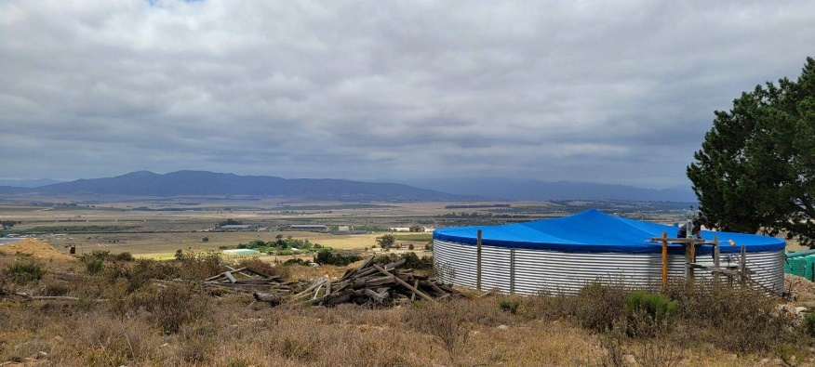



**SCOUR VALVE** – used when a pump is attached to extract, otherwise the pump vibration may cause metal fatigue at the point at which the connection is attached to the sheet.

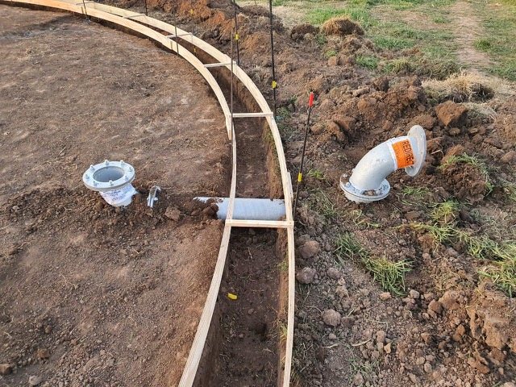

OTHER GUIDE LINES

* It is best to fill via the top – then it becomes visible to see whether the borehole or source of water is in fact pumping into the dam, the water is visible.
* Extraction can happen from the bottom connector point, and if pumped we must supply a scour valve.